Software Requirement Specification

 | INDEX
1 | Product Vision
 | 1.1 Purpose
 | 1.2 Problem Statement
 | 1.3 Proposed Solution
2 | Use Cases
 | 2.1 User Login witx1h Registered account
 | 2.2 User List
 | 2.3 Graph Page
3 | Test Cases
4 | Data Flow Diagram
5 | Setup of KIT-O-KAT
 | 5.1 Install Python
 | 5.2 Install Flask
 | 5.3 Steps to run KIT-O-KAT

1. Product Vision
1.1 Purpose
To create a webapp that list the pictorial representation of effort, task due date, work load, task status and completion rate for a better understanding. The webapp not only shows the daily status but also the week’s. The pictorial representation not only helps an individual for betterment but also the scrum master/product owner to manage the progress of product well.
1.2 Problem statement
The user needs to know the effort put in by him/her put in on a day or over a week, the tasks that are due today and over a week, the completion rate and the status of the tasks. The product owner needs to know what an individual is working on and the status of the user’s workload.
1.3 Proposed solution
This webapp allows the user to view the statistics in a graphical manner of the effort put in, the number of tasks that are due(Today/week), the completion rate and the workload of the users. The graphs for each requirement will be on a daily or weekly manner (two graphs, one for the day and one for the week in few cases).
2. Use Cases
Title | Login page
Description | The user logs using Kat login credentials.
Pre-Condition | The user should have an account in Kat.
Success Scenario | Logs in successfully  User will be able to view the list of employees
Failure Scenario | Authentication failure  Unable to login with right credentials  Incorrect username/password/domain name
Priority | High

Title | User List
Description | Displays all users.
Pre-Condition | Nil
Success Scenario | User will be able to view the list of employees.
Failure Scenario | Page not found  Users not displayed.
Priority | High

Title | Graph Page
Description | Displays all graph related to Due date, Assigned workload, Task Status and efficiency
Pre-Condition | User should have reported the task to KAT.
Success Scenario | User will be able to view the graphs.
Failure Scenario | Unable to view the graph.
Priority | High
3. Test Cases

4. Data Flow Diagram
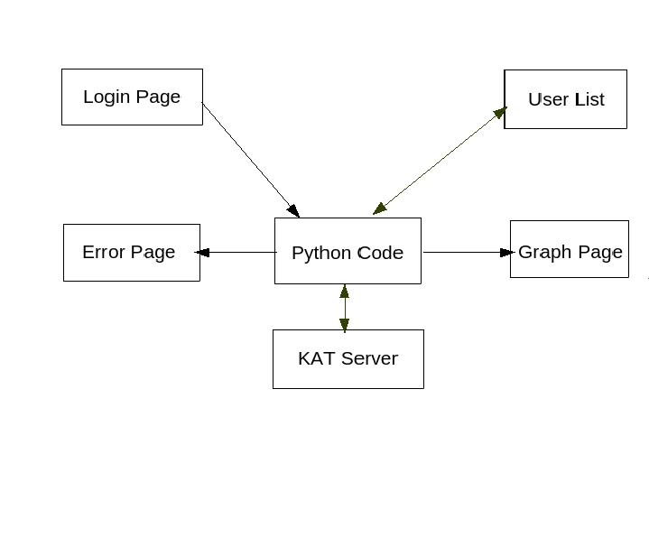
5. Setup of KIT-O-KAT
5.1 Install Python
a. sudo apt-get install build-essential checkinstall
b. sudo apt-get install libreadline-gplv2-dev libncursesw5-dev libssl-dev libsqlite3- dev tk-dev libgdbm-dev libc6-dev libbz2-dev
c. cd/ usr/src
d. wget https://www.python.org/ftp/python/3.5.2/Python-3.5.2.tgz
e. tar xzf Python-3.5.2.tgz
f. cd Python-2.7.12
g. sudo ./configure
h. sudo make altinstall

5.2 Install Flask
a. sudo apt-get install python-virtualenv
b. sudo apt-get install python-pip
c. mkdir flask-application
d. cd flask-application
e. virtualenv flask-env
f. source flask-env/bin/activate
g. pip install Flask

5.3 Steps to run KIT-O-KAT
a. Run web_app.py
b. Open the login.html in the web browser

