**Design and Implement Loadable Kernel Module and User Space Module**

**Team members:** Prachi Shirode (819718205)  
 Raksha Gopal Kulkarni (820935343)

**Project plan:** We are planning to implement a loadable kernel module and a user space module for a task and compare their performance based upon the execution time and memory space usage (tentatively). The loadable kernel module will include reading the data from sensor and averaging the read values. The same will be implemented in the user space module.

**Application areas:** The temperature and humidity sensors play a very important role in various platforms like air cooling systems, greenhouse, weather department, incubators, aircrafts, spacecraft, and scientific labs. The temperature and humidity application in an aircraft or incubator forms a critical parameter for the system. Hence, measuring them accurately and adjusting the variations becomes very important and prominent.

**Accomplishments:**

**Significance of selected hardware components:** Raspberry Pi 3, temperature and humidity sensor (DHT22), breadboard, 10kΩ resistor and jumper wires.

* **Raspberry Pi 3:** This is the third generation model of raspberry pi. Compared to other generations, this model is 10x times faster. We chose raspberry pi for our project because it is widely used for project like reading values from sensors which is easy to understand with lot of information available online.
* **DHT22 sensor:** We had option of selecting sensor DHT11 or DHT22. We found that DHT22 is more accurate compared to DHT11. The temperature and humidity range is high and more accurate in DHT22. The size of this sensor is small with low consumption and long transmission distance (20m) which makes DHT22 suitable to perform its best even in harsh case applications. DHT22 has exclusive digital signal collecting technique and humidity sensing technology which contributes to its reliability and stability. DHT22 has 4 pins in a single row. From left to right, the pin 1 is the VDD power supply (3.3 – 6 V DC), pin 2 is data signal, pin 3 is null and pin 4 is grounded. The temperature and humidity values are measured once every 2 secs.

**Software implementation:**

* Operating system used on Pi: Raspbian Jessi
* Tools used:VNC, GCC compiler
* Programming language used: C, python

**Experiments performed:**

**User space:** We implemented the program to read the temperature and humidity values from the sensor DHT22 using C language. But, the C program did not work for the sensor DHT22 which always resulted in the ‘skip data, data not good’ output. Hence, we tried to implement the same using python programming language.

We implemented the python program which reads three temperature and humidity values and takes average of it. The time required to run the program is also displayed.

**Kernel space:** We implemented the program of ‘hello world’ and ‘goodbye world’ in the kernel space.

**Results:**

**User space output:**

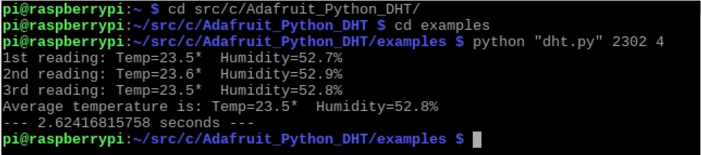

**Kernel space output:**



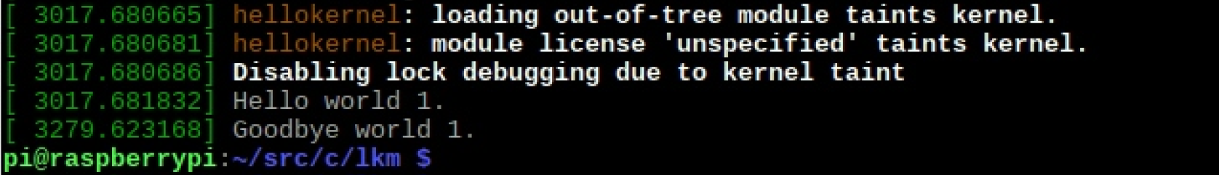

**Milestones covered:**

|  |  |  |  |
| --- | --- | --- | --- |
| **Proposed Deliverable** | **Proposed Date** | **Delivered Date** | **Comments** |
| 1. Setting up the Raspberry pi. 2. Remotely accessed Linux server using VNC. 3. Drafting project proposal. | Sept 17th, sun | Sept 17th, sun | N/A |
| 1. Final editing of project proposal and procuring the sensors and studying its datasheet and acquiring knowledge to for creating user space module for sensor. 2. Interfacing sensor and developing user module. | Sept 24th, sun | Sept 24th, sun | N/A |
| 1. Development continued | Oct 1st, sun | Oct 1st, sun | N/A |
| 1. Running test iterations and observing values | Oct 8th , sun | Oct 8th , sun | N/A |
| 1. Buffer period | Oct 15th , sun | Oct 15th , sun | N/A |
| 1. Midterm week | Oct 22nd, sun | Oct 22nd, sun | N/A |
| 1. Drafting project progress demo and preparation of presentation 2. . 3. Project progress demo | Oct 29th, sun  Oct 30th, mon | Oct 29th, sun  Oct 30th, mon | N/A |

**Future milestones:**

|  |  |  |
| --- | --- | --- |
| **Week** | **Date** | **Task** |
| Week 10 | Nov 5th, sun | 1. Understanding the process of making modifications to raspbian kernel using LKM. |
| Week 11 | Nov 12th, sun | 1. Designing LKM |
| Week 12 | Nov 19th, sun | 1. Designing continued (buffer period) |
| Week 13 | Nov 26th, sun | 1. Running test iterations and observing results. |
| Week 14 | Dec 3rd, sun | 1. Comparing test results of both the modules |
| Week 15 | Dec 10th, sun | 1. Drafting Final Project Report and proof reading |
| Week 16 | Dec 11th, mon | 1. Final project demo |

**References:**