OJT Daily Narrative Report
Bachelor of Science in Information Technology

Student Information
Name | Deluna John Paul M.
Course/Section | BSIT - 4103
Company Name | Technological Vocational Learning Center
Company Address | St. Laforteza Subd, Saint Agnes, Camarin Rd, Brgy 175, Caloocan, 1400 Metro Manila
Date | February 3, 2026
Company Supervisor | Tom T. Binas

Daily Log and Narrative
Time | Activity | Tools/Software Used/others | Narrative / Description of Work Done
7:00 AM – 4:00 PM | Floord Plan | others. | Floorplan Creator

Daily Insights and Learning

During my twelve-day industrial attachment, I was actively involved in supporting the daily administrative and operational functions of the office. One of my primary responsibilities was assisting with various routine office tasks that ensured the smooth running of activities within the organization. These tasks required attention to detail, effective time management, and coordination with different departments. I was entrusted with the responsibility of creating detailed floor plans for all facilities. This task required careful assessment of spatial arrangements, accurate measurements, and proper documentation to ensure clarity and functionality. Preparing the floor plans enhanced my technical and analytical skills, as well as my ability to translate physical layouts into organized visual representations.

Photo Documentation

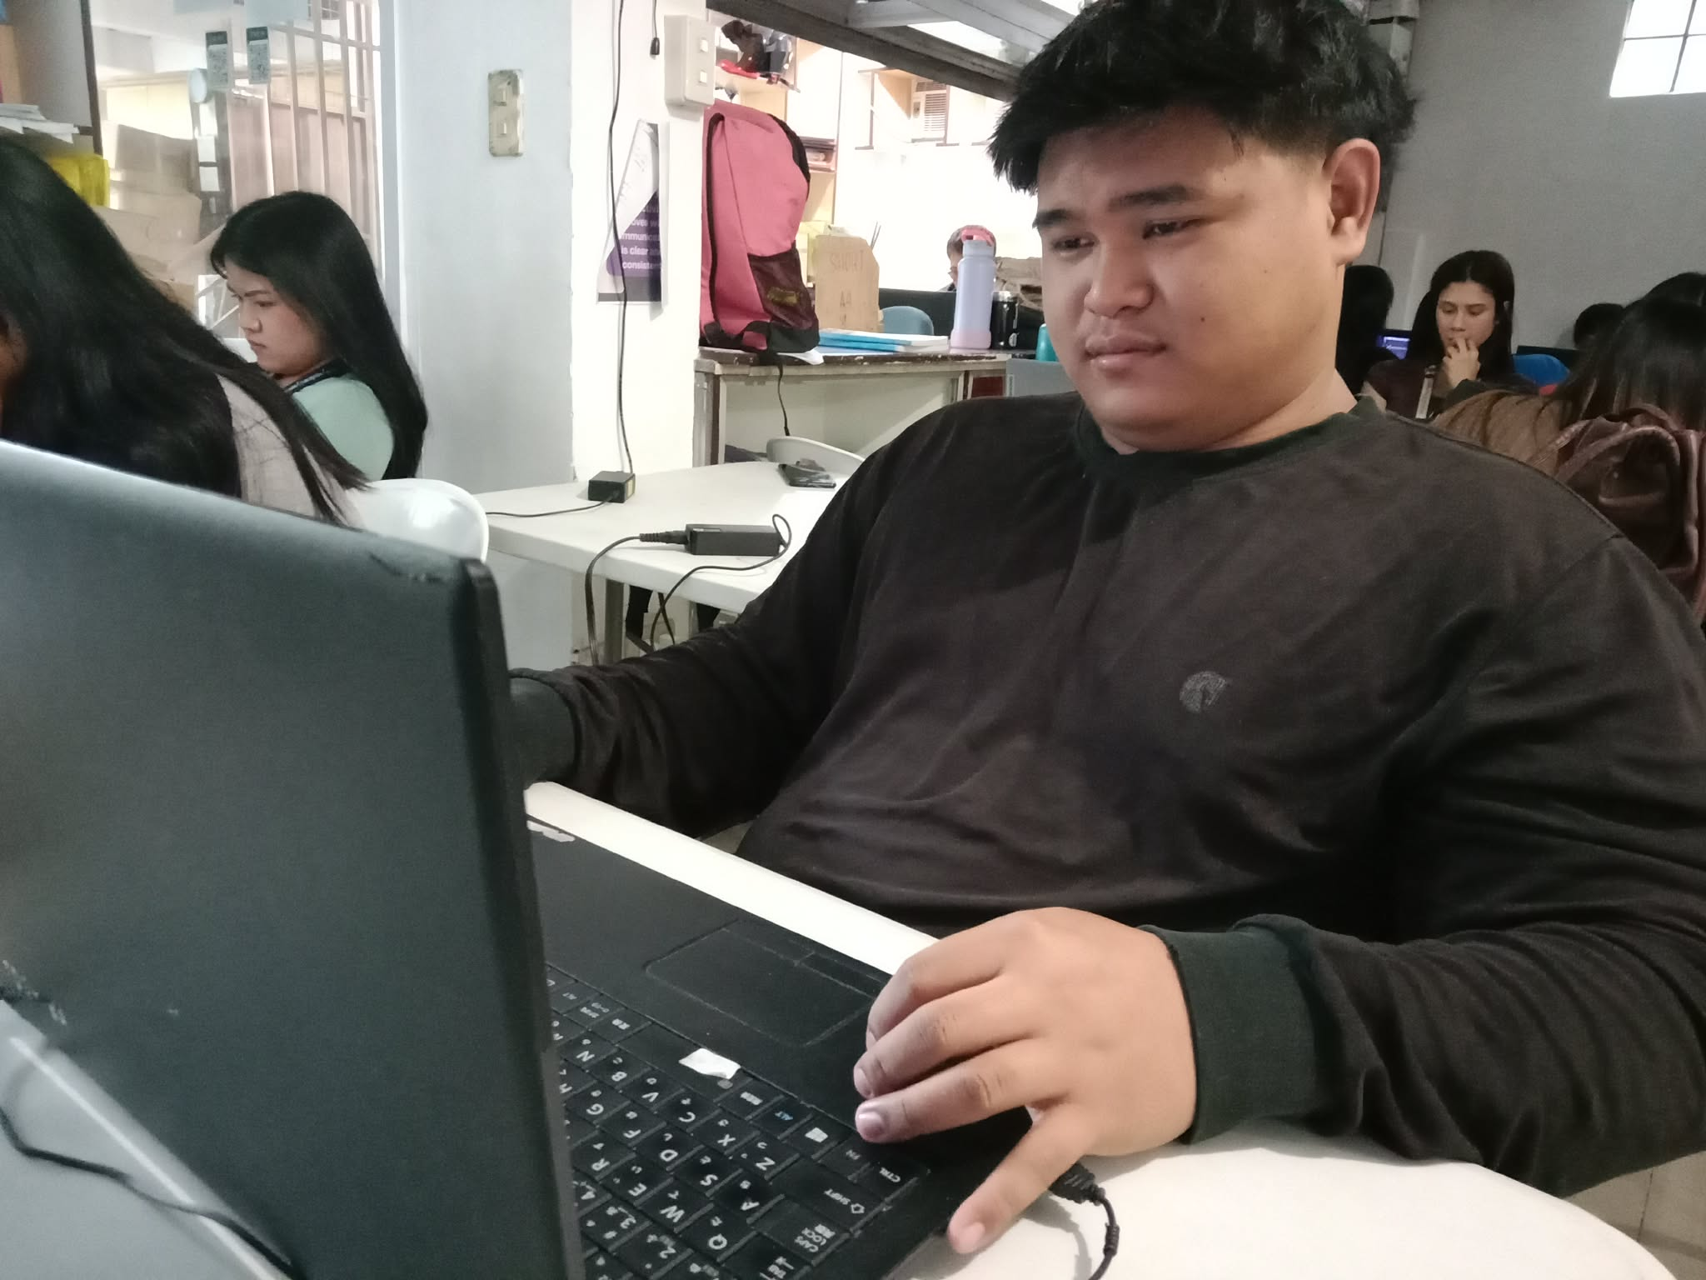
Caption: We assisted the company to do papers and organize.

OJT Daily Narrative Report
Bachelor of Science in Information Technology

Student Information
Name | Deluna John Paul M.
Course/Section | BSIT - 4103
Company Name | Technological Vocational Learning Center
Company Address | St. Laforteza Subd, Saint Agnes, Camarin Rd, Brgy 175, Caloocan, 1400 Metro Manila
Date | February 4 ,2026
Company Supervisor | Tom T. Binas

Daily Log and Narrative
Time | Activity | Tools/Software Used | Narrative / Description of Work Done
7:00 AM – 4:00 PM | Orientation | IDE tools, Website developing | They explained what we must do in developing.

Daily Insights and Learning

On my thirteenth day, I was assigned to work on the frontend development of the organization’s website, with a primary focus on designing and implementing popup modals to enhance user interaction and content visibility. These popups were created to allow users to view information more clearly without navigating away from the main page, thereby improving the overall user experience and interface functionality. In completing this task, I utilized core web development technologies such as HTML for structuring the content, CSS for styling and layout design, and JavaScript for adding interactivity and dynamic behavior to the modal components. The assignment required precision, problem-solving skills, and the ability to meet deadlines efficiently.

Photo Documentation
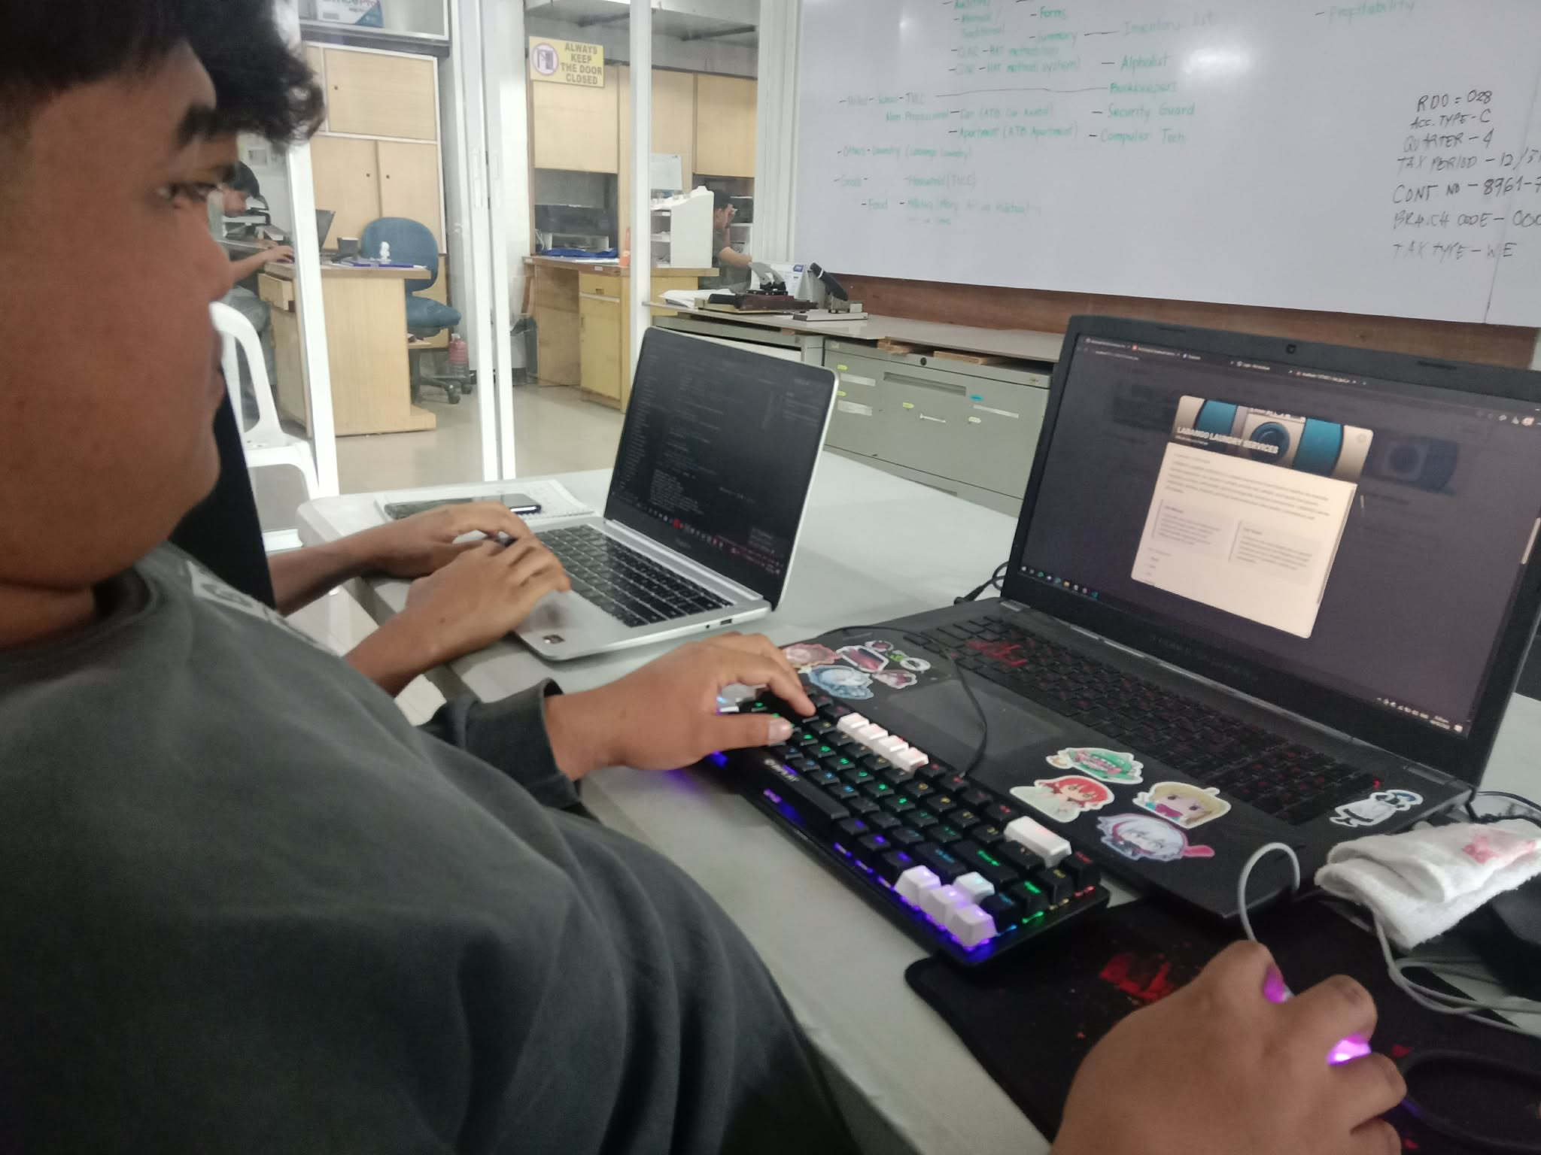
Caption: Enjoying what we are doing.

OJT Daily Narrative Report
Bachelor of Science in Information Technology

Student Information
Name | Deluna John Paul M.
Course/Section | BSIT - 4103
Company Name | Technological Vocational Learning Center
Company Address | St. Laforteza Subd, Saint Agnes, Camarin Rd, Brgy 175, Caloocan, 1400 Metro Manila
Date | Feb 6,2026
Company Supervisor | Tom T. Binas

Daily Log and Narrative
Time | Activity | Tools/Software Used | Narrative / Description of Work Done
7:00 AM – 4:00 PM | Continuation of developing | IDE tools, Website developing | They explained supporting details about what we have to do in developing.

Daily Insights and Learning

On my fourteenth day, I continued with the development of the organization’s website, focusing on improving its design structure and responsiveness. During this phase, the team introduced the use of modern frontend frameworks such as Bootstrap and Tailwind CSS to enhance efficiency and maintain consistency in the overall layout. Learning to integrate these frameworks into the project allowed me to better understand how pre-built components, utility classes, and responsive grid systems can significantly streamline the development process.
Working with Bootstrap and Tailwind CSS also expanded my knowledge of contemporary web design practices, particularly in creating mobile-friendly and visually appealing interfaces. I was able to apply these tools to refine the website’s appearance, ensure responsiveness across different devices, and maintain clean, organized code. This experience strengthened my adaptability in learning new technologies and reinforced the importance of using industry-standard frameworks to produce professional and scalable web applications.

Photo Documentation
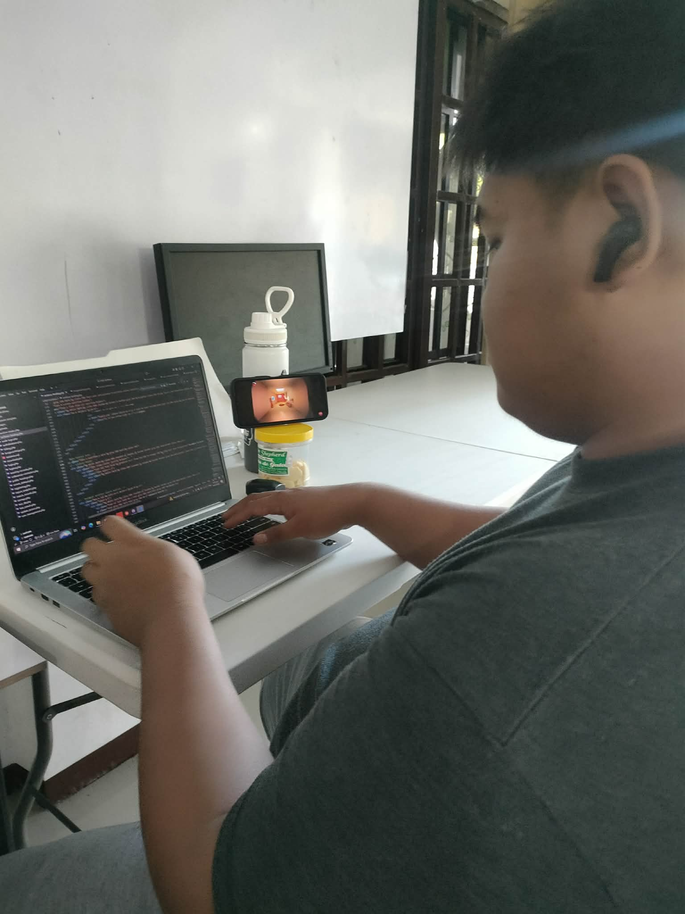
Caption:Used Frameworks.

OJT Daily Narrative Report
Bachelor of Science in Information Technology

Student Information
Name | Deluna John Paul M.
Course/Section | BSIT - 4103
Company Name | Technological Vocational Learning Center
Company Address | St. Laforteza Subd, Saint Agnes, Camarin Rd, Brgy 175, Caloocan, 1400 Metro Manila
Date | February 9, 2026
Company Supervisor | Tom T. Binas

Daily Log and Narrative
Time | Activity | Tools/Software Used | Narrative / Description of Work Done
7:00 AM – 4:00 PM | They want us to learn more about them when they are working and collaborative | Projector | Meetings collaborative meeting

Daily Insights and Learning

On my fifteenth day, I was given the opportunity to observe and learn how the employees collaborate as a team within the organization. I attended meetings where ongoing projects, company goals, and task allocations were discussed. During these sessions, I noticed how team members communicated their ideas clearly, shared progress updates, and addressed challenges collectively. The meetings demonstrated the importance of coordination, active participation, and mutual respect in achieving organizational objectives.
Aside from meetings, I also observed the different responsibilities and daily activities carried out by the employees to ensure the company operates efficiently. Each member had specific roles, yet they worked collaboratively to complete tasks and meet deadlines. This experience helped me understand the value of teamwork, proper communication, and professional accountability in a workplace setting. It also gave me insight into how structured collaboration contributes to the overall success and growth of the company.

Photo Documentation
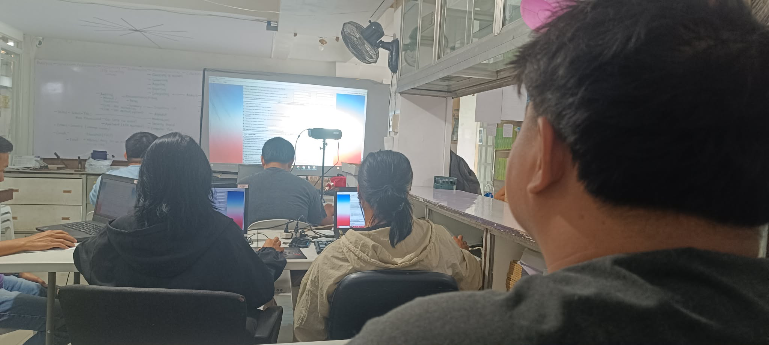
Caption:meetings.

OJT Daily Narrative Report
Bachelor of Science in Information Technology

Student Information
Name | Deluna John Paul M.
Course/Section | BSIT - 4103
Company Name | Technological Vocational Learning Center
Company Address | St. Laforteza Subd, Saint Agnes, Camarin Rd, Brgy 175, Caloocan, 1400 Metro Manila
Date | February 10, 2026
Company Supervisor | Tom T. Binas

Daily Log and Narrative
Time | Activity | Tools/Software Used | Narrative / Description of Work Done
7:00 AM – 4:00 PM | Continuation of developing collaborating with other devs | IDE tools, Website development, GitHub, git , GitHub desktop | We devs use a version for git to GitHub to be centralized are works

Daily Insights and Learning
On my sixteenth day, I was introduced to the team’s version control workflow, where we used Git in collaboration with GitHub to centralize our codebase and manage project updates efficiently. I learned how developers push their changes to a shared repository, create branches for new features, and submit pull requests for review before merging them into the main project. This process ensured that all modifications were properly tracked, documented, and reviewed, reducing the risk of conflicts and maintaining the stability of the application.
Through this experience, I gained a deeper understanding of how version control systems help identify errors, monitor code history, and maintain accountability within the development team. By reviewing commits and change logs, we were able to trace issues back to specific updates and resolve them systematically. Working with Git and GitHub enhanced my technical skills and emphasized the importance of collaboration, transparency, and structured workflows in professional software development environments.

Photo Documentation
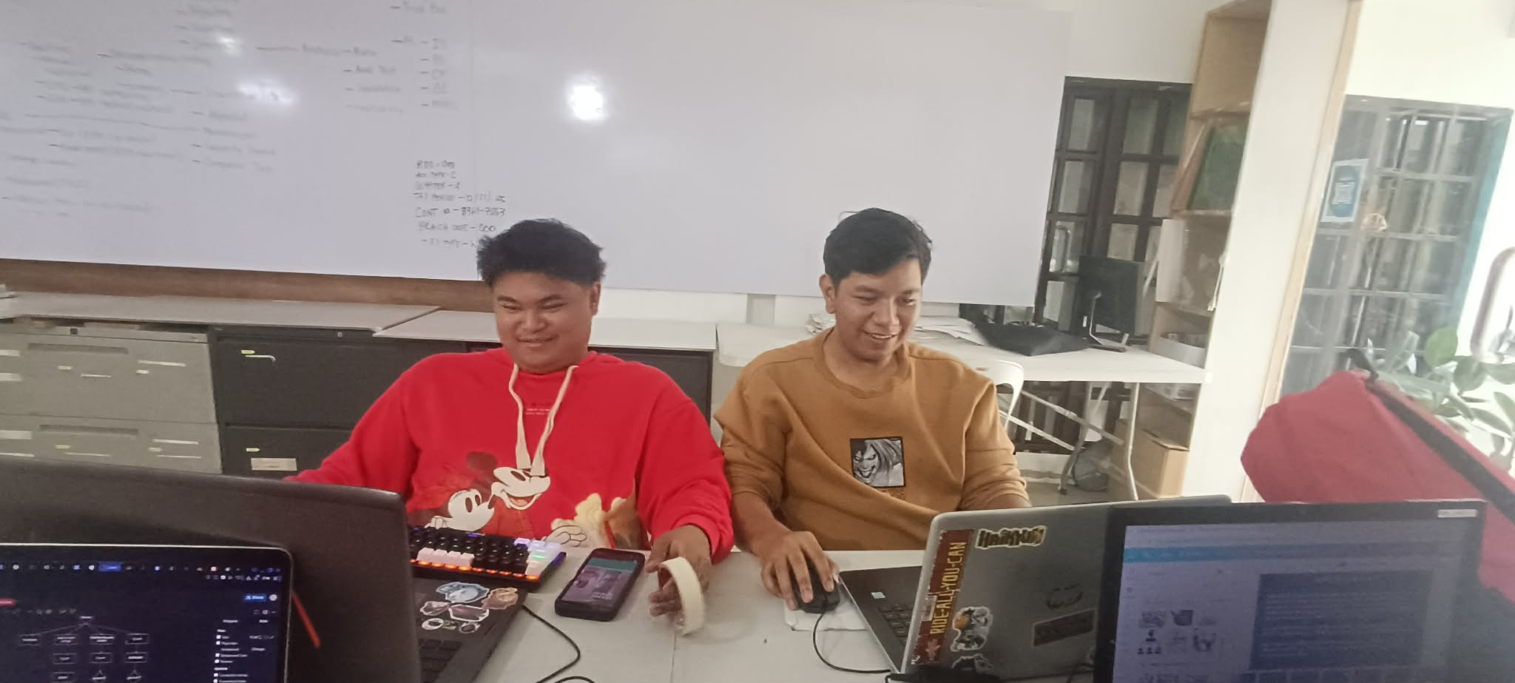
Caption: Version control workflow.

OJT Daily Narrative Report
Bachelor of Science in Information Technology

Student Information
Name | Deluna John Paul M.
Course/Section | BSIT - 4103
Company Name | Technological Vocational Learning Center
Company Address | St. Laforteza Subd, Saint Agnes, Camarin Rd, Brgy 175, Caloocan, 1400 Metro Manila
Date | February 11, 2026
Company Supervisor | Tom T. Binas

Daily Log and Narrative
Time | Activity | Tools/Software Used | Narrative / Description of Work Done
7:00 AM – 4:00 PM | Continuation of developing/ Lessons we put in system | IDE tools , Website developing | They explained supporting details about what we have to do in developing. They told us to make presentations about their courses .

Daily Insights and Learning

On our seventeenth day, the team decided that the system was ready for deployment so that stakeholders could see the actual results of our development work. We were tasked with researching and identifying a free deployment platform that could host the project online. This required us to explore various hosting services, compare their features, and evaluate which platform would best support our system’s technical requirements. The goal was to make the website accessible on the internet, allowing the team and supervisors to test its functionality in a live environment.
This task helped me understand the importance of deployment as a critical phase in the software development lifecycle. Beyond coding, I realized that making a system publicly accessible involves configuring servers, managing build settings, and ensuring the application runs smoothly outside the local development environment. The experience strengthened my problem-solving skills and broadened my knowledge of web hosting solutions, while reinforcing the significance of delivering a functional and accessible final product.

Photo Documentation
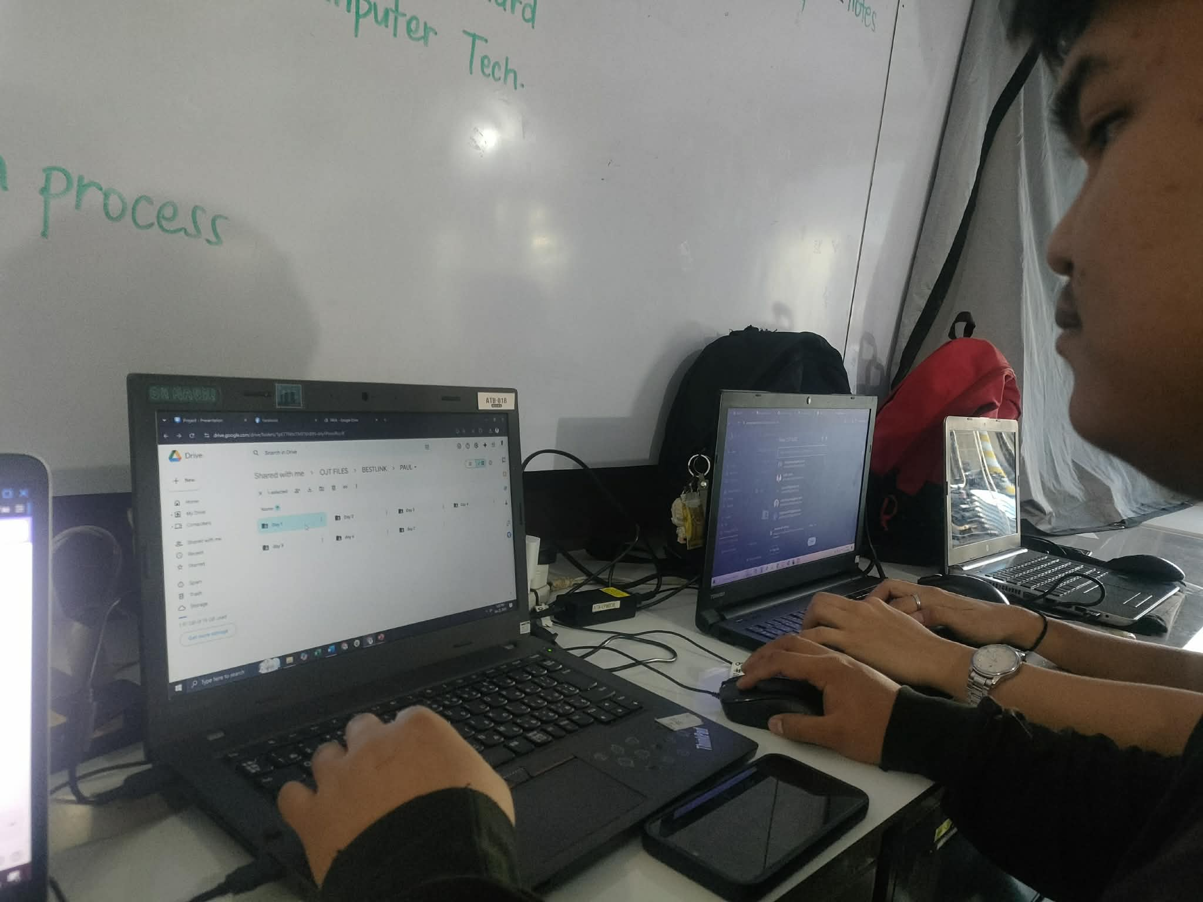
Caption: Deployment

OJT Daily Narrative Report
Bachelor of Science in Information Technology

Student Information
Name | Deluna John Paul M.
Course/Section | BSIT - 4103
Company Name | Technological Vocational Learning Center
Company Address | St. Laforteza Subd, Saint Agnes, Camarin Rd, Brgy 175, Caloocan, 1400 Metro Manila
Date | February 13, 2026
Company Supervisor | Tom T. Binas

Daily Log and Narrative
Time | Activity | Tools/Software Used | Narrative / Description of Work Done
7:00 AM – 4:00 PM | Lessons | Canva | Adding a lesson in the system

Daily Insights and Learning

On my eighteenth day, we were assigned to add another PowerPoint (PPTX) file to the system as part of its content enhancement. The organization requested that we create a presentation file that would be integrated into the platform to support their lessons and training materials. This task required us to carefully prepare the slides, ensuring that the content was accurate, well-organized, and aligned with the objectives of the system. We also made sure that the file was properly formatted and accessible within the platform for users to easily view or download.
This activity allowed me to understand the importance of integrating instructional materials into a digital system to make it more functional and user-friendly. It strengthened my skills in content preparation, organization, and system integration, while also emphasizing the need for clarity and professionalism in educational resources. Overall, the experience contributed to improving both my technical and presentation skills in developing a more comprehensive and practical system.

Photo Documentation
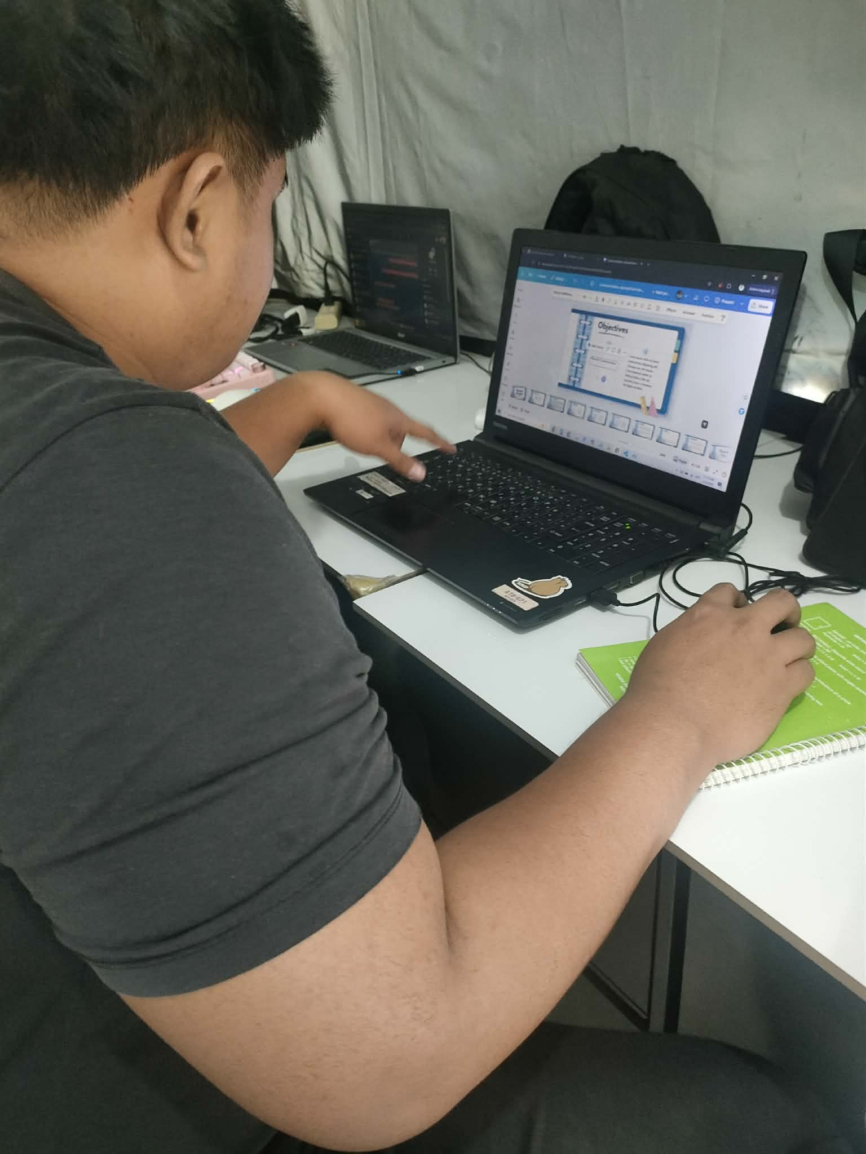
Caption: Another PPTX files

OJT Daily Narrative Report
Bachelor of Science in Information Technology

Student Information
Name | Deluna John Paul M.
Course/Section | BSIT - 4103
Company Name | Technological Vocational Learning Center
Company Address | St. Laforteza Subd, Saint Agnes, Camarin Rd, Brgy 175, Caloocan, 1400 Metro Manila
Date | February 18 , 2026
Company Supervisor | Tom T. Binas

Daily Log and Narrative
Time | Activity | Tools/Software Used | Narrative / Description of Work Done
7:00 AM – 4:00 PM | Testing the website using mock database | Vscode | Backend and Databases

Daily Insights and Learning

On my nineteenth day, we concentrated on enhancing the system’s security features while continuing to test it using a mock database. After evaluating potential vulnerabilities, the team decided to implement stronger authentication measures such as Two-Factor Authentication (2FA) and One-Time Passwords (OTP). These security features were designed to add an extra layer of protection beyond the standard username and password login. By incorporating 2FA and OTP verification, we aimed to ensure that only authorized users could access sensitive parts of the system, thereby improving data privacy and overall system integrity.
We also held a meeting to clearly define each developer’s responsibilities in implementing these security enhancements. Tasks were distributed based on individual strengths, with some members focusing on backend authentication logic, others on frontend verification interfaces, and others on database security configurations. This collaborative approach allowed us to efficiently integrate the new security features while maintaining system functionality. The experience deepened my understanding of cybersecurity practices and reinforced the importance of safeguarding user information in modern web development.
."

Photo Documentation
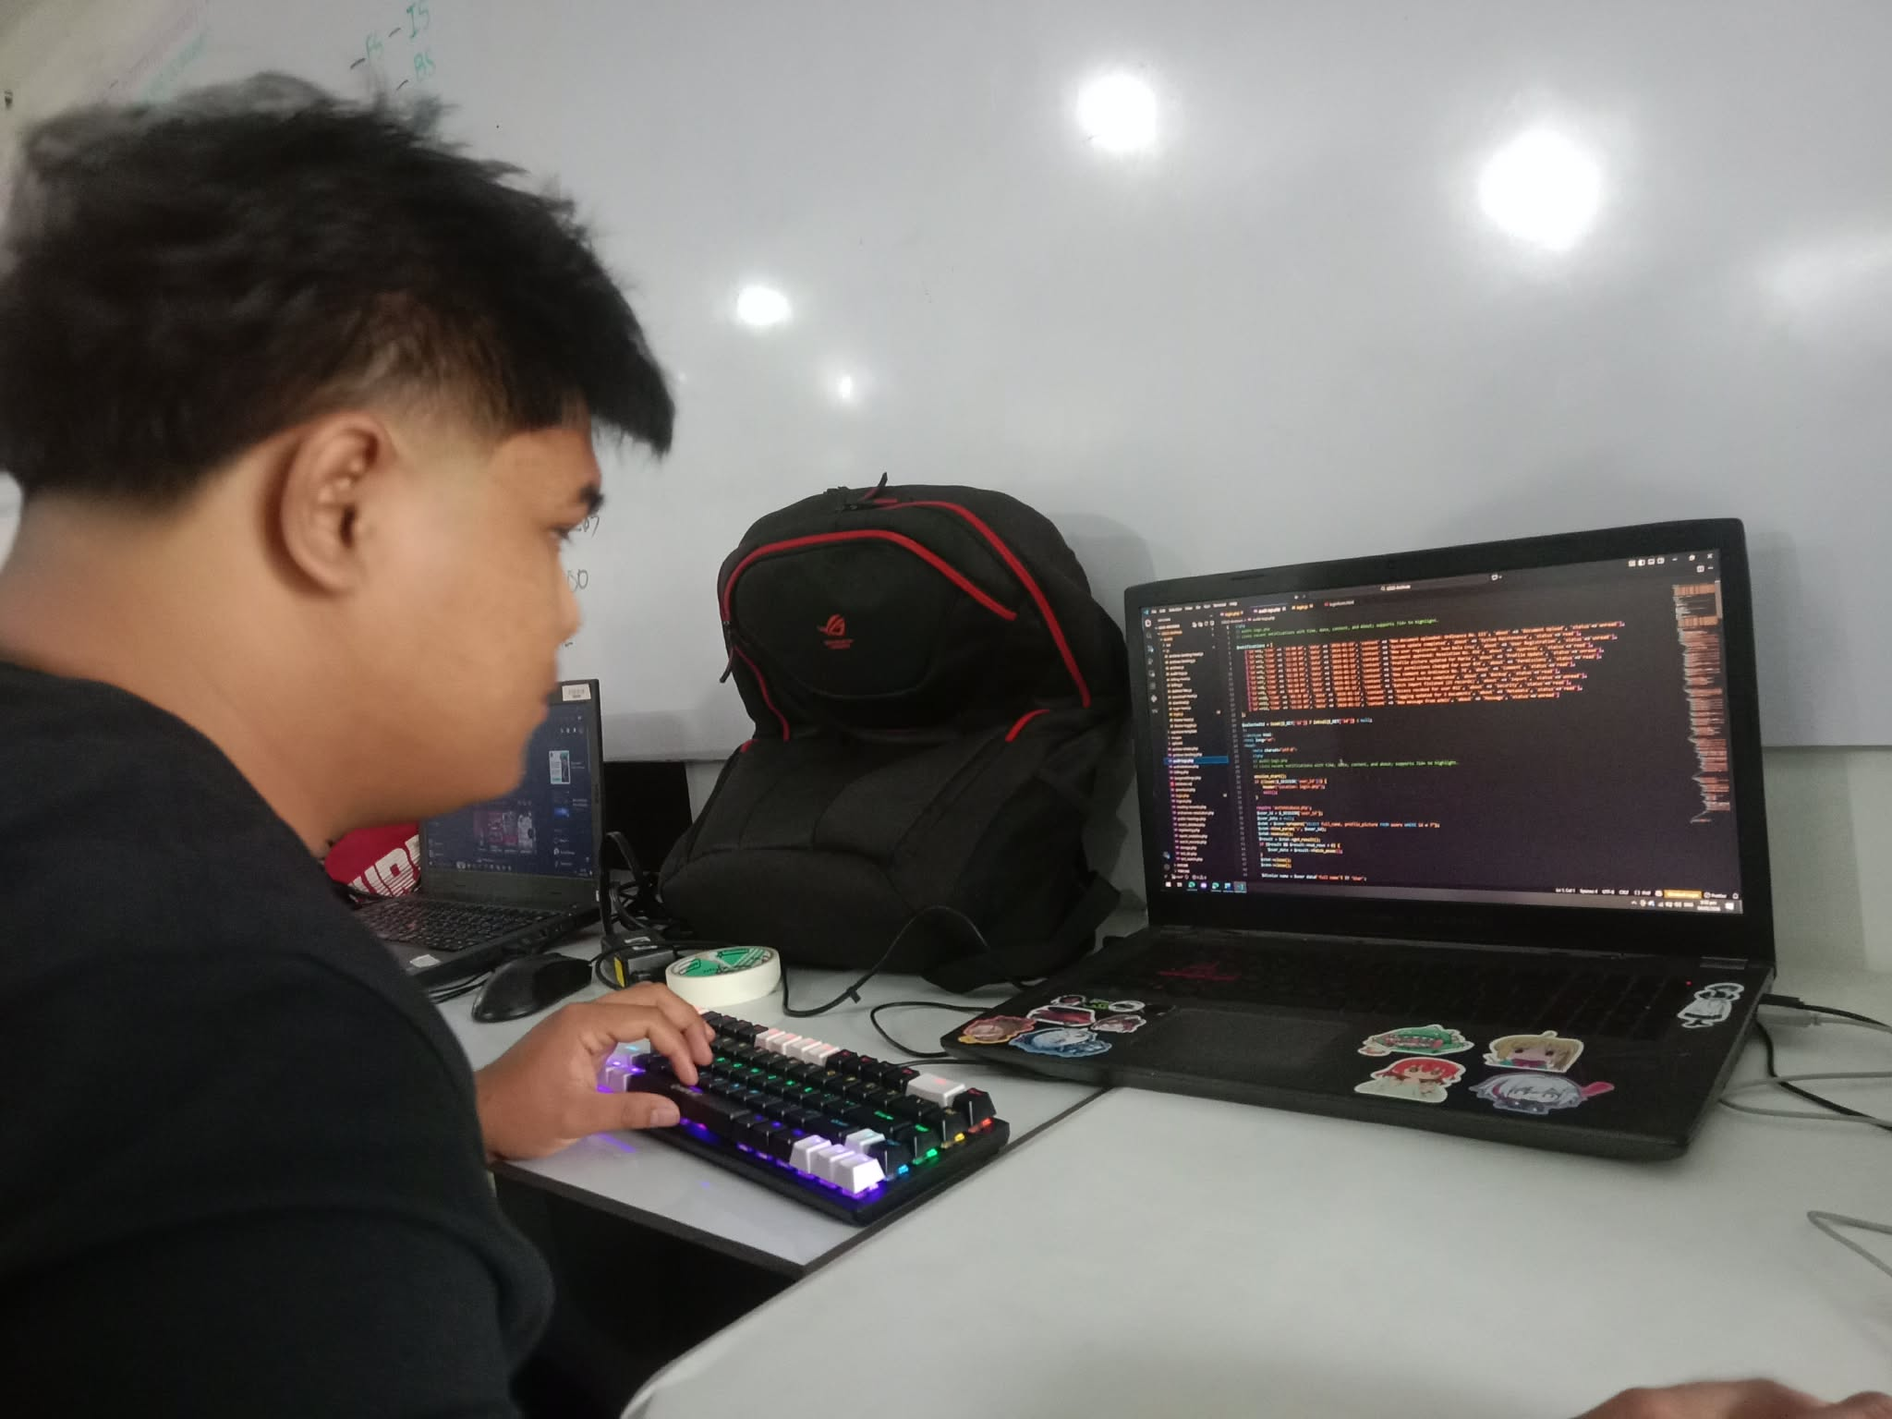
Caption: Testing the database and backend parts

