**Project**

**JSPR-Techies**

**System Requirements Document  
  
10/10/2023**

**Members**

Jayani Sumanka Gerine

Pallavi Dabade

Raksha Varahamurthy

Surya Subramani

**System's Functional Requirements**

Authentication - User login with unique id and umich email

* New User should be able to create account using unique name and University of Michigan email address
* Existing User should be able to access the blog using unique name and University of Michigan email address

Landing Page - User’s welcome page is loaded

* User sees the welcome page
* User sees Search option to enter keyword for search
* User can select department associated along with search keyword
* User can see Search button

Search Article -

* User can enter keyword and select department
* User can click search button

Search Result -

* User can get a list of articles matching the search criteria
* If no article is found, user will get error message
* User can reset and go for new search

Read Article -

* User can view specific article by clicking the name of the article

**System’s Nonfunctional Requirements**

**Product Requirement**

Security Measure -

* Can not be accessed by entities who don't have Umich email id

**Use Case Diagram:** Overall functionality of the system

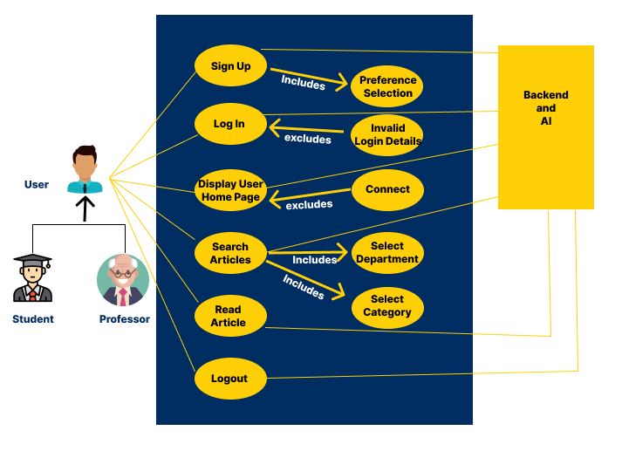

**User Stories based on Use case**

1. **User Login - New User (Sign Up)**

User Role : Student, Faculty and Alumni of University of Michigan

Goal : User access the JSPR-Techies blog and landed on Login page

Reason : User can access blog if they are associated with University of Michigan

Preconditions: User access the blog using domain name

Postcondition: User create account using unique name as username and email as password

1. **User Story - User Login - Existing User**

User Role : Student, Faculty and Alumni of University of Michigan

Goal : User access the JSPR-Techies blog and landed on Login page

Reason : User can access blog if they are associated with University of Michigan

Preconditions: User access the blog using domain name

Postcondition: User must enter unique name as username and email as password

1. **User Story - Landing Page after User Authentication**

User Role : Student, Faculty and Alumni of University of Michigan

Goal : User access the JSPR-Techies blog and landed on Home page

Reason : User can access blog if they are associated with University of Michigan

Preconditions: User should be successfully logged into JSPR- Techblog after user is authenticated.

Postcondition: User can view the welcome message

1. **User Story - Search Articles**

User Role : Student, Faculty and Alumni of University of Michigan

Goal : User should be able to search relevant articles

Reason : User can access top 5 articles according to his preference

Preconditions: User should enter keywords for search.

Postcondition: User should click on submit button

1. **User Story - Display List of Article**

User Role : Student, Faculty and Alumni of University of Michigan

Goal : User should be able to view the list of articles based on the search criteria

Reason : User can access top 5 articles according to his preference

Preconditions: User should enter keywords and click enter.

Postcondition: User should be able to view a list of articles.

1. **User Story - View Article from the list of articles**

User Role : Student, Faculty and Alumni of University of Michigan

Goal : User should be able to search relevant articles

Reason : User should be able to read articles

Preconditions: User should be able to click on specific article to read

Postcondition: User should be able to read articles

**Complex User Stories Breakdown**

At this time, no user story requires further breakdown.

**Context Model**

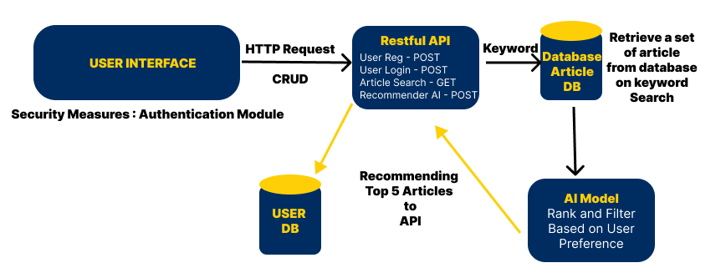

**Glossary**

| **Words** | **Context** |
| --- | --- |
| umich | University of Michigan |
| User DB | Database to store user information |
| AI model | Ranking & filtering model for articles |
| API | Application Program Interface |

**Project Progress & Meeting Updates**

**JSPRT Sprint 2 (9/29/2023 - 10/13/2023)**

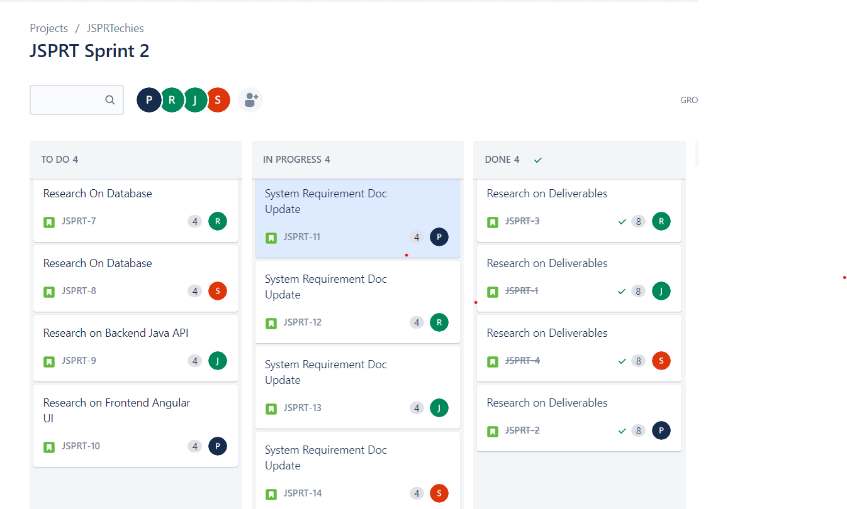

**Meeting Updates:**

Meeting Agenda for 9/29/2023 - 10:30 a.m.

* Discussion about past sprint
  + What went wrong and how can we improve it
  + What went well and we can continue it
* Discussion about Jira - <https://jspr-techies.atlassian.net/>
* Sprint planning - Define deliverables
* Discuss next deliverable - next assignment submission discussion

-------------------------------------------------------------------------------------------------------------------

Google Meet: [meet.google.com/xjg-ijjr-bmz](https://meet.google.com/xjg-ijjr-bmz?hs=224)

Meeting Date and Time: Sunday - 9/29/2023 - 10:30 a.m.

Meeting Duration: 1:15

Meeting Attendance: Jayani, Pallavi, Raksha, Surya

Meeting Points:

Discussion about past sprint

* + What went wrong and how can we improve it
    - Consider time constraint and limit meeting time
    - Avoid unnecessary meetings
  + What went well and we can continue it
    - Went well with deliverables
* Discussion about Jira - <https://jspr-techies.atlassian.net/>
  + Discussed about Jira board
  + Create current sprint and user story for each team member
* Sprint planning - Define deliverables for next submission
  + Discuss about next assignment deliverables
    - Need research to define system specifications
    - Discuss about use cases

—-----------------------------------------------------------------------------------------------------------------  
Google Meet: [meet.google.com/xjg-ijjr-bmz](https://meet.google.com/xjg-ijjr-bmz?hs=224)

Meeting Date and Time: Friday - 10/6/2023 - 10:30 a.m.

Meeting Duration: 1:30

Meeting Attendance: Jayani, Pallavi, Raksha, Surya

Meeting Points:

Past week User Stories update

* Discussion about research done on database
* Discussion about research done on Backend API
* Discussions about research done on Frontend UI

Discussion System requirements assignment

* Discussion on formal and informal requirements
* Discussion on use case diagram and context model

Update Jira board

* Closed previous User Stories
* Created new User Stories and assigned

—------------------------------------------------------------------------------------------------------------------------