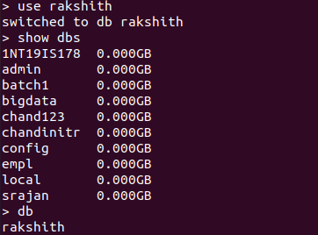

Insert one operation:

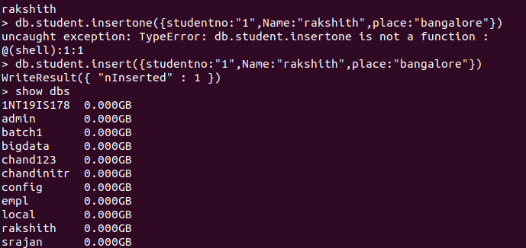

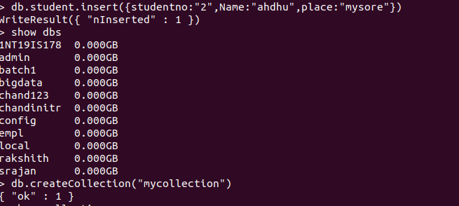

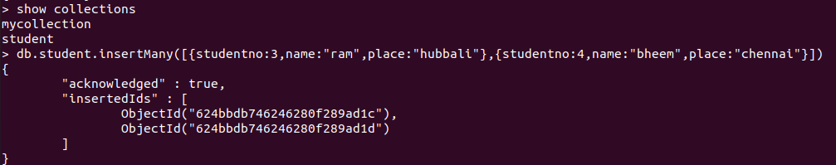

Find operation:

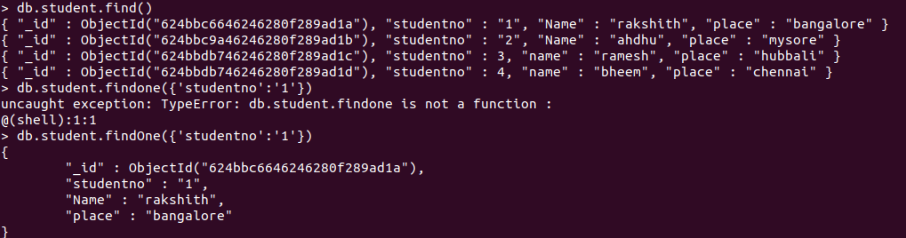

And & OR operation:

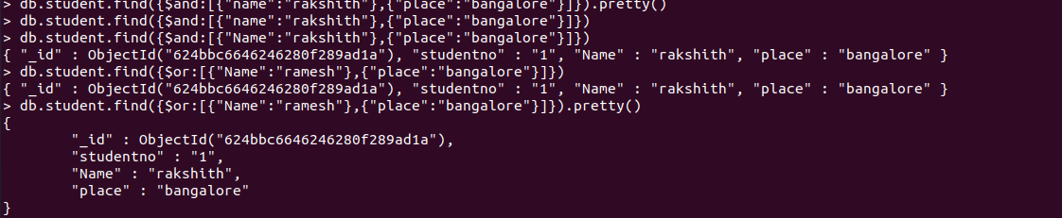

April 12th lab:

Remove operation:

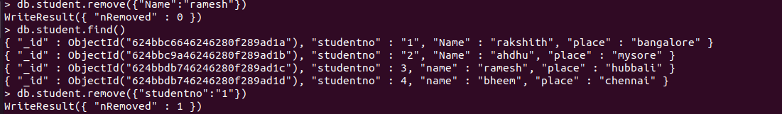

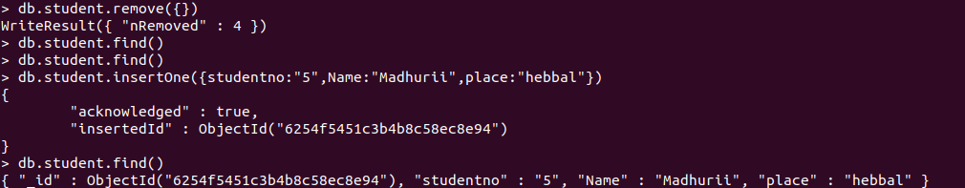





Find one and Update:

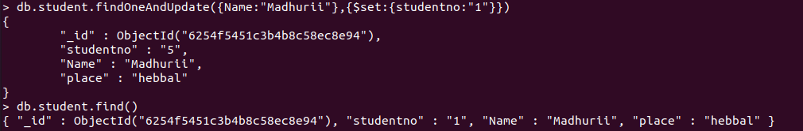



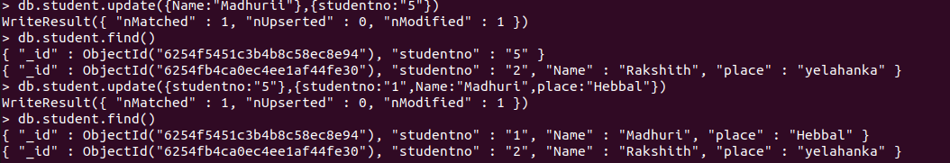

Aggregate function:

