

N.R.SWAMYCOLLEGEOFCOMMERCE&ECONOMICSANDSMT. THIRUMALAICOLLEGE OF SCIENCE

(*Affiliated to University of Mumbai*)

MUMBAI-400031

DEPARTMENTOFCOMPUTERSCINECE

**SY BSc Computer Science**

Academic Year 2023-24

Roll no. :- “38028”

**ANDROID APPLICATION DEVELOPMENT**

**PROJECT**

ON

**“News App”**

Submitted By

**Rakshit Shetty**



**S.I.W.S.**

**N.RSWAMYCOLLEGEOFCOMMERCE&ECONOMICS**

**AND**

**SMT.THIRUMALAICOLLEGEOFSCIENCE**

Plot No.337, Major R. Parmeshwaran Marg, Sewree Wadala Estate,

Wadala, Mumbai-400 031.

**S.Y.B.Sc. (ComputerScience)**

**Semester IV**

**CERTIFICATE**

Class: S.Y. B.ScC.S. UniversitySeatNo :__________

RollNo.:38063

This is to certify that the experiments entered in this project of Android Application Development is the work of **Mr./~~Ms~~. HariPrasanna** in the Computer Science Department of S.I.W.S Degree College during the year2023– 2024.

_________________ _________________

Teacher-In-Charge Co-Ordinator

_________________ _________________

InternalExaminer ExternalExaminer

Date:  **College Stamp**

**Introduction:**

The Math Quiz Android application presents an engaging platform designed to challenge users' arithmetic skills while providing an entertaining gaming experience. With its dynamic question generation and multiple-choice options, users are prompted to solve a variety of math problems under the pressure of a countdown timer. This app offers an interactive way for individuals of all ages to sharpen their mental math abilities, whether they're looking to boost their skills or simply enjoy a fun and stimulating challenge.

Through its intuitive interface and responsive layout, the Math Quiz app caters to users seeking an educational yet enjoyable way to practice arithmetic on their Android devices. With features such as score tracking, immediate feedback, and the ability to reset the game for continuous play, users can immerse themselves in a rewarding experience that encourages learning and improvement with each round.

**Features:**

**Dynamic Question Generation:** The Math Quiz app dynamically generates arithmetic questions using random numbers and operators, ensuring a diverse range of challenges for users.

**Timer Countdown:** Users face the pressure of time with a countdown timer displayed prominently on the screen, adding an element of urgency and excitement to the gameplay.

**Multiple Choice Options:** Each question is accompanied by four multiple-choice options, allowing users to select their answer from a range of possibilities.

**Score Tracking:** Users' scores are tracked throughout the game, with points awarded for correct answers. The app keeps users motivated as they strive to achieve a high score.

**Immediate Feedback:** Users receive immediate feedback on their answers through toast messages, providing instant validation or correction of their responses.

**Game Over Notification:** When the game ends, users are notified with a toast message displaying their final score, allowing them to reflect on their performance and strive for improvement in subsequent rounds**.**

**Game Reset:** After completing a game, users have the option to reset and start a new round, enabling them to continue practicing and honing their math skills.

**Shuffle Option Choices:** To add an extra layer of challenge, the app shuffles the order of the multiple-choice options for each question, preventing users from relying solely on memorization.

**Responsive Layout:** The app features a responsive layout optimized for various screen sizes, ensuring a seamless and enjoyable experience across different Android devices.

**OUTPUT**

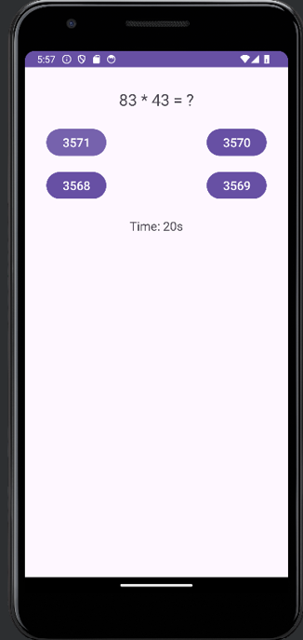 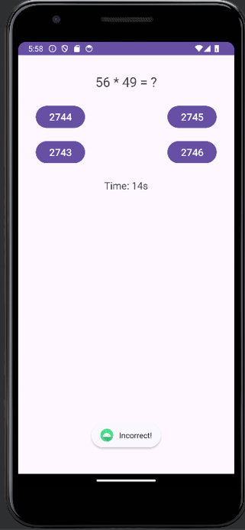

**CONCLUSION**

In its essence, the Math Quiz Android application encapsulates the convergence of education and entertainment, offering users an engaging platform to enhance their mathematical skills while enjoying a dynamic gaming experience. Through its innovative approach of dynamically generating arithmetic questions and providing multiple-choice options, the app presents users with a diverse array of challenges that cater to varying skill levels and preferences. Furthermore, with features like score tracking, immediate feedback, and a responsive layout, Math Quiz fosters a conducive environment for continuous learning and improvement.

By seamlessly integrating educational content with interactive gameplay, Math Quiz transcends traditional learning methods and transforms arithmetic practice into an enjoyable and rewarding activity. Its accessibility and user-friendly design make it suitable for users of all ages and backgrounds, whether they're looking to reinforce basic arithmetic concepts or seeking a stimulating mental workout. Ultimately, Math Quiz not only serves as a valuable educational tool but also as a testament to the potential of mobile applications in facilitating engaging and effective learning experiences.