Assignment 4 (functions)

Function prototype, Definition and Call, Type of Functions, Scope of variables in (Block, Function, Program, File), Storage classes (Auto, Register, Static and Extern), Recursion (with the introduction of Stack), Implementation of recursion to solve the problem of Tower of Hanoi.

1. Learn the meaning and application of function prototype, function call and function definition. Practice various return types such as void, int, float, char etc. using small programs.
2. Practice 4 storage classes (auto, static, register and extern) to learn their scope, life, automatic initial value and storage location.
3. WAP to swap two variables using with and without a temp variable using a function besides the main function.
4. Find factorial.
5. If a number is prime or not.
6. Display first *n* prime numbers.
7. HCF of two numbers using a separate function
8. LCM of two numbers using a function
9. Fibonacci series of n numbers using recursion
10. Add digits of an integer using a function
11. Find various problems that can be solved using recursion and which one is your favorite?
12. What is a stack and what is its relation with recursion? Discuss with your lab teacher. (next page) —>

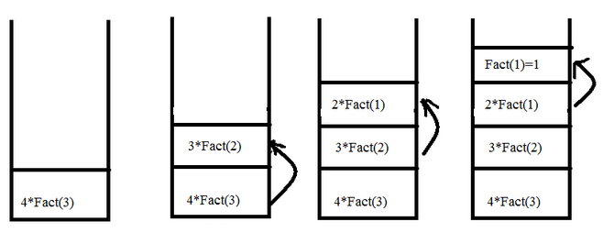

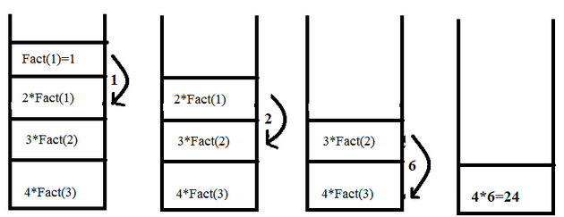

1. Solve the game of Tower of Hanoi using recursion. Rules of this game are (i) move one disk at a time (ii) a bigger disk have to be always below.

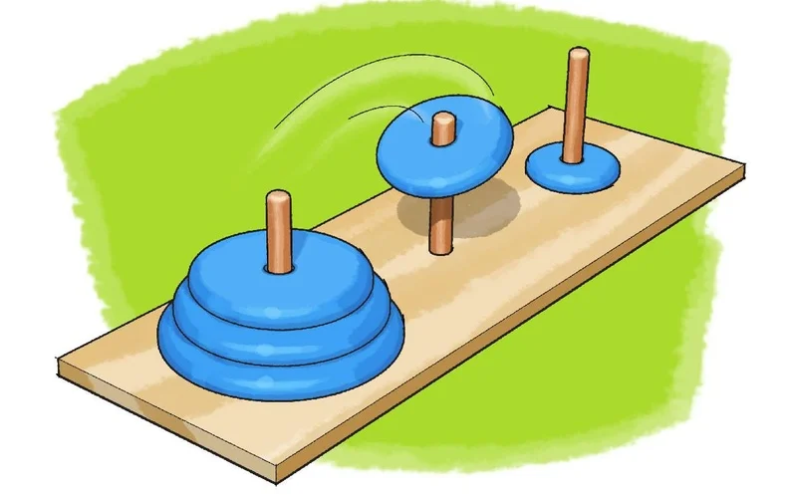

Hint: Try with 1, 2, 3 etc disks and see the pattern. Also find out how many passes will be needed to move n disks. Few diagrams below:

