SMART UTILITY TOOLKIT
Node.js Core Modules – Hands-on Lab Assignment
Submitted By:
Name: Rakshit Kamboj
Roll No.: 2501060039
Class / Semester: BCA(AI & DS) – Sec-A (Sem3)
Subject: Backend Development / Node.js
Date: 06 September 2026

1. Introduction
The Smart Utility Toolkit is a command-line based Node.js project developed to demonstrate fundamental backend development concepts using only Node.js built-in modules. The project contains a CLI calculator, reusable custom modules, a basic HTTP server, a file manager, and a random dice generator.

2. Objectives
- Understand how Node.js executes JavaScript outside the browser.
- Use process.argv for command-line inputs.
- Create and reuse custom modules using module.exports and require().
- Build an HTTP server and implement basic URL routing using the http module.
- Perform file operations using the fs module.
- Generate random values using the crypto module.
- Use console.log() to observe execution, requests and operation results.

3. Technology Stack
Technology | Purpose
Node.js | JavaScript runtime environment.
JavaScript (ES6) | Backend logic and module handling.
process | Command-line argument handling.
http | HTTP server and routing.
fs | File system operations.
crypto | Random dice number generation.
Terminal / Command Prompt | Program execution and testing.

4. Project Structure
smart-utility-toolkit/
├── calculator.js
├── app.js
├── server.js
├── fileManager.js
├── dice.js
├── test.txt
├── README.md
└── modules/
├── isEven.js
└── logger.js

5. Implementation and Results

5.1 CLI-Based Calculator using process.argv
The calculator accepts an operation and two numbers from the command line. It supports addition, subtraction, multiplication and division and handles invalid operations and division by zero gracefully.
Example command: node calculator.js add 10 5
Expected output: Result: 15
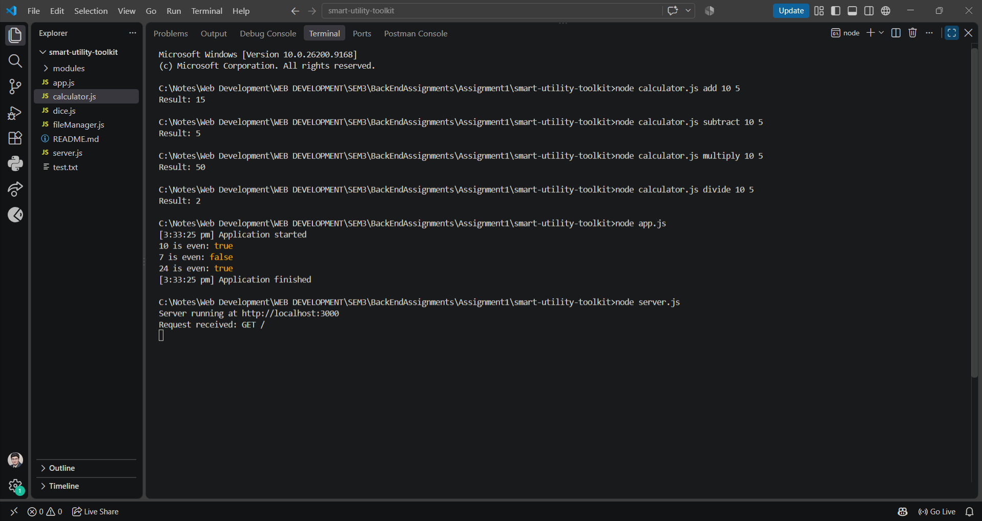
Figure 1. CLI calculator operations using process.argv.

5.2 Custom Module Creation and Reusability
The project uses a reusable isEven custom module and a logger module. The isEven function is exported using module.exports and imported into app.js using require(). The logger prints timestamped messages.
function isEven(number) {
return number % 2 === 0;
}
module.exports = isEven;
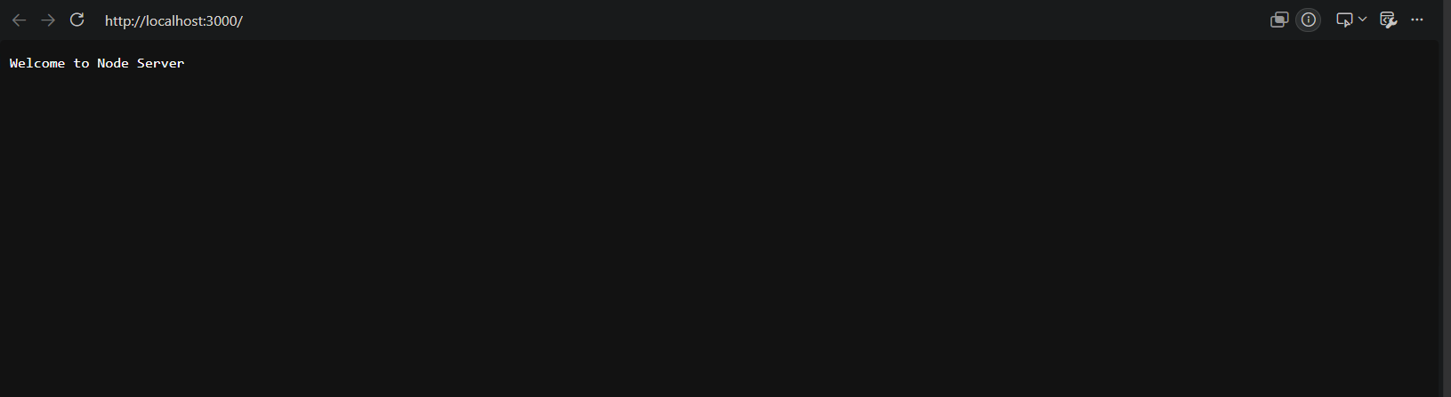
Figure 2. Custom module demonstration using require() and module.exports.

5.3 Basic HTTP Server using the http Module
The server runs on port 3000 and provides different responses for the root, /about and /contact routes. Unknown routes return a 404 response. Incoming requests are logged in the terminal.
/ -> Welcome to Node Server
/about -> About Page
/contact -> Contact Page
other -> 404 - Page Not Found
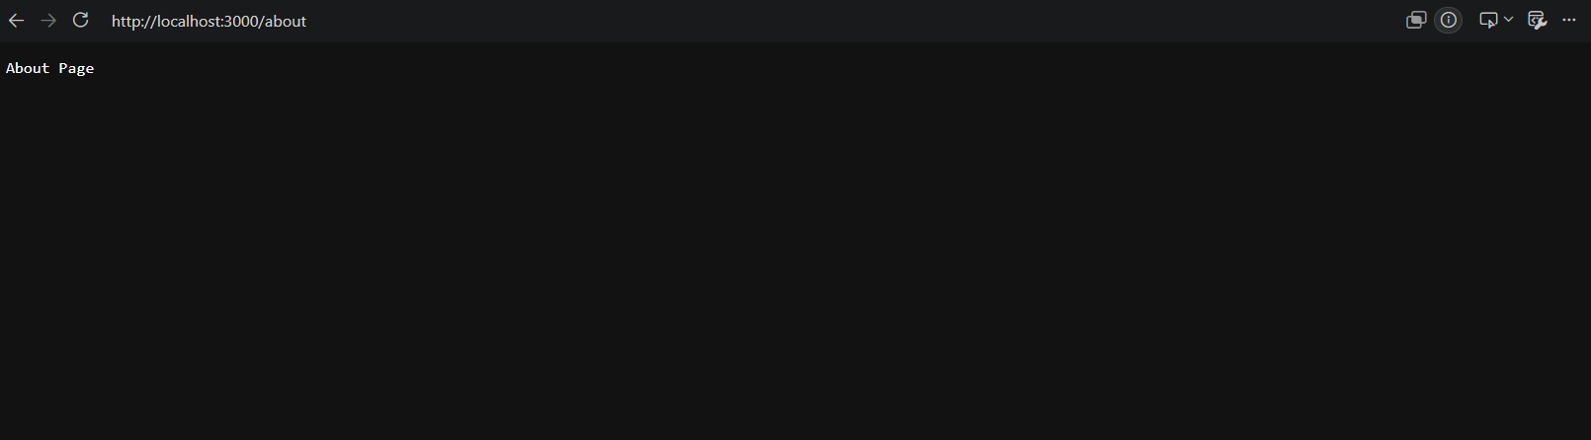
Figure 3. HTTP server running and handling the root route.
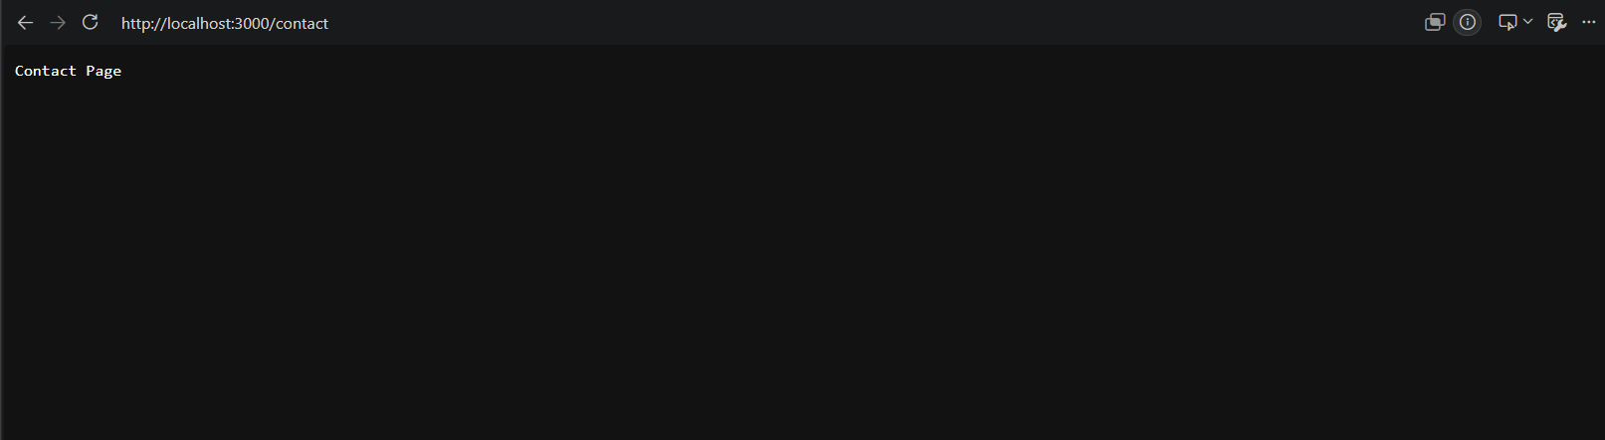
Figure 4. About and Contact routes tested in the browser.
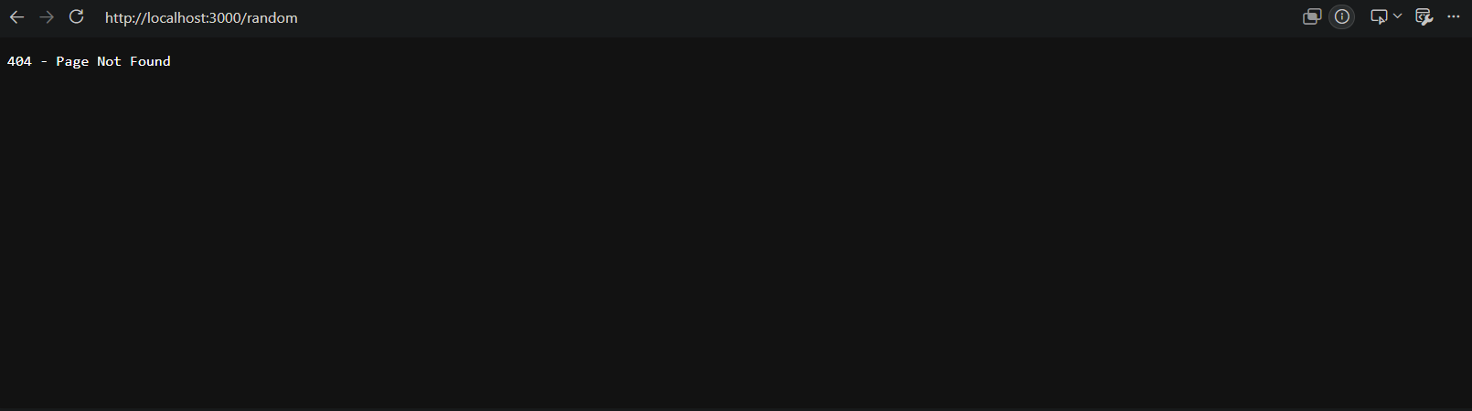
Figure 5. Invalid route returning a 404 response.

5.4 File Manager using the fs Module
The file manager demonstrates create, read, update, append and delete operations. The assignment was tested using terminal commands and the operations completed successfully.
node fileManager.js create
node fileManager.js read
node fileManager.js update
node fileManager.js append
node fileManager.js delete
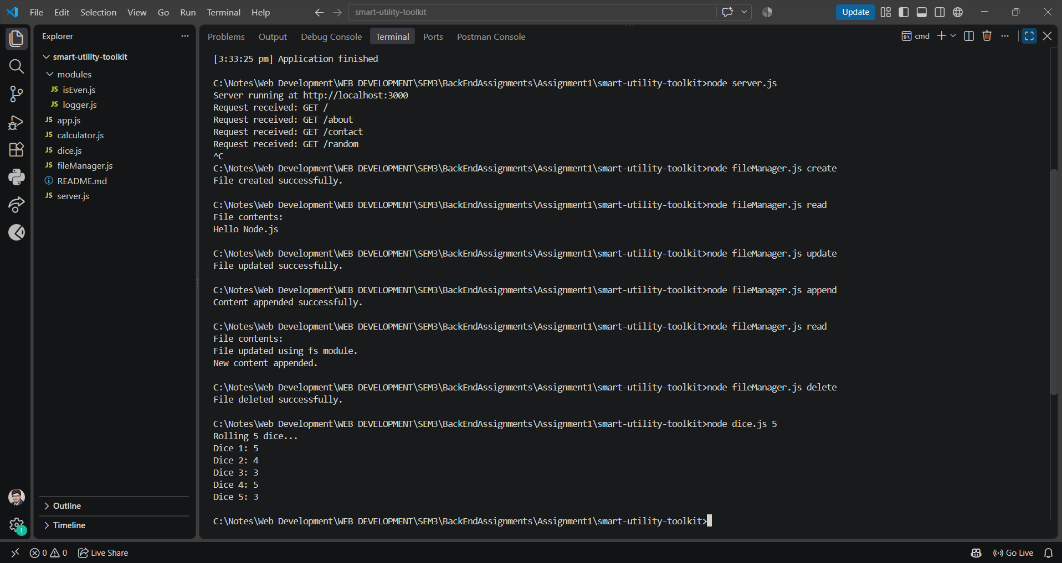
Figure 6. File manager CRUD operations and dice generation.

5.5 Random Dice Generator using crypto
The dice utility uses crypto.randomInt(1, 7) to generate random values from 1 to 6. A loop allows multiple dice rolls to be simulated with one command.
Example command: node dice.js 5
The actual values change between executions because the numbers are generated randomly.

6. Execution Flow and Console Analysis
- process.argv is read before the calculator performs the requested operation.
- Custom modules are loaded using require() and their exported functions are reused.
- The HTTP server logs each request and sends a response according to the requested route.
- File operations display success or error messages in the terminal.
- The dice generator performs multiple random integer operations inside a loop.

7. Functional Requirements Checklist
Requirement | Status | Evidence
CLI calculator using process.argv | Completed | Calculator output
Custom module using module.exports / require() | Completed | app.js output
HTTP server with multiple routes | Completed | Browser + terminal output
File CRUD using fs | Completed | File manager output
Random dice using crypto | Completed | Dice output
Console logging / execution analysis | Completed | Terminal logs
External npm packages | Not used | Built-in modules only

8. Learning Outcomes
This assignment provided practical experience with Node.js core modules, command-line interaction, modular programming, HTTP routing, file-system handling, random number generation, error handling and terminal-based debugging.

9. Conclusion
The Smart Utility Toolkit was successfully implemented and tested using Node.js built-in modules. The calculator, custom modules, HTTP server, file manager and dice generator fulfilled the required functionality without using external npm packages or frameworks.

10. Submission Notes
The project folder/ZIP should be submitted along with this report. The included README.md contains the commands required to execute each utility.

