**Project Title: Local Business Online Platform**

**Team Members:**

* Rakshit Singhvi
* Deev Shah
* Vraj Borad
* Tanushree Harish

**1. Problem Statement**

Small local vendors often lack the resources and technical expertise to create and maintain an online presence. This restricts their ability to reach a broader customer base and compete with larger, tech-enabled businesses. On the other hand, customers looking to support local businesses face difficulty in discovering nearby vendors or verifying their credibility.

**Objective:**  
The platform aims to empower local businesses by providing them with a user-friendly digital storefront. Simultaneously, it offers customers a seamless way to browse, order, and review products/services from local vendors. This bridges the digital divide and promotes the growth of small enterprises.

**2. Pain Points Addressed**

**For Vendors:**

* **Limited Online Exposure:** Vendors often rely solely on walk-in customers or word-of-mouth.
* **Order & Inventory Management Challenges:** Manual tracking leads to errors and inefficiencies.
* **Lack of Customer Feedback Mechanism:** No structured way to gain insights or build trust.

**For Customers:**

* **Difficulty Discovering Local Offerings:** No centralized platform showcasing vendors in a specific locality.
* **Low Transparency & Trust:** No access to reviews or product ratings.
* **Feedback Loop Missing:** No way to share their experience or report issues with products or vendors.

**3. Proposed Solution**

A full-stack web application that serves as a digital marketplace for local vendors and a discovery platform for customers.

**Tech Stack:**

* **Frontend:**
  + HTML5
  + CSS for styling
  + JavaScript for interactivity
* **Backend:**
  + Node.js with Express framework
* **Database:**
  + MySQL with structured schema for real-time updates

**Key Features:**

* Intuitive UI with clean design and mobile responsiveness.
* Vendor dashboard for managing products and orders.
* Real-time inventory update using MySQL triggers.
* Customer reviews and rating system for transparency and trust.

**4. User Interface Overview**

**Main Screens & Functionality:**

1. **Home Page:**
   * Prominent search bar for discovering vendors and products
   * Carousel/banner featuring top vendors or categories
   * Call-to-action buttons for vendors to sign up
2. **Browse/Search Page:**
   * Category-based filters (e.g., Bakery, Grocery, Handicrafts)
   * Location-based sorting
   * Pagination and product previews
3. **Vendor Profile Page:**
   * Vendor’s bio and contact information
   * Grid view of listed products
   * User-generated ratings and reviews
4. **Product Detail Page:**
   * Detailed description, price, stock availability
   * Add to Cart button
   * Product reviews
5. **Cart & Checkout Page:**
   * Cart item list with quantity controls
   * Order summary and total amount
   * Address input and order confirmation
6. **User Account Page:**
   * Order history
   * Ability to track current orders
   * Feedback submission form
7. **Vendor Dashboard:**
   * Add, edit, and remove products
   * View orders placed by customers
   * Real-time stock updates and basic sales analytics

**5. Database Design**

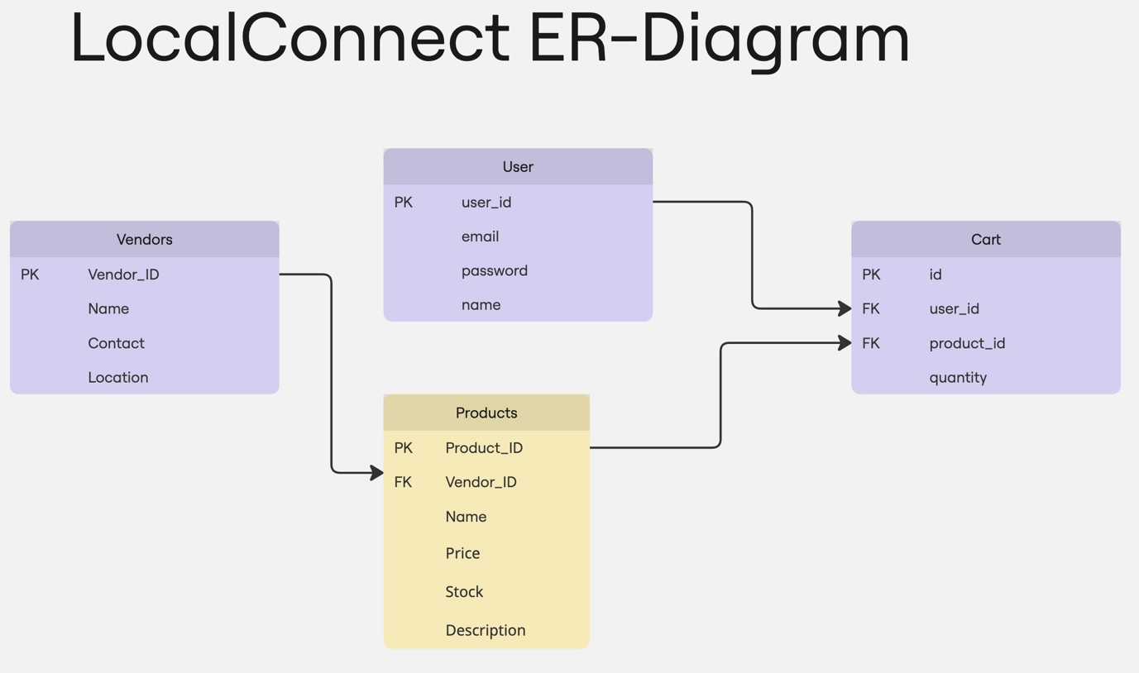

**6. System Integration**

* The **frontend** utilizes HTML forms and fetch() API to send data to the **Node.js Express** backend.
* The backend processes these requests and interacts with **MySQL** to perform CRUD operations.
* JSON responses are sent back and dynamically rendered on the frontend using basic DOM manipulation and template components.

**7. Testing Methodology**

**Testing Approaches:**

* **Manual Testing:**  
  End-to-end testing of user flows:
  + Product discovery → Add to cart → Checkout → View order
* **Form Validation:**
  + Ensured proper input formats using regex and conditionals
  + Client-side and server-side validation for critical fields

**Testing Results:**

* User interactions performed as expected across all flows
* Trigger correctly reduced stock post order
* No data inconsistencies found during testing

**8. Challenges & Lessons Learned**

**Key Challenges:**

* **Database Triggers:** Ensuring atomicity and consistency during simultaneous order placements.
* **Frontend-Backend Coordination:** Mapping frontend form data accurately with backend database schema.
* **UI/UX Consistency:** Making the platform equally intuitive for both vendors and customers.
* **Authentication:** Role-based access control posed complexity during integration.

**Lessons Learned:**

* Importance of planning schema before UI development
* Real-time updates require efficient query logic
* Regular testing reduces debugging effort significantly
* Building an MVP is critical before scaling

**9. Future Improvements**

* **Payment Gateway Integration:**  
  Enable online transactions using Razor pay or Stripe.
* **Role-based Session Management:**  
  Distinct login flows and dashboards for customers and vendors.
* **Mobile App Version:**  
  Build a cross-platform mobile app using React Native or Flutter.
* **Advanced Analytics for Vendors:**
  + Sales reports with charts
  + Product performance tracking
  + Customer insights dashboard
* **Search Optimization:**  
  Add autocomplete and typo correction using fuzzy search algorithms.

**Conclusion**

This project demonstrates the feasibility and impact of digitizing local businesses through a thoughtfully designed web platform. It addresses both vendor and customer pain points and lays the groundwork for scalable, future-ready solutions.