Heart Disease Detection
Machine Learning

Rakshit Raj 25BAI11234
Department of Computer Science Engineering (AI & ML)
Vellore Institute of Technology
Bhopal, Madhya Pradesh
rakshit.25bai11234@vitbhopal.ac.in

Abstract: This project explores the uses of machine learning to predict the presence of heart disease in patient using a sample of medical data. Logistic Regression (Scikit-Learn) is used to a public dataset after throughout data analysis, cleaning, featuring engineering, and visualization. Then using multiple state-of-the-art classification algorithms-including Random Forest, Gradient Boosting (XGBoost, LightGBM, and CatBoost) were also implemented along with Logistic Regression.
The model performance was then evaluated using cross-validation metrics such as accuracy, precision, recall, F1-scores, and ROC-AUC.

Table of Contents
I. Introduction 2
II. Methodology 2
A. Data Collection: 2
B. Data Processing 3
C. Exploratory data analysis 3
III. Implementation 5
A. Logistic Regression 5
B. Random forest 5
C. Gradient boosting (GBM) 6
D. XGBoost 6
E. LightGBM 6
F. CatBoost 7
IV. Result and Discussion 7
V. Conclusions 8
VI. Reference 8

Introduction

Heart Disease is a major cause of poor health and high death rate worldwide. Early detection through the advance machine learning model helps to provide critical benefits. This project builds predictive model using the clinical data to classify patient’s heart disease status, aiming to enhance diagnostic accuracy. Traditional diagnostics protocols rely heavily on the physician’s knowledge and manual expertise, which can be time consuming.
In recent years, Machine Learning (ML) has emerged as an effective to traditional methods by automatically detecting complex pattern in medical disease dataset, aiming to build per formant predictive model that can distinguish patient with and without heart disease based in clinical measurements.
This project aims to compare different machine learning algorithm like Random Forest, Gradient Boost, and Logistic Regression

Methodology
This proposed consist of 4 steps. In step 1 data collection is being performed and step 2 gives an overview of preprocessing, step 3 exploratory analysis is being performed to understand the data set and the last step, step 4 includes the hyper parameter tuning by grid search CV

- Data Collection:

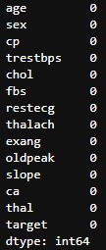
The dataset which is used is heart.csv file (UCI Heart Disease Dataset), comprising 303 patient’s record with 13 features plus a binary target variable indicating heart disease presence. The features include:
- Age, sex
- Chest pain (categorical)
- Resting blood sugar (trestbps)
- Serum cholesterol (chol)
- Fasting blood sugar (fbs)
- Resting electrocardiographic result (restecg)
- Maximum heart rate achieved (thalach)
- Exercise-induced angina (exang)
- ST depression induced by exercise relative to rest (old peak)
- Slope of the peak exercise ST segment (slope)
- Number of major vessels colored by fluoroscopy
Fig.1 Shows that no
Null values in dataset

- Thalassemia

- Data Processing:

The process of converting raw data into comprehensible format is known as data processing, real world data may have noise, missing values or he in an incompatible format that prevent it to being directly used in machine learning models.

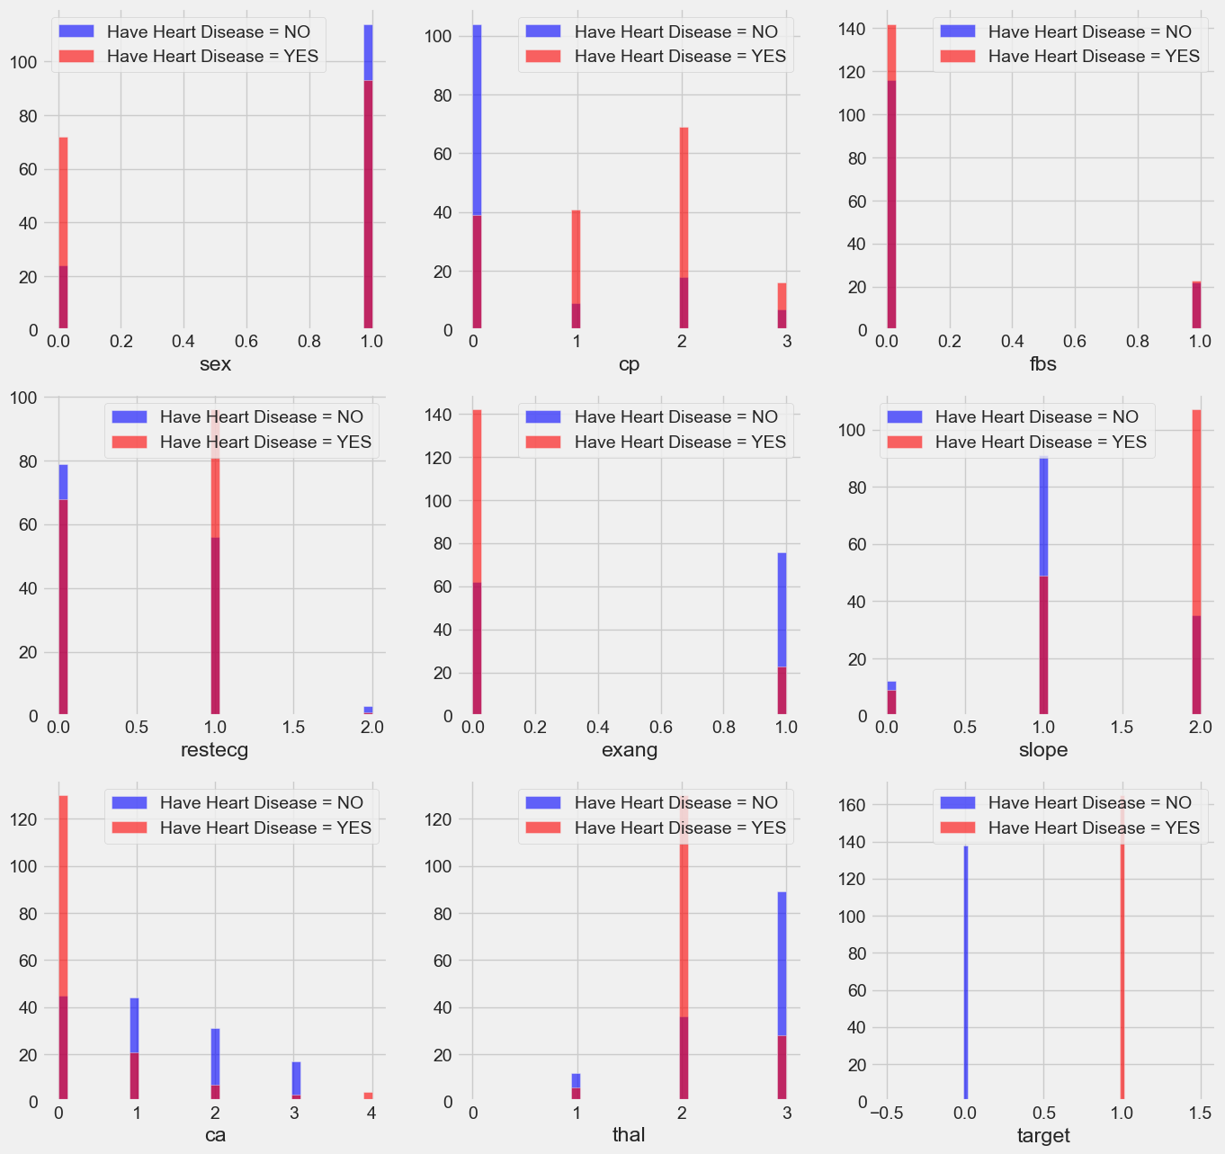

Fig.2 Histogram of all attributes

- Exploratory data analysis :

Basic statistics and visualizations such as histograms and correlation heat maps identified relationships between features and the target variable. For instance, chest pain type and maximum heart rate showed strong correlations with disease presence.

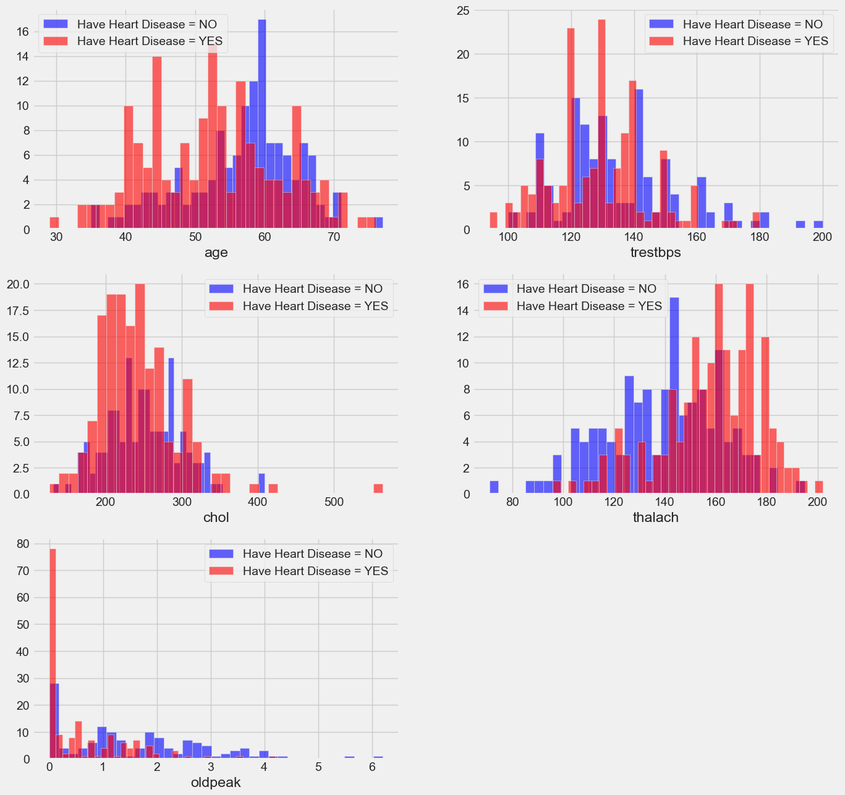
Fig.4 Graph Showing number of patient with or without disease

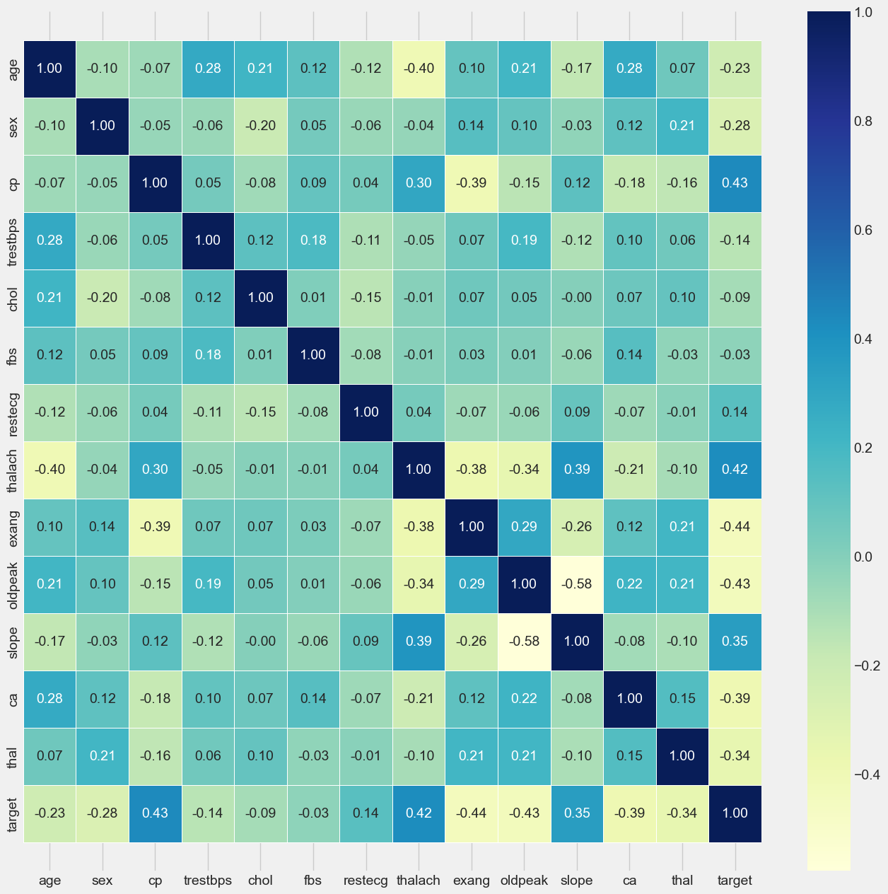

Fig.5 Correlation Matrix

Implementation
With the growth of computer technology, predictive modeling is changing. We are now able to make predictable modeling more efficient, and less expensive than before. In our project, we use various classification algorithms to predict and use a grid search CV to find the most advance solution for each algorithm. Some of the categorization algorithm that has been employed includes:
- Logistic Regression

Logistic regression is a data categorization technique that uses machine learning. This algorithm, models the odds of the potential outcome of a single experiment using a logistic function. The easiest way to understand the influence of numerous independent factors on single outcome variable is to use logistic regression.
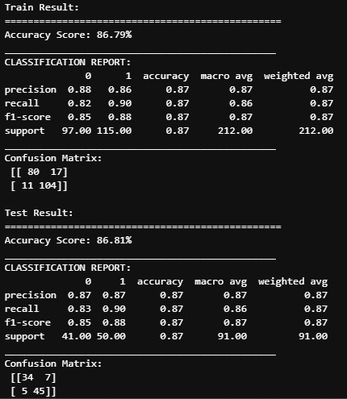

- Random forest

The classifier is meta-estimator that adapts to decision trees on the dataset’s on different subsamples and utilizes the average to increase the models predicted accuracy and control over fitting. In most circumstances the random forest seems to be more accurate than other decision trees and it also minimizes over fitting.
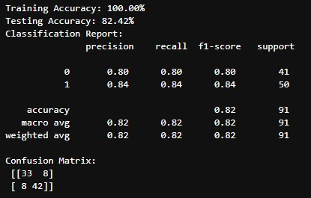

- Gradient boosting (GBM)

Gradient boosting is ensemble machine learning technique that combines multiple weak models, typically decisions trees, to create a single, strong predictive model.
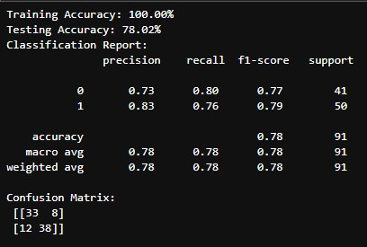

- XGBoost

XGBoost is an open source machine learning library that provides an optimized, scalable, and highly efficient implementation of the gradient boosted decision trees.
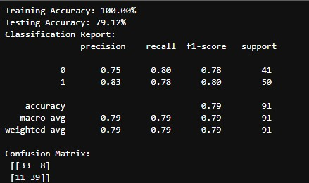

- LightGBM

LightGBM is short for light gradient boosting machine, is free open source distributed gradient boosting framework for machine learning
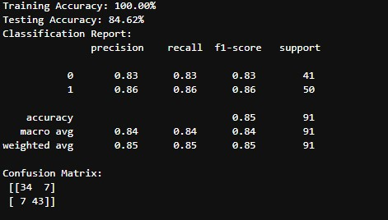

- CatBoost

CatBoost is high performance, open source gradient boosting library for decision tree, developed by Yandex, and used in various applications.
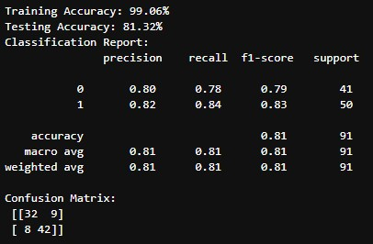

Result and Discussion
To evaluate the effectiveness of the machine learning algorithm applied in this experiment, we decide to adopt the accuracy, mean squared method, precision, recall, and f measure which is widely used in domain such as information retrieval, machine learning and other domains that involve binary classification.
On comparing all the models:
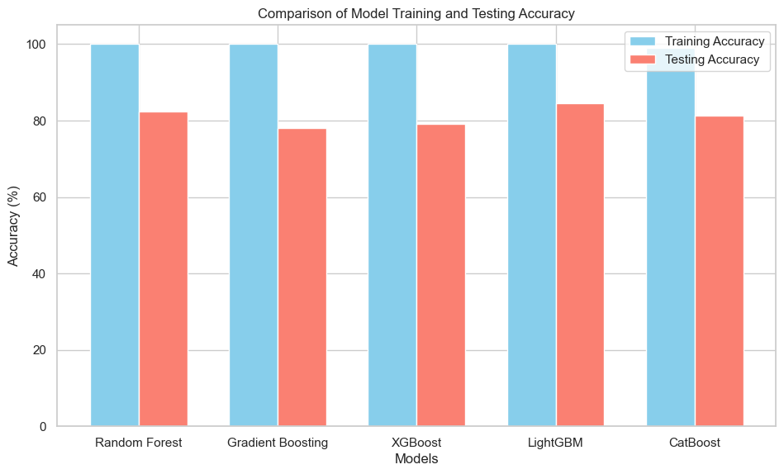

Conclusions
This project validates that enable and boosting algorithm significantly improve the accuracy and reliability f heart disease predictions compared to traditional logistic regression. Through careful preprocessing, feature engineering, and model evaluation, the study provides a solid foundation for integrating ml driven diagnostic in clinical settings.

Reference
- UCI Machine Learning repository : Heart Disease Dataset
- El-Sofany H, et al. “A proposed technique for predicting heart disease using feature selection and ML (2024)”
- Ahmad AA, et al. “Prediction of heart disease based on machine learning (2023)”
- Scikit-Learn, XGBoost, LightGBM, CatBoost Documentation.
- Additional academic papers on heart disease ML Prediction

