# MongoDB -Aggregation Exercises

Import the zips.json file into your MongoDB. Database name is "population" and collection name is "zipcodes".

mongoimport --db population --collection zipcodes --file zips.json

# Atlanta Population

1. use db.zipcodes.find() to filter results to only the results where city is ATLANTA and state is GA.

**Ans : db.zipcodes.aggregate([{$group : {_id: {city: “ATLANTA”}, count: {$sum:1}}}])**

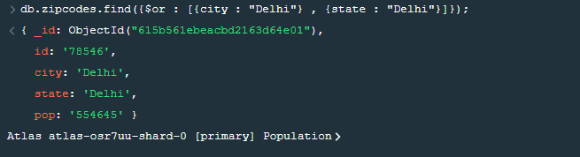

1. use db.zipcodes.aggregate with $match to do the same as

above.

**db.zipcodes.aggregate([{$group : {_id: {city: “ATLANTA”}, count: {$sum:1}}}])**

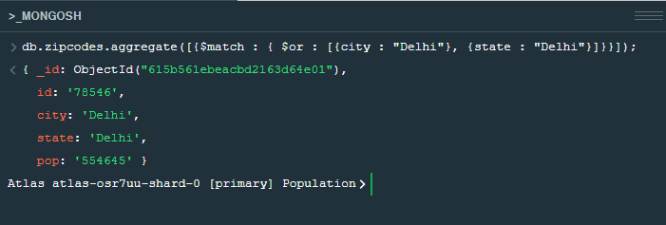

1. use $group to count the number of zip codes in Atlanta.

**db.zipcodes.aggregate([{$group : {_id: {city: “ATLANTA”}, count: {$sum:1}}}])**

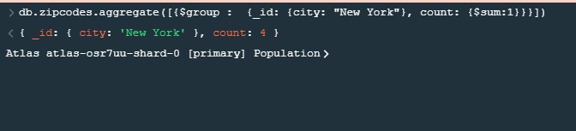

1. use $group to find the total population in Atlanta.

**db.zipcodes.aggregate([{$group : {_id: {city: “ATLANTA”}, count: {$sum:1}}}])**

# Populations By State

1. use aggregate to calculate the total population for each state

**db.zipcodes.aggregate([{$group : {_id: {city: “ATLANTA”}, count: {$sum:1}}}])**

1. sort the results by population, highest first

**db.zipcodes.aggregate([{$group : {_id: {city: “ATLANTA”}, count: {$sum:1}}}])**

1. limit the results to just the first 3 results. What are the top 3 states in population?

**db.zipcodes.aggregate([{$group : {_id: {city: “ATLANTA”}, count: {$sum:1}}}])**

# Populations by City

1. use aggregate to calculate the total population for each city (you have to use city/state combination). You can use a combination for the _id of the $group: { city: '$city', state: '$state' }

**db.zipcodes.aggregate([{$group : {_id: {city: “ATLANTA”}, count: {$sum:1}}}])**

1. sort the results by population, highest first

**db.zipcodes.aggregate([{$group : {_id: {city: “ATLANTA”}, count: {$sum:1}}}])**

1. limit the results to just the first 3 results. What are the top 3 cities in population?

**db.zipcodes.aggregate([{$group : {_id: {city: “ATLANTA”}, count: {$sum:1}}}])**

1. What are the top 3 cities in population in Texas?

**db.zipcodes.aggregate([ {$match: { state: “TX” }}, {$group: {_id: { city:”$city” }, population : { $sum: “$pop” } } }, { $sort: { population: -1 } }, {$limit : 3 }])**

# 

# Bonus

1. Write a query to get the average city population for each state.

**db.zipcodes.aggregate([ {$match: { state: “TX” }}, {$group: {_id: { city:’$city’ }, population : { $sum: '$pop' } } }, { $sort: { population: -1 } }, {$limit : 3 }])**

1. What are the top 3 states in terms of average city population?

**db.zipcodes.aggregate([ {$match: { state: “TX” }}, {$group: {_id: { city:'$city' }, population : { $sum: '$pop' } } }, { $sort: { population: -1 } }, {$limit : 3 }])**