Distribution
- Simulate 30 rolls with = RANDBETWEEN(1,6). What is the probability of rolling a 3 exactly 5 times? (Hint: Use BINOM.DIST)
- Number of trials, n =30
Number of successes rolling a 3, k = 5
Probability of success in a single trial, p = 1/6
Probability of failure, q = 1-p = 1-1/6 = 5/6
Now using the BINOM.DIST function in excel-



= 0.192108 or approx. 19.21%

- Generate 100 values in Excel using the continuous uniform distribution RAND() and plot a histogram. Describe the shape of the distribution.
- In A1, enter =RAND() and copy this formula till A100, each cell contains random number between 0 and 1. Copy the values from A1 to A100 and create a histogram from insert chart tab.

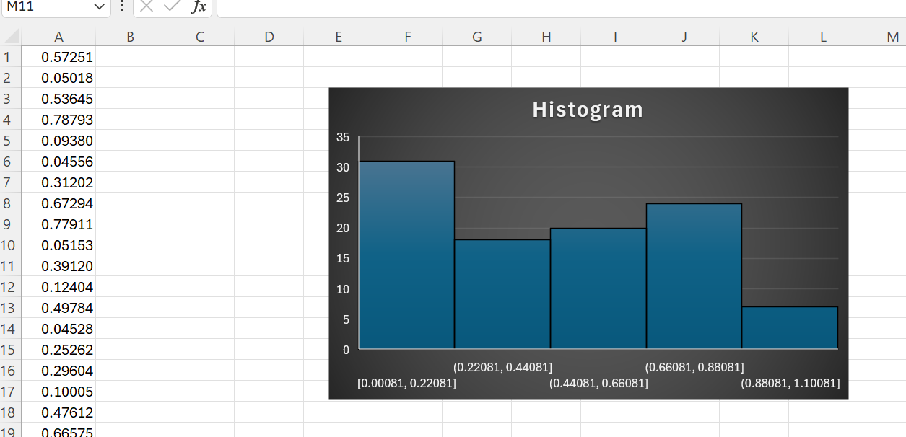

- Each interval (e.g., 0–0.1, 0.1–0.2, …) has equal probability, with only 100 samples, you’ll see small fluctuations (some bins slightly higher or lower). As the number of samples increases (say 1,000 or 10,000), the histogram becomes more evenly flat.

- A dataset has a mean of 50 and a standard deviation of 5. What percentage of values lie between 45 and 55 if the data follows a normal distribution?
- Mean, $μ$ = 50
Standard deviation, 𝜎 = 5
Range, 45 to 55
- The question asks for the percentage of data within one standard deviation ($±1σ$) of the mean.
- Apply the Empirical Rule (68-95-99.7 Rule). For a normal distribution, the Empirical Rule states specific percentages of data fall within certain standard deviations: Approximately 68.27%, round up will 68% of the data.

- What is the concept of standardization (z-score), and why is it important in data analysis? Explain the formula and how standardization transforms a dataset.
- Standardization (also called z-score normalization) converts raw data into values that represent how many standard deviations each observation is from the mean and it is important in data analysis because it ensures all variables are on the same scale, which is crucial in statistical analysis and machine learning where algorithms are sensitive to differences in magnitude.
- Formula – zi(z-score) = (xi – $μ$) / 𝜎
xi = individual data value, $μ$ = mean of the dataset, 𝜎 = standard deviation of the dataset
- Standardization transforms by Subtracting the mean shifts the dataset so its average becomes 0, Dividing by the standard deviation adjusts the spread so the dataset’s variability becomes 1. The transformed dataset follows a standard normal distribution (mean = 0, SD = 1), though the shape of the distribution remains the same

- What is Kurtosis and their type?
- It is a statistical measure that describes the shape of a distribution’s tails relative to its overall shape. It indicates whether data are prone to producing outliers. Mathematically, kurtosis is based on the fourth central moment of a distribution.
- There are 3 types of Kurtosis:
- Mesokurtic - Distribution with kurtosis ≈ 3 (same as normal distribution)
- Leptokurtic - Distribution with kurtosis > 3
- Platykurtic - Distribution with kurtosis < 3 (same as uniform distribution)

- Explain why the uniform distribution is a good model for the outcome of rolling a fair die.
- The uniform distribution is a good model for a fair die because each of its finite outcomes (1, 2, 3, 4, 5, 6) has an equal probability (1/6) of occurring, meaning there's no bias, perfectly matching the "fairness" concept where every face is equally likely to land up, forming a simple discrete uniform distribution.

- Use Excel to compute the probability of getting at least 8 successes in 15 trials with success probability 0.5.
- Number of trials (n) - 15, Success probability (p) – 0.5, At least 8 successes – means P(X>=8)
- Formula- =BINOM.DIST(k, 15, 0.5, FALSE)
For exactly 8 success- =BINOM.DIST(8, 15, 0.5, FALSE)
Cumulative probability upto 7 success- =BINOM.DIST(7, 15, 0.5, TRUE), this gives P(X<=7)
Probability for at least 8 success- =1 – BINOM.DIST(7, 15, 0.5, TRUE).
If we enter this in excel, the probability is 0.5. so there’s about a 50% chance of getting at least 8 successes in 15 trials.

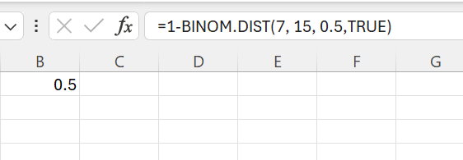

- How does log transformation help in stabilizing variance and making data more normally distributed?
- Log transformation stabilizes variance and normalizes right-skewed data by compressing large values more than small ones, reducing the influence of outliers and pulling in the long tail, which makes the distribution more symmetric and bell-shaped, satisfying assumptions for many statistical tests like t-tests and regression. It's effective for data spanning orders of magnitude (e.g., income, populations) that follow a log-normal distribution.

