# Analysis of factors affecting unresolved crime cases in Karnataka

Rakshita Wagh  
Department of Computer Science and Engineering  
KLE Technological University Hubli, Karnataka

01fe21bcs280@kletech.ac.in

Sanjana Murgod  
Department of Computer Science and Engineering  
KLE Technological University Hubli, Karnataka

01fe21bcs357@kletech.ac.in

Srajana Naik  
Department of Computer Science and Engineering  
KLE Technological University Hubli, Karnataka  
01fe21bcs364@kletech.ac.in

Dr P.G Sunitha Hiremath   
Department of Computer Science and Engineering  
KLE Technological University Hubli, Karnataka

pgshiremath@kletech.ac.in

Tanushree Kabbur  
Department of Computer Science and Engineering  
KLE Technological University Hubli, Karnataka  
01fe21bcs262@kletech.ac.in

Tulasa A.Badagi

Department of computer science and Engineering

KLE Technological University Hubli, Karnataka

tulsa.badagi@kletech.ac.in

**Abstract:**

**Purpose:** The purpose of this study is to analyse the factors influencing unresolved cases of crimes affecting the human body in Karnataka.

**Design:** To carry out this work,2018–21 data was collected from data.gov.in. Each year's data contains 24 different attributes and 117 reasons for these crimes. This extensive data enables us to analyse and gain insights into the distribution and trends of these reported crimes across various categories.

**Findings:** There are seven different categories of crimes, among which **offenses affecting the human body** were found to be the highest and contributed more to this sector with a percentage of 44. The least contributing crime category is found to be other IPC (Indian Penal Code) crimes, with a percentage of 0.9.

The other remaining Categories are Miscellaneous IPC crimes (16.4%), Offences against public tranquillity (18.1%), Offences against property (10.3%), Offences relating to documents and property (8.6%) and Offences against the state (1.7%).

The percentage increases in offences against the human body from 2018 to 2019, from 2019 to 2020, and from 2020 to 2021 are approximately 1.57%, 3.06%, and 7.70%, respectively. Among the 50 subcategories of offenses affecting the human body, ‘voluntarily causing simple hurt’ is the highest, it was found that more of the cases were disposed of by the police, which leads to more cases being unresolved. By further analyzing cases disposed of by the police, we found the ‘Final Report-Total’ to be the highest. Among this Final Report's total, the ‘Final Report:

Cases Ended as Mistakes of Fact or Law or Civil Dispute’ is the highest.

**Conclusion:** The analysis suggests that a particular category significantly contributes to unresolved crimes in Karnataka and can be further categorised based on the type of unresolved case. Additionally,

The analysis identifies the year with the highest number of unresolved crimes in Karnataka. This highlights the significance of effective handling by the judiciary to reduce the overall number of pending cases and build public trust in the judicial system.

**Keywords**: unresolved cases, total cases, pending cases of crime in Karnataka.

**Introduction:**

A crime investigation is a complex process aimed at maintaining justice and order in society. A crime investigation is like solving a puzzle to find out what happened and who did it when a crime occurs. It involves collecting clues and talking to people to put all the pieces together. Sometimes it can be tricky, and it may take time to figure everything out, but investigators work hard to make sure the right person is held responsible for their actions. Their job is crucial to keeping our communities safe and making sure justice is served. However, despite the hard work of law enforcement and investigators, some cases remain unsolved, leaving victims and communities seeking answers. In this study, we take a close look at the information about different crimes that happened between 2018 and 2021. Our main focus is to figure out why some cases were not solved by the investigators. We want to understand the reasons behind these unsolved cases to find ways to improve the investigation process in the future. By doing this, we hope to provide valuable insights that can help law enforcement and investigators solve more cases and bring justice to the victims and their families. Our goal is to solve the mystery of these unsolved cases and identify key factors that hinder their resolution. These factors could include difficulties in following procedures, limited resources, or challenges in gathering evidence. By uncovering patterns in unresolved cases of crimes in Karnataka, our report aims to provide valuable insights to law enforcement, policymakers, and investigative teams. This understanding can lead to better strategies for resolving more unresolved cases of crimes in Karnataka and increasing public trust in the justice system. We hope that our findings will contribute to improving investigative practices, resource allocation, and empowering law enforcement to bring justice to victims and resolve these unresolved cases of crime in Karnataka.

**Literature and Survey:**

The field of crime data analysis has gained significant attention across the world due to the increasing need for effective crime prevention and law enforcement strategies. Several research papers have explored different approaches and methodologies to analyze crime data, identify criminal patterns, and predict criminal activities. However, despite these efforts, there seems to be a gap in the specific area of crime data analysis concerning the state of Karnataka, India.

Authors in [1] focuses on using a computer system to predict the most likely suspect in a crime using advanced computer techniques. It employs data mining and analyses the suspects past criminal history to enhance crime-solving efficiency.

But In [2] authors discuss the application of frequent pattern mining and association rule mining on crime pattern mining. It emphasizes the need for methods to find the probability of criminals to reduce crime rates effectively.

Crime data analysis, visualization, and prediction using the Long Short-Term Memory (LSTM) model in India has been explored by the authors of [3]. However, this study's scope does not cover the specific challenges faced in Karnataka.

And also authors in [4] analyses global crime patterns using data from 166 countries. It identifies high crime rates in African and Latin American countries and explores possible determinants. While valuable for understanding global crime patterns, it does not address the Karnataka-specific issues.

Whereas data mining techniques to predict features affecting high crime rates in a region has been done by authors in [5]. While the approach is useful, it does not focus on the challenges faced in Karnataka.

And the authors in [6] critically analyses crime data against women in India and suggests preventive measures. Although addressing an important issue, it does not investigate the reasons for pending cases in Karnataka.

Authors of [7] critiques crimes against children in India, focusing on kidnapping, rape, and other offenses. However, it does not specifically explore the reasons for unsolved cases in Karnataka.

An overview of crime prediction methods and the challenges associated with accurate predictions has been provided by authors [8]. While relevant, it lacks a specific focus on Karnataka's crime data.

The authors in [9] uses machine learning to predict the types of crimes in a particular area, aiding in classification and speeding up case resolution. Although relevant to crime data analysis, it does not specifically address the reasons for pending cases in Karnataka.

In conclusion, the literature survey reveals several valuable contributions to crime data analysis across the world. However, none of the surveyed papers specifically explore the reasons behind the pending cases and unsolved crimes in the state of Karnataka, India. Our work aims to fill this gap by analyzing the crime dataset of Karnataka and investigating the underlying factors causing delays in case resolution. By identifying these issues, we intend to provide insights and recommendations to improve the efficiency and effectiveness of law enforcement agencies in the region.

**Methodology:**

## **Data Collection and Description**

To carry out this study we collected 4 years of data of crime patterns of unresolved cases of crimes in Karnataka from the government website [10] .

**Attributes of the collected dataset**

* Crime HEAD:
* Cases pending investigation from previous year
* Cases reported during the year
* Cases reopened for Investigation
* Total cases for investigation
* Cases Not Investigated under 157_1_b CRPC
* Cases Transferred to other State or Agency
* Cases Withdrawn by the Govt during Investigation
* Final Report - Cases Ended as FR Non-Cognizable:
* Final Report - Cases Ended as Mistake of Fact or of Law or Civil Dispute
* Final Report - Cases Ended as Final Report False
* Final Report - Cases Abated during Investigation
* Final Report - Cases True but Insufficient Evidence or Untraced or No Clue
* Final Report - TOTAL
* Chargesheets Submitted - Cases Charge sheeted Out of Cases from Previous Year
* Submitted - Cases Charge sheeted Out of Cases during the Year
* Chargesheets Submitted - Cases Charge sheeted
* Total Cases Disposed Off by Police
* Cases Quashed at Investigation Stage
* Cases Stayed at Investigation Stage
* Cases Pending Investigation at End of the Year
* Charge sheeting Rate
* Pendency Percentage

complications, we decided to drop the attribute "Total Cases" for each year, as this attribute was a summation of several other attributes related to unresolved cases of crimes in Karnataka. We selected five attributes for all four years, as the remaining attributes were derived from them and would be used for further analysis

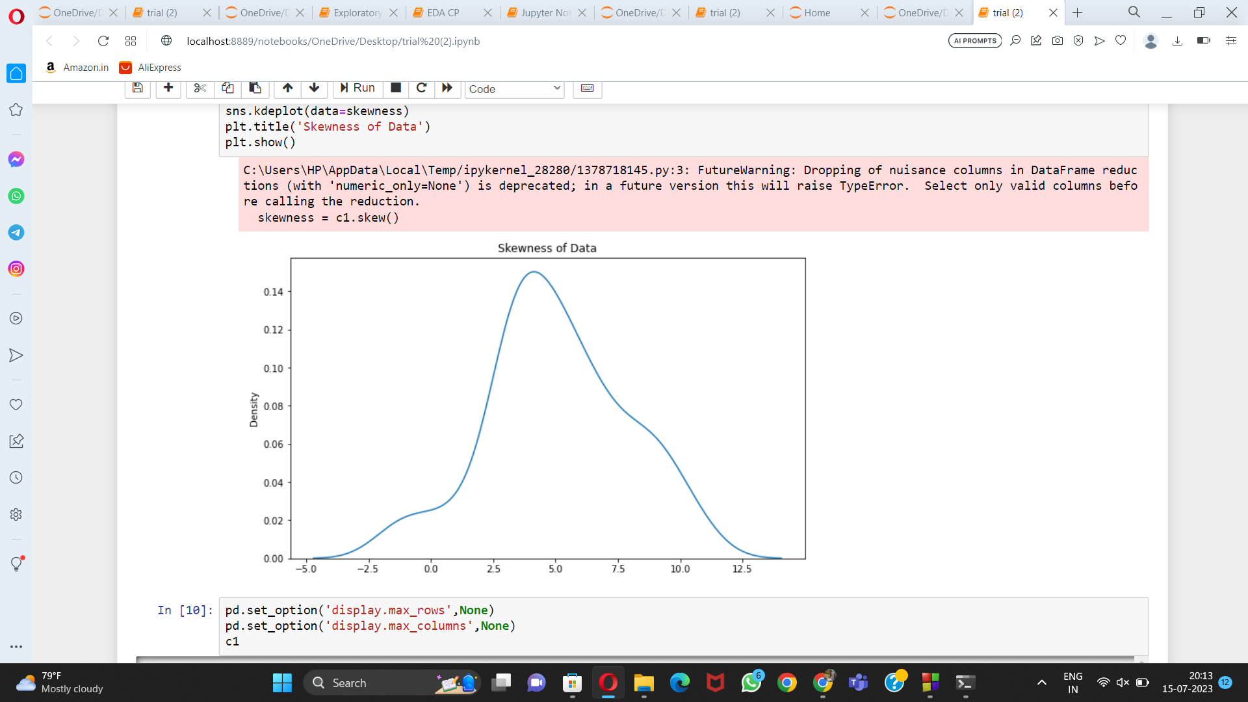

The next section discusses the pre-processing of the data carried out to get quality data for analysis and prediction.

**Experiments and Results**

**Pre-processing:**

Pre-processing has

* Data cleaning
* Data transformation

**Data cleaning and transformation**:

In the data cleaning process, we identified attributes with null values and addressed them by replacing the null values with appropriate statistical measures like mean, median, or mode, depending on the data type and skewness. Based on the skewness of our dataset, we determined that using the mean was the most suitable approach.The majority of the null values were found in the subcategory "Vigilant," which falls under the broader category of "Offences against Public Tranquility." Additionally, we discovered and removed duplicate columns, resulting in the elimination of 27 rows with duplicate values. Furthermore, certain exceptional columns, such as "Pendency," required special consideration, and we replaced their null values according to their respective formulas.

Despite performing the above pre-processing techniques, the overall skewness of our data remained unchanged. To facilitate data analysis and avoid

**Figure 1.1: Skewness of the crime data distribution**

**Data Analysis:**

In analysis part firstly we focused on which category has the highest crime rates

There are seven main categories of crime head under which all crime reasons fall

1)Offences affecting the human body.

2)Offences against public tranquility.

3) Miscellaneous IPC crimes.

4) Offences against property.

5) Offences relating to documents and property.

6) Offences against the state.

7) Other IPC crimes.

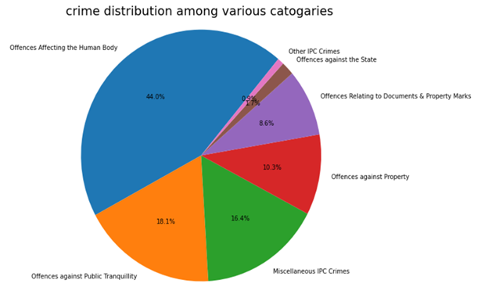

**Figure 1.2: crime distribution among various categories**

By observing the above figure 1.2, it was known that the category ‘Offences affecting the human body’ contributed more to the unresolved cases of crimes in Karnataka

**Table 1: categories and their percentage contribution to unresolved cases**

|  |  |
| --- | --- |
| **Category** | **Percentage** |
| Offences affecting the human body. | 44 |
| Offences against public tranquillity. | 18.1 |
| Miscellaneous IPC crimes. | 16.4 |
| Offences against property. | 10.3 |
| Offences relating to documents and property. | 8.6 |
| Offences against the state. | 1.7 |
| Other IPC crimes. | 0.9 |

Table 1 depicts the seven main categories and their contribution to the unresolved cases of crimes in Karnataka.

There could be several reasons for this:

● Complexity of Cases:

Crimes involving harm to the human body, such as assault, murder, or other violent offences, can be complex to investigate. The evidence may be difficult to gather, and the circumstances surrounding the crime might be unclear, making it challenging for law enforcement to solve the case.

● Lack of Witnesses:

In some cases, there might be a lack of witnesses willing to come forward or fear of retaliation, which makes it harder for authorities to piece together what happened.

● Backlog and Resources:

Some regions or jurisdictions may have a backlog of cases, limited resources, or inefficient investigative processes. This can hinder the timely resolution of cases, especially if offences against the human body are not prioritized adequately.

● Challenges in Forensics:

In some instances, forensic evidence may be challenging to collect, analyze, or interpret, slowing down the investigation and resolution process.

● Challenges in Evidence Collection:

Collecting substantial evidence in cases involving bodily harm can be challenging.

In further analysis, we focused on the category of crimes that had the highest number of unresolved cases in Karnataka. Within this category, there were 50 subcategories of crimes that we examined. To understand these subcategories better, we plotted a line graph. This graph allowed us to visualize any trends or patterns within each subcategory over the years 2018 to 2021. By analyzing the data in this way, we aimed to gain more insights into the specific types of crimes that were contributing the most to the unresolved cases of crime in Karnataka. This information could be valuable in identifying areas where additional attention and resources may be needed to improve the resolution of these cases and enhance public safety. Furthermore, this analysis enables law enforcement agencies and policymakers to prioritize their efforts in tackling the identified high-impact subcategories. By addressing the root causes behind the unresolved cases of crimes in Karnataka in these specific crime types, we can work towards more effective crime prevention and a safer community for all.

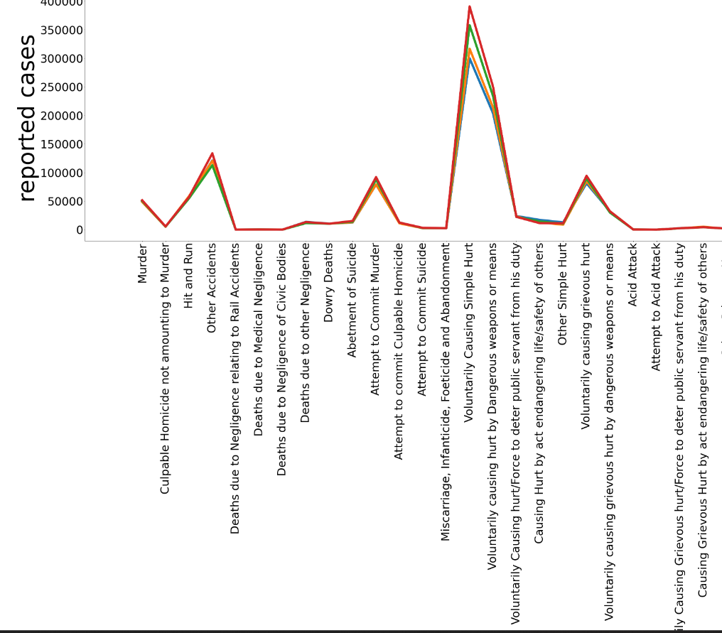

**Figure 1.2: Total cases for investigation**

From figure 1.2 it has been concluded that among sub categories of ‘Offences affecting the human body’ the category ‘Voluntarily causing simple hurt’ has reported the highest cases among all the four years.Then we compare the total cases and the pending cases varying over the years

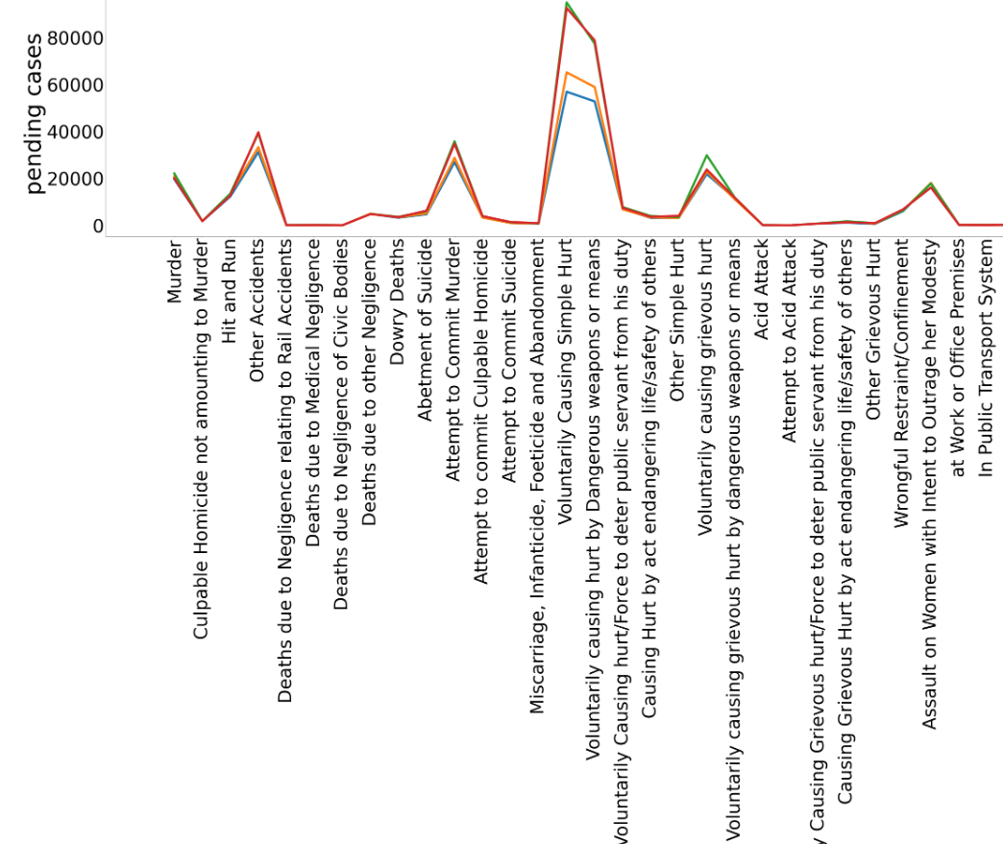

**Figure 1.3: Pending cases at the end of the year**

From figures 1.2 and 1.3 it has been concluded that many cases remain unresolved. The main reason for this we will explore at the end of our analysis.

**Table 2: Comparison between total cases reported and pending cases**

|  |  |  |
| --- | --- | --- |
| **Year** | **Total Cases** | **Pending Cases** |
| 2018 | 4384601 | 1239923 |
| 2019 | 4470678 | 1307738 |
| 2020 | 5584135 | 2134975 |
| 2021 | 5810088 | 2042045 |

Table 3 shows that there is a major difference between total cases reported and pending cases at the end of the year among all the four years.Now, we will mainly focus on the Pending cases of the year 2021

**Table 3: Cases pending against each crime head**

|  |  |
| --- | --- |
| **Crime Heads** | **Cases** |
| Voluntarily causing simple hurt | 92624 |
| Voluntarily causing hurt by dangerous weapon | 78810 |
| Other accidents | 39692 |
| Attempt to commit murder | 34763 |
| Voluntarily causing grievous hurt | 23798 |

From table 4, it has been concluded that the main five reasons for which cases remain unsolved are Voluntarily causing simple hurt, Voluntarily causing hurt by dangerous weapon, Other accidents, Attempt to commit murder,Voluntarily causing grievous hurt From our dataset there are main three sub-attributes which contribute for total unresolved cases of crimes in Karnataka. which has been concluded from the formula.

Total cases=Pending cases-unresolved cases of crimes in Karnataka.

The main three reasons are: Cases quashed at investigation, Cases withdrawn by government, Cases disposed of by police.

Labels of graphs:

R1- Other Accidents

R2- Attempt to commit murder

R3- Voluntarily causing simple hurt

R4- Voluntarily causing hurt by dangerous weapons or means.

R5- Voluntarily causing grievous hurt

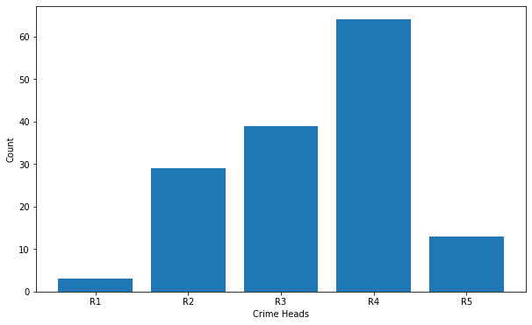 **Figure 1.4: Quashed at investigation**

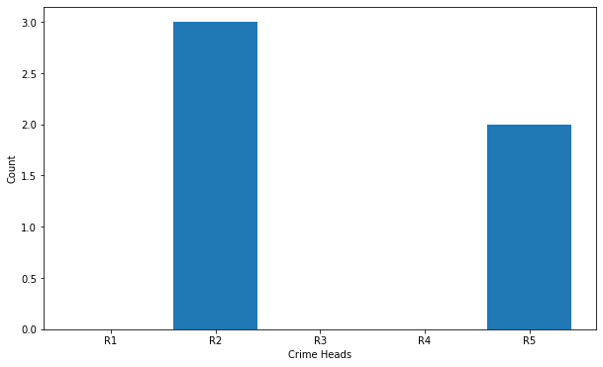

**Figure 1.5: Withdrawn by government**

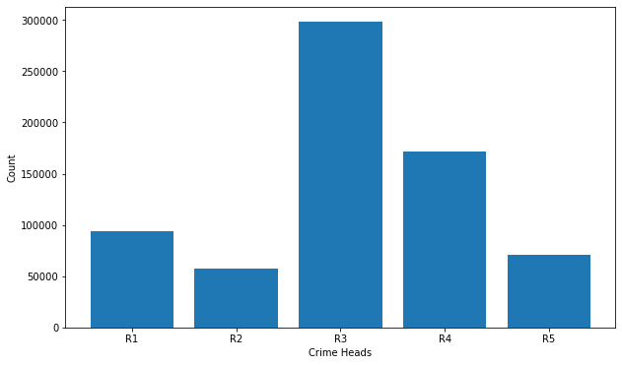**Figure 1.6: Disposed of by the police**

By observing the figures 1.4,1.5,1.6 it has been concluded that cases disposed off by the police contributed most to the cases being unresolved. So, to check the reasons for cases disposed off by the police.

#### The cases disposed of by the police can be categorised into four main reasons:

#### 1) Cases Not Investigated under 157_1_b CRPC

#### 2) Cases Transferred to other States or Agency

#### 3) Final Report - Total

#### 4) Chargesheets Submitted - Cases Charge sheeted.

#### To gain a comprehensive understanding of these reasons, an area plot was created, considering the five main crime heads within the "Disposed off by the police" category. The area plot showcases the distribution of cases among the mentioned reasons, providing valuable insights into the disposition of different crime types by law enforcement agencies.

#### **Figure 1.7: Cases Not Investigated Under 157_1_b CRPC**

Figure 1.7 indicated that a considerable number of 120 cases were not investigated under this provision, with the majority of these cases being related to accidents

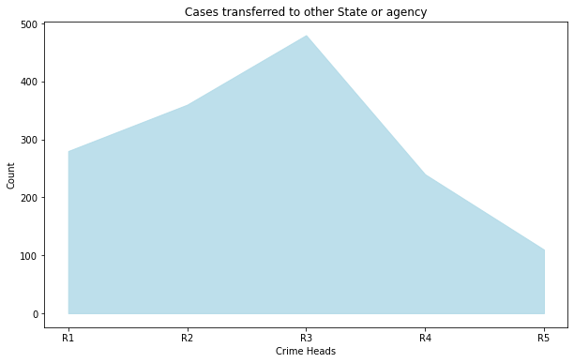

**Figure 1.8: Cases Transferred to Other State or Agency.**

Figure 1.8 revealed that a total of 500 cases were transferred, primarily involving instances of "voluntarily causing simple hurt."

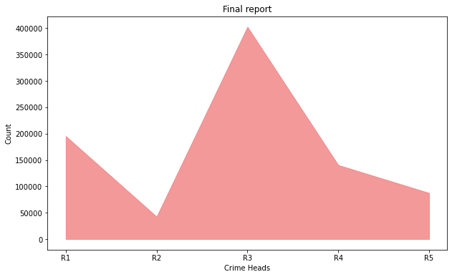**Figure 1.9: Final Report**

From Figure 1.9, it was observed that a significant number of cases, approximately 4,00,000, were classified under this category. Among these cases, the most prevalent subcategory was "Simple hurt," which accounted for the highest number of instances

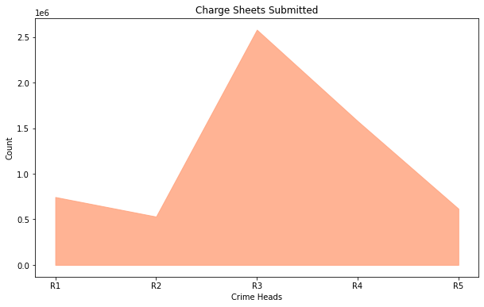

**Figure 2.0: Charge Sheets Submitted**

Figure2.0 shows that charge sheeting rate is highest but many of the cases are not being resolved even after the chargesheets submitted.

"Chargesheet submitted" in the context of a criminal case, it indicates that the investigation is complete, and the case is ready to proceed to trial in court. It does not necessarily mean that the case has been resolved or concluded. Therefore, here we considered the second highest which is affecting more to the unresolved cases for further analysis. And that is "Final Report - Total" again this category consists of five subcategories: "Final Report - Cases Ended as FR Non-Cognizable," "Final Report - Cases Ended as Final Report False," "Final Report - Cases Ended as Mistake of Fact or of Law or Civil Dispute," "Final Report - Cases True but Insufficient Evidence or Untraced or No Clue," and "Final Report - Cases Abated during the investigation”.

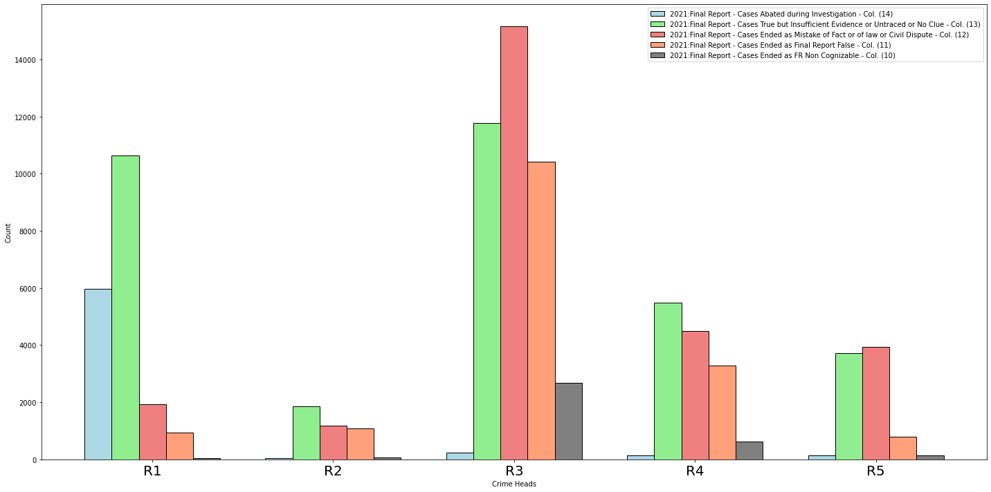

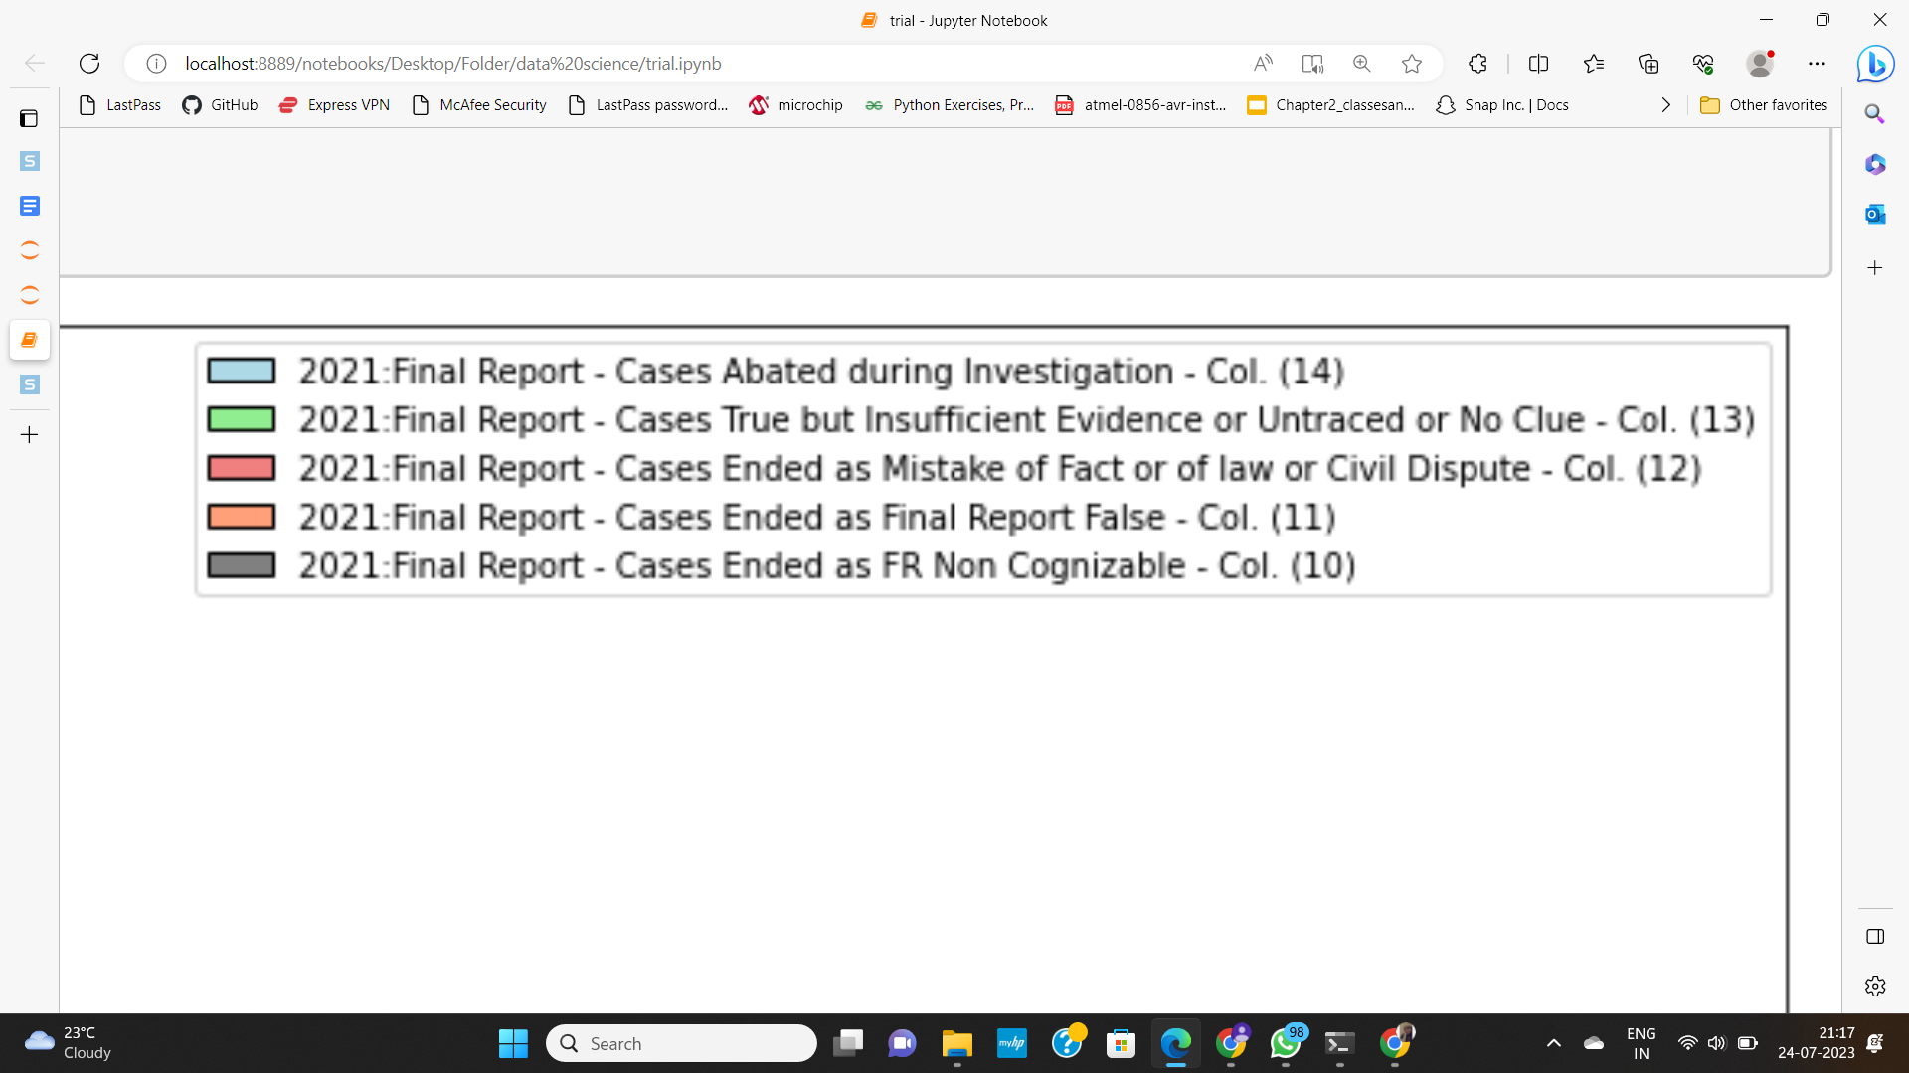

**Figure 2.1: Final Report Total-sub categories**

In figure 2.1, we found out that the Final Report - Cases Ended as Mistake of Fact or of Law or Civil Dispute is the highest.

## **Table 4: Subtypes of final-report**

|  |  |
| --- | --- |
| **Final Report** | **Percentage** |
| Cases Ended as Mistake of Fact or of Law or civil dispute | 35 |
| Cases True but Insufficient Evidence or untraced or no clue | 33 |
| Cases ended as final report false | 24.9 |
| Cases ended as FR non-cognizable | 5.8 |
| Cases abated during investigation | 0.74 |

## The table 4 presents the distribution of subtypes within the "Final Report" category. It shows that the most common subtype is "Cases Ended as Mistake of Fact or of Law or Civil Dispute," accounting for 35% of the cases. These findings provide valuable insights into the different outcomes of closed cases and can aid in improving the effectiveness of the judicial system.

**Conclusion:**

Based on the comprehensive analysis of four years' data from 2018 to 2021, which included 24 different attributes and seven distinct categories of crimes, it is evident that offenses affecting the human body accounted for the highest percentage of reported crimes, representing 44% of the total. Conversely, other IPC crimes had the least contribution, comprising only 0.9% of the cases.

## Within the category of offenses affecting the human body, it was found that voluntarily causing simple harm was the most prevalent subcategory among the 50 identified subcategories. Further examination of cases disposed of by the police revealed that the subcategory "Final Report: Cases Ended as Mistakes of Fact or Law or Civil Dispute" ranked highest in contributing to unresolved cases of crimes in Karnataka. This highlights the significance of effective handling by the judiciary to reduce the overall number of pending cases and build public trust in the judicial system. Addressing the subcategory "Final Report: Cases Ended as Mistakes of Fact, Law, or Civil Dispute" under the main category of offenses affecting the human body becomes crucial in decreasing the number of unresolved cases of crimes in Karnataka.

## To achieve this, a proactive approach by the judiciary is essential to streamline the resolution process. By doing so, we can foster a more efficient judicial system and instill confidence among the public in its efficacy.

In conclusion, targeted efforts towards resolving

Cases related to the human body, specifically focusing in the subcategory "Final Report: Cases Ended as Mistakes of Fact, Law, or Civil Dispute, it can significantly contribute to reducing the number of unresolved cases of crimes in Karnataka and ultimately lead to a safer and more just society.

## References:

## [1] Ganesh Kukreja, Siddharth Mav, Anand Vaswani, Prabhav,Pathak,Dr.Mrs.Greesha,BhatiaStudent,Student,Student,Student,DeputyHOD,Vivekanand Education Society of Institute and Technology, Chembur, India

## <https://www.ijcrt.org/papers/IJCRT1803196.pdf>

[2]A Complete Survey on the application of Frequent Pattern Mining and Association Rule Mining on Crime Pattern Mining

D.Usha, Dr.K.Rameshkumar Assistant Professor, Associate Professor Hindustan University, Chennai

[ijacst05342014.pdf (warse.org)](https://www.warse.org/pdfs/2014/ijacst05342014.pdf)

[3] Ayele, Nigus & Kibru, Yidnekachew & Meskela, Tsion & Mengist, Tagele & Teferi, Muluken. (2020). Designing Time Series Crime Prediction Model using Long Short-Term Memory Recurrent Neural Network. International Journal of Recent Technology and Engineering.

[(PDF) Long Short-Term Memory in Recurrent Neural Networks (researchgate.net)](https://www.researchgate.net/publication/2562741_Long_Short-Term_Memory_in_Recurrent_Neural_Networks)

[4]Dijk, Jan & Nieuwbeerta, Paul & Larsen, Jacqueline. (2021). Global Crime Patterns: An Analysis of Survey Data from 166 Countries Around the World, 2006–2019. Journal of Quantitative Criminology. 38. 10.1007/s10940-021-09501-0.

[[5]](https://www.semanticscholar.org/paper/Predictive-Modelling-of-Crime-Dataset-Using-Data-Yerpude-Gudur/eea6a08f1a7500321fb77b102b62c0c8a870901e) author={Prajakta Yerpude and Vaishnavi Gudur}, journal={International Journal of Data Mining \& Knowledge Management Process}, year={2017}, volume={7}, pages={43-58} }

article{Yerpude2017PredictiveMO, title={Predictive Modelling of Crime Dataset Using Data Mining},

[6]M C, Janaki & T, Manikanta. (2014). CRIME AGAINST WOMEN - A QUALITATIVE ANALYSIS.

[7] Apeksha Rajput, A Critique on Crimes against Children in India, 4 (2) IJLMH Page 2070 - 2087 (2021), DOI: <http://doi.one/10.1732/IJLMH.26467>

[8] Shamsuddin, Nurul & Ali, Nor Azizah & Alwee, Razana. (2017). An overview on crime prediction methods. 1-5. 10.1109/ICT-ISPC.2017.8075335.

Nurul Hazwani Mohd Shamsuddin and others published An overview on crime prediction methods

[9]P. Bhanumathi and S. Greeshma, International Journal of Research in Engineering, IT and Social Sciences

<https://indusedu.org/pdfs/IJREISS/IJREISS_3990_20668.pdf>

[10] Government website

[data.gov.in](http://data.gov.in)