**SSN College of Engineering**

**Department of Computer Science and Engineering**

**UCS2313 – Object Oriented Programming Lab**

**II Year CSE  - ( III Semester)**



**JAVA MINIPROJECT**

**PROJECT TITLE**

**LIBRARY MANAGEMENT SYSTEM**

**MEMBERS:**

**Rakshith Subramanian 3122215001078**

**S Rohitram 3122215001086**

**CLASS DIAGRAM FOR**

**LIBRARAY MANAGEMENT SYSTEM**

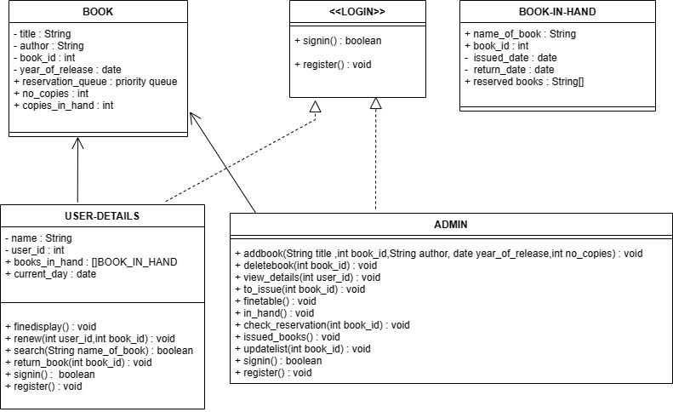

1. **PROBLEM STATEMENT-** To use various

**Object Oriented Programming** concepts learnt in the course to develop a

**LIBRARY MANAGEMENT SYSTEM** To handle the process of enrolling new users, addition and deletion of books, issue and return of books, fine calculation, searching and reservation of books.

**b) MOTIVATION**

Libraries are constantly changing and evolving to keep up with the times and provide their patrons with the best possible experience. Librarians are responsible for a lot of tasks to keep everything running smoothly.

[Library Management System](https://www.slimkm.com/products/library-management-system/)(LMS) improves efficiency by filling in the gaps in a library’s struggles. The LMS can cut down time spent on administrative tasks, such as searching for books, updating available books and fine calculation and display etc.

Libraries can do the smart work instead of

the hard work and grow their patrons’ satisfaction with excellent services.

Such a system would improve the general security of data as we use object-oriented programming.

**Module Split-up:**

* The system consists of 2 modules, namely the **USER module** and **ADMIN module**.
* The USER is first asked if he is admin or a normal user.

**Description**

* + - * + **USER MODULE**
* The user is asked if wants to **sign-in** or **Register.**
* After sign-in/register process is completed, user is redirected to the **Personal Book List(PBL).**
* PBL consists of :

1. **User-Name**
2. **User-ID**
3. **Book Name**
4. **Book ID**
5. **ISSUE DATE**
6. **Return Date**
7. **Fine**

* The User is then given **Three options:**

1. **SEARCH:** This allows the user to search for the book he wants.

If the user requests an unavailable book an option is given to **reserve** that book. A Queue is maintained for each book and reservations are made by implementing data structures.

1. **RENEW:** This allows the user to extend the due date for the books he has.
2. **FINE DISPLAY**: This option enables the user to view his outstanding fines.

**ADMIN MODULE**

* The user is asked for a **password** to confirm if he is an **ADMIN.**
* The user is then given 3 options:

1. **VIEW_ALL:**To view the library’s Total Stock data
2. **IN_HAND:** To view the list of books currently available
3. **ISSUED:** To view the list of books issued.

* The user is then allowed to choose between three options:

1. **ADD:** To add new books to the library.
2. **DELETE:** To delete from the existing set of books.
3. **TO_ISSUE:** To issue books based on the availability and reservation queue of that book
4. **RETURNED:** to get the books back from the book user
5. **FINE_DISPLAY:** To view list of defaulters along with their respective outstanding fines.
6. **CHECK_RESERVATION:** Displays the reservation queue of the required book.