**CHAPTER 5**

**SCREEN SHOTS**

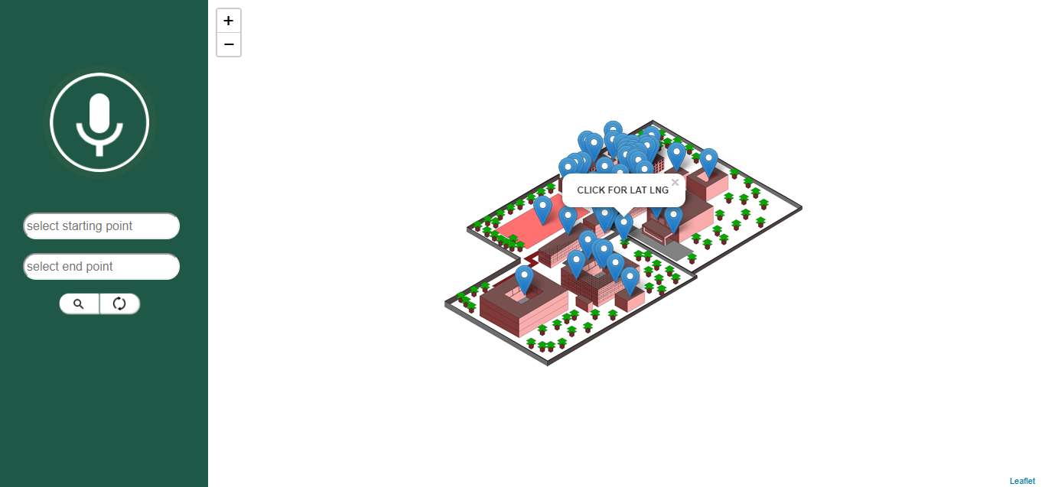

**Fig 1:**Loading page

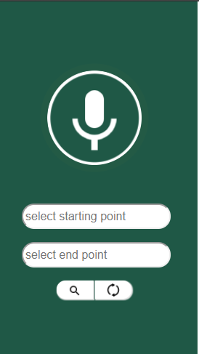

**Fig 2:**Speech and text input interface

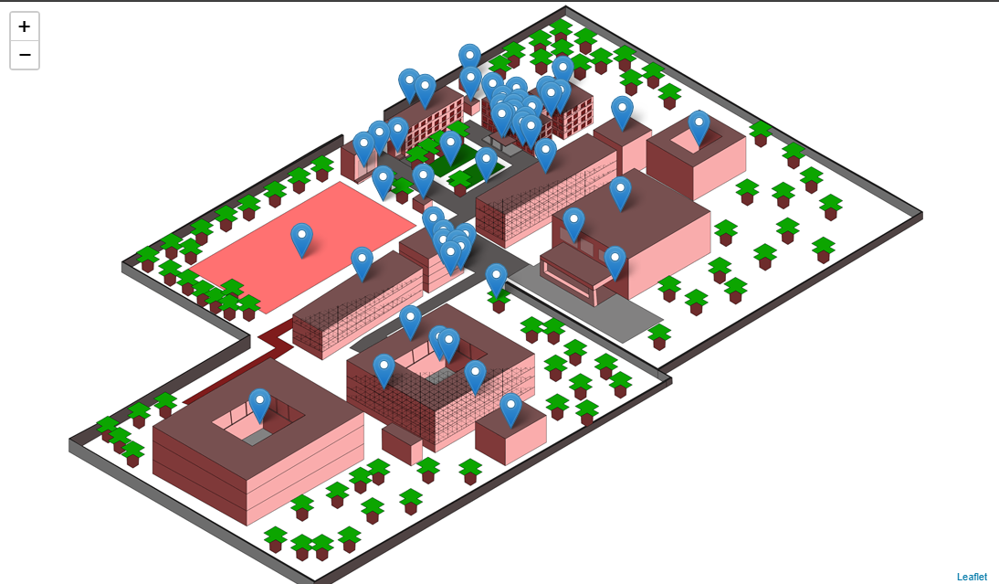

**Fig 3:**Map with all points