**CHAPTER 1**

**INTRODUCTION TO PROJECT**

**1.1 INTRODUCTION**

A Blood Bank stores blood of various blood groups. Many donors donate blood, each of different blood group/type. A donor may donate blood more than once and donor is identified by a donor id (DID), name, sex, age, address and phone number. The blood donated by the donor is characterized by blood type, code and cost. Before each donor donates his blood, he is required to register himself as a donor with the receptionist who works at the Blood Bank. The receptionist is identified by employee id, name, address and phone number. The Blood Banks receives orders for blood from many hospitals for emergency purposes and other surgical requirements and each blood bank issues the same of required blood type. Each blood bank has its own blood bank number (BNO), issues, orders and blood types stored. The Blood Bank is managed by the blood bank manager who is identified by employee id, name, email id and phone number and his responsibility is to proper management of the blood bank. The hospitals are identified by name, address and phone number.

**CHAPTER 2**

**REQUIREMENT SPECIFICATION**

**2.1 Functional Requirements**

1. Blood Donor.
2. Register the donor by receptionist.
3. Search blood.
4. Adding blood by receptionist.
5. Ordering blood by hospital.
6. Viewing orders by blood bank.

**2.2 Non-Functional Requirements**

1. Secure access of required data.
2. User friendly.
3. Simple user interface.
4. 24*7 availability.

**2.3 Hardware Requirements**

1. Intel i3 2.00GHz or above.
2. 2GB RAM or above.
3. 125GB HDD Minimum.

**2.4 Software Requirements**

1. Operating system: Windows 8 or Higher
2. Data base : My SQL
3. Front end : ASP.NET
4. Language :C#.NET
5. IDE : VisualStudio.NET 2015.

**CHAPTER 3**

**SYSTEM DESIGN**

**3.1Complete ER-diagram**

Registers

Stored

Works

RECEPTIONIST

BLOOD

Donate

DONOR

1 N

1

N

N

1 1 N

Orders

HOSPITAL

1 1 M

Manages

BLOOD BANK MANAGER

BLOOD BANK

1 1

1. **DONOR :-**

|  |  |  |  |  |  |
| --- | --- | --- | --- | --- | --- |
| Name | Address | Age | Sex | Phno | DID |

1. **BLOOD:-**

|  |  |  |
| --- | --- | --- |
| Blood type | COST | code |

1. **HOSPITAL:-**

|  |  |  |
| --- | --- | --- |
| Name | Address | Phno |

1. **RECEPTIONIST:-**

|  |  |  |  |
| --- | --- | --- | --- |
| Name | Emp id | Address | Phno |

1. **BLOODBANK:-**

|  |  |  |  |
| --- | --- | --- | --- |
| Blood type | BNO | Orders | Issues |

1. **MANAGER:-**

|  |  |  |  |
| --- | --- | --- | --- |
| Name | Email id | Emp id | Phno |

1. **ORDERS:-**

|  |  |  |  |  |  |
| --- | --- | --- | --- | --- | --- |
| Ord_no | Ord_date | Btype | Quantity | HID |  |

**3.2 The entities**

1. Donor
2. Blood
3. Receptionist
4. Blood Bank
5. Blood Bank Manager
6. Hospital

**3.3 The relationships**.

1. A donor may donate blood any number of times. So cardinality is 1:N.
2. Many donors may register blood donation with a single receptionist. So cardinality is N:1.
3. Blood of different type in large numbers is stored in a single Blood Bank. So cardinality is N:1.
4. Blood Bank is managed by an blood bank -manager. So cardinality is 1:1.
5. A receptionist works in a Blood Bank. So cardinality is 1:1.
6. Hospitals may order blood from different Blood Banks. So cardinality is N:M.

**3.4 The key attributes**.

1. Donor – donor id (DID).
2. Blood – code (code).
3. Receptionist – employee id (empid).
4. Blood Bank–Blood Bank number (BNO).
5. Blood Bank Manager – employee id (empid).
6. Hospital – name, phone number (phno).

**3.5 Other relevant attributes**

1. Donor – name, age, sex, address, phone number (phno).
2. Blood – blood type, cost.
3. Receptionist – name, address, phone number (phno).
4. Blood Bank– issues, orders, blood type.
5. Blood Bank Manager – name, email _id, phone number (phno).
6. Hospital-address.

**CHAPTER 4**

**IMPLEMENTATION**

**DONOR**

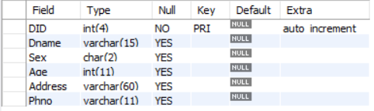

**BLOOD**

**BLOOD.PNG**

**BBANK**

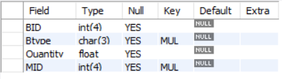

**MANAGER**

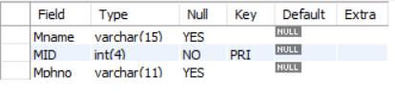

**RECEPTIONIST**

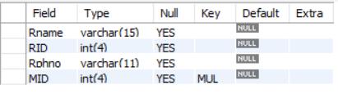

**HOSPITAL**

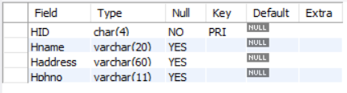

**ORDERS**

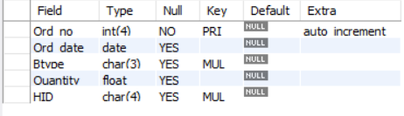

# CHAPTER 5

**SCREEN SHOTS**

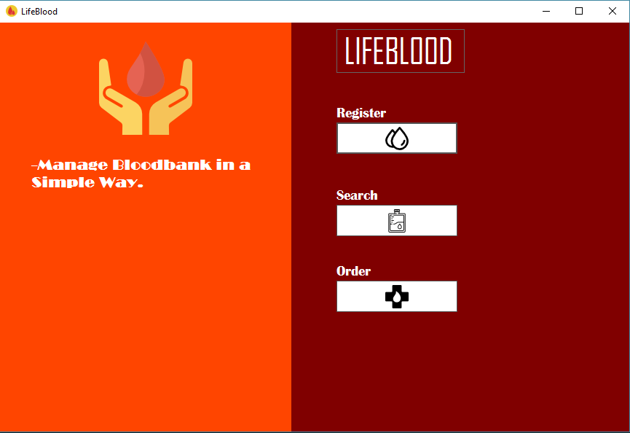

Figure 5.1: Starting page of Blood bank management system

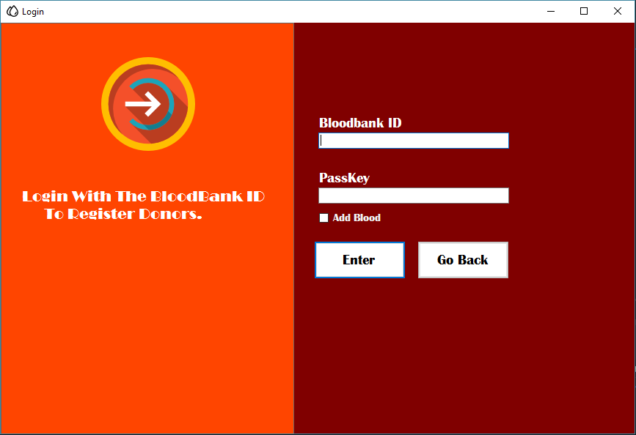

Figure 5.2: Donors Login using Blood bank ID

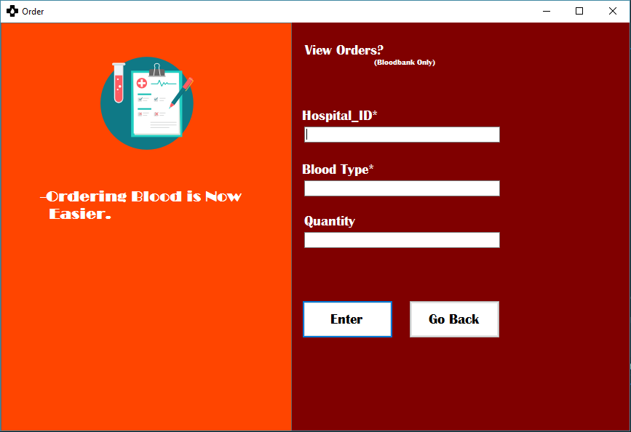

Figure 5.3: Hospitals Orders Blood.

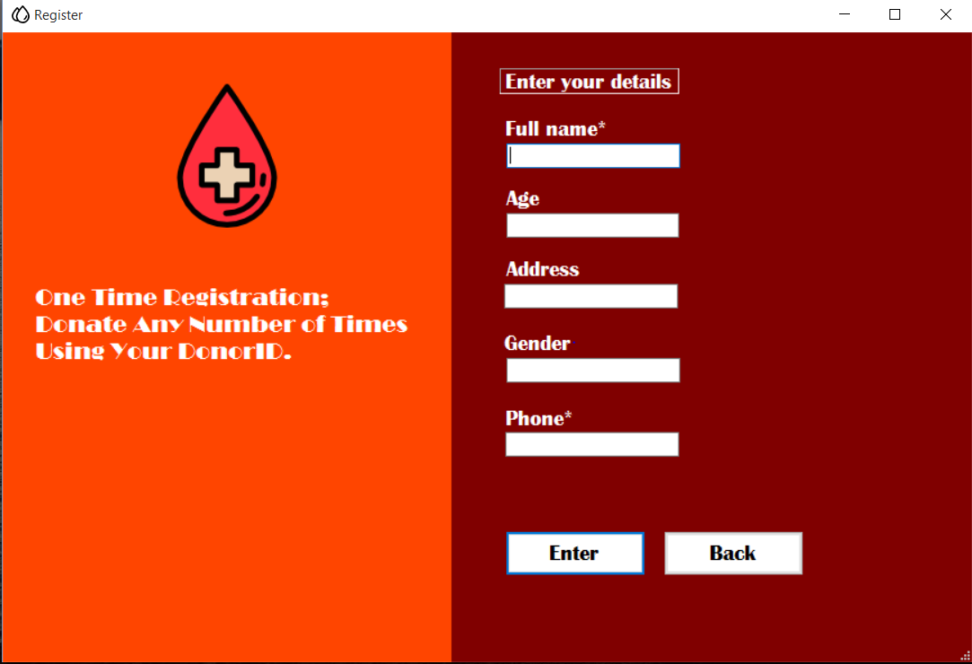

Figure 5.4: New user registration.

**CHAPTER 6**

**CONCLUSION AND SCOPE FOR FUTURE WORK**

**Conclusion:-**

* The software created with the purpose of replacing all of paper work done at the blood bank.
* All aspects of blood banking-Donor record management, blood search, blood availability, Blood ordering.

**Future Work:-**

* Our future work would be to integrate this blood bank management system with other health care provider center, hospital and blood bank.
* We will add new features as and when required.
* Improve the effectiveness.

**BIBILIOGRAPHY**

[1] Christian Nagel, “C# 6 and .NET Core 1.0”, 1st Edition, Wiley India Pvt Ltd, 2016. Andrew Stellman and Jennifer Greene, “Head First C#”, 3rd Edition, O’Reilly Publications, 2013.

[2] Database systems Models, Languages, Design and Application Programming, Ramez Elmasri and Shamkant B. Navathe, 6th Edition, Pearson.

[3] [www.stack](http://www.stack)overflow.com