Name: Jeevan K
Course: Data Science and AIML

Customer Analytics EDA
Introduction:
This project presents an Exploratory Data Analysis (EDA) of a Customer Analytics dataset to study customer characteristics and behavior using visualization and statistical methods. The objective is to examine the dataset, perform data cleaning, and discover useful patterns and relationships among different features. Each record in the dataset corresponds to an individual customer and includes details such as demographics, income level, and spending habits. Using Python libraries like Pandas, Matplotlib, and Seaborn, the analysis helps visualize data distributions, identify trends, and generate insights that can assist in making informed business decisions.

Graphs and Analysis:
- Age Distribution (Histogram)
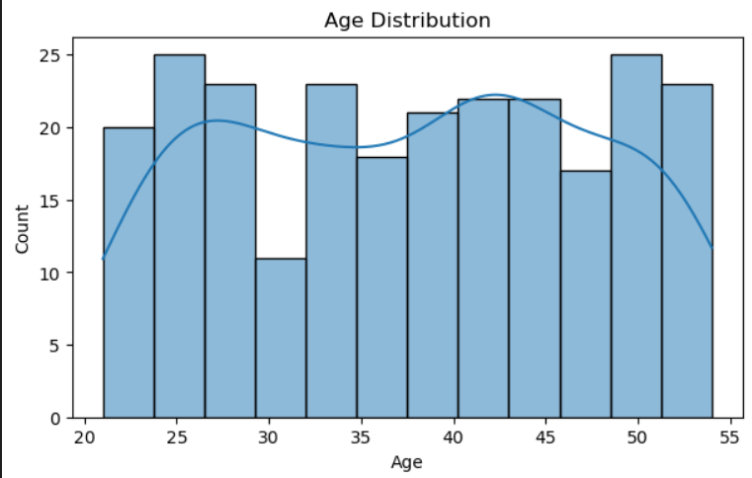
The histogram illustrates the distribution of customer ages across different age groups. It shows that most customers belong to the young to middle-age category, suggesting that the dataset primarily consists of adult customers with a diverse age range.

- Gender Distribution (Bar Chart)
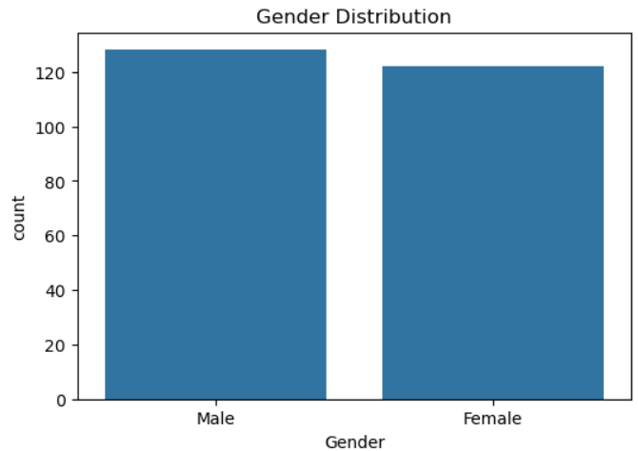
The bar chart displays the distribution of customers by gender. It indicates that both genders are represented in similar numbers, suggesting that the dataset does not have a significant gender imbalance.

- Spending Score Distribution (Histogram)
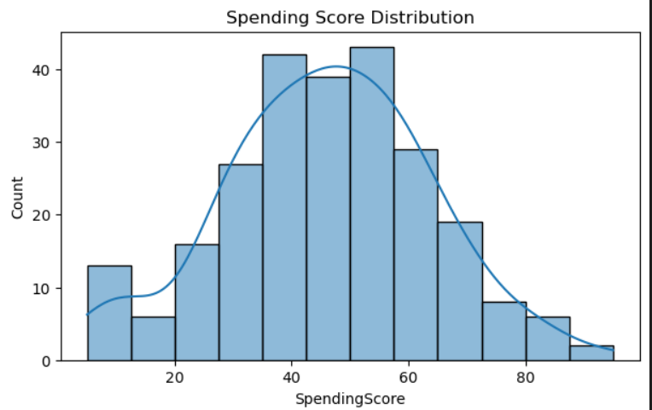

This histogram displays how spending scores are distributed among customers. The spread of values indicates that customers have different spending behaviors, ranging from low to high spenders.

- Annual Income vs Spending Score (Scatter Plot)
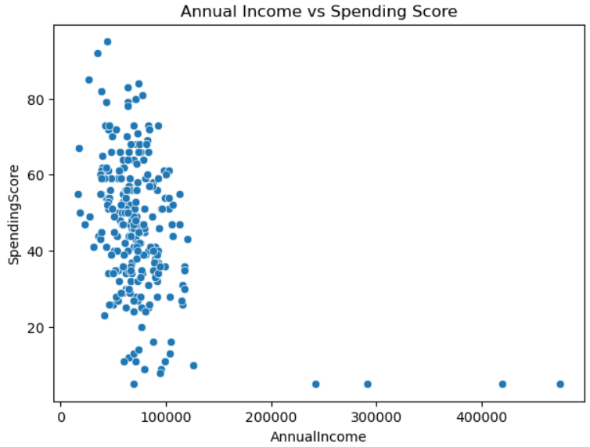
The scatter plot shows the relationship between annual income and spending score. The points are scattered without a strong pattern, suggesting that higher income does not always mean higher spending.
- Spending Score by Preferred Device (Boxplot)
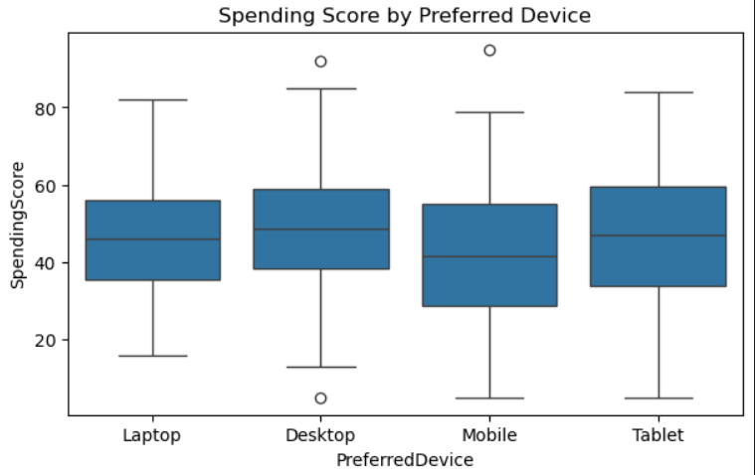
The boxplot compares spending scores across different preferred devices. It helps identify variations in customer spending behavior depending on the device they use, showing differences in median values and spread.

- Correlation Heatmap
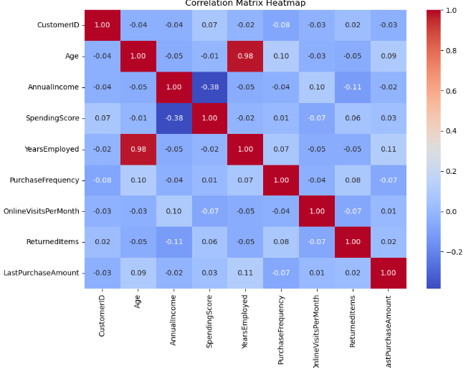
The correlation heatmap shows relationships between numerical variables in the dataset. Stronger colors indicate stronger relationships, helping identify which features are positively or negatively related to each other.

Code Snippet:
- Dataset Loading

import pandas as pd
import matplotlib.pyplot as plt
import seaborn as sns

# Load dataset
df = pd.read_csv("customer_analytics.csv")

# View data
df.head()
- Data Cleaning (Missing Values & Duplicates)
# Check missing values
df.isnull().sum()

# Fill missing values
df['Education'] = df['Education'].fillna(df['Education'].mode()[0])
df['AnnualIncome'] = df['AnnualIncome'].fillna(df['AnnualIncome'].median())

# Remove duplicate rows
df = df.drop_duplicates()

- Plot Generation Code
# Age Distribution
sns.histplot(df['Age'], kde=True)
plt.title("Age Distribution")
plt.show()

# Gender Distribution
sns.countplot(x='Gender', data=df)
plt.title("Gender Distribution")
plt.show()

# Spending Score Distribution
sns.histplot(df['SpendingScore'], kde=True)
plt.title("Spending Score Distribution")
plt.show()

# Income vs Spending Score
sns.scatterplot(x='AnnualIncome', y='SpendingScore', data=df)
plt.title("Annual Income vs Spending Score")
plt.show()

# Spending Score by Preferred Device
sns.boxplot(x='PreferredDevice', y='SpendingScore', data=df)
plt.title("Spending Score by Preferred Device")
plt.show()

# Correlation Heatmap
corr = df.select_dtypes(include='number').corr()
sns.heatmap(corr, annot=True, cmap='coolwarm')
plt.title("Correlation Heatmap")
plt.show()

Conclusion:
This Exploratory Data Analysis (EDA) project provided a better understanding of customer data through statistical analysis and visualization techniques. By examining various graphs, we identified patterns related to customer demographics, spending behavior, and relationships between different variables. The results indicate that spending habits differ among customers and are influenced by multiple factors rather than income alone. Overall, the project strengthened knowledge of data cleaning, visualization, and extracting meaningful insights, which are key steps in effective data analysis.

