Project Title: AI-Powered Data Validation and Verification System

Project Overview

Developer: RAKSHITH M

Description: The AI-Powered Data Validation and Verification System is a pioneering solution designed to efficiently process and validate large datasets using state-of-the-art AI models. This project leverages the capabilities of GPT-35-Turbo and Claude-3-Haiku models from LLM Foundry to intelligently analyze and verify the integrity of structured data inputs.

Goals and Objectives

1. Automate Data Validation: Automate the process of validating and verifying large datasets with minimal human intervention.
2. Enhance Efficiency: Use parallel processing and advanced AI models to significantly reduce the time required for processing data.
3. Ensure Accuracy: Validate information with high precision to maintain integrity and consistency across datasets.

Technologies Utilized

Python: Utilized for its powerful libraries and community support in data processing and modelling.

Pandas: Employed for data manipulation and seamless Excel file handling.

Requests: Used to facilitate HTTP interactions with AI model APIs.

TQDM: Implemented to provide a real-time progress bar for tracking data processing progress.

Concurrent Futures: Enables parallel processing to optimize task execution efficiency.

Key Features:

Integration with AI Models:

* GPT-35-Turbo: Used for generating contextually accurate responses, aiding in data verification.
* Claude-3-Haiku: Provides structured feedback in a conversational format, enhancing the clarity and correctness of results.

AI Models Screenshot:

Parallel Data Processing:

Utilizes `ThreadPoolExecutor` to process datasets concurrently, boosting performance and reducing latency.

Comprehensive Data Validation:

Validates output from AI models by cross-referencing with expected criteria, ensuring high accuracy and reducing discrepancies.

Implementation Details:

1. Data Loading and Preparation:

* Excel data and prompts are loaded and prepared for processing using Pandas.
* Incorporates placeholder validation checks to handle missing result columns.

2. AI Model Communication:

* Interaction with AI models via HTTP requests, with error handling and response evaluation for reliability.
* AI responses are parsed and integrated into the validation workflow.

3. Progress Tracking and Result Handling:

* A progress bar provides real-time updates during the processing loop.
* Post-processing, results are compiled, analyzed for accuracy, and saved to Excel for review.

Challenges and Solutions:

* Challenge: Handling large datasets with diverse input structures.
* Solution: Implemented parallel processing to efficiently manage data handling and reduce processing time.

* Challenge: Ensuring accurate and reliable model outputs.
* Solution: Integrated robust validation checks and cross-verification of outputs to achieve high accuracy.

Project Print Statements:

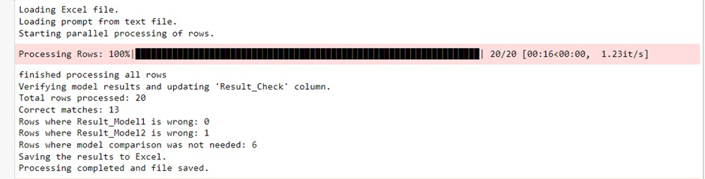

Project Impact

This project showcases the transformative impact of AI in automating complex data validation tasks. By integrating these advanced AI models, the system significantly enhances the reliability and efficiency of data processing workflows, making it a valuable tool in environments requiring large-scale data validation.

Future Work

Extend AI Model Range: Explore additional AI models to enhance the versatility of the validation system.

Integrate Machine Learning: Incorporate machine learning techniques to improve the adaptability and predictive accuracy of the system.

User Interface Development: Develop a user-friendly interface for easier interaction and visualization of results.

Conclusion

The AI-Powered Data Validation and Verification System is a demonstration of how modern AI technologies can be effectively applied to solve traditional data processing challenges. Its efficient design and implementation underscore the potential for AI-driven automation to revolutionize industries reliant on accurate data handling and verification.

Final Output:

