GROUP 9 IMDB Final Project

ERD:
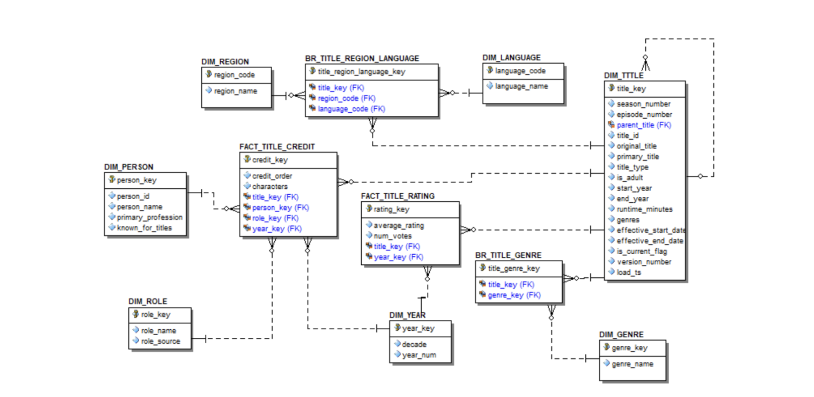

Title_crew file:
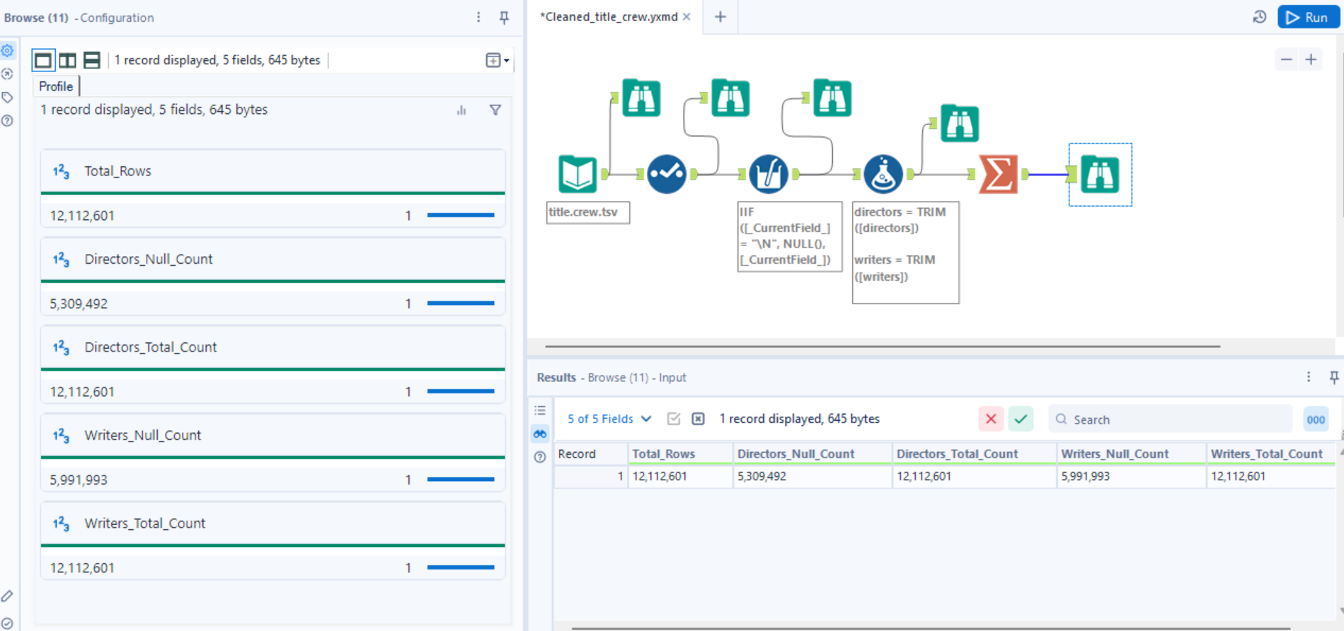
Profiling Summary for title.crew:
Field Name | % Missing | Unique Values | Shortest Value | Longest / Example Values
title_id | 0.0% | 12,112,601 | tt0000001 | tt10001000
directors | 43.8% | 986,667 | nm0005690 | nm0390776, nm2427430, nm0334353, nm024…
writers | 49.5% | 1,466,818 | nm0721526 | nm0293166, nm0552399, nm0087433, nm002…

Title_Episode title:
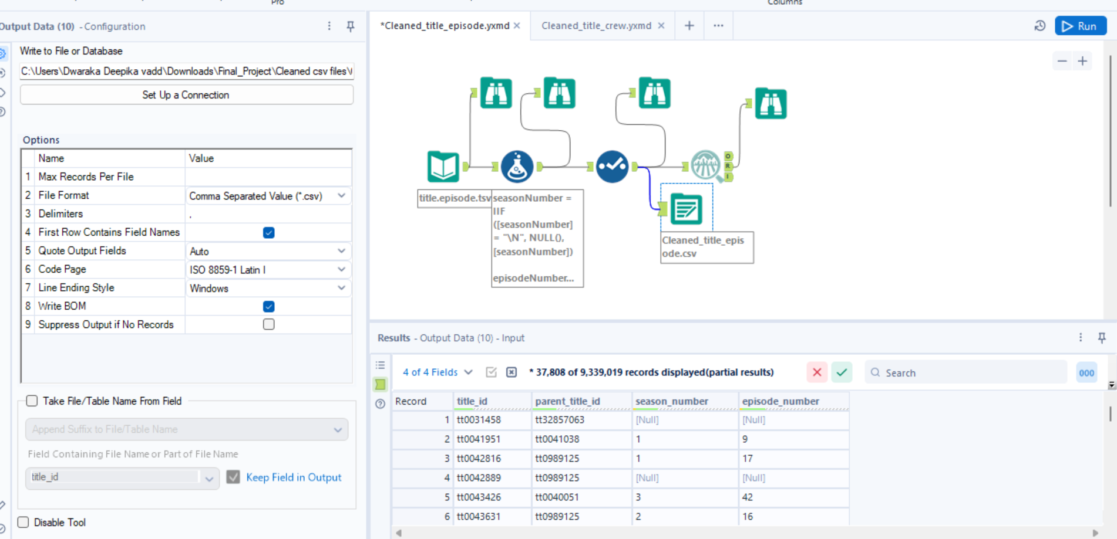
Profile summary:
Field Name | % Missing | Unique Values | Min | Mean | Median | Max | Std Dev | Remarks
season_number | 20.4% | 329 | 1 | 3.835 | 1 | 2,024 | 23.307 | This field has over 10% missing values. Consider imputing or treating these values.
episode_number | 20.4% | 15,874 | 0 | 443.977 | 28 | 91,334 | 1,409.034 | This field has over 10% missing values. Consider imputing or treating these values.

Field Name | % Missing | Unique Values | Shortest Value | Longest Value | Min Value Count | Max Value Count | Remarks
parent_title_id | 0.0% | 229,176 | tt0041038 | tt32857063 | 1 | 18,593 | Some values of this field have a small number of value counts. If appropriate, consider grouping similar values.
title_id | 0.0% | 9,339,019 | tt0031458 | tt10001006 | 1 | — | Some values of this field have a small number of value counts. If appropriate, consider grouping similar values.

Title_ratings
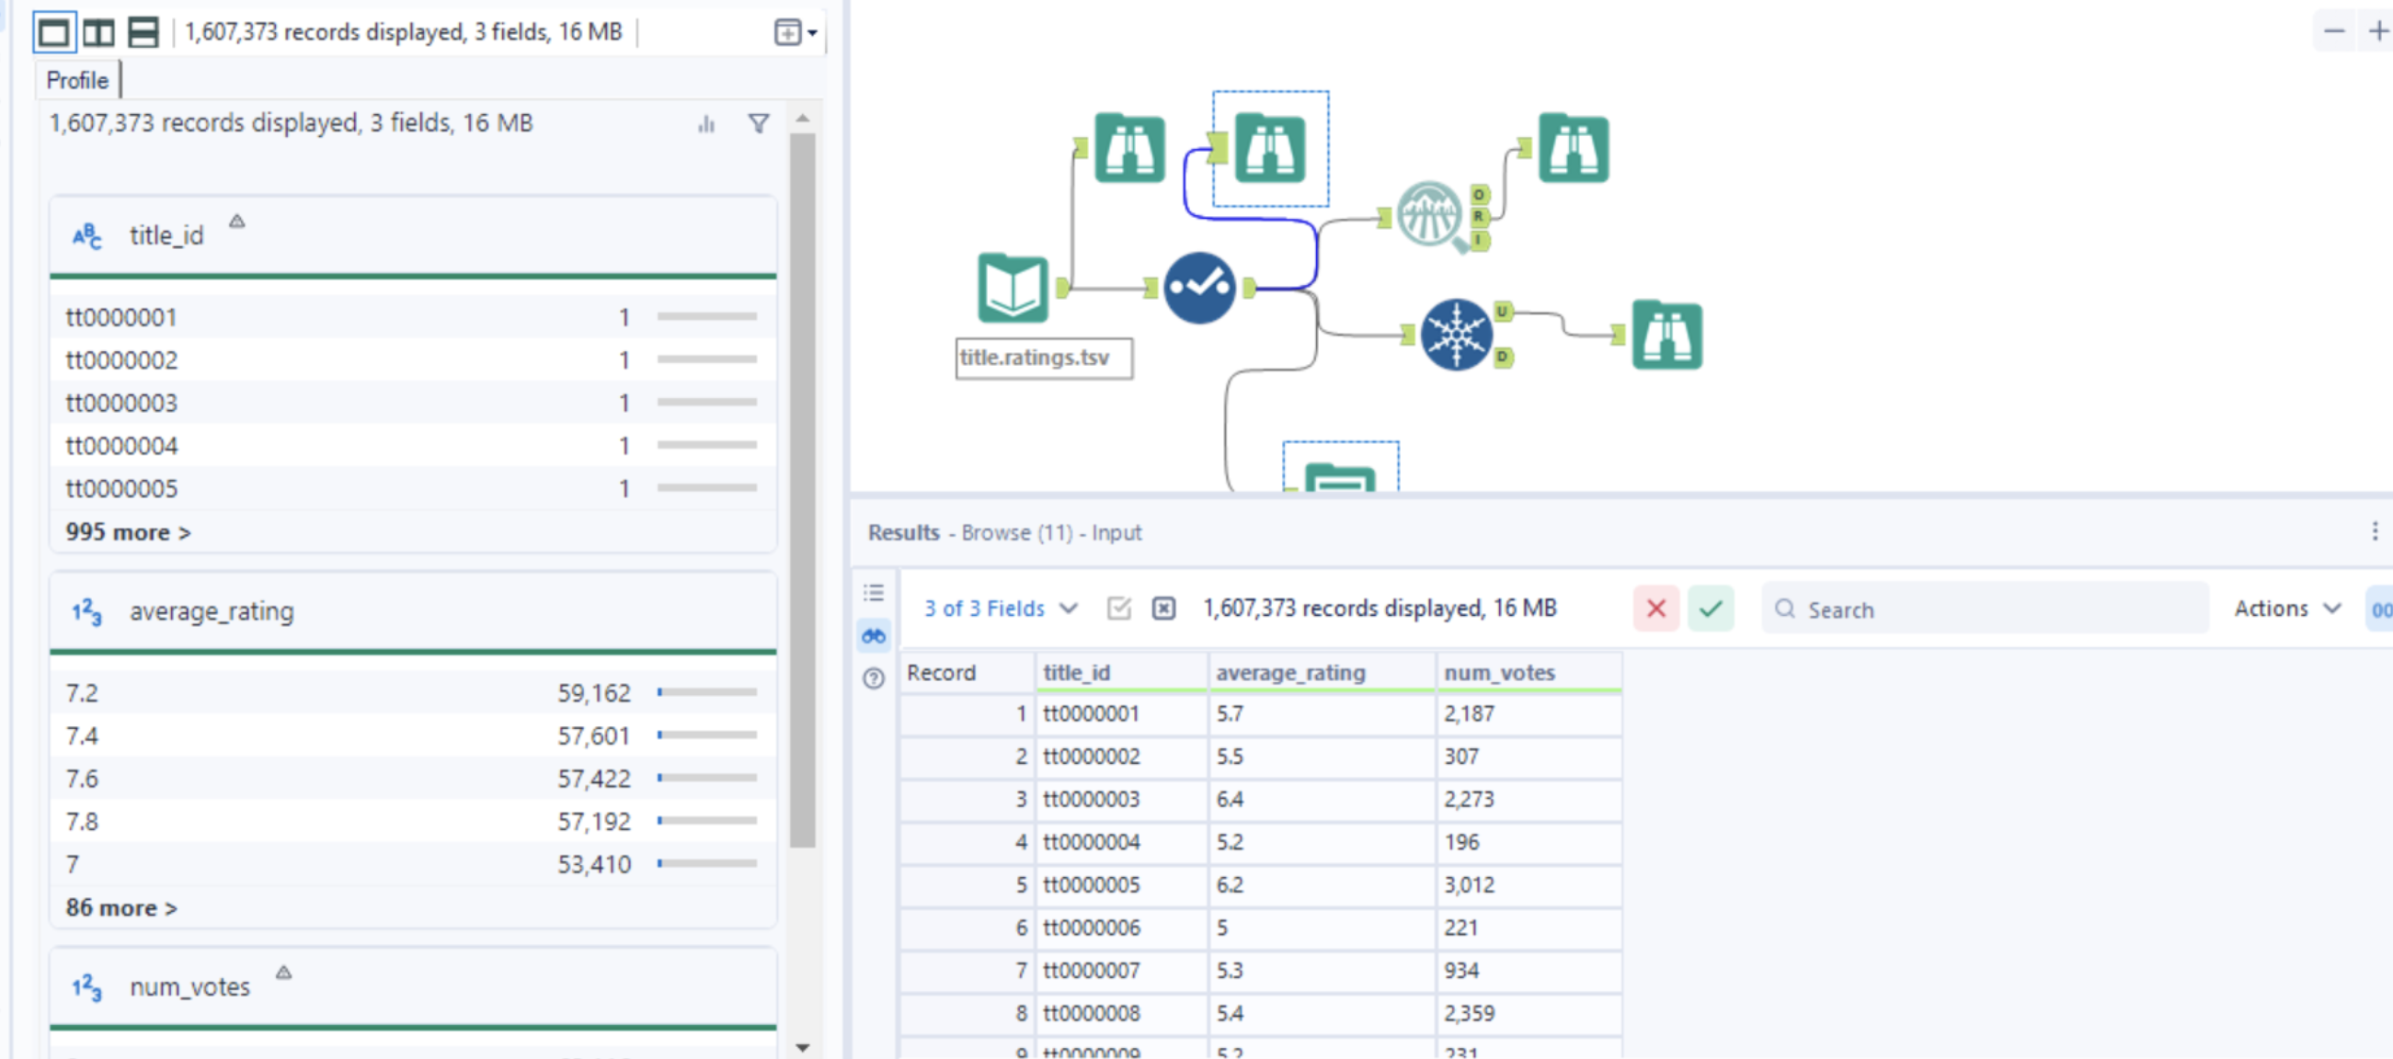
Using the filter tool we found that All average_rating values are within [1,10].
Field Name | Data Type | Min | Max | Median | Std. Dev. | % Missing | Unique Values | Remarks
average_rating | Numeric | 1 | 10 | 7.2 | 1.407336 | 0% | 91 | Values range 1–10 (valid).
num_votes | Numeric | 5 | 3,128,355 | 27 | 18,108.693039 | 0% | 23,919 | No missing values, high variance.
title_id | String | — | — | — | — | 0% | 1,607,373 | Unique key, no quality issues.

Field Name | Shortest Value | Longest Value | Min Count | Max Count
title_id | tt0000001 | tt10001002 | 1 | 1
average_rating | Null | Null | Null | Null
num_votes | Null | Null | Null | Null

Name_basics:
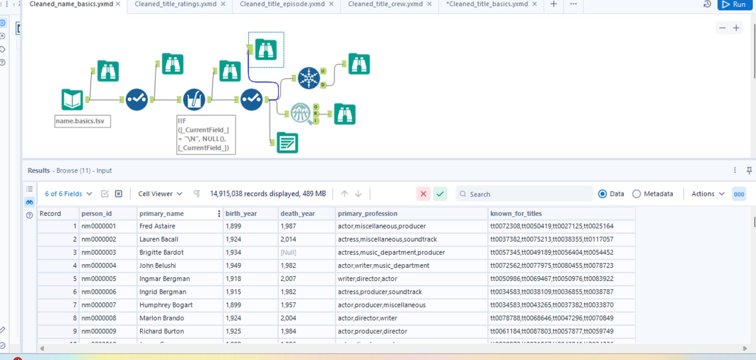
29 records shows “Invalid age anomalies where death_year < birth_year.”

Field summary:
Numeric:
Field Name | Min | Max | Median | Mean | Std Dev | % Missing | Unique Values | Remarks
birth_year | 4 | 2025 | 1961 | 1954.326 | 35.5729 | 95.57% | 558 | Over 10% missing values. Consider imputing or leaving missing.
death_year | 17 | 2025 | 2003 | 1994.697 | 36.527 | 98.31% | 503 | Over 10% missing values. Consider imputing or leaving missing.

String:
Field Name | Unique Values | Shortest Value | Longest Value | Remarks
person_id | 14,915,038 | nm0000001 | nm10001000 | Field has long text values and no missing values.
primary_name | 11,389,055 | Q | The Annointed Voices of Higher Ground Young Adult Choir | Some values have long text lengths.
primary_profession | 25,914 | actor | editorial_department,production_department,... | Over 10% missing values; multi-valued field.
known_for_titles | 6,161,052 | tt0107688 | tt32367551,tt27784227,tt30215084,tt26420234 | Some values have a small number of characters; comma-separated list.

Title_basics
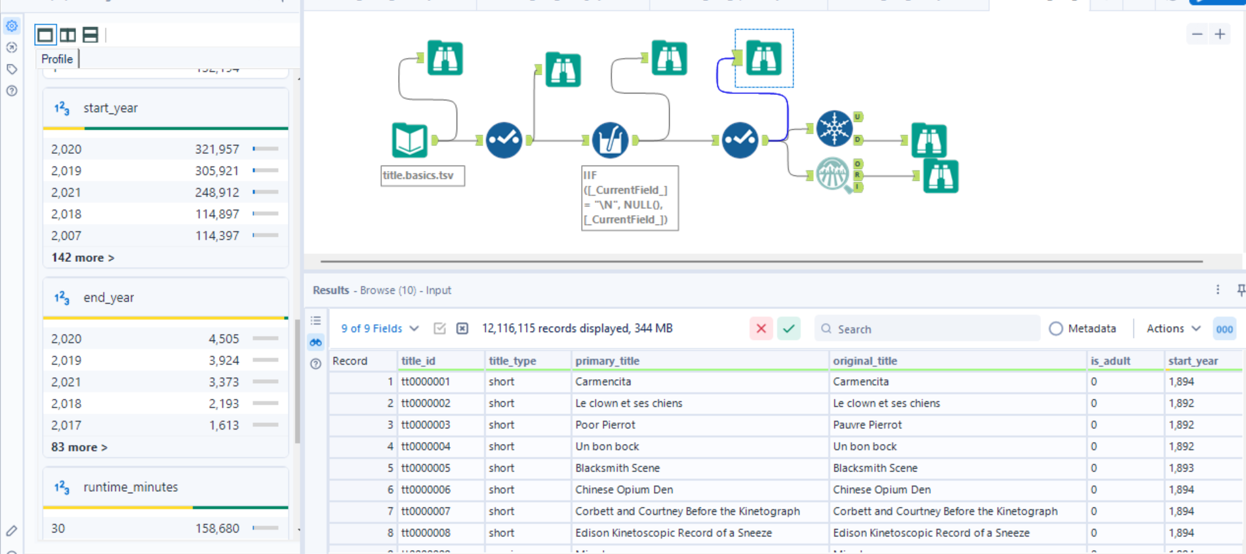

Findings from field summary tool:
Field Name | Category | Min | Max | Median | Std Dev | % Missing | Unique Values | Shortest Value | Longest Value | Remarks
is_adult | Numeric | 0 | 1 | 0 (Null: 55.56%) | 0.1775 | 0% | 2 | Null | Null | Small number of unique values → OK
end_year | Numeric | 1928 | 2032 | 2014 | 16.4269 | 98.76% | 99 | Null | Null | Over 10% missing → review but expected for ongoing titles
start_year | Numeric | 1874 | 2115 | 2014 | 20.166 | 11.93% | 154 | Null | Null | Over 10% missing values
runtime_minutes | Numeric | 0 | 3,692,080 | 30 | 1780.4180 | 4.36% | 2,380 | Null | Null | Some extremely large runtimes exist (possible anomalies)
genres | String | Null | Null | Null | Null | 0% | 5,434,915 | War | Documentary, Game-Show, Reality-TV | Some values contain multiple genres (comma separated)
primary_title | String | Null | Null | Null | Null | 0% | 12,116,115 | "M" | Blodiga harpor och lyriska… | Expected: long text field
title_id | String | Null | Null | Null | Null | 0% | 11 | tt0000001 | tt10001000 | OK
title_type | String | Null | Null | Null | Null | 0% | 11 | short | tvMiniSeries | OK
original_title | String | Null | Null | Null | Null | 0% | 5,461,920 | "M" | Blodiga harpor och lyriska… | Expected multilingual values

Title_principals:
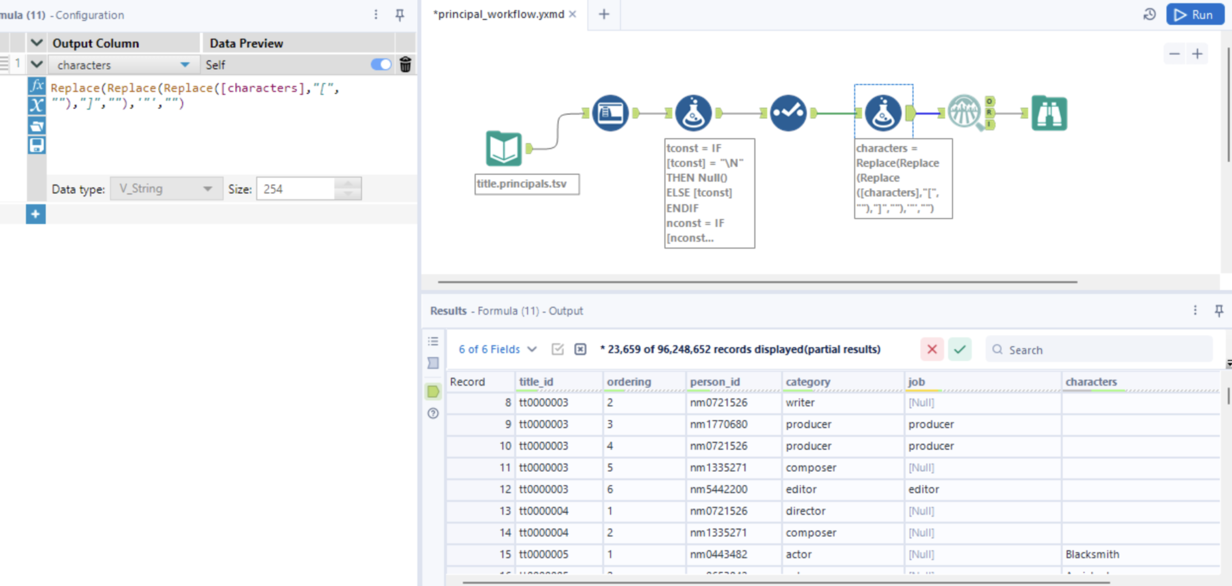

Profiling:
Field Name | Data Type | Min | Max | Median | Std. Dev. | % Missing | Unique Values | Shortest Value | Longest Value | Min Count | Max Count | Remarks
ordering | Numeric | 1 | 75 | 6 | 5.173591 | 0% | 75 | Null | Null | Null | Null | None
title_id | String | Null | Null | Null | Null | 0% | 10,947,472 | tt0000001 | tt10001000 | 1 | 75 | Some values have few unique counts
person_id | String | Null | Null | Null | Null | 0% | 6,896,755 | nm1588970 | nm10501864 | 1 | 39,320 | Some values have few unique counts
category | String | Null | Null | Null | Null | 0% | 13 | self | production_designer | 12,536 | 22,821,765 | Some values have few unique counts
job | String | Null | Null | Null | Null | 81.23% | 45,909 | e | sketches..., scripts..., etc. | 1 | 78,190,952 | Field has over 10% missing values
characters | String | Null | Null | Null | Null | 0% | 4,397,454 | Null / empty | Self - … (long descriptive text) | 1 | 49,314,192 | Some values have few unique counts

Title_akas:
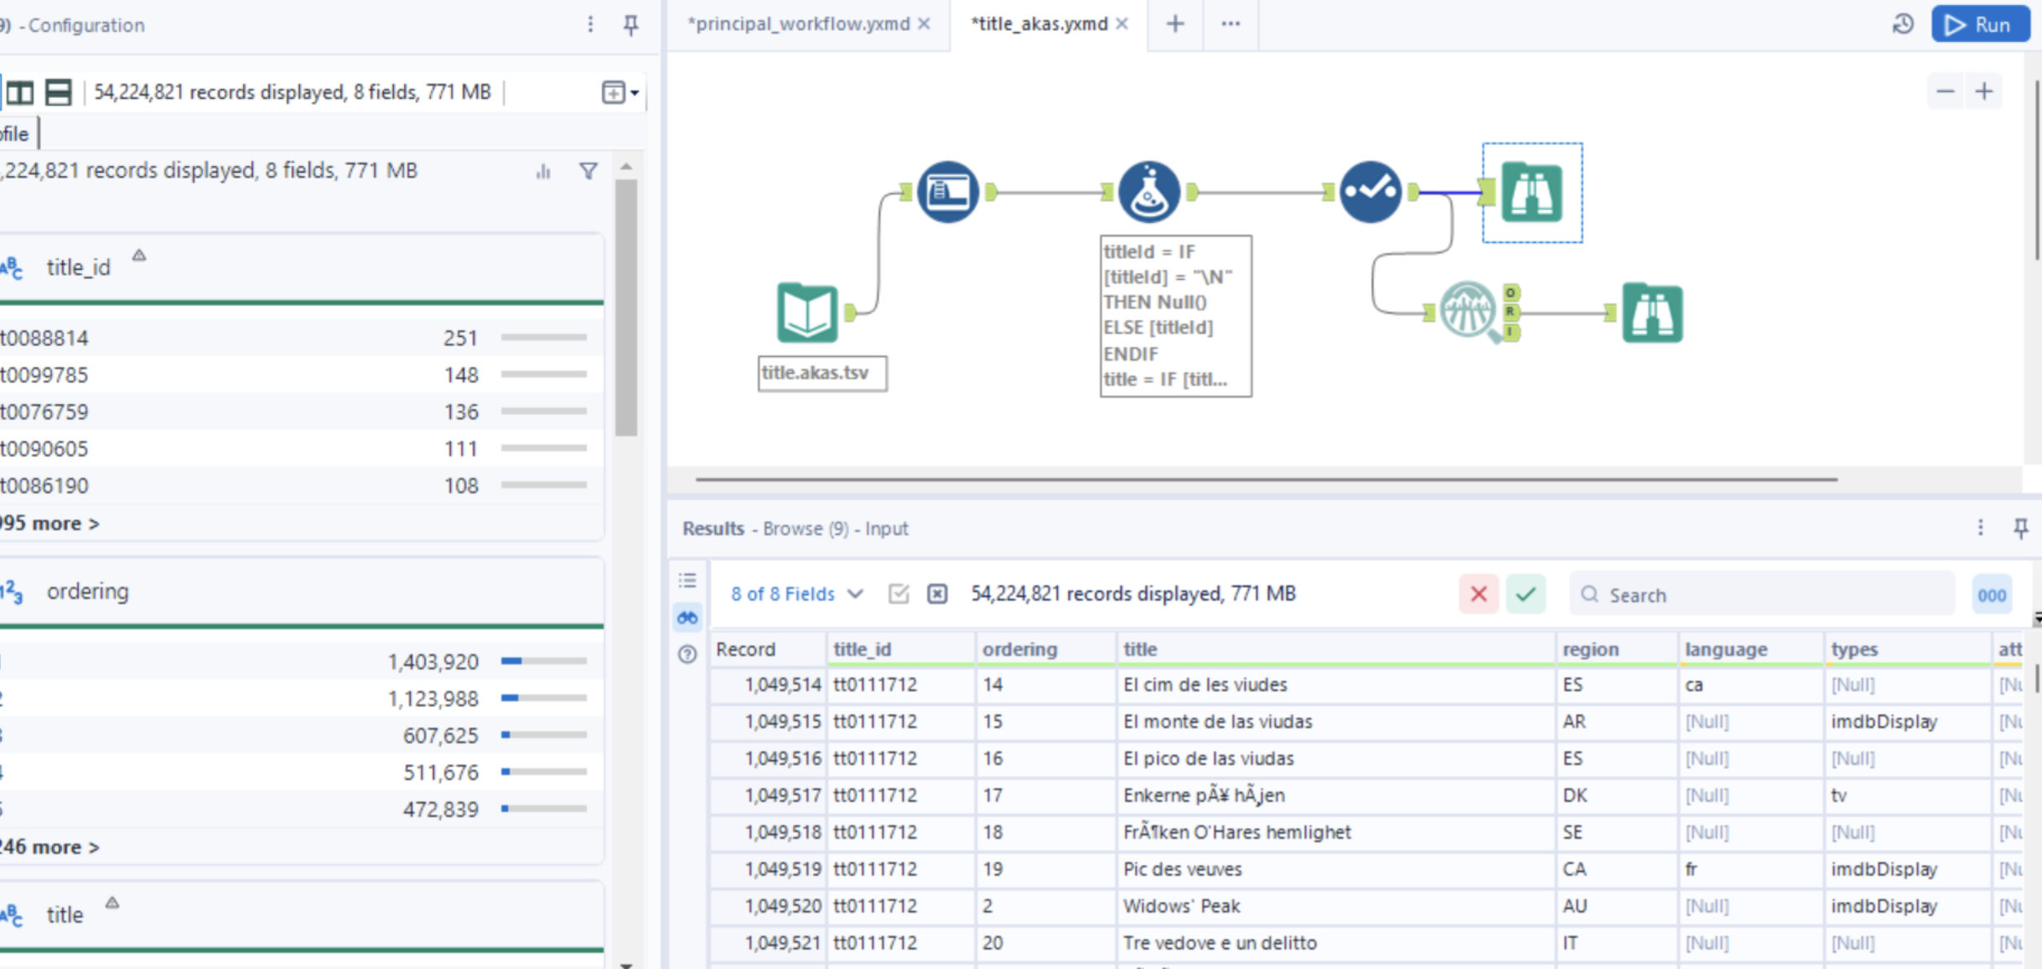
Profiling:
Field Name | Field Category | Min | Max | Median | Std. Dev. | % Missing | Unique Values | Remarks
is_original_title | Numeric | 0 | 1 | 0 | 0.0416451 | 0% | 2 | Small number of unique values (binary field).
ordering | Numeric | 1 | 251 | 4 | 4.107213 | 0% | 251 | No issues found.

Field Name | Field Category | % Missing | Unique Values | Remarks
language | String | 33.04% | 111 | Field has >10% missing values.
title_id | String | 0% | 12,107,864 | No issues found.
attributes | String | 99.43% | 185 | Extremely high missing values; rarely populated.
title | String | 0% | 7,704,846 | No issues.
types | String | 69.32% | 24 | High missing values; may require review.
region | String | 22.48% | 252 | Moderately high missing values.

Title.basics had issues where year<1890. Had values scattered and incorrect form of values
Title.principals had issues where the category and job had incorrect form of values
Title.akas had values where region and language size >2 and unwanted incorrect values
Found 1 code in region which is not present in iso
Found 6 codes in language which is not present in iso

