LABTASK – 1

Program – 1:

#include <stdio.h>

int main() {

int n,\*ptr,arr[20];

int sum=0;

printf("Enter the size of the array: ");

scanf("%d", &n);

printf("Enter the elements of the array:\n");

for (int i = 0; i < n; ++i) {

scanf("%d", &arr[i]) }

ptr = arr;

for (int i = 0; i < n; ++i) {

sum += \*(ptr + i) }

printf("Sum of elements in the array: %d\n", sum);

return 0;

}

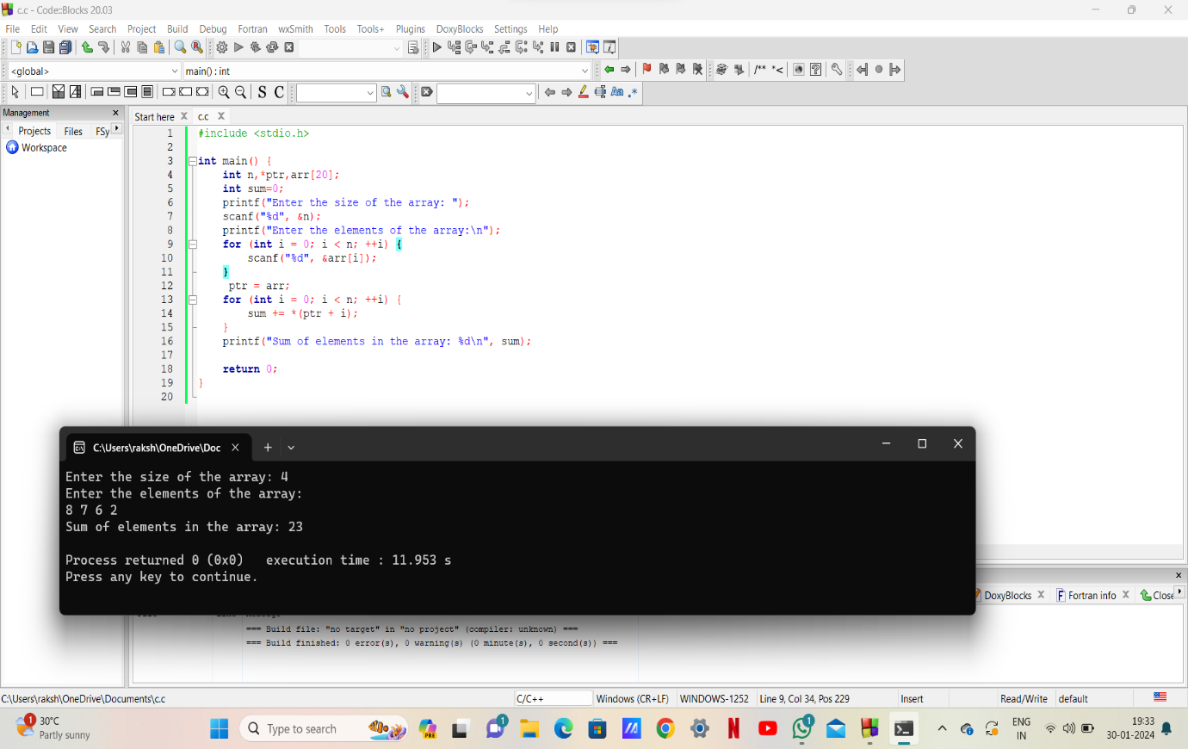

Program – 2 :

#include<stdio.h>

void swap(int ,int);

int main()

{

int a,b;

printf("enter values for a and b\n");

scanf("%d%d", &a,&b);

swap(&a,&b);

printf("a = %d and b = %d\n",a ,b);

return 0;

}

swap(int \*P,int \*Q){

int temp;

temp = \*P;

\*P = \*Q;

\*Q = temp;

}

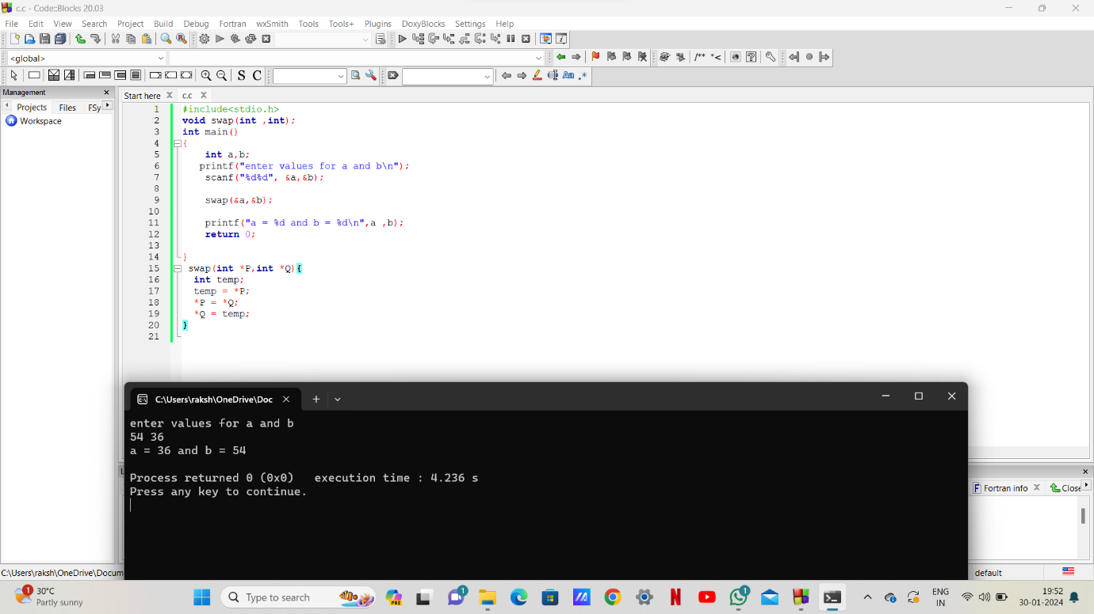

Program – 3 :

#include<stdio.h>

int main()

{

char str[100],temp;

char \*p1,\*p2;

printf("enter a string\n");

scanf("%s",str);

p1=str;

p2=str+strlen(str)-1;

while(p1<p2)

{

temp = \*p1;

\*p1 = \*p2;

\*p2 = temp;

p1++;

p2--;

}

printf("Reversed string:%s\n",str);

return 0;

}

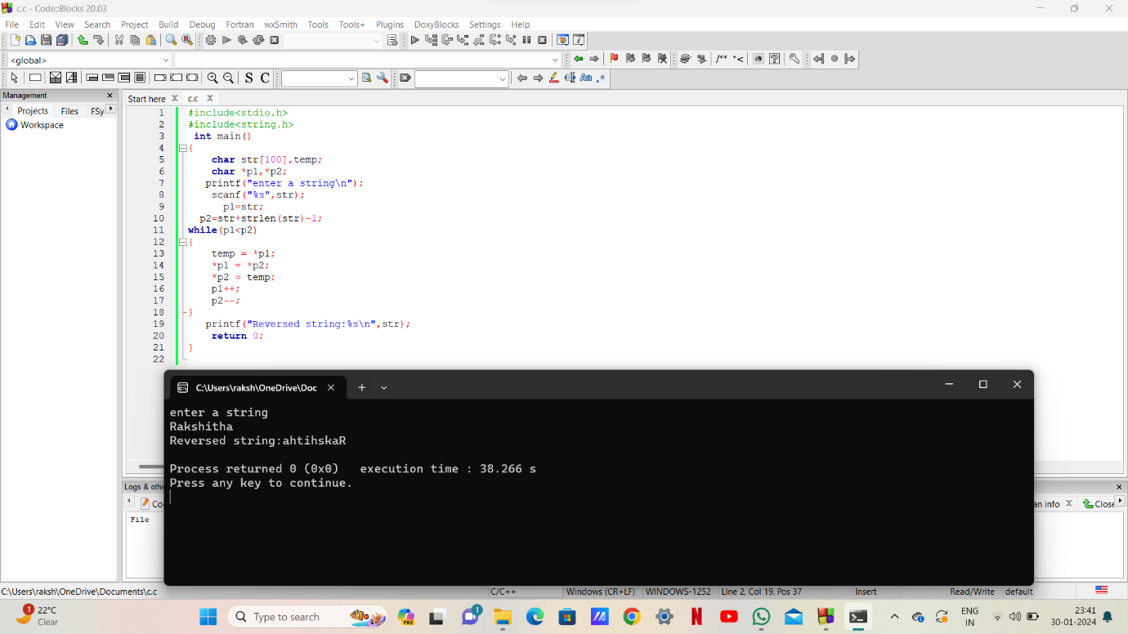

Program – 4 :

#include<stdio.h>

int main(){

int base, exponent;

int value = 1;

printf("Enter a base value:");

scanf("%d", &base);

printf("Enter an exponent value: ");

scanf("%d", &exponent);

while (exponent != 0){

value \*= base;

--exponent;

}

printf("result = %ld", value);

return 0;

}

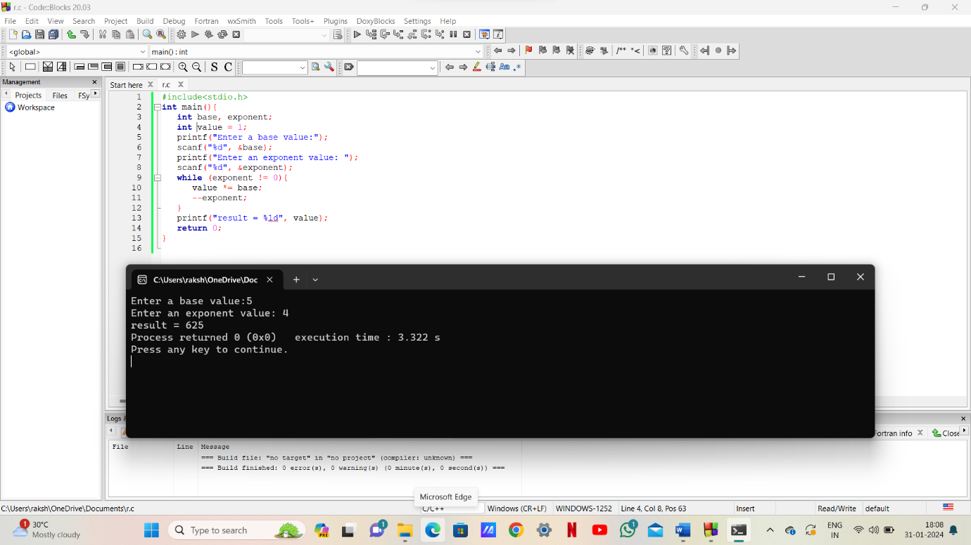

Program – 5 :

#include<stdio.h>

#include<stdlib.h>

int main (){

int n=3,m=3,i,j;

int \*arr=(int)malloc(n\*sizeof(int));

for (i=0;i<n;i++) {

arr[i]=(int\*)malloc(m\*sizeof(int));}

for(i=0;i<n;i++) {

for(j=0;j<m;j++) {

scanf("%d",&arr[i][j]);

}

}

for(i=0;i<n;i++){

for(j=0;j<m;j++){

printf("%d",arr[i][j]);

}

printf("\n");

}

for(i=0;i<n;i++)

{

free(arr[i]);

}

free(arr);

return 0;

}

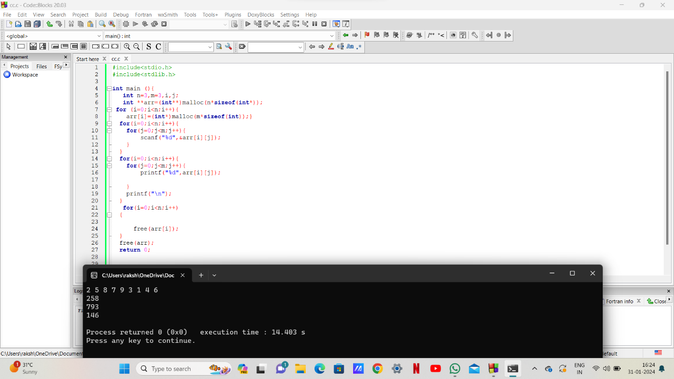

\*\*\*\*\*\*\*\*\*\*\*\*\*\*\*THE END\*\*\*\*\*\*\*\*\*\*\*\*\*\*\*\*