FINAL PROJECT REPORT
Software Installation Request Automation
1. INTRODUCTION

1.1 Project Overview
The Software Installation Request Automation project is a comprehensive ServiceNow application designed to digitize and manage the lifecycle of employee software requests. It replaces manual, disjointed email processes with a centralized Service Catalog item.

1.2 Purpose
The primary purpose is to streamline IT operations, ensure compliance with software licensing, accelerate manager approval times, and provide end-users with real-time tracking of their software requests.

2. IDEATION PHASE

2.1 Problem Statement
Employees face significant delays when attempting to acquire necessary licensed software due to a reliance on unstructured emails, lost manager approvals, and manual tracking by IT staff.

2.2 Empathy Map Canvas
The empathy map illustrates the frustration of end-users regarding the lack of transparency in the current IT procurement process.
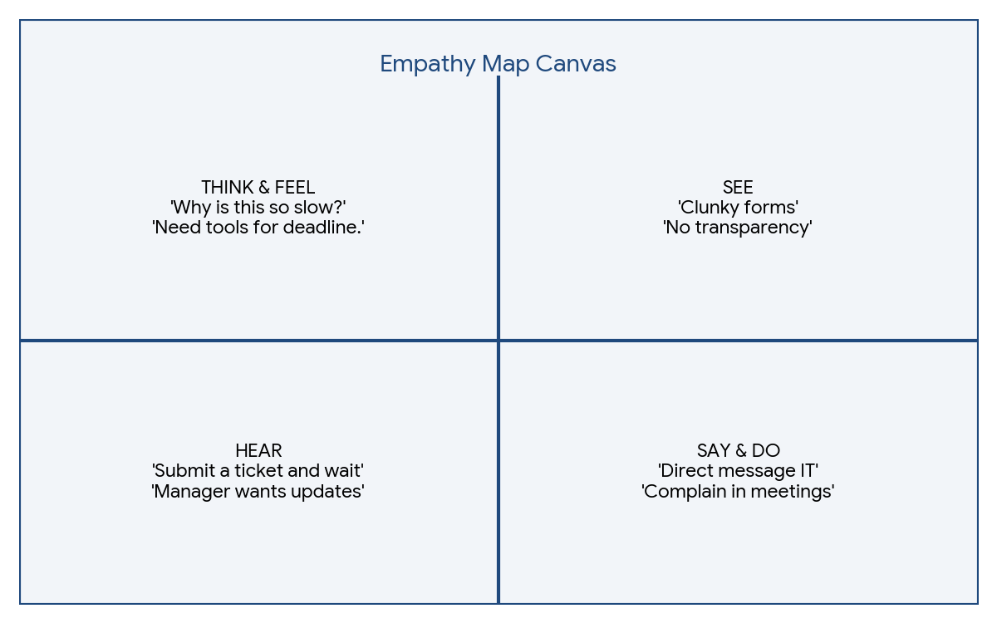
Figure: Empathy Map Canvas

2.3 Brainstorming
Ideas generated included utilizing the ServiceNow Service Portal for intake, leveraging Flow Designer for automated manager approvals, and utilizing Server-Side scripting to monitor and flag license shortages dynamically.

3. REQUIREMENT ANALYSIS

3.1 Customer Journey map
The user journey simplifies from hunting down email addresses to selecting variables on a structured portal and awaiting automated task fulfillment.
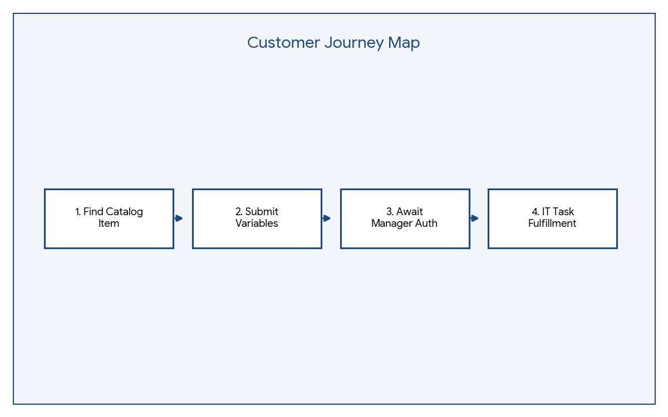
Figure: Customer Journey Map

3.2 Solution Requirement
The solution requires a Catalog Item with four variables (Software Name, Version, Justification, Urgency), an automated Flow to route requests to the 'Software Support' group, and a Business Rule for exception management.

3.3 Data Flow Diagram
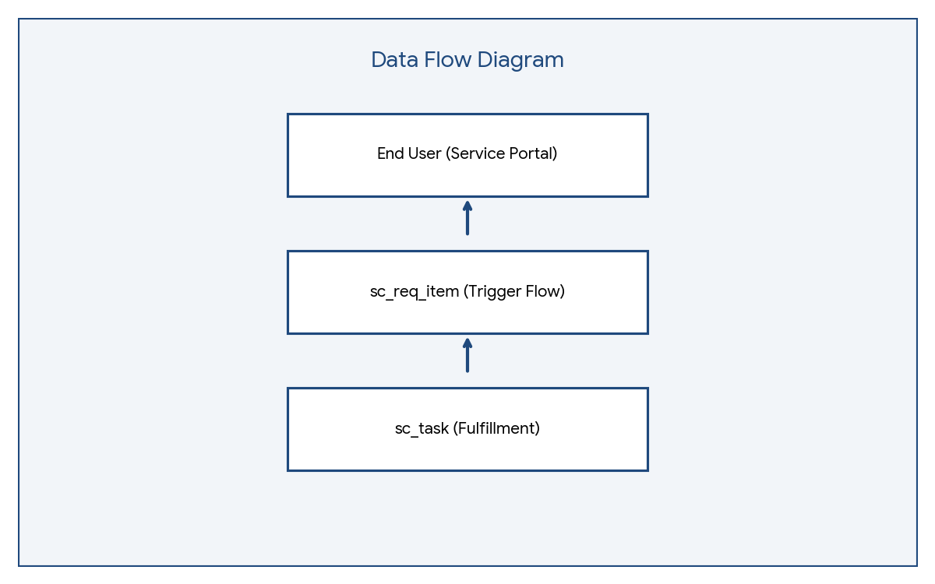
Figure: Data Flow Diagram

3.4 Technology Stack
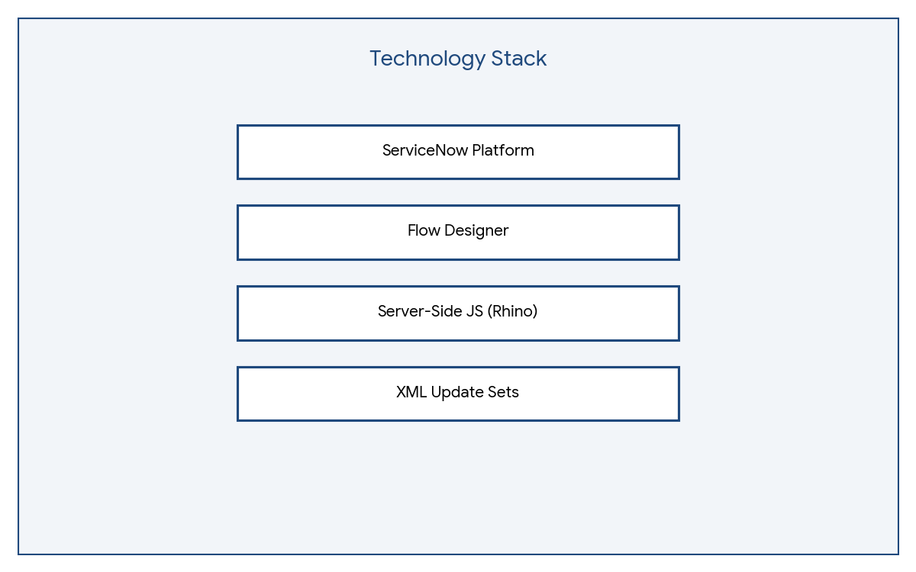
Figure: Technology Stack

4. PROJECT DESIGN

4.1 Problem Solution Fit
The automated Flow Designer fits the problem perfectly by removing the human bottleneck of routing emails and verifying manager authorizations manually.

4.2 Proposed Solution
A scoped ServiceNow application containing a Service Catalog Item. When submitted, a Flow asks the Software Support group for approval. If approved, a Catalog Task (SCTASK) is created. If rejected, the Request Item (RITM) is closed.

4.3 Solution Architecture
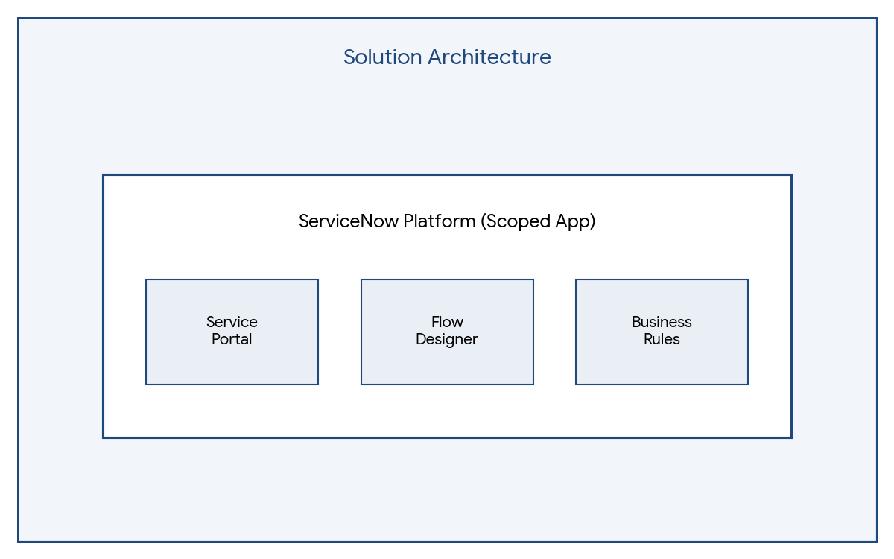
Figure: Solution Architecture

5. PROJECT PLANNING & SCHEDULING

5.1 Project Planning
The project was executed in an Agile framework consisting of Sprints focusing on UI, Flow Logic, and Scripting respectively.
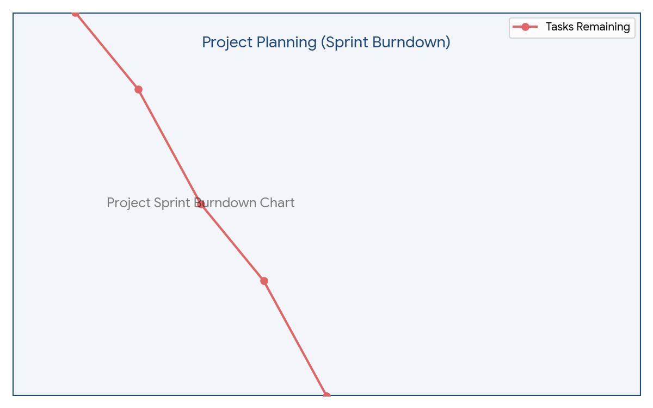
Figure: Project Sprint Burndown Chart

6. FUNCTIONAL AND PERFORMANCE TESTING

6.1 Performance Testing
The application was tested across three primary paths: 1) Happy Path (Successful approval and task creation), 2) Rejection Path (Clean closure of ticket), and 3) Exception Path (Manual state change to 'Pending' successfully generating a priority Incident). All database inserts executed within acceptable platform limits.

7. RESULTS

7.1 Output Screenshots

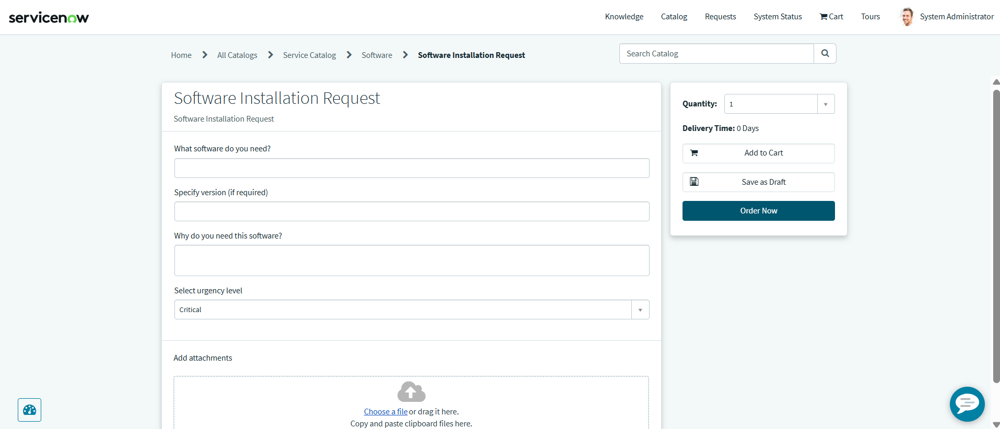
Service Portal Request Form
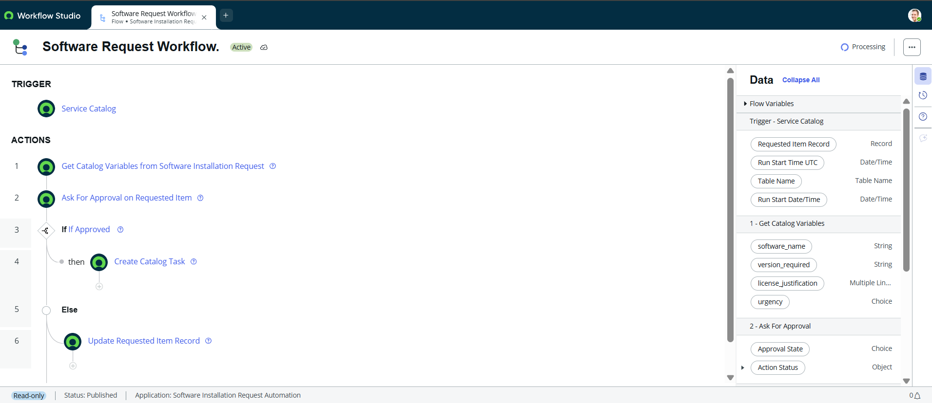
Flow Designer Logic
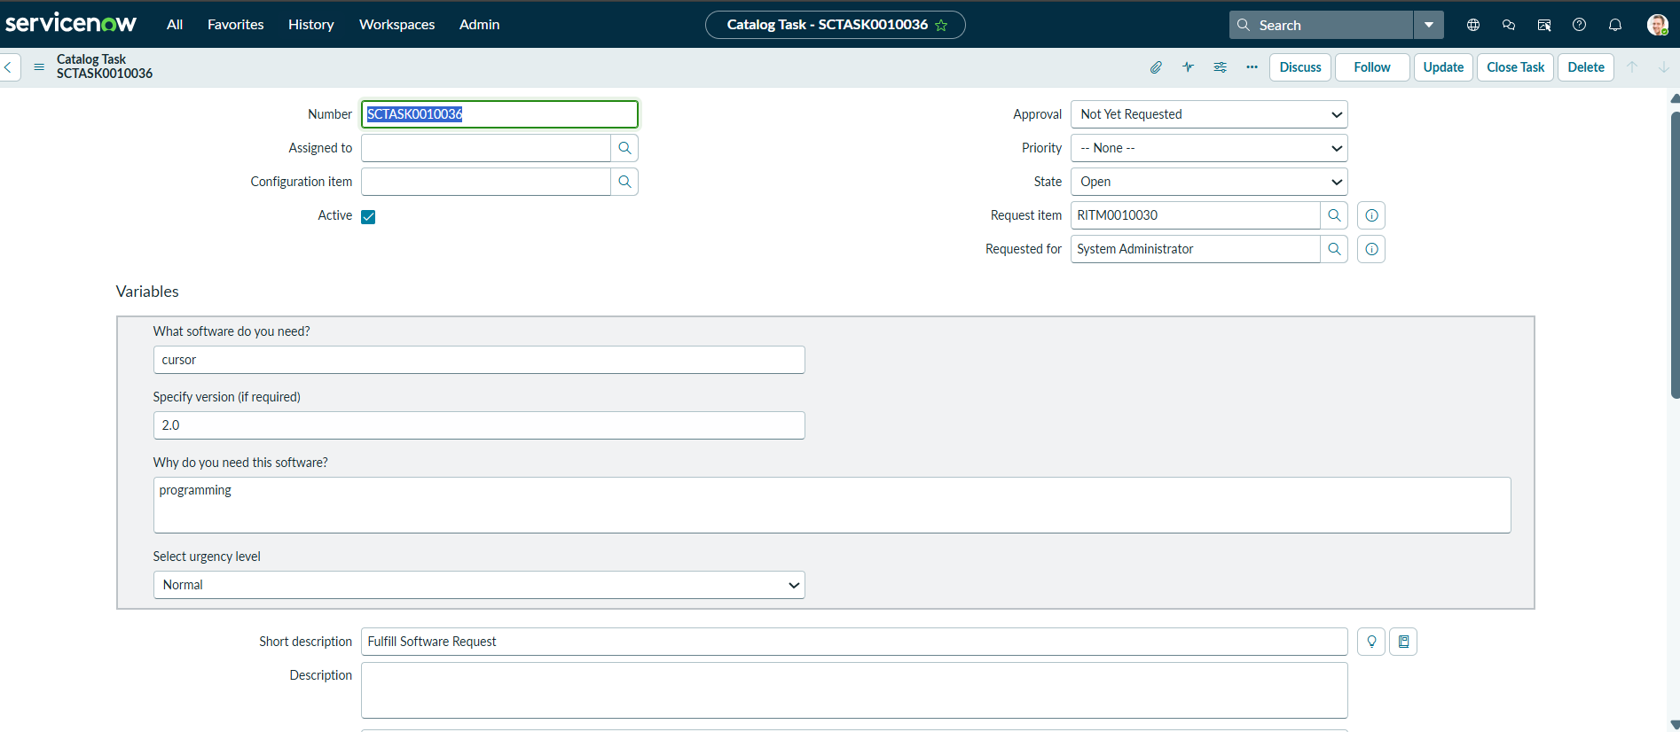
Generated Catalog Task (SCTASK)
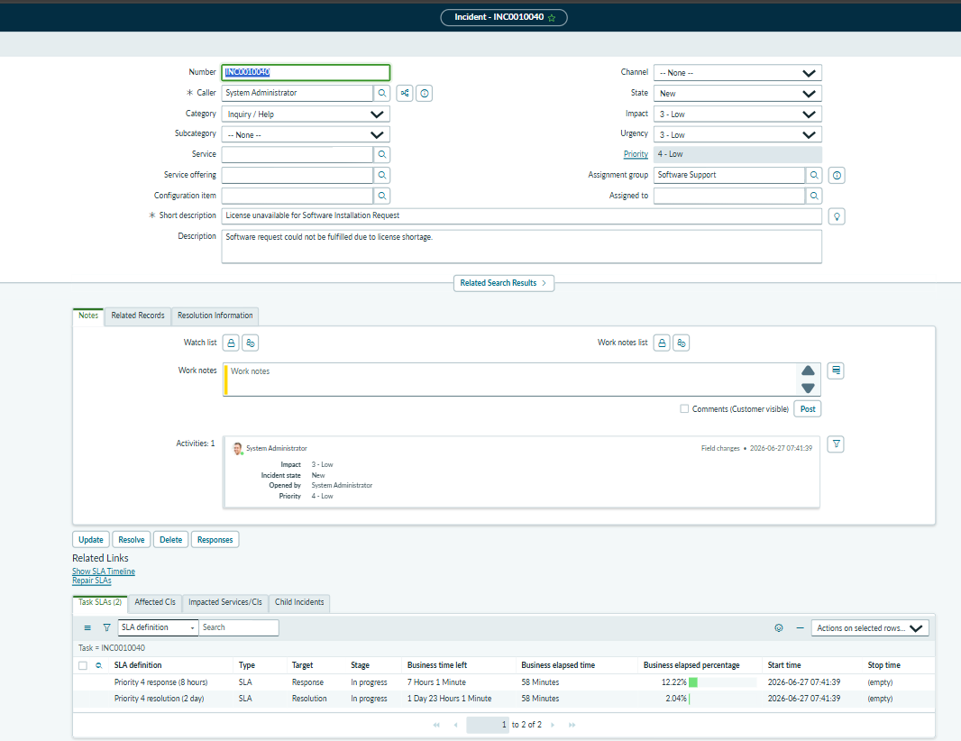
Generated License Incident

8. ADVANTAGES & DISADVANTAGES
Advantages: Vastly decreases fulfillment time, enforces standardized data intake, creates auditable approval records, and handles license exceptions proactively.
Disadvantages: Requires active ServiceNow licensing and assumes managers will interact promptly with platform notifications.

9. CONCLUSION
The project successfully delivers an enterprise-grade automated pipeline for software provisioning, resolving the core issues of manual tracking, lost approvals, and IT inefficiency.

10. FUTURE SCOPE
Future enhancements include integrating ServiceNow Software Asset Management (SAM) to perform automated, real-time license checks against the CMDB prior to generating fulfillment tasks.

11. APPENDIX

GITHUB LINK: https://github.com/dharnisha-07/Software_Installation_Request_Automation
PROJECT DEMO VIDEO LINK:
Source Code (Business Rule: Create Incident on License Issue):
(function executeRule(current, previous /*null when async*/) {
var inc = new GlideRecord('incident');
inc.initialize();
inc.short_description = 'License unavailable for ' + current.cat_item.getDisplayValue();
inc.description = 'Software request could not be fulfilled due to license shortage.';
inc.caller_id = current.request.requested_for;
inc.assignment_group.setDisplayValue('Software Support');
inc.priority = 3;
inc.insert();
})(current, previous);

