Student_info table:

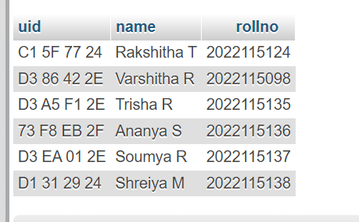

Student_card2 table:

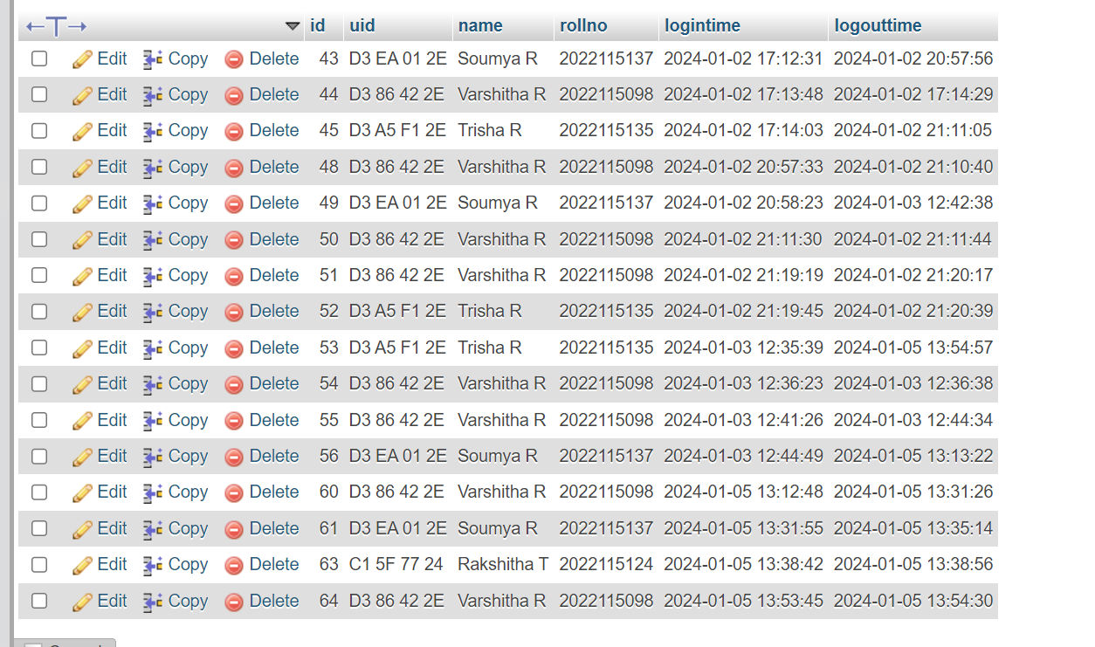

These two are the two tables in the SQL DATABASE MYPHPADMIN.