**FINAL PROJECT**

**HEALTH INSURANCE**

**DEPARTMENT OF INFORMATION OF SCIENCE**

**UNIVERSITY OF NORTH TEXAS**

**DSCI 5360: DATA VISUALIZATION**

**DR. VESS JOHNSON**

**SUBMITTED BY:**

**RAKSHITHA AMARAGONDA**

**INTRODUCTION**

How many accidents do you have to have before you realize you need health insurance? It necessitates. One trip to the hospital is all it takes to understand how fragile we are. A second has passed. For the affluent and the poor, male and female, young and oldBeing diagnosed with a sickness and the need to be treated, whether young or elderly, being in the hospital may be a trying experience. Heart disease, diabetes, stroke, and kidney disease. The list of lifestyle diseases seems to be growing larger and longer. These days, it's rather frequent. Thankfully, there are more specialized hospitals and clinics available. Specialist physicians are available, but they come at a price. Only the ultra-wealthy can afford such luxuries.

**OBJECTIVE**

Big data analysis is gaining traction in a variety of areas, including healthcare. Visualization is vital not only for displaying the outcomes of data analysis in an intelligible manner, but also for the entire process of gathering, cleaning, analyzing, and sharing data. This study describes a method for interactively visualizing and analyzing healthcare data. Tableau is a business intelligence solution that allows you to visualize data.

**DATA COLLECTION**

**Health Insurance Exchange Public Use Files (Exchange PUFs)**

The Centers for Medicare & Medicaid Services (CMS) Center for Consumer Information and Insurance Oversight (CCIIO) is committed to increasing transparency in the Health Insurance Exchange. While health plan information including benefits, copayments, premiums, and geographic coverage is publicly available on Healthcare.gov, CMS also publishes downloadable public use files (PUFs) so that researchers and other stakeholders can more easily access Exchange data.

The Health Insurance Exchange Public Use Files (Exchange PUFs) are available for plan years 2014 to 2022 to support timely benefit and rate analysis. It is important to note that the 2022 Exchange PUFs will be updated regularly to reflect the plan data that consumers will see when shopping for an Exchange Qualified Health Plan (QHP). Data for the 2022 Exchange PUFs were imported to CMS systems by November 15, 2021.

The Exchange PUFs include plan and issuer level information on certified Qualified Health Plans (QHPs) and stand-alone dental plans (SADPs) offered to individuals and small businesses through the Health Insurance Exchange. The Exchange PUFs include data from states participating in the Federally Facilitated Exchanges (FFE) including states performing plan management functions, and states whose State-based Exchanges rely on the federal information technology platform for QHP eligibility and enrollment (SBE-FP). The PUFs also include data on Multi-State Plans (MSPs) and certified off-exchange SADPs. The Exchange PUFs generally exclude information from SBEs that do not rely on the federal platform for QHP eligibility and enrollment.

**The Exchange PUFs consist of twelve separate files as described below:**

* Benefits and Cost Sharing PUF (Ben CS-PUF) – Plan variant-level data on essential health benefits, coverage limits, and cost sharing.
* Plan Attributes PUF (Plan-PUF) – Plan-level data on maximum out of pocket payments, deductibles, HSA eligibility, formulary ID, and other plan attributes.
* Business Rules PUF (BR-PUF) – Plan-level data on rating business rules, such as maximum age for a dependent, and allowed dependent relationships.
* Service Area PUF (SA-PUF) – Issuer-level data on geographic service areas including state, county, and zip code.
* Network (Ntwrk-PUF) – Issuer-level data identifying provider network URLs.

**Overview of the Benefits and Cost Sharing PUF**

The Center for Consumer Information & Insurance Oversight (CCIIO) of the Centers for Medicare & Medicaid Services (CMS) publishes the Exchange PUFs to promote openness and access to data on Qualified Health Plans (QHPs) and Stand-alone Dental Plans (SADPs) provided through the Exchange. Individual market exchange and the Small Business Health Options Program (SHOP). Among the PUFs are: data from states that have Federally Facilitated Exchanges (FFEs), including those that are implementing their plans State-based Exchanges that rely on federal information technology and management functions platform for determining QHP eligibility and enrolling in the plan (SBE-FPs). Data on Multistate Plans (MSPs) and certified off-exchange SADPs is also included in the Exchange PUFs. Data from SBEs that do not have PUFs is not included in the PUFs. For QHP eligibility and enrollment, do not rely on the federal platform. One of the files that make up the Exchange PUFs is the Benefits and Cost Sharing PUF (BenCS-PUF). The BenCS-PUF database includes data on essential health benefits at the plan variation level.For QHP eligibility and enrollment, don't rely on the federal platform. One of the files that makes up the Exchange PUFs is the Rate PUF (Rate-PUF).

Rate-PUF is made from of pricing information at the plan level dependent on the age of an eligible subscriber. One of the files that make up the Exchange PUFs is the Plan Attributes PUF (Plan-PUF). The PUF-Plan includes data at the plan variant level. PUFs are comprised of data from states that have Federally Facilitated Exchanges (FFEs), including those that are implementing a plan State-based Exchanges that rely on federal information technology, as well as managerial services. platform for determining eligibility for and enrolling in a Qualified Health Plan (QHP) (SBE-FPs). Multistate Plans (MSPs) and approved off-exchange SADP data are also included in the Exchange PUFs. Data from SBEs that do not have PUFs is not included. For QHP eligibility and enrollment, don't rely on the federal platform. The Exchange PUFs include several files, including the Business Rules PUF (BR-PUF). The BR-PUF is an acronym that stands for "Brand-Related Provides data on evaluating business rules at the plan level, such as the maximum. Data on Multistate Plans (MSPs) and certified off-exchange SADPs is also included in the Exchange PUFs. Data from SBEs that do not have PUFs is not included in the PUFs. For QHP eligibility and enrollment, do not rely on the federal platform. One of the files that make up the Exchange PUFs is the Network PUF (Ntwrk-PUF). Ntwrk-PUF (Ntwrk-PUF = Ntwrk-PU provides issuer-specific information such as provider network URLs. State-based Exchanges that rely on federal information technology and management functions platform for determining QHP eligibility and enrolling in the plan (SBE-FPs). Data on Multistate Plans (MSPs) and certified off-exchange SADPs is also included in the Exchange PUFs. Data from SBEs that do not have PUFs is not included in the PUFs. For QHP eligibility and enrollment, do not rely on the federal platform.

**DATA DICTIONARY**

|  |  |  |
| --- | --- | --- |
| VARIABLE | DATA TYPE | DESCRIPTIVE |
| BusinessYear | Text | Year for which plan provides coverage to enrollees |
| StateCode | Text | Two-character state abbreviation indicating the state where the plan is offered |
| IssuerId | Text | Five-digit numeric code that identifies the issuer organization in the Health Insurance Oversight System (HIOS) |
| SourceName | Text | Categorical identifier of source of data import Data |
| VersionNum | Text | Integer value for version of data import |
| ImportDate | Date/Time | Date of data import |
| IssuerId2 | Text | Five-digit numeric code that identifies the issuer organization in HIOS |
| StateCode2 | Text | Two-character state abbreviation indicating the state where the plan is offered |
| MarketCoverage | Text | Categorical indicator of market coverage of plan |
| DentalOnlyPlan | Text | Categorical indicator of dental-only status of plan |
| TIN | Text | Tax ID Number of issuer |
| NetworkId | Text | Identifier for a health care provider network organization |
| ServiceAreaId | Text | Identifier for a service area |
| FormularyId | Text | Identifier for a service area |
| IsNewPlan | Text | Categorical indicator of whether the insurance plan is new for the current year or existed previously in the marketplace |
| PlanLevelExclusions | Text | Variable The list of exclusions to the insurance plan that apply to all benefits |
| ChildOnlyOffering | Text | The types of adult and child enrollment options (Allows Adult and Child-only, Allows Adult-only, Allows Child-only) of an insurance plan |
| EHBPercentTotalPremium | Text | The percent of the plan’s total premium relative to the EHB benchmark plan for the state. |
| EHBPercentPremiumS4 | Text | The projected percent of the plan’s total premium relative to the EHB benchmark plan for the state. |
| IsGuaranteedRate | Text | An indication of whether the rates for the insurance plan are guaranteed or estimated |
| PlanEffectiveDate | Text | The activation date of enrollment  coverage on an Insurance plan |
| PlanExpirationDate | Data | The end date of plan selection for enrollment on an Insurance plan |
| OutOfCountryCoverage | Data | Indicates whether out of country coverage is provided for health services |
| OutOfCountryCoverageDescription | Text | The conditions under which out of country health services are covered |
| OutOfServiceAreaCoverage | Text | Indicates whether out of service area coverage is provided |
| County Variable | Text | Federal Information Processing Standards (FIPS) code assigned to the county within a state that is covered by the service area |
| PartialCounty | Text | Categorical indicator of whether entire county is covered by the service area |
| ZipCodes | Text | Zip codes within the partial-county region covered by the service area |

These are the few sheets attached below to look into the issue and find the problem areas.

Below sheet gives the information about Market coverage over the globe which indicates the service area and the service is null in the western part of united states and it varied in the southern part.

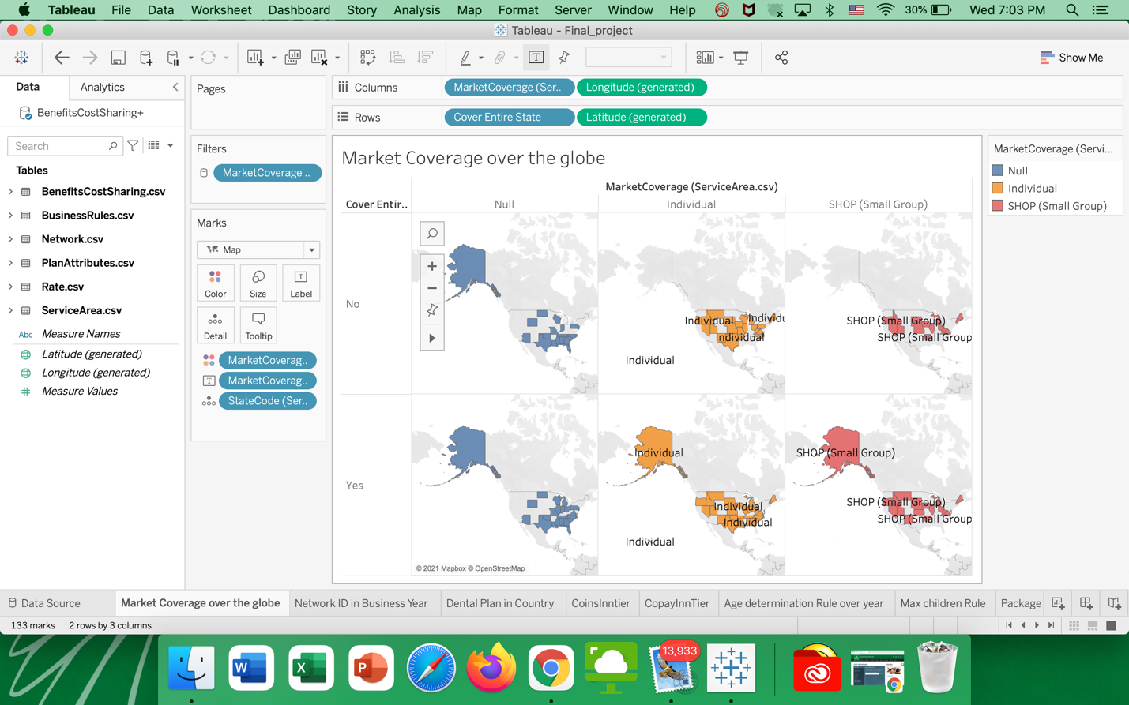

This sheet gives the information about the details of Network ID used in that particular Business year and count of the networks over there and it makes easy to filter and find the details of the particular network id.

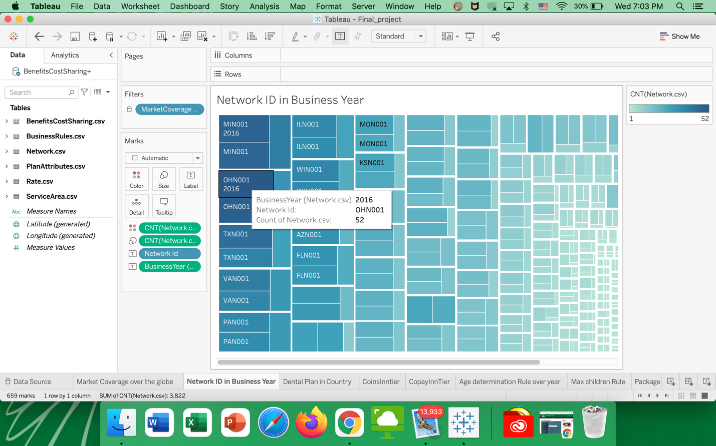

This sheet is about the dental plan in country where it helps us to know in which part of the country it is widely used and where it isn’t used and it filters the part of where they used and only dental plans and where they used all the plans.

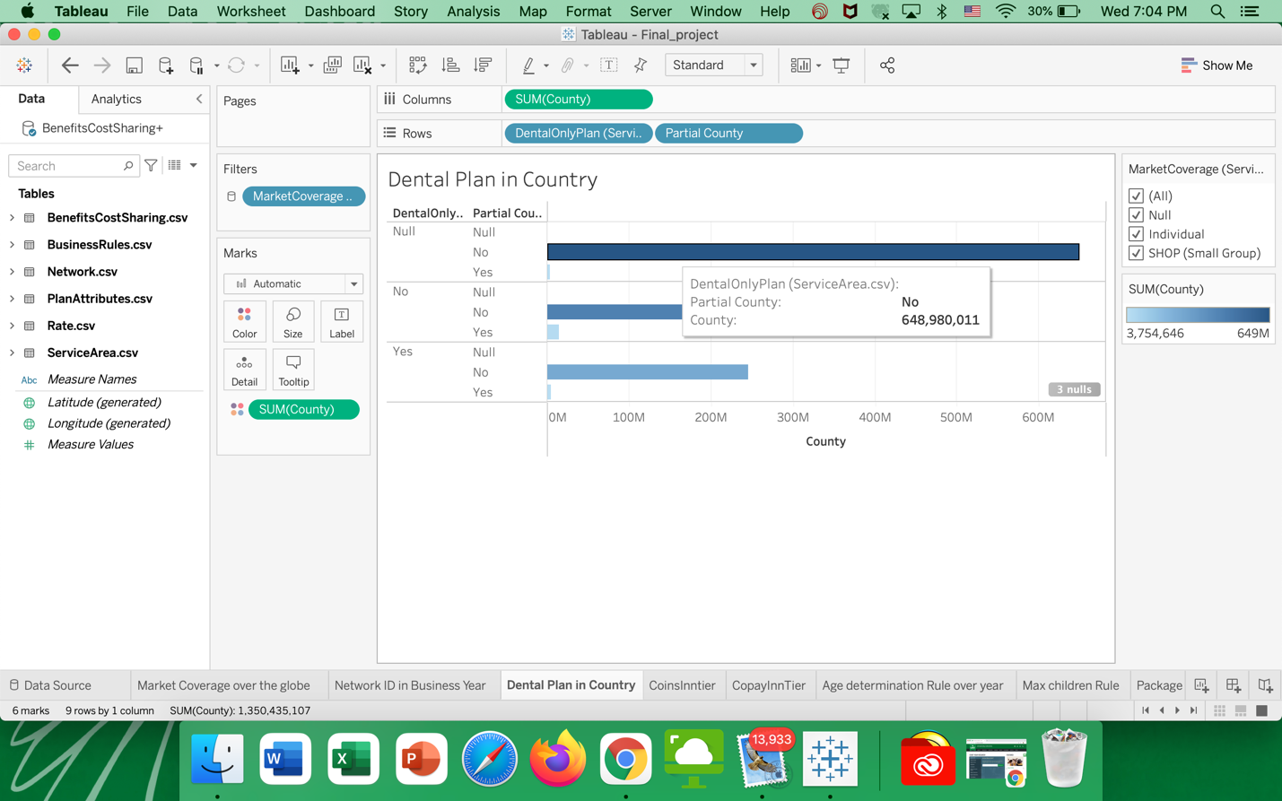

In this sheet it shows two tiers of coinsurance after deductible based on its percentage in the particular state and business year and the null value is greater in Arkansas state.

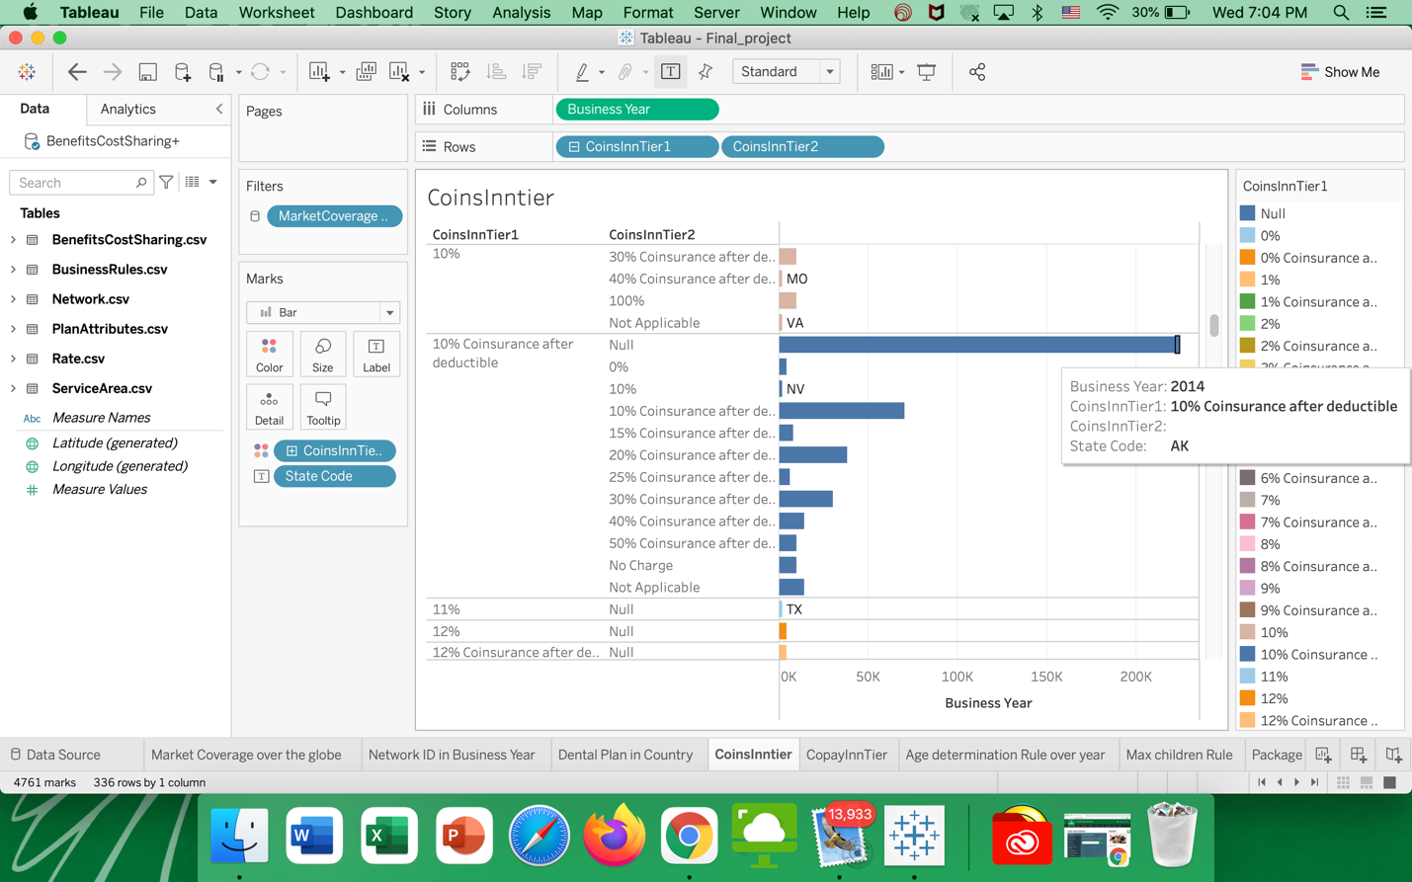

In this sheet it shows two tiers of copayinsurance after deductible based on its percentage in the particular state and business year and its greater in the Arkansas state and lesser in different states like Ohio , Kansas etc.,

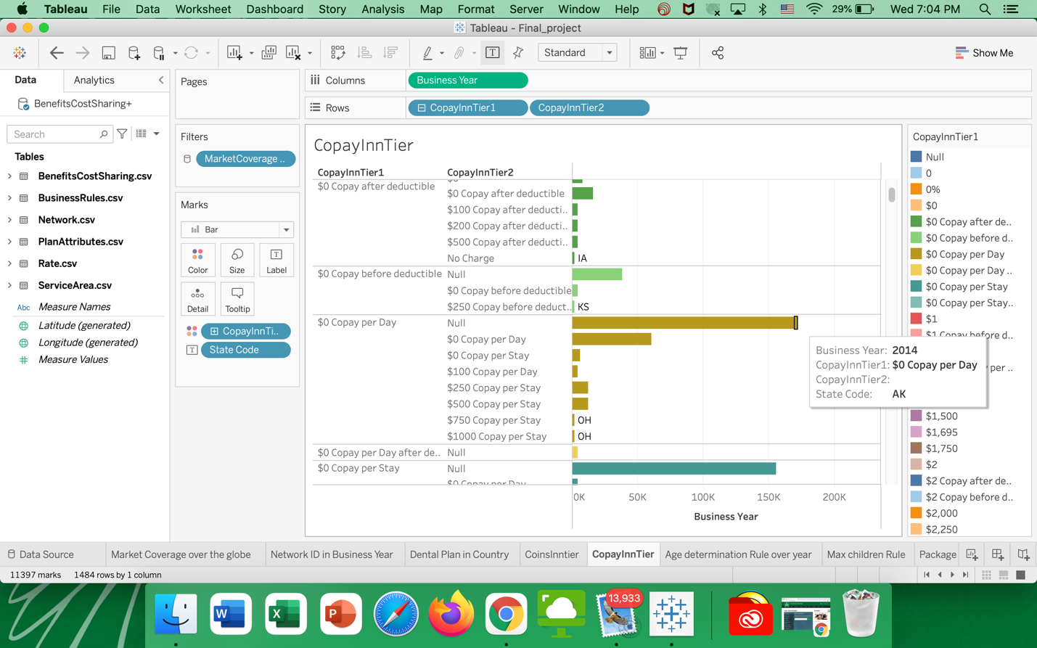

This sheet explains about the age determination rule over year in both the years and 2015 and 2016 and its higher in the year 2015.

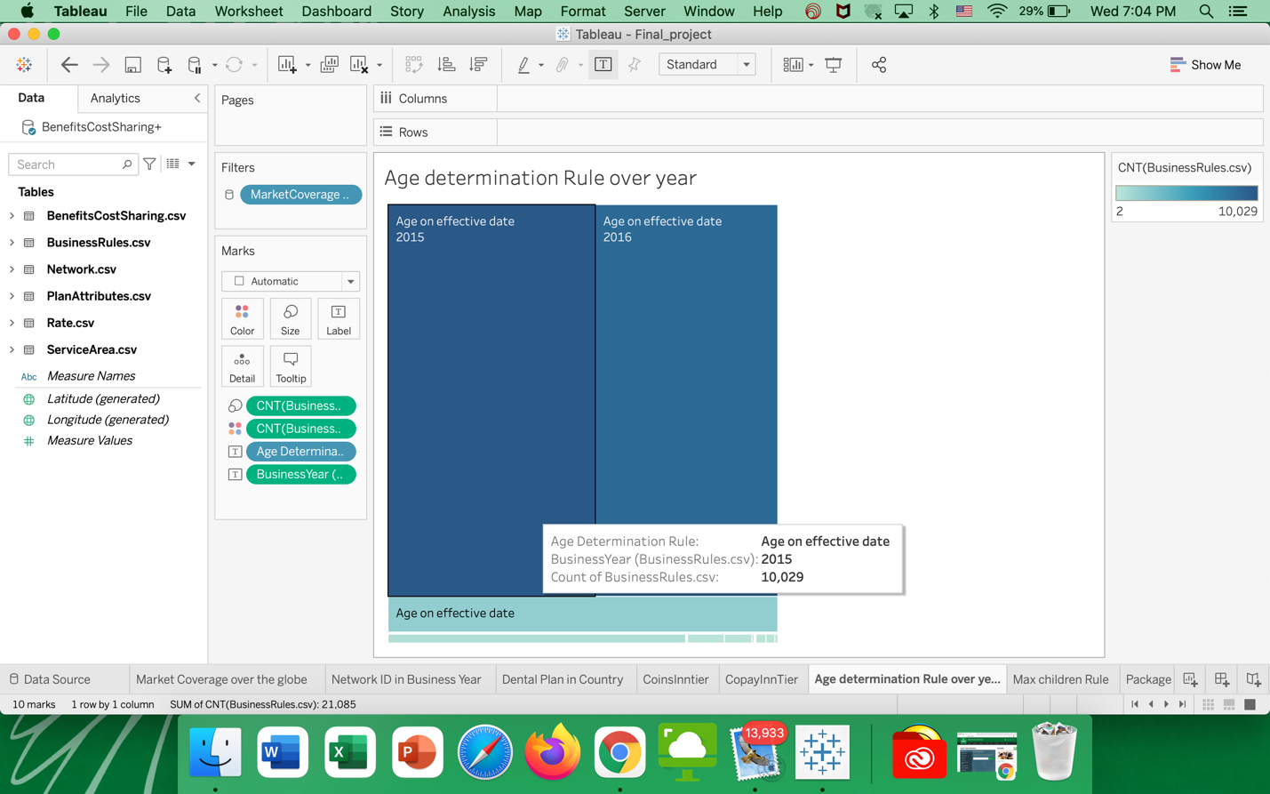

This sheet explains about the plans used by only children and it helps in filtering only the children plans in the particular business year 2015.

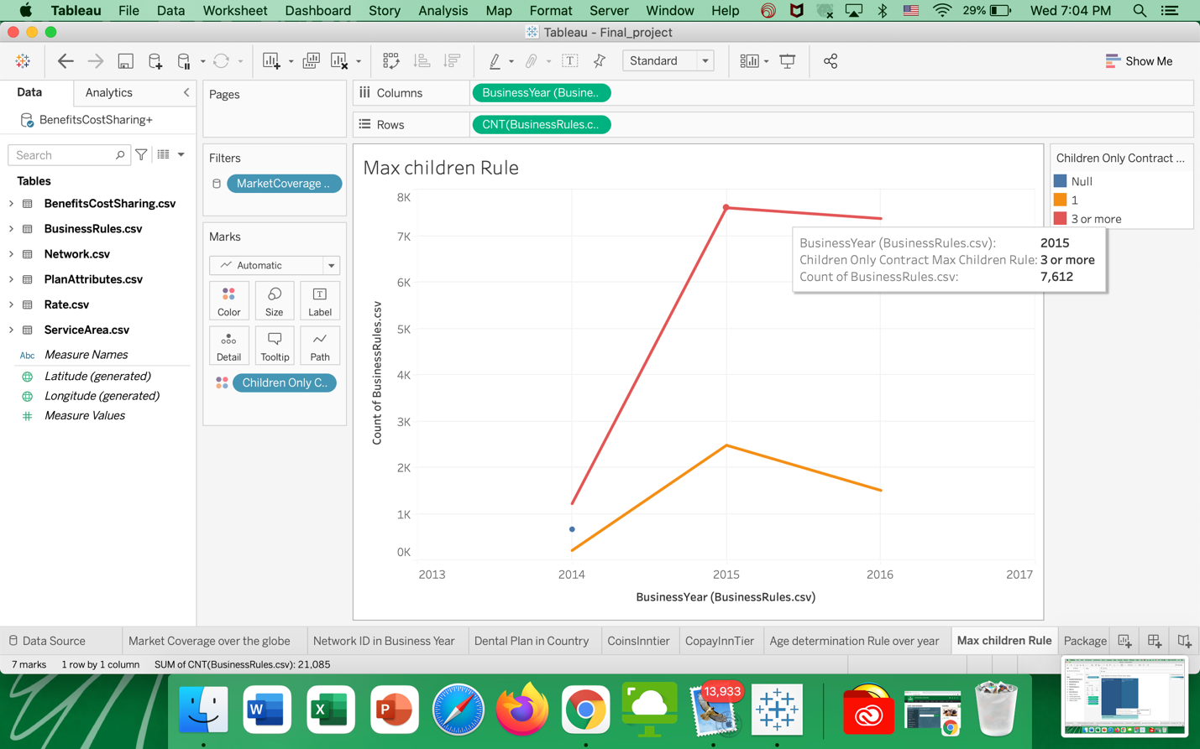

This sheet explains about the tobacco users who uses the medical plan and Non-tobacco users in the particular year and it is mostly used by the non tobacco users.

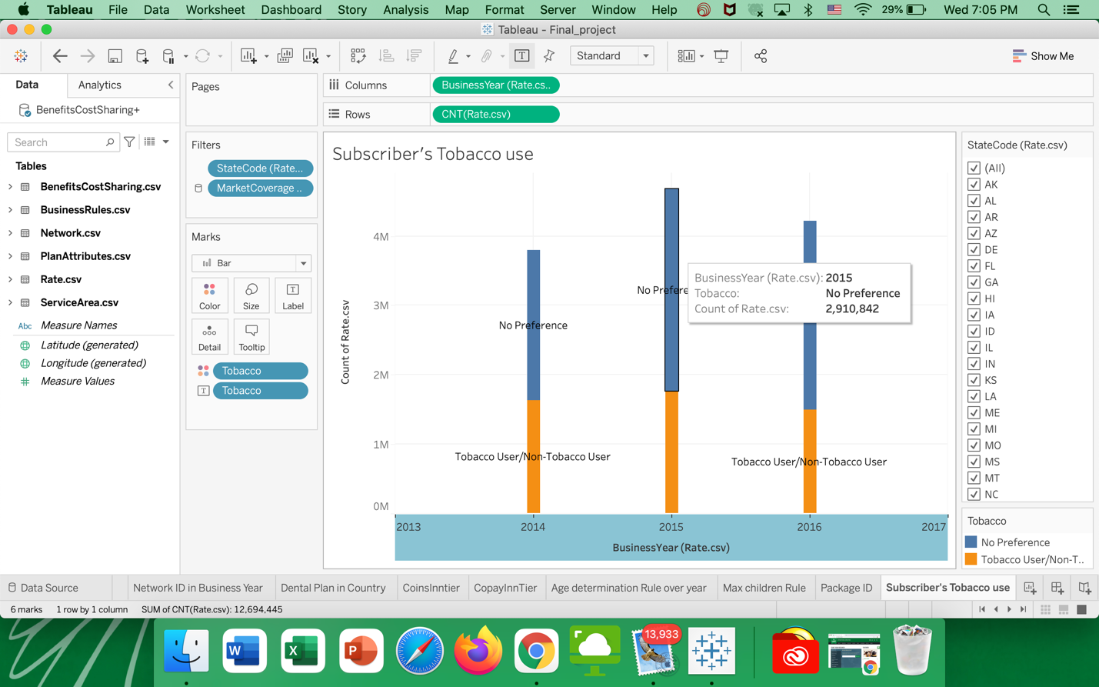

This sheet explains about the no of tobacco free months in the years from 2013-17 where it is highest in the year 2016 and lowest in the year 2014.

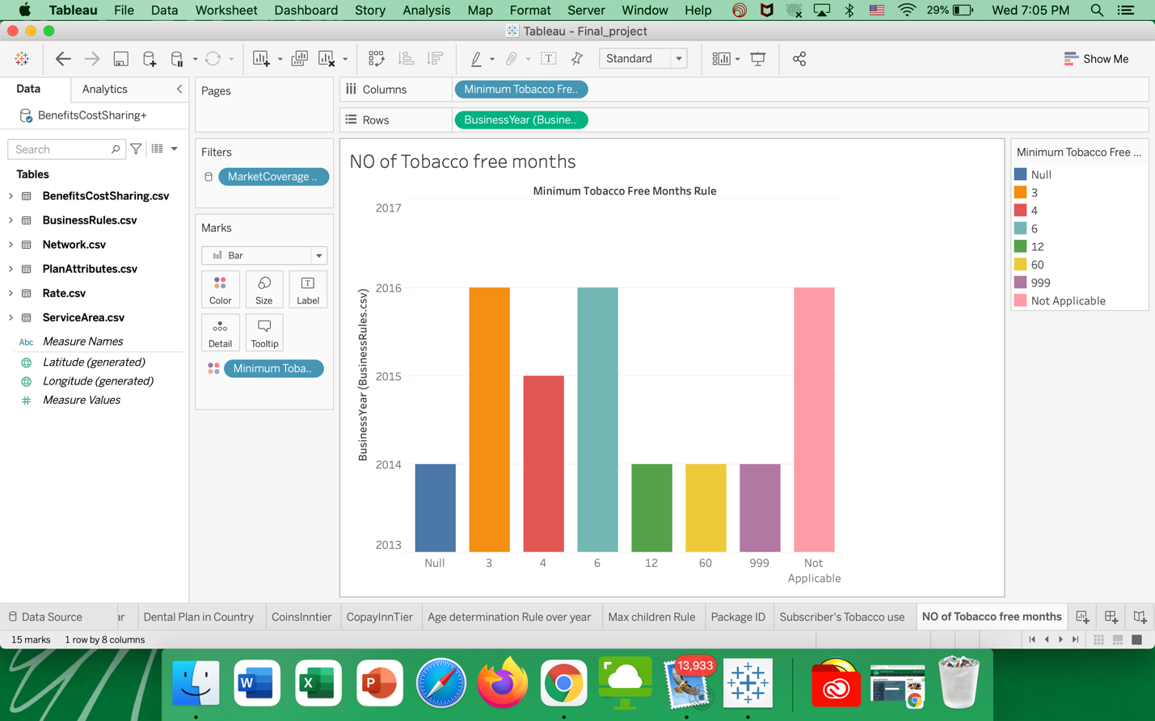

**CONCLUSION**:

As a result, the Health Insurance dataset is thoroughly analyzed using Tableau software, and numerous hypotheses are proposed. These hypotheses are backed up by a variety of visuals. We may conclude that correctly analyzing the Health Insurance dataset yielded a wealth of useful information.