

INTERNSHIP REPORT

AT

VR INSTITUTE OF CHEMICAL, BIOLOGICAL AND

INFORMATION TECHNOLOGY SCIENCE

2nd Floor, Sri Krishna Complex, No. S-1195

7th Main Road, 2nd Phase, Bharath Nagar

Bengaluru-560091, Karnataka, INDIA.

17TH OCT 2025 - 17TH APRIL 2026

Submitted By
Rakshitha.M
AI/ML and Data Science Intern
Under the Guidance of

Adithya BR Dr. Rakesh
AI Engineer Administrator Head
VR Institute VR Institute

Dr. Phani Kumar Pullela Dr. Ravi Kumar
Director – Corporate & Alumni Relations Founder
RV University VR Institute

CERTIFICATE OF COMPLETION
This is to certify that Ms. Rakshitha M. has successfully completed a 6 Months Internship at VR Institute of Chemical, Biological and Information Technology, Bengaluru, Karnataka, India.
During the internship period, she worked on multiple interdisciplinary projects in the domains of Bioinformatics, Artificial Intelligence, Computational Biology, Data Science, and Academic Content Development. Her responsibilities included literature survey, computational modeling, molecular docking analysis, AI-based system design support, documentation, and academic content creation.
She demonstrated strong skills in Python programming, bioinformatics tools, data analysis, machine learning concepts, and scientific documentation. Her contributions were found to be sincere, technically sound, and valuable to the research and academic activities of the institution.
We appreciate her dedication, discipline, and willingness to learn throughout the internship period.
The internship was successfully completed from 17-Oct-2025 to 17-Apr-2026, fulfilling all assigned requirements.
We wish her success in all future academic and professional endeavors.

Date:
Place: Bengaluru, Karnataka
Supervisor / Guide
Name: Dr. K. R. Ravikumar
Designation: Founder
Organization: VR Institute of Chemical, Biological and Information Technology
Signature: ___________

ACKNOWLEDGEMENT

I express my sincere gratitude to VR Institute for providing me with the opportunity to undertake my internship in the field of Artificial Intelligence, Machine Learning, and Data Science. This experience has been highly enriching and has significantly contributed to my technical and professional growth.
I would like to extend my heartfelt thanks to Mr. Adithya BR, AI Engineer, VR Institute, for his constant guidance, valuable insights, and continuous support throughout the internship period. His mentorship played a crucial role in helping me understand real-world applications of AI/ML and data science concepts.
I am also deeply grateful to Dr. Rakesh, Administrator Head, VR Institute, for his encouragement and for providing a conducive environment for learning and innovation.
I sincerely thank Dr. Phani Kumar Pullela, Director – Corporate & Alumni Relations, RV University, for his support and encouragement, which made this internship opportunity possible.
I also express my respectful gratitude to Dr. Ravi Kumar, Founder, VR Institute, for establishing such a platform for students to gain practical exposure and industry-relevant skills.
Finally, I would like to thank all the staff members and peers who supported me directly or indirectly during the course of this internship.

Rakshitha.M
(AI/ML and Data Science Intern)

Contents

Abstract 4
Introduction 5
Project 1: Enzyme Design and Substrate Docking Analysis 6
Project 2: ANRF Mission Proposal – AI-Driven Enzyme Design and Biocatalysis Platform for Accelerated Pharmaceutical Development(Government Submission) 8
1. Project Overview 8
2. Scientific Rationale 8
3. Objectives 9
4. Methodology 9
4.1 Computational Phase 9
4.2 Wet-Lab Validation 9
4.3 AI Feedback Loop 9
5. Expected Outcomes 10
Short-Term Outcomes (Years 1–2) 10
Long-Term Outcomes (Year 3+) 10
6. Significance of the Project 10
7. Collaborations 10
8. Conclusion 10
Project 3: Full Stack Development (FSD) and AI Database Academic Content Creation 12
Objective 12
Role:Academic Content Developer and Assessment Designer 12
Tools and Technologies Used 12
Methodology 12
Outcomes and Results 13
Deliverables 13
Project 4: Student Enrollment Outreach via Tele-calling 14
Project 5: Development and Validation of an Explainable AI-Enabled Genomic Platform for Antimicrobial Resistance Prediction in India 15
1. Project Overview 15
2. Scientific Rationale 15
3. Objectives 16
4. Methodology 16
5. Expected Outcomes 17
6. Significance of the Project 18
7. Conclusion 18
Project 6-Non-coding regulatory variants in breast cancer: Current prediction models and experimental gaps 20
Project Overview 20
Objectives 20
Methodology 20
Expected Outcome 21
Collaboration 21
Conclusion 21
Project 7: CSR Policy Study and Industry Benchmarking 23
1. Introduction 23
2. Objectives of the Study 23
3. Methodology 23
4. List of Companies Studied 24
5. Conclusion 24
Project 8: Email Template Development 26
1. Objective 26
2. Tools & Technologies Used 26
3. Methodology 26
4. Outcomes 27
5. Conclusion 27
Project 9: AI-driven Climate Intelligence Platform for decentralized Panchayat-level planning 29
1. Project Overview 29
2. Scientific Rationale 29
3. Objectives 30
4. Methodology 30
4.1 Data Integration Phase 30
4.2 AI and Modeling Phase 30
4.3 Platform Development Phase 30
4.4 Feedback and Iteration 30
5. Expected Outcomes 31
Short-Term Outcomes (0–12 months) 31
Medium-Term Outcomes (12–24 months) 31
Long-Term Outcomes (24–36 months) 31
6. Significance of the Project 31
7. Collaborations 31
8. Conclusion 31
Conclusion 33

ABSTRACT
This project portfolio presents a collection of interdisciplinary computational and applied research works spanning bioinformatics, artificial intelligence, data science, and academic system development. The primary objective is to design and implement intelligent frameworks that support enzyme engineering, genomic prediction systems, educational content development, and socio-environmental decision-making.
In the computational bioinformatics domain, an end-to-end enzyme–substrate docking pipeline was developed using tools such as AutoDock Vina, PyMOL, and Python-based preprocessing scripts, enabling structural analysis and identification of key binding residues. Extending this foundation, an AI-driven enzyme design and biocatalysis platform was conceptualized to accelerate pharmaceutical development through a Design–Build–Test–Learn (DBTL) framework integrated with protein language models and generative AI systems.
In healthcare informatics, an explainable AI-based antimicrobial resistance prediction platform was designed using genomic datasets, machine learning models, and SHAP-based interpretability techniques to improve clinical decision-making. Complementary academic initiatives included structured curriculum development for Full Stack Development and AI Database courses, along with assessment design and lab manual creation.
Additionally, operational and communication systems such as CRM-based email template development and student outreach tele-calling workflows were implemented to improve engagement and institutional efficiency. Strategic research contributions included CSR benchmarking studies and climate intelligence platforms for decentralized governance using AI and geospatial analytics.
Collectively, these projects demonstrate the integration of computational biology, artificial intelligence, and applied systems engineering to develop scalable, interpretable, and impact-oriented solutions across scientific, educational, and societal domains.

INTRODUCTION
In recent years, the convergence of artificial intelligence, bioinformatics, and data-driven systems has transformed research and applied problem-solving across biotechnology, healthcare, education, and governance. This project portfolio represents a multidisciplinary journey spanning computational enzyme design, AI-driven biological systems, genomic analysis, academic content development, and socio-technical applications.
The core focus of these works is the application of computational intelligence and structured workflows to solve complex biological and real-world challenges. In biotechnology, molecular docking and AI-based enzyme design pipelines were explored to understand protein–ligand interactions and accelerate biocatalyst development. In public health genomics, explainable AI frameworks were studied for antimicrobial resistance prediction using genomic datasets.
Beyond biological systems, the portfolio extends into academic and operational domains, including curriculum design for Full Stack Development and AI Database systems, CRM-based communication systems, outreach operations, and policy-level research in CSR and climate intelligence platforms. Together, these projects reflect a unified approach that integrates machine learning, data engineering, and domain knowledge to build scalable, interpretable, and impactful solutions.

Project 1: Enzyme Design and Substrate Docking Analysis
(Computational Bioinformatics Model Development)

Objective: To computationally analyze enzyme–substrate interactions using molecular docking and bioinformatics tools to understand binding mechanisms and support enzyme engineering applications.

Role: Computational Research Intern – Bioinformatics Workflow Developer

Tools/Technologies Used:
  - Programming: Python
  - Molecular Modeling: AutoDock Vina, PyMOL/PyMOL2, Open Babel, MGLTools
  - Bioinformatics: Biopython, AlphaFold/ColabFold
  - Libraries: os, subprocess, requests, pymol, vina, numpy, matplotlib
  - File Formats: .fasta, .pdb, .pdbqt, .sdf

Methodology:
  - Structure Preparation: Collected enzyme sequence/structure files and ligand substrate files in appropriate molecular formats.
  - Format Conversion: Developed Python scripts to convert enzyme and ligand structures into PDBQT format (required for AutoDock Vina), including hydrogen addition and atom formatting.
  - Molecular Docking: Executed docking using AutoDock Vina with defined search box coordinates focused on the enzyme's probable active site; generated multiple binding pose predictions.
  - Visualization: Rendered docked complexes in PyMOL with enzyme in cartoon format and ligand in stick format; applied color coding for component distinction.
  - Binding Pocket Analysis: Highlighted residues surrounding the ligand to identify the probable substrate interaction pocket and catalytic environment.
  - Output Generation: Saved processed structures, docking results, and rendered images for interpretation and future analysis.

Outcome/Results:
- Successfully established an end-to-end computational workflow for enzyme–substrate interaction studies.
- Generated docked binding poses with visual confirmation of probable binding interactions.
- Identified key residues in the binding pocket region for potential mutagenesis or engineering targets.
- Produced reusable scripts and documentation for future docking projects.

Deliverables: receptor.pdbqt, ligand.pdbqt, docked.pdbqt, EstB_binding.png, complex.png
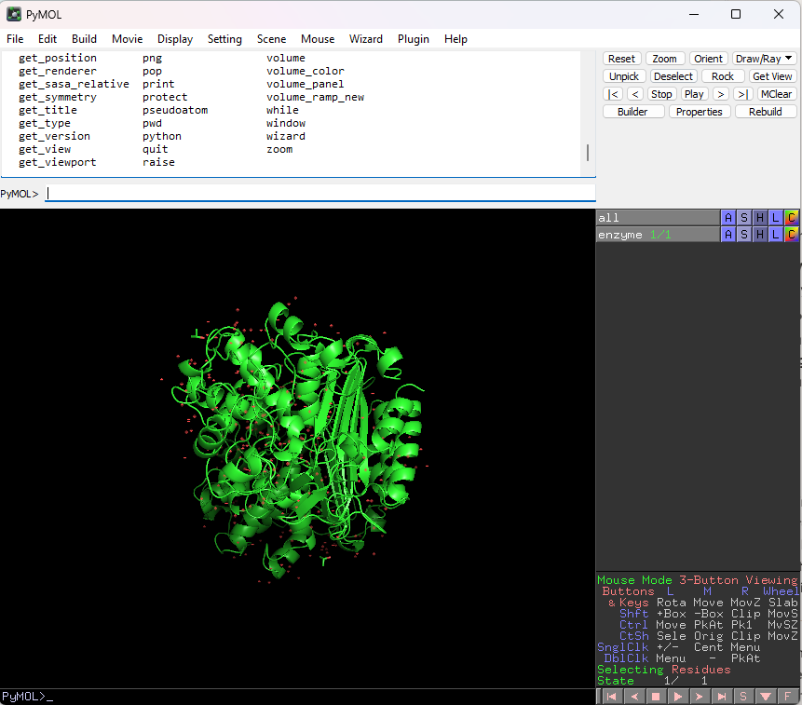

Project 2: AI-Driven Enzyme Design and Biocatalysis Platform for Accelerated Pharmaceutical Development

(ANRF Mission Proposal Government Submission)

Project Reference
Reference No.: 642025002329
Duration: 36 Months
Principal Investigator: Dr. K. R. Ravikumar, VR Institute of Chemical, Biological and Information Technology, Bengaluru, Karnataka, India

1. Project Overview
This project proposes the development of a next-generation AI-driven enzyme design and biocatalysis platform aimed at accelerating pharmaceutical synthesis. The core objective is to integrate advanced artificial intelligence models with experimental biochemistry to significantly reduce the time, cost, and complexity associated with enzyme engineering.
Modern drug manufacturing increasingly relies on biocatalysts; however, conventional enzyme discovery and optimization remain slow and experimentally intensive. This project addresses this limitation by establishing an automated Design–Build–Test–Learn (DBTL) pipeline powered by state-of-the-art AI systems.

2. Scientific Rationale
Enzymes are highly selective and efficient biological catalysts that enable sustainable and greener pharmaceutical manufacturing. Despite their advantages, engineering novel enzymes for industrial applications is constrained by long development cycles and limited predictive capability.
This project leverages recent advances in:
- Protein foundation models (e.g., sequence-to-function learning systems)
- Diffusion-based generative models for protein structures
- Low-Rank Adaptation (LoRA) for enzyme family specialization
- Structural prediction tools (e.g., AlphaFold systems)
- Molecular dynamics and stability prediction frameworks
By integrating these tools into a unified AI platform, the project aims to dramatically enhance enzyme design efficiency and industrial applicability.

3. Objectives
The major objectives of the project are:
- Develop an AI-driven DBTL platform for enzyme engineering.
- Curate a high-quality dataset of approximately 50,000 enzyme sequences with annotations and structural metadata.
- Develop specialized LoRA adapters for 10 industrially important enzyme families.
- Generate and computationally evaluate novel enzyme variants using AI models.
- Experimentally validate 3–5 high-confidence enzyme designs through wet-lab studies.
- Establish an open-source ecosystem of datasets, models, and benchmarking tools.

4. Methodology

4.1 Computational Phase
- Dataset curation from UniProt, PDB, and literature sources
- Sequence encoding using protein language models (ProtT5, ESM-based systems)
- Structural generation using diffusion models (e.g., RFdiffusion, P450Diffusion)
- Stability and functional prediction using energy-based and ML-based tools
- Ranking of candidates using multi-criteria evaluation

4.2 Wet-Lab Validation
- Gene synthesis and cloning into expression systems (E. coli, yeast systems)
- Protein expression and purification using affinity chromatography
- Enzyme activity assays, kinetic studies (Km, Vmax, kcat)
- Stability analysis using thermal shift and biochemical assays

4.3 AI Feedback Loop
- Integration of experimental results into AI models
- Continuous improvement through iterative DBTL cycles
- Refinement of LoRA adapters based on experimental feedback

5. Expected Outcomes

Short-Term Outcomes (Years 1–2)
- Curated enzyme dataset (~50,000 sequences)
- AI-based enzyme generation pipeline
- Functional LoRA adapters for 10 enzyme families
- Initial wet-lab validation of designed enzymes

Long-Term Outcomes (Year 3+)
- National-scale AI platform for enzyme design
- Open-source models, datasets, and benchmarks
- Validated industrial enzymes for pharmaceutical synthesis
- Strengthened biotechnology and AI ecosystem in India

6. Significance of the Project
- Enables faster and greener pharmaceutical manufacturing
- Reduces dependency on chemical catalysts and hazardous reagents
- Promotes sustainable biocatalytic processes
- Strengthens India’s capability in AI-driven biotechnology
- Supports innovation in drug discovery and industrial biomanufacturing

7. Collaborations
- Simposys Healthcare LLP: Wet-lab fermentation and bioprocess validation support
- Robust Materials Technology Pvt Ltd.: Enzyme screening, purification, and biochemical characterization

8. Conclusion
This project establishes a fully integrated AI–biotechnology framework for enzyme engineering. By combining advanced generative AI models with experimental validation, it aims to create a scalable and nationally impactful platform for accelerating pharmaceutical development through biocatalysis

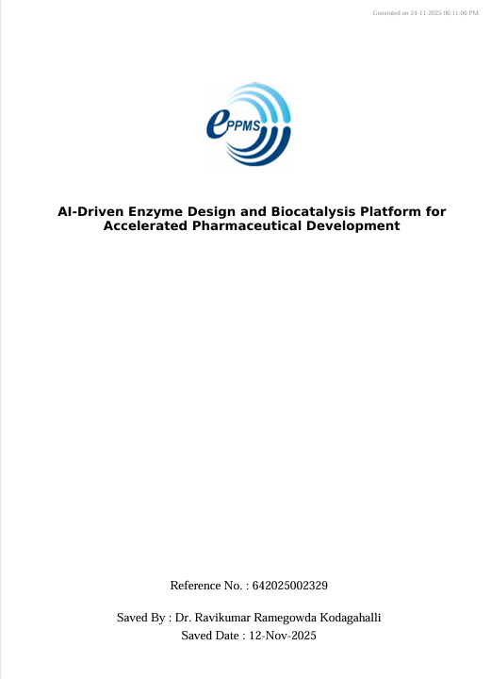

Project 3: Full Stack Development (FSD) and AI Database Academic Content Creation

Objective
To develop structured, syllabus-aligned learning materials and assessment resources for Full Stack Development (FSD) and AI Database courses, supporting classroom instruction, student self-learning, and examination preparation.

Role:Academic Content Developer and Assessment Designer

Tools and Technologies Used
MS Word, LaTeX, Microsoft Excel, Python (for question randomization scripting), SQL, pandas, SQLite, Syllabus Mapping Framework, Bloom’s Taxonomy Guidelines

Methodology

1. Syllabus Alignment
Reviewed the approved syllabus for FSD and AI Database courses and mapped module-wise learning outcomes and competency targets to ensure curriculum compliance.

2. Content Structuring
Developed progressive concept notes, coding examples, practical exercises, and visual learning aids to enhance conceptual clarity and hands-on understanding.

3. Assessment Design
Prepared question banks categorized according to Bloom’s Taxonomy levels, including theoretical, application-based, debugging, and architecture-oriented questions for internal assessments and exam preparation.

4. Lab Manual Development (AI Database)
Designed a comprehensive AI Database Lab Manual containing step-by-step experiments covering relational databases, NoSQL systems, vector databases, and AI-integrated querying techniques, along with dataset references and implementation tasks.

5. Iterative Review Process
Collaborated with the project guide, Adithya, to review and refine the content for pedagogical effectiveness, technical accuracy, and alignment with student learning capabilities.

Outcomes and Results
- Delivered standardized and reusable academic content packages for FSD and AI Database courses, improving consistency in classroom delivery.
- Enhanced student self-learning and examination readiness through structured question banks and practical exercises.
- Reduced instructor preparation time by providing modular and reusable teaching templates.
- Established a scalable framework for future curriculum updates and new course content development

Deliverables
- Module-wise concept notes
- Code repositories and implementation examples
- Question bank indices
- AI Database Lab Manual (Experiments 1–12)
- Assessment rubrics and evaluation guidelines

Project 4: Student Enrollment Outreach via Tele-calling
(Academic Operations Support)

Objective: Drive student enrollment for VR Institute's AI/ML, Data Science, and technical courses through structured tele-calling campaigns and personalized outreach.

Role: Student Outreach & Enrollment Coordinator

Tools/Technologies Used: CRM/Telecalling Software, Excel Tracking Sheets, Script Optimization Framework, Follow-up Automation Templates, Google Workspace

Methodology:
  - Script Development: Created personalized outreach scripts aligned with course outcomes, career benefits, and student pain points.
  - Lead Management: Executed structured tele-calling campaigns; logged responses, categorized leads (Hot/Warm/Cold), and scheduled counseling sessions.
  - Objection Handling: Trained in addressing common concerns (fees, duration, placement, prerequisites) with evidence-based responses.
  - Follow-up Pipeline: Maintained systematic follow-up schedules via email/SMS; tracked conversion metrics and provided feedback to academic team for course positioning improvements.
  - Performance Tracking: Monitored key metrics: call volume, connection rate, conversion rate, and student feedback for continuous optimization.

Outcome/Results:
- Supported institutional enrollment drives with structured communication protocols.
- Improved lead-to-enrollment conversion through personalized engagement and timely follow-ups. Gained hands-on experience in professional communication, stakeholder management, and academic sales operations.
- Contributed actionable insights to refine course marketing messaging and student onboarding workflows.

Deliverables: Tele-calling script templates, lead tracking dashboard, conversion analytics report, student feedback summary

Project 5: Development and Validation of an Explainable AI-Enabled Genomic Platform for Antimicrobial Resistance Prediction in India
(DBT Proposal – Government Submission)

Duration: 36 Months
Principal Investigator: Dr. K. R. Ravikumar, VR Unnathi Health and Education Trust, Bengaluru, Karnataka, India
Project Contributor (Intern): Rakshitha.M
Role: Literature Survey, Technical Documentation, and Proposal Development Support

1. Project Overview
This project proposes the development of an explainable artificial intelligence (AI)-enabled genomic platform for rapid prediction of antimicrobial resistance (AMR) in priority bacterial pathogens. The platform integrates bacterial whole-genome sequencing (WGS) data, antimicrobial susceptibility testing (AST) data, and machine learning models to support faster and more accurate resistance prediction.
The project aims to address the growing public health challenge of antimicrobial resistance in India by reducing dependence on time-consuming conventional susceptibility testing and enabling data-driven decision support for laboratories and surveillance programs.

2. Scientific Rationale
Antimicrobial resistance is one of the most significant global health threats, causing increased mortality, treatment failure, and healthcare costs. Conventional AST methods typically require 24–72 hours to generate results, leading to empirical antibiotic use and accelerated resistance development.
Recent advances in genomics and artificial intelligence provide an opportunity to predict resistance directly from genomic data. However, most existing AI-based AMR prediction systems suffer from limited interpretability, lack of experimental validation, and poor adaptation to Indian pathogen populations.
The project addresses these limitations through:
• Integration of genomic and phenotypic AMR datasets
• Explainable AI techniques such as SHAP-based interpretation
• Machine learning models including XGBoost and Random Forest
• Prospective wet-lab validation using Indian clinical isolates
• Development of a laboratory-ready software platform for AMR prediction and surveillance

3. Objectives
The major objectives of the project are:
- Curate and harmonize more than 10,000 high-quality genomic and phenotypic AMR datasets from public repositories.
- Develop explainable machine-learning models for antimicrobial resistance prediction.
- Experimentally validate AI predictions using prospective antimicrobial susceptibility testing on Indian clinical isolates.
- Develop a modular software platform for resistance prediction, visualization, and surveillance analytics.
- Ensure compliance with DBT data governance requirements through structured submission to the Indian Biological Data Centre (IBDC).

4. Methodology

4.1 Data Collection and Harmonization
• Acquisition of WGS and AST datasets from BV-BRC, CARD, and NCBI repositories
• Metadata standardization using CLSI and EUCAST guidelines
• Quality control and database integration using PostgreSQL

4.2 Feature Engineering
• Resistance gene detection using CARD and ResFinder
• Genome-wide k-mer extraction
• SNP and mutation profiling
• Analysis of operons, plasmids, and mobile genetic elements

4.3 Machine Learning Development
• Development of XGBoost and Random Forest models
• Hyperparameter optimization using Optuna
• Five-fold cross-validation
• Explainability using SHAP-based feature attribution
• Experiment tracking using MLflow

4.4 Experimental Validation
• Phenotypic AST using disk diffusion and MIC testing
• Blinded prediction evaluation
• PCR and sequencing-based validation of resistance determinants
• Model recalibration using local clinical isolate data

4.5 Platform Development
• FastAPI-based backend architecture
• PostgreSQL database integration
• Streamlit-based visualization dashboard
• Docker containerization for deployment

5. Expected Outcomes

Short-Term Outcomes (Years 1–2)
• Curated AMR genomic database (>10,000 WGS–AST pairs)
• Explainable AI models for resistance prediction
• SHAP-based resistance mechanism interpretation framework
• Initial wet-lab validation studies

Long-Term Outcomes (Year 3)
• Deployable AI-AMR software platform
• Laboratory-ready resistance prediction system
• Submission of curated datasets to IBDC
• Publications and technical documentation
• Pilot implementation in selected Indian laboratories

6. Significance of the Project
• Supports rapid antimicrobial resistance detection
• Improves antimicrobial stewardship and clinical decision-making
• Strengthens national AMR surveillance programs
• Enhances integration of AI, genomics, and public health
• Contributes to India's biotechnology and AI innovation ecosystem
• Provides a scalable framework for future pathogen surveillance initiatives

7. Conclusion
The proposed project represents a multidisciplinary effort integrating artificial intelligence, bioinformatics, microbiology, and public health to address antimicrobial resistance in India. Through explainable AI models, genomic analytics, and experimental validation, the project aims to establish a scalable and deployable platform for rapid AMR prediction and surveillance. My internship involvement provided practical experience in scientific literature analysis, research proposal development, technical documentation, and AI applications in biotechnology.

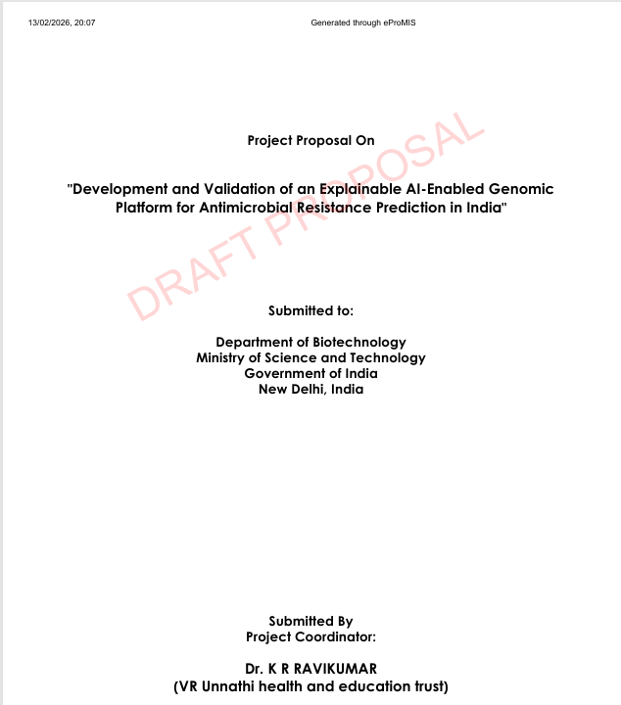

Project 6-Non-coding regulatory variants in breast cancer: Current prediction models and experimental gaps
(Publication)

Project Type: Systematic Literature Review (Review Article)
Principal Investigator: Dr. K. R. Ravikumar
VR Institute of Chemical, Biological and Information Technology, Bengaluru, Karnataka, India

Project Overview
This project is based on a systematic literature review focused on the role of non-coding regulatory variants in breast cancer. Although genome-wide association studies (GWAS) have identified multiple susceptibility loci, most of the associated variants are located in non-coding regions of the genome. These regions influence gene expression through regulatory mechanisms such as enhancers, promoters, transcription factor binding sites, and chromatin architecture rather than altering protein sequences.
A major challenge addressed in this review is the distinction between true functional regulatory driver variants and non-functional passenger variants within linkage disequilibrium regions. The study also evaluates current computational prediction models and experimental validation approaches used in identifying and characterizing these variants.

Objectives
The main objectives of this review are:
- To investigate the role of non-coding regulatory variants in breast cancer development and progression.
- To distinguish functional driver variants from passenger variants in GWAS loci.
- To analyze limitations of current computational prediction models in regulatory genomics.
- To evaluate the importance of integrating multi-layer genomic data such as epigenomics, chromatin structure, and transcriptional networks.
- To explore the use of deep learning and transformer-based models for regulatory variant prediction.
- To assess experimental validation methods such as CRISPR-based perturbation and MPRA assays.

Methodology
This study is a systematic literature review conducted using published scientific articles.
- Research articles published mainly between 2017 and 2025 were collected from Google Scholar and related scientific databases.
- Keywords included: non-coding regulatory variants, breast cancer GWAS, enhancer–promoter interactions, chromatin architecture, deep learning in genomics, and regulatory variant prediction models.
- Inclusion criteria focused on studies involving breast cancer regulatory genomics, computational prediction methods, and experimental validation approaches.
- Exclusion criteria removed studies unrelated to breast cancer or lacking regulatory or functional genomic relevance.
- A total of approximately 17,900 publications were initially identified. After screening and filtering, 22 high-quality studies were selected for detailed review and analysis.

Expected Outcome
The review is expected to:
- Improve understanding of non-coding regulatory variants in breast cancer biology.
- Identify limitations in existing computational prediction models.
- Support development of integrated multi-omics and 3D genome-aware predictive frameworks.
- Encourage interpretable deep learning models in regulatory genomics.
- Bridge the gap between computational predictions and experimental validation strategies.
- Contribute to advancements in precision oncology and subtype-specific risk assessment.

Collaboration
This review was carried out under the guidance of:
- Principal Investigator: Dr. K. R. Ravikumar
- Institution: VR Institute of Chemical, Biological and Information Technology, Bengaluru, Karnataka, India
The review article was authored by Rakshitha M., with support and academic contributions from co-authors and the research team. The study was conducted as part of a collaborative academic research initiative under the guidance of the principal investigator.

Conclusion
This systematic review highlights that most breast cancer-associated genetic variants are located in non-coding regions and influence disease progression through regulatory mechanisms rather than protein-coding changes. Current computational models, while effective in prioritization, still lack integration of 3D chromatin structure, subtype-specific epigenomics, and multi-layer regulatory interactions.
The review emphasizes the need for integrated multi-omics frameworks combining genomic, epigenomic, and chromatin interaction data along with experimental validation methods. Advances in deep learning, transformer models, CRISPR screening, and MPRA technologies are expected to significantly improve the identification and interpretation of functional regulatory variants, ultimately supporting precision medicine approaches in breast cancer.

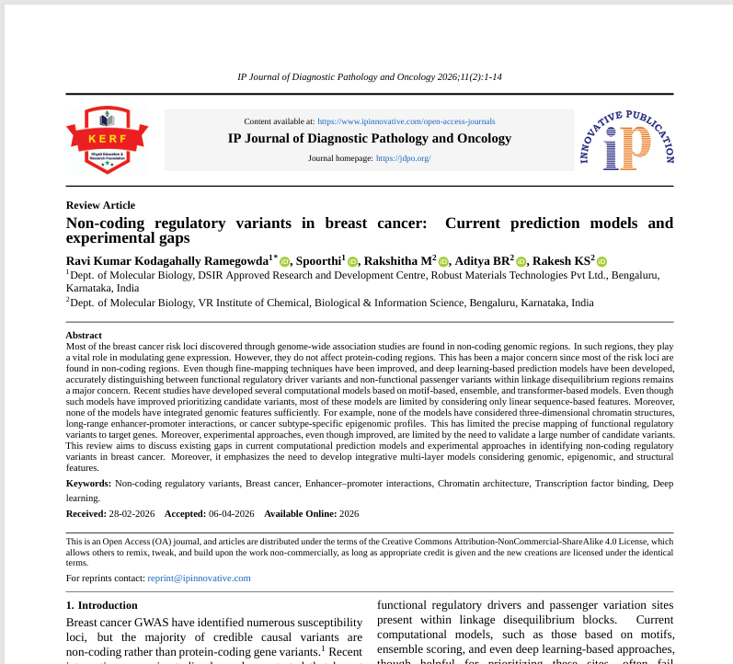

Project 7: CSR Policy Study and Industry Benchmarking
(Knowledge Building & Strategic Planning)

1. Introduction
Corporate Social Responsibility (CSR) has become an integral part of modern corporate governance, emphasizing a company’s responsibility toward society and the environment. In accordance with Section 135 of the Companies Act, 2013, companies meeting specified financial criteria are required to undertake CSR activities and disclose their policies.
The objective of this study was to analyze and benchmark CSR policies of leading Indian and multinational companies. The study also aimed to understand how organizations integrate sustainability, ethical responsibility, and community development into their business strategies. This benchmarking exercise provides insights into best practices followed by industry leaders in CSR implementation.

2. Objectives of the Study
The primary objectives of this CSR policy study were:
- To collect and review CSR policies of leading companies across different sectors
- To understand CSR frameworks and compliance requirements under the Companies Act, 2013
- To analyze key focus areas of CSR such as education, healthcare, environment, rural development, and skill enhancement
- To compare CSR approaches followed by different organizations
- To identify best practices in CSR implementation and reporting
- To develop an understanding of industry standards in corporate sustainability initiatives

3. Methodology
The study was conducted using a secondary research-based approach. CSR policy documents were collected from official company websites and verified sources in PDF format.
The methodology involved the following steps:
- Collection of CSR policy documents from selected companies
- Review and analysis of policy documents and CSR reports
- Identification of key CSR themes, focus areas, and implementation strategies
- Comparative analysis to understand similarities and differences across industries
- Compilation of findings for benchmarking purposes
The study ensured that all data was sourced from authentic and publicly available corporate disclosures.

4. List of Companies Studied
CSR policies of approximately 14 major companies were analyzed as part of the study. These include:
- Accenture
- Bharat Petroleum Corporation Limited (BPCL)
- Godrej Group
- HDFC Limited
- IBM
- Larsen & Toubro (L&T)
- Oil and Natural Gas Corporation (ONGC)
- Reliance Industries Limited
- Wipro Limited
- Coal India Limited (CIL)
- Dalmia Bharat Limited
- Infosys Limited
- Mahindra & Mahindra Limited
- Tata Consultancy Services (TCS)
These companies represent diverse sectors such as IT services, manufacturing, energy, banking, and conglomerates, providing a balanced industry benchmarking perspective.

5. Conclusion
The CSR policy study and industry benchmarking exercise revealed that leading organizations actively integrate social and environmental responsibilities into their core business strategies. Most companies focus on key areas such as education, healthcare, environmental sustainability, rural development, and skill enhancement programs.
It was observed that organizations are increasingly aligning their CSR initiatives with national development goals and Sustainable Development Goals (SDGs). Companies such as Infosys, TCS, and Wipro emphasize education and digital literacy, while organizations like ONGC and BPCL focus on community welfare and environmental sustainability.
Overall, the study highlights that CSR is no longer treated as a compliance requirement but as a strategic business function aimed at long-term sustainable development and stakeholder value creation.
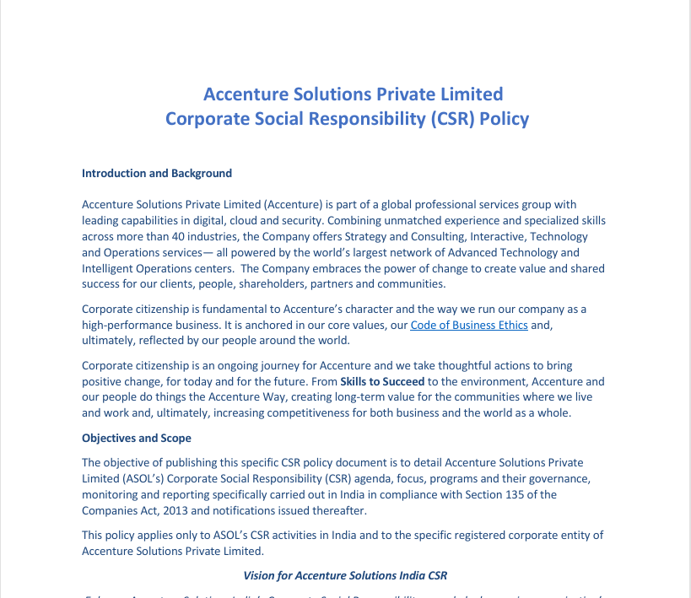

Project 8: Email Template Development
(Communication & Outreach Optimization)

1. Objective
The main objective of this project was to design and develop professional and responsive email templates for a CRM system. These templates were created to improve customer communication through marketing emails, notifications, and informational updates. The goal was to ensure clear content presentation, visual appeal, and compatibility across different devices and email clients.

2. Tools & Technologies Used
The following tools and technologies were used during the project:
- HTML5 – for structuring email content
- CSS3 – for styling and layout design
- CRM Platform – for managing and sending email campaigns (e.g., Zoho CRM / HubSpot / Salesforce depending on usage)
- Canva / Figma – for designing layouts and visual mockups
- Email Testing Tools – for checking responsiveness and compatibility (e.g., Gmail, Outlook previews, Litmus if used)

3. Methodology
The project was developed using a structured design and implementation approach:
- Requirement Analysis: Understanding the purpose of emails such as promotions, updates, and announcements.
- Design Planning: Creating wireframes and layout structure for email templates including header, banner, content sections, and footer.
- Template Development: Converting designs into HTML and CSS email templates with proper structure and inline styling for email compatibility.
- Responsiveness Implementation: Ensuring templates were mobile-friendly and adaptable to different screen sizes.
- Testing & Validation: Testing emails on multiple platforms (Gmail, Outlook, mobile devices) to ensure proper rendering.
- Final Integration: Uploading templates into CRM system for campaign usage.

4. Outcomes
- Developed visually appealing and professional email templates
- Improved readability and user engagement through structured design
- Ensured responsive design compatible with mobile and desktop devices
- Maintained consistent branding across all email communications
- Successfully integrated templates into CRM for real-time usage

5. Conclusion
The CRM Email Template Design project helped in understanding real-world email marketing systems and the importance of effective digital communication. It enhanced skills in HTML, CSS, and UI design principles for email development. The project successfully delivered responsive and reusable email templates that improved customer engagement and ensured consistent communication through CRM platforms.

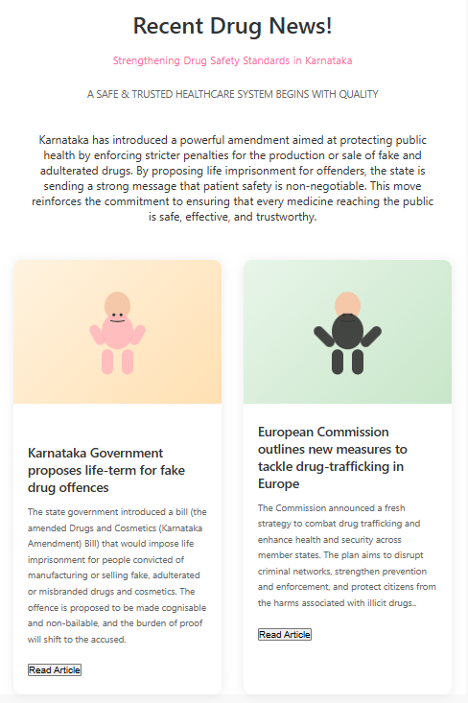


Project 9: AI-driven Climate Intelligence Platform for decentralized Panchayat-level planning
(Google Impact Challenges)

Project Reference
Duration: 36 Months
Principal Investigator: Dr. Ravikumar K. R., ROBUST MATERIALS TECHNOLOGY PRIVATE LIMITED, Bengaluru, Karnataka, India

1. Project Overview
This project proposes the development of an AI-driven Climate Intelligence Platform for decentralized Panchayat-level planning. The core objective is to integrate multi-source environmental, climatic, geospatial, and governance datasets into a unified artificial intelligence system that supports evidence-based rural decision-making.
Rural governance institutions such as Gram Panchayats currently lack tools to synthesize heterogeneous datasets including satellite imagery, weather data, soil health records, and administrative information. This project addresses this gap by developing a scalable AI-based decision-support platform that converts raw data into actionable climate adaptation insights.

2. Scientific Rationale
Rural India is increasingly affected by climate variability, including irregular rainfall, droughts, and agricultural uncertainty. While large volumes of environmental and meteorological data are available, they remain fragmented and underutilized at the local governance level.
This project builds on advances in:
- Time-series forecasting models (LSTM, Transformer-based architectures)
- Geospatial intelligence using satellite data (Google Earth Engine, GIS systems)
- Machine learning models for classification and risk prediction (Random Forest, XGBoost)
- Retrieval-Augmented Generation (RAG) systems for contextual decision support
- Explainable AI (XAI) for transparent governance applications
By integrating these technologies, the project aims to bridge the gap between raw climate data and actionable policy-level insights.

3. Objectives
The major objectives of the project are:
- Develop an integrated AI-based climate decision-support platform for Gram Panchayats.
- Build a multi-source data pipeline integrating climate, soil, satellite, and governance datasets.
- Develop machine learning models for climate risk prediction and prioritization.
- Create geospatial analytics modules for village-level environmental assessment.
- Design a user-friendly dashboard for Panchayat officials.
- Pilot the system in 50–100 Gram Panchayats in Karnataka.
- Release selected components as open-source datasets, tools, and models.

4. Methodology

4.1 Data Integration Phase
- Collection of meteorological data (IMD and open APIs)
- Satellite imagery processing using GIS and Google Earth Engine
- Soil and land-use data integration
- Structuring governance and agricultural datasets

4.2 AI and Modeling Phase
- Time-series forecasting using LSTM-based models
- Risk classification using Random Forest and XGBoost
- Geospatial clustering for vulnerability mapping
- Development of recommendation engine using RAG architecture

4.3 Platform Development Phase
- Backend development in Python
- Model training using TensorFlow/PyTorch
- Cloud deployment using Google Cloud (BigQuery, Vertex AI)
- Dashboard development for Panchayat-level users

4.4 Feedback and Iteration
- Human-in-the-loop validation with Panchayat officials
- Continuous model improvement using field feedback
- Iterative refinement of recommendations and usability

5. Expected Outcomes

Short-Term Outcomes (0–12 months)
- Functional prototype of AI-based climate platform
- Integrated multi-source dataset pipeline
- Initial predictive climate risk models
- Pilot deployment in selected Gram Panchayats

Medium-Term Outcomes (12–24 months)
- Scaled deployment across 30–50 Panchayats
- Improved prediction accuracy and usability
- Training programs for local government officials

Long-Term Outcomes (24–36 months)
- Fully scalable national-level platform
- Open-source datasets and AI models
- Improved climate adaptation planning at rural level
- Stronger integration of AI into decentralized governance

6. Significance of the Project
- Enhances climate resilience in rural communities
- Enables data-driven governance at Gram Panchayat level
- Improves agricultural planning and disaster preparedness
- Strengthens India’s rural AI and geospatial intelligence ecosystem
- Promotes sustainable and evidence-based development planning

7. Collaborations
- VR Unnathi Health & Education (VRUHE) Trust – Technical implementation, training, and stakeholder engagement
- Local Gram Panchayats – Field validation and user feedback
- Government stakeholders – Policy integration and deployment support

8. Conclusion
This project establishes an integrated AI–geospatial decision intelligence framework for decentralized climate governance. By combining machine learning, satellite analytics, and participatory governance, it aims to enable scalable, transparent, and evidence-based decision-making for rural development in India.
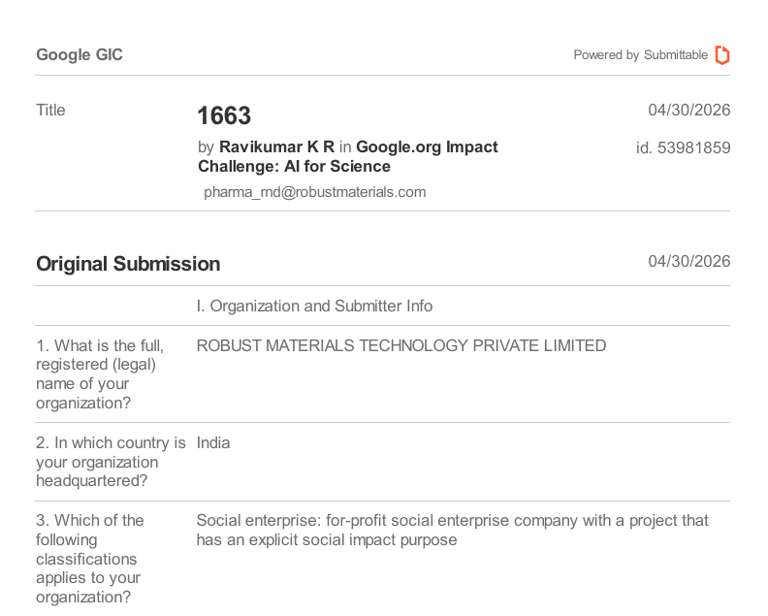

CONCLUSION
This project portfolio demonstrates a strong integration of computational biology, artificial intelligence, and applied data systems across multiple domains of research and real-world implementation. The works collectively highlight the transition from traditional manual analysis to automated, AI-driven pipelines that enhance accuracy, scalability, and interpretability.
In bioinformatics and biotechnology, molecular docking workflows and AI-based enzyme design frameworks provide a foundation for accelerating drug discovery and biocatalyst engineering. In genomics, explainable machine learning models for antimicrobial resistance prediction emphasize the importance of transparency and clinical applicability in healthcare AI systems.
Beyond scientific research, the portfolio extends into educational technology, operational systems, and socio-environmental applications, showcasing adaptability across diverse problem domains. Curriculum development projects improve structured learning delivery, while CRM and outreach systems demonstrate practical communication optimization. Policy and climate intelligence studies further reflect the use of AI for governance and sustainable development.
Overall, this body of work reflects a multidisciplinary skill set combining programming, machine learning, bioinformatics, system design, and analytical thinking. It establishes a foundation for future contributions in AI-driven scientific innovation, translational research, and scalable technology development aimed at solving complex real-world challenges.

