**DBMS - CLASS HACKATHON**

NAME : RAKSHITHA Y

ROLL NO : 20BCS107

ENTITY RELATION DIAGRAM:

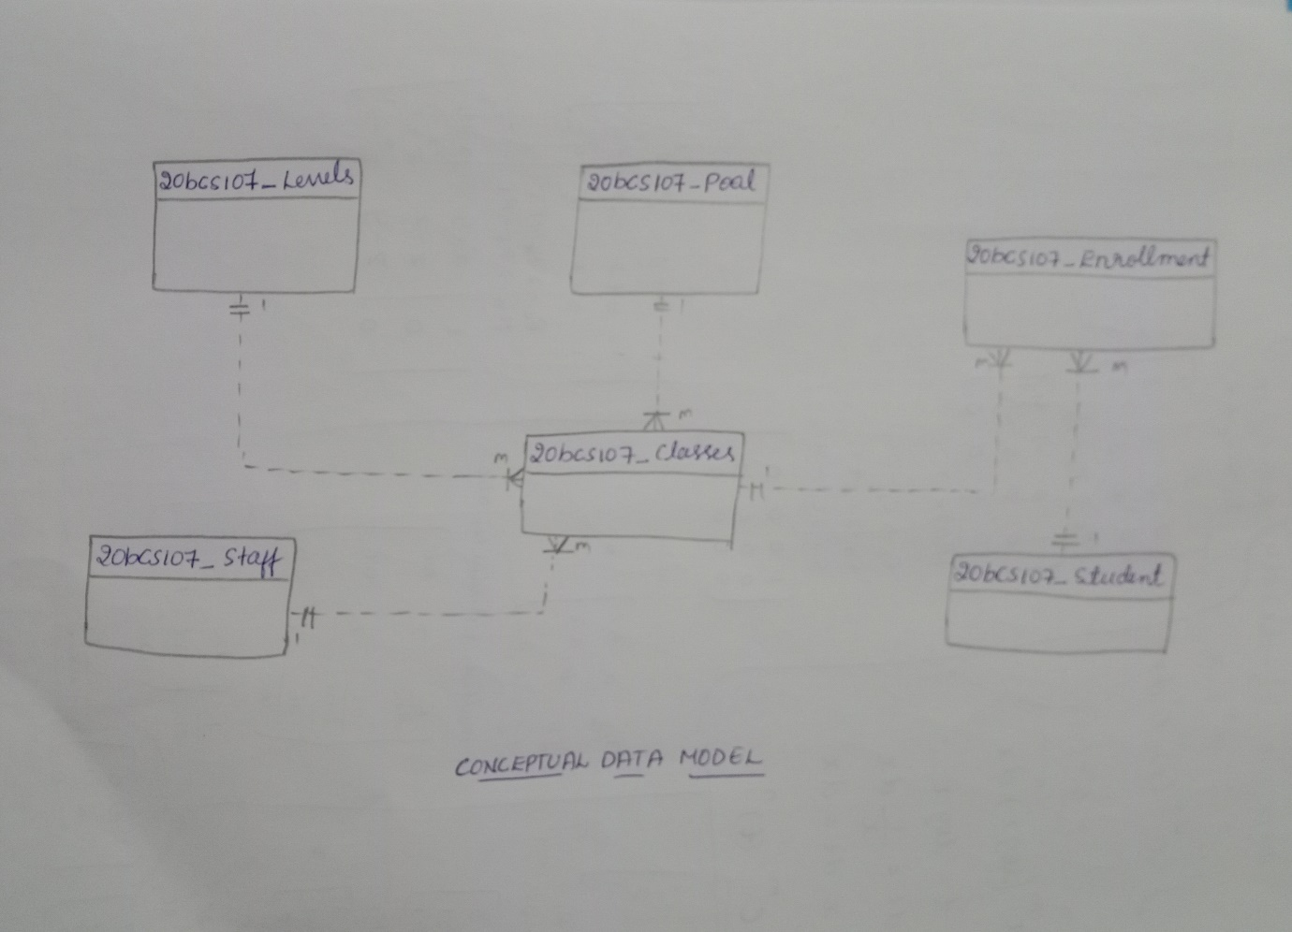

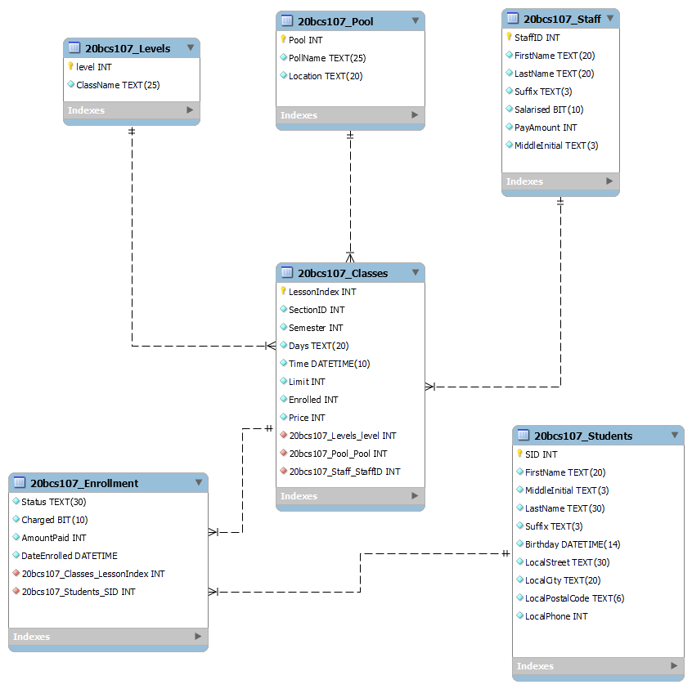

The cardinality of these relationship as follows;

* Classes to Level = Many to one
* Classes to Pool = Many to one
* Classes to Enrollment = One to many
* Classes to Staff = Many to one
* Enrollment to Student = Many to one



In the above diagram enrollment is a weak entity as it does not contain primary key. Here we can use student id or class id to identify enrollment. Therefore, to assign it as a primary key we use composite keys so we can convert it into strong entities.