Explain this architecture in detail in simple words
Absolutely. This diagram is essentially showing how OICL's data will travel from different source systems → into the Data Lakehouse → get processed/governed → become available for analytics, fraud detection, APIs and GenAI.
Think of it like a large central data factory:
Sources → Ingestion → Processing → Storage → Query/Serving → Business Applications
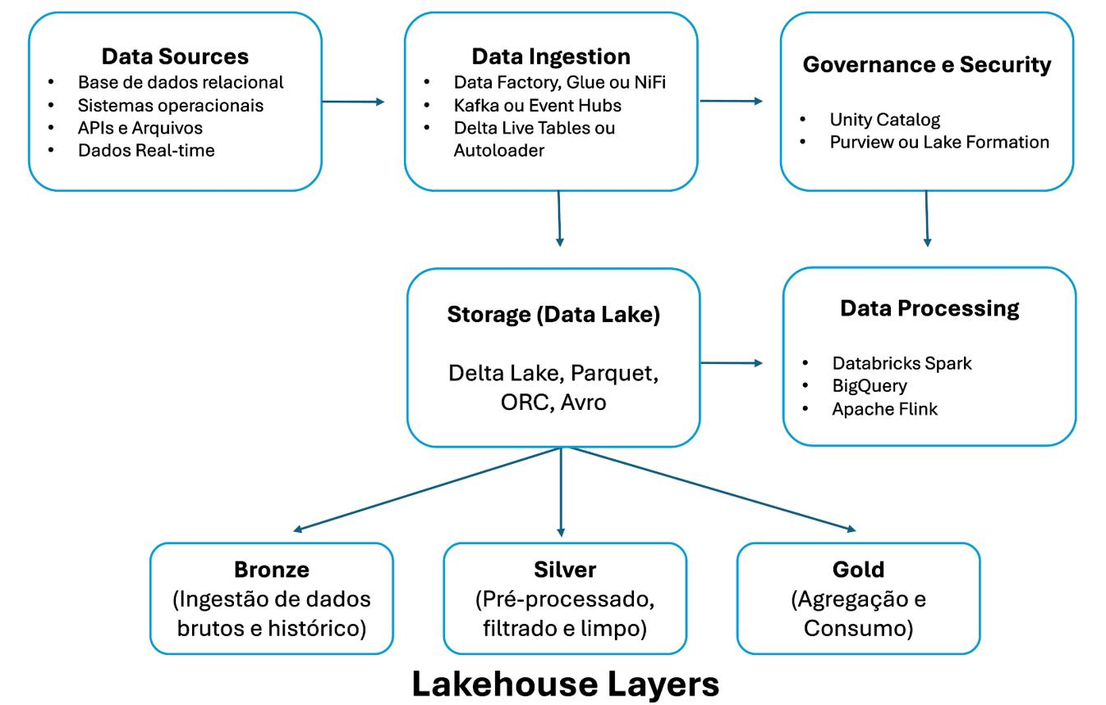
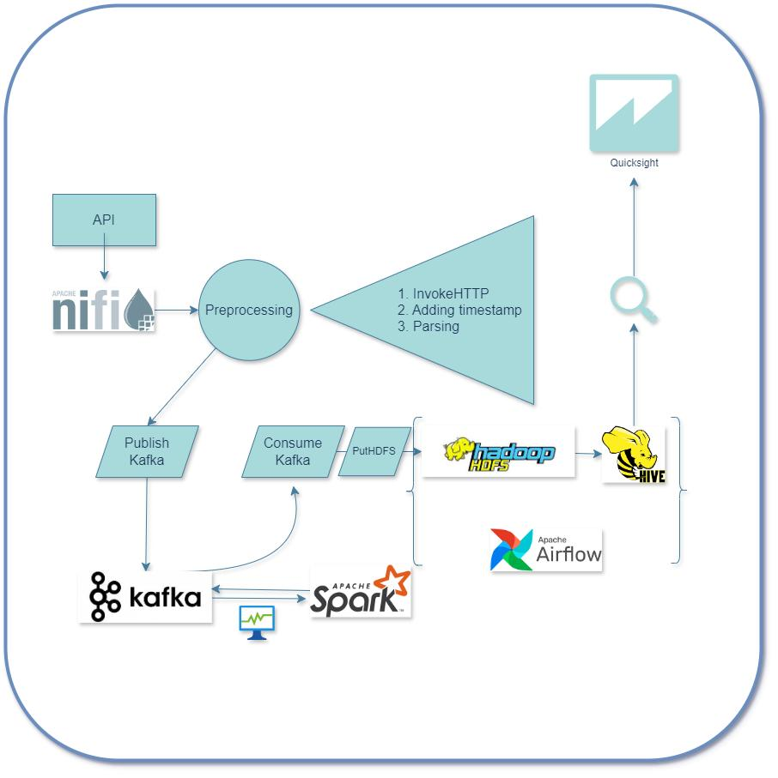
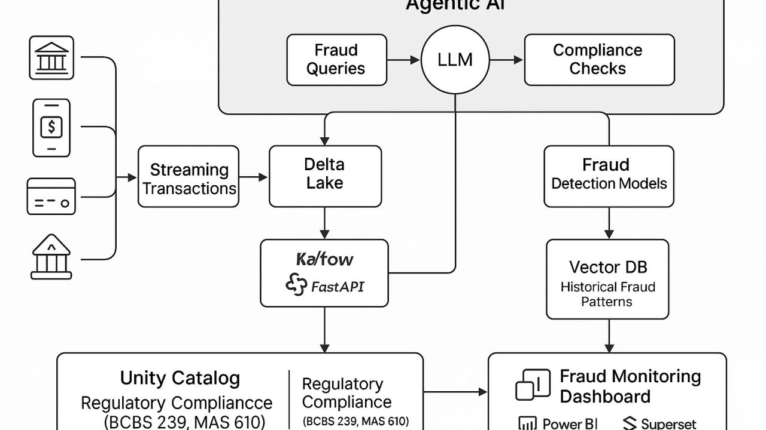
6
1. First understand the complete flow
The architecture can be simplified to:
OICL Source Systems
↓
INGESTION
NiFi + Kafka
↓
PROCESSING / ORCHESTRATION / AI
Spark + Airflow + GPU
↓
LAKEHOUSE STORAGE
MinIO S3
Bronze → Silver → Gold
↓
QUERY / SERVING STORES
Trino + OpenSearch + PostgreSQL
MongoDB + Milvus + Neo4j
↓
CONSUMPTION
BI / Fraud / APIs / GenAI
And across all these layers, there are common services such as:
- Kubernetes
- IAM
- Observability
- Security
- Data Governance
- DR & Resilience
These are called cross-cutting services because they don't belong to just one layer—they support the entire platform.

2. SOURCE SYSTEMS
At the very top, we have the systems from which OICL's data originates.
The diagram shows:
Source | What it means
Middleware | Integration/middleware systems
INLIAS Core | OICL core insurance/application system
ECM OpenText | Enterprise Content Management
HRMS PeopleSoft | Human Resources data
SAP Investment | Investment/financial data
CSOC Logs | Cyber/security operation logs
External TPA/DSP | External third-party data
Simple example
Suppose an OICL policy is created.
The policy information may initially exist in the core insurance system.
Similarly:
- Employee information → HRMS
- Investment information → SAP
- Documents → OpenText
- Security events → CSOC
- Third-party claims/services → TPA/DSP
The Data Lakehouse needs to bring all this information together.
That's where Ingestion starts.

3. INGESTION LAYER
The diagram has two major technologies here:
Apache NiFi
Apache Kafka
They solve slightly different problems.

3.1 Apache NiFi
NiFi is used for moving data from source systems into the platform.
Think of NiFi as a data transportation and routing system.
For example:
HRMS
↓
NiFi
↓
Data Lake
NiFi can handle:
- Batch data
- File-based data
- Database data
- CDC
- Data routing
- Data transformation
- Data movement
What is CDC?
CDC = Change Data Capture.
Suppose an employee's department changes:
Before:
Employee 101 → Finance

After:
Employee 101 → IT
Instead of sending the entire HR database again, CDC can capture the change:
Employee 101
Department changed
Finance → IT
That is much more efficient.

4. Apache Kafka
Kafka is primarily for real-time streaming data.
Think of Kafka as a real-time conveyor belt.
For example:
Application
↓
Kafka
↓
Processing
↓
Fraud Detection
Suppose an insurance claim is submitted.
Kafka can immediately stream the event:
Claim submitted
↓
Kafka
↓
Fraud model
↓
Risk = HIGH
So:
NiFi
Good for:
Moving, routing and ingesting different types of data, including batch/file/CDC.
Kafka
Good for:
Continuous real-time event streaming.
They can therefore complement each other.

5. PROCESSING, ORCHESTRATION & AI
After data enters the platform, it has to be processed.
The diagram shows:
- Apache Spark
- Apache Airflow
- AI/ML – 4 × H200 GPU node

6. Apache Spark
Spark is the heavy-duty data processing engine.
Imagine OICL has:
500 million policy/claim/customer records.
Spark can process huge amounts of data in parallel.
For example:
Raw data
↓
Spark
↓
Clean
Transform
Join
Aggregate
Calculate
↓
Processed data
Example
Suppose:
Policy table
Claims table
Customer table
Spark could join them and calculate:
Customer
Total Policies
Total Claims
Total Claim Amount
Claim Frequency
Risk Score
This processed data then goes into the Lakehouse layers.

7. Apache Airflow
Airflow is different from Spark.
A very important distinction:
Spark does the work. Airflow decides when and in what order the work happens.
Think of Airflow as the manager/scheduler.
For example:
12:00 AM
↓
Extract data
↓
Validate data
↓
Run Spark job
↓
Load Silver
↓
Create Gold tables
↓
Update analytics
Airflow manages this workflow.
It can also:
- Schedule jobs
- Monitor jobs
- Retry failed jobs
- Define dependencies
- Run pipelines
- Coordinate multiple processing tasks
Example
You could have:
Task 1 → Ingest claims
↓
Task 2 → Validate claims
↓
Task 3 → Spark transformation
↓
Task 4 → Store Silver
↓
Task 5 → Create Gold dataset
Airflow makes sure the tasks happen in the correct sequence.

8. AI / ML – 4 × H200 GPU Nodes
This is the AI/ML compute section.
The architecture proposes:
4 × NVIDIA H200 GPU nodes
These GPUs are intended for computationally intensive AI/ML workloads.
For OICL, examples could include:
Fraud detection
Claim data
↓
ML model
↓
Risk score
↓
Potential fraud
GenAI
OICL documents/data
↓
AI/LLM
↓
Chatbot / question answering
Other possible workloads
- Fraud prediction
- Anomaly detection
- Classification
- Risk scoring
- NLP
- Document intelligence
- Embeddings
- GenAI/LLM inference
So the GPU infrastructure is essentially the AI engine of the platform.

9. LAKEHOUSE STORAGE
This is probably the most important section of the architecture.
The diagram proposes:
MinIO S3 Object Store – 700 TB usable (PROD-DC)
MinIO provides S3-compatible object storage.
Think of this as the main warehouse where the organization's data is stored.

10. Why is it called a Data Lakehouse?
A traditional:
Data Warehouse
is structured and optimized for analytics.
A:
Data Lake
can store many types of raw data.
A:
Data Lakehouse
tries to provide the flexibility of a data lake with many of the management/analytics capabilities associated with a warehouse.
This architecture is therefore using object storage as the central data foundation.

11. Bronze → Silver → Gold
This is extremely important.
The architecture divides the data into three zones.
Bronze – Raw Zone
This is the original/raw data.
Example:
Source:
HRMS

Data:
Employee_ID | Name | Dept | Salary
The idea is:
Don't heavily modify the original data.
Bronze acts as the raw historical copy.
Think:
Bronze = What came from the source

12. Silver – Schema Zone
Now the raw data gets:
- Cleaned
- Validated
- Standardized
- Deduplicated
- Transformed
- Structured
For example:
Bronze:
"01-08-26"
"2026/08/01"
"Aug 1 2026"
Silver could standardize these into:
2026-08-01
Similarly:
"Male"
"M"
"M"
could be standardized.
Think:
Silver = Clean and standardized data

13. Gold – Curated Zone
Gold contains business-ready data.
For example, instead of making a BI dashboard repeatedly process millions of raw records, we can create a curated dataset:
Monthly Claims Summary

Month | Claims | Amount | Fraud Cases
Jan | 20,000 | ₹XX | 350
Feb | 22,000 | ₹XX | 420
This is much easier for:
- BI
- Reporting
- Fraud analytics
- APIs
- Business users
Think:
Gold = Ready-to-use business data

14. Very simple example of the three layers
Imagine a customer makes an insurance claim.
Bronze
Raw claim received
↓
Silver
Claim cleaned
Customer ID validated
Date standardized
Duplicate removed
Amount validated
↓
Gold
Customer claim history
Claim frequency
Claim amount
Fraud risk
Business KPIs
That's the basic idea behind:
Bronze → Silver → Gold

15. QUERY & SERVING STORES
After data is stored, different applications need to access it efficiently.
That's why the architecture doesn't use one database for everything.
It has:
- Trino
- OpenSearch
- PostgreSQL
- MongoDB
- Milvus
- Neo4j
Each has a different purpose.

16. Trino
Trino is the SQL query engine.
Think of Trino as a person who can go into different data stores and ask:
"Give me the data I need."
For example:
SELECT
month,
SUM(claim_amount)
FROM claims
GROUP BY month;
Trino can query data stored in the lakehouse.
The architecture also indicates federated SQL.
That means Trino can potentially query data from multiple sources without physically moving everything into one database.
Simple example
MinIO
\
PostgreSQL → Trino → SQL Query
/
Other sources

17. OpenSearch
OpenSearch is designed primarily for:
- Search
- Log analytics
- Fast text-based querying
- Operational analytics
For example:
Search:
"Claim number 12345"
or:
Find all security logs
where severity = HIGH
It is particularly useful for log/search-oriented workloads.

18. PostgreSQL
PostgreSQL is a relational database.
It is useful for structured operational data.
For example:
Customer
Policy
Transaction
Application
Configuration
It is not necessarily intended to replace the large central lakehouse.
Instead, it can support operational/metadata/application workloads.

19. MongoDB
MongoDB is a document database.
Instead of storing data primarily as rows and columns, it works well with document-style data.
Example:
{
"customer": 101,
"policy": 5001,
"claims": [...]
}
Useful where flexible document structures are required.

20. Milvus
Milvus is a vector database.
This becomes important for AI/GenAI.
Suppose OICL has thousands of documents:
Policy documents
Claim documents
Circulars
Guidelines
FAQs
Reports
These documents can be converted into embeddings/vectors.
Milvus stores those vectors.
Then a user can ask:
"What is the procedure for settling this type of claim?"
The system can find documents that are semantically similar to the question.
This is commonly used in:
RAG – Retrieval Augmented Generation

21. Neo4j
Neo4j is a graph database.
It is particularly useful when relationships between entities are important.
For fraud detection, imagine:
Customer A
↓
Phone Number X
↓
Bank Account Y
↓
Customer B
↓
Policy Z
A graph database can help identify suspicious relationships.
For example:
Multiple customers
↓
Same phone number
↓
Same bank account
↓
Multiple suspicious claims
That can be extremely useful for fraud analytics.

22. Why so many databases?
This is an important architecture concept.
The design is polyglot persistence.
It means:
Don't force every workload into one database.
Instead:
Technology | Main purpose
MinIO | Central lakehouse/object storage
Trino | SQL querying
OpenSearch | Search/log analytics
PostgreSQL | Relational/operational workloads
MongoDB | Document workloads
Milvus | Vector/AI search
Neo4j | Relationship/graph analytics
Each technology is selected for a specific workload.

23. CONSUMPTION LAYER
This is where the business users finally see/use the data.
The diagram shows four major consumption areas:
BI & Reports
Fraud Analytics
Data APIs
GenAI / Chatbot

24. BI & Reports
BI = Business Intelligence.
Examples:
Claims Dashboard
Policy Dashboard
Investment Dashboard
Branch Performance
Premium Analysis
Customer Analysis
Business users can view:
- KPIs
- Charts
- Trends
- Reports
- Dashboards
The data generally comes from the curated/Gold layer or serving systems.

25. Fraud Analytics
This is one of the major use cases.
The flow could look like:
Claims
Policies
Customers
Transactions
External data
↓
Lakehouse
↓
Spark / ML
↓
Fraud models
↓
Fraud score
↓
Fraud Analytics
For example:
Claim #12345
Risk Score = 92%
The system can flag it for investigation.

26. Data APIs
The data shouldn't only be consumed by dashboards.
Other applications may need data.
For example:
Mobile App
↓
API
↓
Data Platform
↓
Customer information
So Data APIs provide controlled access to data for other applications/services.

27. GenAI / Chatbot
This is the AI interface.
A user could ask:
"Show me the claims with unusually high fraud risk in Karnataka."
Or:
"What is the claim settlement procedure for policy type X?"
The system can potentially combine:
Lakehouse data
+
Vector search
+
LLM
+
Business rules
and provide an answer.

28. CROSS-CUTTING SERVICES
Now we come to the right side of the architecture.
This section is extremely important because these services apply to almost the entire platform.

29. Kubernetes Platform
The architecture is described as:
Kubernetes-native
Kubernetes manages containerized applications.
Instead of manually managing every application server:
Server 1
Server 2
Server 3
Server 4
...
Kubernetes manages workloads as containers/pods.
For example:
Kubernetes
├── NiFi
├── Kafka
├── Spark
├── Airflow
├── Trino
├── OpenSearch
└── Other services
It can help with:
- Deployment
- Scaling
- Restarting failed containers
- Resource management
- High availability
- Service discovery

30. Keycloak IAM
IAM = Identity and Access Management.
Keycloak handles things such as:
- User authentication
- Login
- Roles
- Permissions
- Single Sign-On
For example:
Admin
Can access:
All data
All configurations
Analyst
Can access:
Analytics
Reports
Data Engineer
Can access:
Data pipelines
Processing
The objective is:
The right user should get the right access.

31. Observability
The diagram mentions:
Grafana / Prometheus / Loki
These are used for monitoring and observability.
Think of this as the health-monitoring system of the platform.
You want to know:
Is Kafka running?
Is Spark running?
How much CPU is being used?
How much memory?
Are jobs failing?
Is storage filling up?
Are APIs responding?
For example:
CPU usage = 85%
Memory = 78%
Kafka broker = Healthy
Spark job = Failed
This helps operations teams detect problems quickly.

32. Security
The diagram mentions security technologies such as:
- IAM
- SIEM
- SOAR
- EDR
- PAM
These provide different security capabilities.
IAM
Controls identities and access.
SIEM
Security Information and Event Management.
Collects and analyzes security logs/events.
SOAR
Security Orchestration, Automation and Response.
Automates security responses.
EDR
Endpoint Detection and Response.
Monitors endpoints/servers for suspicious activity.
PAM
Privileged Access Management.
Controls highly privileged accounts.
So security isn't just one product—it is a layer around the entire platform.

33. Data Governance
The diagram mentions:
Catalog, Lineage, DQ, MDM
These are extremely important in an enterprise data platform.
Data Catalog
Answers:
What data do we have?
Example:
Customer_Master
Claims
Policies
Investments

Data Lineage
Answers:
Where did this data come from?
Example:
HRMS
↓
NiFi
↓
Bronze
↓
Spark
↓
Silver
↓
Gold
↓
Dashboard
So if someone asks:
"Where did this KPI come from?"
lineage can help answer that.

Data Quality – DQ
Answers:
Is the data correct and usable?
Checks can include:
- Null values
- Duplicate records
- Invalid dates
- Invalid IDs
- Incorrect formats
- Missing fields

MDM
MDM = Master Data Management.
It tries to establish trusted master records for important entities such as:
- Customer
- Policy
- Branch
- Employee
- Product

34. DR & RESILIENCE
DR = Disaster Recovery.
The diagram shows:
100% replica @ PROD-DR
The basic idea is:
PROD-DC
↓
Replication
↓
PROD-DR
DC = Data Centre
DR = Disaster Recovery site.
If the primary data centre experiences a major failure, the DR environment is available to support recovery/business continuity.

35. ENVIRONMENTS
The architecture shows four environments:
PROD-DC
Production environment in the primary data centre.
This is the live environment.

PROD-DR
Production Disaster Recovery.
This is the recovery environment.
The architecture indicates that it is intended to be a replica of production.

UAT
UAT = User Acceptance Testing.
Business users test whether the system works correctly before production deployment.
Example:
New dashboard
↓
UAT
↓
Business users test
↓
Approved
↓
Production

Pre-Prod
Pre-production is an environment that closely resembles production and is used for final technical validation before going live.

36. Why does UAT/Pre-Prod have lower compute?
At the top of the architecture, it says:
PROD-DC with 100%, PROD-DR replica, UAT / Pre-Prod at ~45% compute
The idea is that production requires the full capacity because it handles actual workloads.
UAT and Pre-Prod don't normally need the same compute capacity as production.
For example, conceptually:
Production → 100% compute
UAT → ~45%
Pre-Prod → ~45%
This reduces infrastructure cost while still providing sufficient capacity for testing.

37. Put everything together
Let's follow one example.
Suppose a customer submits an insurance claim.
Step 1 – Source
Claim originates from an OICL application/system.
Source System
↓
Step 2 – Ingestion
If it is an event that needs real-time processing:
Kafka
If it is batch/file/CDC-oriented:
NiFi

Step 3 – Processing
Data can be processed using:
Spark
Airflow controls the workflow:
Airflow
↓
Spark

Step 4 – Storage
Raw claim:
Bronze
Cleaned claim:
Silver
Business-ready claim dataset:
Gold
All stored on:
MinIO S3

Step 5 – Analytics
Trino can query the data.
Fraud analytics can use:
Spark + ML
Neo4j can analyze relationships.

Step 6 – AI
The AI/ML infrastructure can process the claim.
For example:
Claim
↓
ML Model
↓
Fraud probability = 87%

Step 7 – Consumption
The result can reach:
Fraud Dashboard
+
BI Reports
+
Data APIs
+
GenAI/Chatbot

38. The most important architectural idea
If you are reviewing this architecture against an RFP, don't just look at the individual products.
Look at whether the complete data lifecycle is covered.
The architecture is basically covering:
Requirement area | Architecture component
Source integration | Source systems
Data ingestion | NiFi + Kafka
Batch processing | Spark
Real-time processing | Kafka + processing
Workflow orchestration | Airflow
Central data lakehouse | MinIO
Raw data | Bronze
Clean data | Silver
Curated data | Gold
SQL analytics | Trino
Search/log analytics | OpenSearch
Relational workloads | PostgreSQL
Document workloads | MongoDB
Vector/AI search | Milvus
Graph/fraud relationships | Neo4j
BI | BI & Reports
Fraud detection | Fraud Analytics + AI/ML
API access | Data APIs
GenAI | GenAI/Chatbot + GPU
Container platform | Kubernetes
IAM | Keycloak
Monitoring | Prometheus/Grafana/Loki
Security | IAM/SIEM/SOAR/EDR/PAM
Governance | Catalog/Lineage/DQ/MDM
DR | PROD-DR
Testing | UAT + Pre-Prod

39. One thing I would pay special attention to in this architecture
The diagram is a high-level solution architecture, not necessarily proof that every detailed RFP requirement is satisfied.
For an RFP review, I would ask the OEM/vendor to explicitly map:
RFP requirement → component/product → edition/version → quantity → capacity → HA/DR → license → environment → compliance
For example, merely writing:
"Data Governance – Catalog, Lineage, DQ, MDM"
doesn't prove that all four capabilities are actually covered.
You need to know which product provides each capability, its edition, deployment model, licensing and sizing.
Similarly:
"Security – IAM, SIEM, SOAR, EDR, PAM"
is a capability statement. It doesn't by itself tell you which actual products are being proposed.

40. In one sentence
The entire architecture can be understood as:
OICL collects data from many insurance/business systems, brings it into the platform using NiFi/Kafka, processes it using Spark and Airflow, stores it centrally in MinIO using Bronze/Silver/Gold layers, makes it available through specialized query/serving databases, and finally delivers BI, fraud analytics, APIs and GenAI—with Kubernetes, security, governance, monitoring and DR protecting the entire platform.
If you're using this for your OICL RFP technical review, the next useful step is to break this exact diagram into Data Lake + Data Warehouse/Lakehouse + Data Governance + Fraud Detection + BI + AI/ML + Infrastructure + Security, and identify what is covered, what is missing, and what questions you should ask the OEM/vendor.
Explain the flow in short and simple
Sure. The whole flow can be understood in just 6 simple steps:
🔄 OICL Data Flow
1. Source Systems → Data comes from different OICL systems
Examples:
- INLIAS
- HRMS
- SAP
- OpenText
- CSOC
- External systems
⬇️
2. Ingestion → Bring the data into the platform
- NiFi → batch/files/CDC data
- Kafka → real-time streaming data
⬇️
3. Processing → Clean and process the data
- Spark → processes/transforms large data
- Airflow → schedules and manages the processing jobs
- AI/ML → performs AI/fraud-related processing
⬇️
4. Lakehouse Storage → Store the data
Data is stored in MinIO in 3 layers:
Bronze → Silver → Gold
- 🟤 Bronze = Raw data
- ⚪ Silver = Cleaned/processed data
- 🟡 Gold = Business-ready data
⬇️
5. Query & Serving → Make the data easily usable
Different tools serve different purposes:
- Trino → SQL queries
- OpenSearch → search/logs
- PostgreSQL/MongoDB → application data
- Milvus → AI/vector search
- Neo4j → relationships/fraud analysis
⬇️
6. Consumption → Business users use the data
Finally, the data goes to:
- 📊 BI & Reports
- 🚨 Fraud Analytics
- 🔌 Data APIs
- 🤖 GenAI/Chatbot
In one line:
Source Systems → NiFi/Kafka → Spark/Airflow → MinIO (Bronze/Silver/Gold) → Trino & other serving stores → BI/Fraud/API/GenAI
And Kubernetes, Security, IAM, Monitoring, Governance and DR support the entire flow from beginning to end.

