What is lighthouse? Simply explain what is the problem and objective and what solution is required?
Yes. Let me explain “Lighthouse” in this EOI context very simply, because here “Lighthouse” is not the software term—it refers to marine lighthouses and the wider navigation infrastructure managed by DGLL.
1. First: What is a lighthouse?
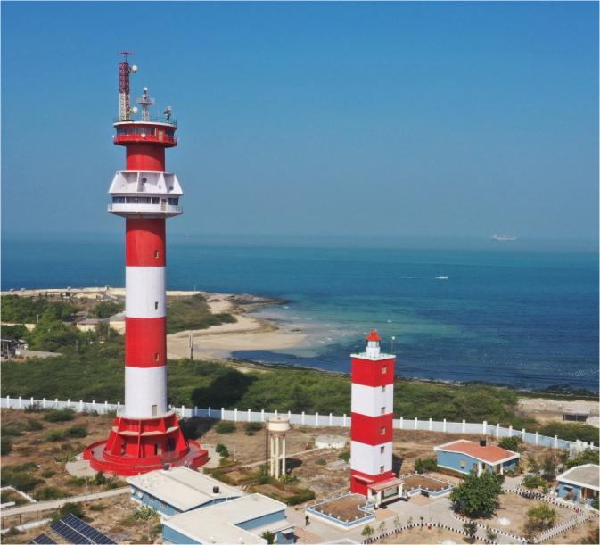
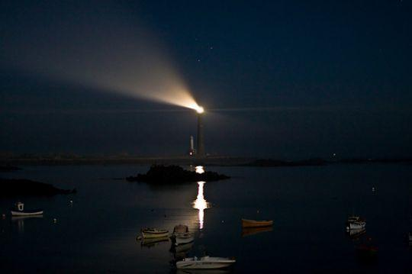
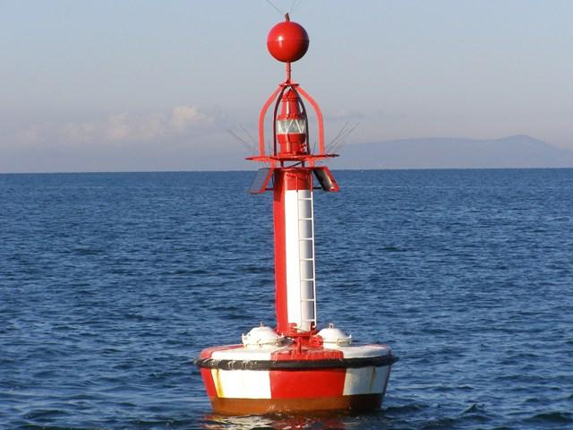
5
A lighthouse is a navigation aid for ships.
Imagine a ship travelling along the Indian coast at night or during bad weather. It needs to know:
- Where is the coastline?
- Where are dangerous areas?
- Where should I go?
- Is there a navigation obstacle?
- Are navigation signals working?
A lighthouse provides a visible light/signalling reference so ships can safely navigate.
But DGLL's job is much bigger than just lighthouses.
DGLL manages many Aids to Navigation (AtoN), including:
- Lighthouses
- Light beacons
- Buoys
- Racon radar beacons
- NAIS/AIS
- DGNSS
- Navtex
- VTS
- SCADA/PLC systems
- CCTV
- Solar power, batteries, DG sets, UPS
- Sensors and communication systems
The EOI says DGLL manages AtoN infrastructure along approximately 11,000+ km of Indian coastline and island territories.

2. So what is the actual problem?
This is the most important part.
DGLL has many different systems generating huge amounts of data, but currently that data is largely monitored and analysed manually or semi-automatically, station by station.
The EOI specifically says this results in:
reactive maintenance, delayed fault identification, and under-utilisation of available data.
Think of this example:
Suppose a lighthouse has:
Solar panel → Battery → UPS → Light → Communication equipment
Today, the system may generate data such as:
Battery voltage
Solar generation
Light operating hours
Temperature
Communication status
Equipment alarms
Maintenance records
But imagine this data is sitting in different systems.
One system knows the battery status.
Another knows the lighthouse status.
Another has maintenance records.
Another has weather data.
Another has vessel data.
And people have to manually look at these systems and understand what is happening.

3. The biggest problem: they are reacting AFTER something goes wrong
Suppose a lighthouse battery is slowly deteriorating.
Today:
Battery health decreasing
↓
Nobody notices early enough
↓
Battery fails
↓
Lighthouse may stop functioning
↓
Engineer receives alert
↓
Engineer investigates
↓
Maintenance/replacement
This is reactive maintenance.
The EOI wants to change this to:
Battery health decreasing
↓
AI analyses historical + real-time data
↓
AI predicts:
"Battery likely to fail in ~30 days"
↓
System generates alert
↓
Maintenance team takes preventive action
↓
Battery replaced/repaired
↓
Failure avoided
This is predictive maintenance.
That is one of the central ideas behind the entire project. DGLL explicitly wants to move from reactive, manual monitoring to predictive, automated and intelligence-led operations.

4. Then what is the objective?
The objective is basically:
Take all the scattered data from DGLL's lighthouse/AtoN infrastructure, bring it into one platform, use AI/ML to understand and predict problems, and give DGLL people dashboards and alerts so they can make better decisions.
The EOI describes the objective as strengthening AI/ML-based data analytics and statistical decision support across the AtoN network, while also strengthening cybersecurity of the underlying OT environment.
So there are actually two major objectives:
Objective 1 — Intelligence
Use data + AI/ML to answer:
What is happening?
Why is it happening?
What is likely to happen?
What should DGLL do about it?
Objective 2 — Security
Protect the systems producing this data from cyber threats.
For example:
Lighthouse
Racon
NAIS
DGNSS
Navtex
VTS
SCADA/PLC
↓
DATA
↓
AI/Analytics Platform
The systems above are considered critical maritime infrastructure, so the EOI requires cybersecurity for both the IT analytics platform and the underlying OT environment.

5. What solution are they asking the vendor to provide?
This is where the EOI becomes a technology project.
They essentially want the vendor to build a central AI/ML-enabled Data Analytics Platform for DGLL.
Think of it as a central brain for DGLL's AtoN infrastructure.
Current situation
Lighthouse ────────┐
Racon ─────────────┤
NAIS ──────────────┤
DGNSS ─────────────┤
Navtex ────────────┤
VTS ───────────────┤
SCADA/PLC ─────────┤
CCTV ──────────────┤
Weather ───────────┤
ERP ───────────────┤
Maintenance data ──┘

↓

Different systems
Manual monitoring
Limited central analysis
Proposed situation
DGLL AtoN SYSTEMS
│
┌─────────────┼─────────────┐
↓ ↓ ↓
NAIS DGNSS Racon
VTS Navtex SCADA
CCTV Weather IoT
ERP Maintenance etc.
└─────────────┬─────────────┘
↓
DATA INGESTION LAYER
↓
ENTERPRISE DATA LAKE
↓
AI / ML PLATFORM
↓
┌─────────────┼─────────────┐
↓ ↓ ↓
Predictive Anomaly Vessel
Maintenance Detection Analytics
↓ ↓ ↓
└─────────────┼─────────────┘
↓
GIS + DASHBOARDS
↓
DGLL Officers / Engineers
↓
Alerts + Recommendations
The EOI specifically calls for a centralised Enterprise Data Lake/data platform, AI/ML models, an enterprise AI platform, role-based dashboards, GIS integration and integration with existing DGLL systems.

6. What will AI actually do?
This is another important point.
They don't just want a dashboard showing numbers.
They want AI to analyse the data and predict things.
Example 1 — Lighthouse failure
AI looks at:
Voltage
Temperature
Operating hours
Historical failures
Maintenance history
Weather
Power generation
and predicts:
"High probability of lighthouse equipment failure."
The EOI calls for predictive failure analysis and remaining-useful-life prediction.

Example 2 — Battery
AI could analyse:
Battery voltage
Charge/discharge cycles
Temperature
Age
Historical behaviour
Solar generation
and estimate:
"Battery remaining useful life is decreasing."
Battery health and remaining-life prediction are explicitly listed as use cases.

Example 3 — Ship movement
NAIS/AIS provides vessel movement information.
The platform can analyse:
Ship location
Ship speed
Ship direction
Historical routes
Traffic density
and identify things such as:
- unusual vessel movement
- illegal anchorage
- vessels with AIS switched off ("dark vessels")
- congestion
- potential close-quarters/near-collision situations
These are specifically listed under Vessel Traffic Intelligence.

Example 4 — Navigation coverage
Using GIS, the system can identify:
"Is there an area along the coast where AtoN coverage is insufficient?"
It can analyse:
- AtoN locations
- service radius
- vessel traffic
- geographical risk
- coastal areas
and support decisions about where a buoy/lighthouse/AtoN should be placed.
The EOI calls this coverage gap analysis, service-radius optimisation, buoy placement optimisation and DGNSS coverage optimisation.

7. What does the final solution look like to DGLL officers?
They should not have to understand all the AI models.
They should see something like:
National Dashboard
------------------------------------------------
DGLL NATIONAL ATO N DASHBOARD
------------------------------------------------

Total AtoN 1,XXX

Healthy 92%

At Risk 5%

Critical 3%

------------------------------------------------
Critical Alerts

🔴 Lighthouse ABC
Battery failure predicted

🔴 Racon XYZ
Performance degradation detected

🟠 DGNSS Station
Signal quality declining

------------------------------------------------

Vessel Traffic
High congestion → Mumbai Coast

Navigation Risk
High → Coastal Segment X
------------------------------------------------
The EOI specifically requires role-based dashboards from national → regional → divisional → station level, with GIS, drill-down, alerts and reporting.

8. Why do they need GIS and Digital Twin?
Because this is geographical infrastructure.
A normal table saying:
Lighthouse A = Healthy
Lighthouse B = Critical
Lighthouse C = Healthy
is useful.
But putting them on a map is much more useful:
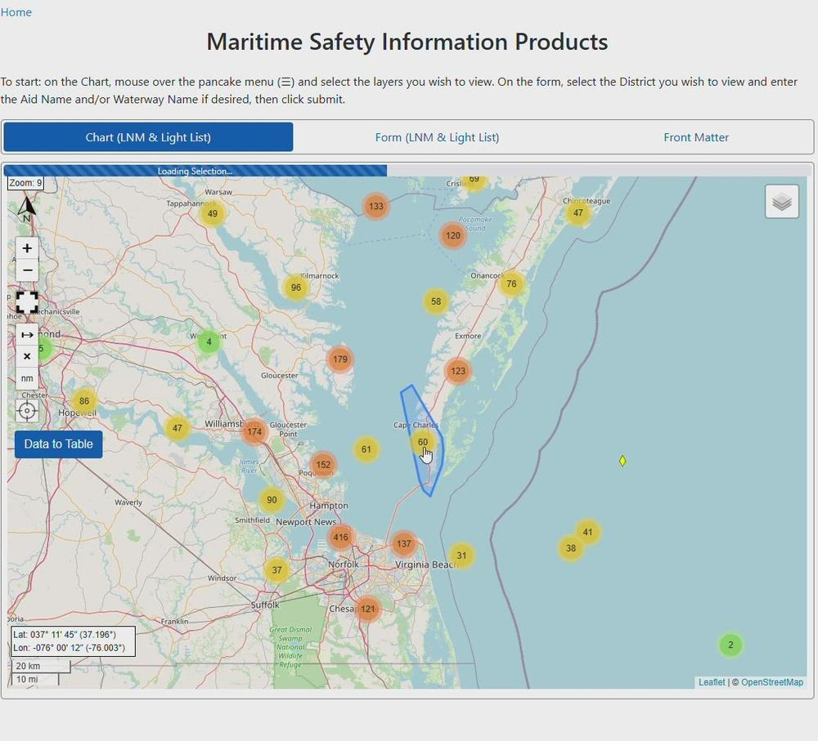
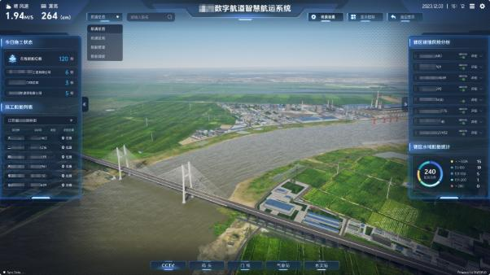
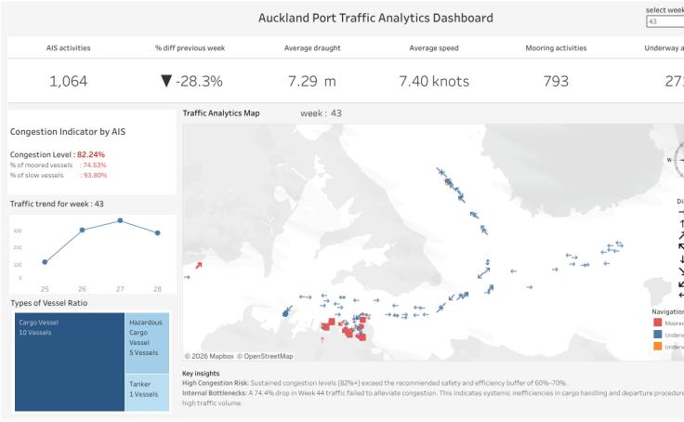
7
INDIA COAST

🟢 Lighthouse
|
🔴 Critical AtoN
|
🟠 High traffic
|
🟢 Healthy
The EOI therefore asks for a GIS layer and, where feasible, a Digital Twin of DGLL's AtoN network. The Digital Twin should eventually allow "what-if" analysis—for example, understanding the impact if a station goes offline.

9. One more very important requirement: Cybersecurity
This is not just an AI project.
This is a critical infrastructure project.
The vendor has to secure:
IT PLATFORM
+
OT ENVIRONMENT
The EOI mentions:
- Zero Trust
- MFA
- RBAC
- encryption
- audit logging
- SIEM integration
- secure coding
- CERT-In requirements
- ISO 27001 practices
- STQC testing where applicable
among other controls.
And the underlying systems include things like Racon, NAIS, DGNSS, Navtex, VTS and SCADA/PLC.

10. In one simple sentence
If I had to explain this entire EOI to someone in one sentence, I would say:
DGLL wants to build a central "intelligent brain" that collects data from all its lighthouses and other marine navigation systems across India, uses AI/ML to detect and predict failures and maritime risks, displays everything on GIS-based dashboards, provides alerts and recommendations, and securely protects the entire environment.

11. Problem → Objective → Solution
 | Simple explanation
PROBLEM | DGLL has thousands of geographically distributed AtoN assets and many systems generating data, but monitoring/analysis is largely manual and fragmented.
Result of problem | Faults may be detected late, maintenance is reactive, and valuable data is under-used.
OBJECTIVE | Move from manual/reactive monitoring to centralised, predictive, automated and intelligence-led operations.
SOLUTION | Build an AI/ML-enabled central data analytics platform.
Data | NAIS, DGNSS, Racon, Navtex, VTS, SCADA/PLC, CCTV, weather, IoT, ERP, maintenance records, etc.
Central Platform | Enterprise Data Lake + AI/ML platform
AI | Predict failures, detect anomalies, forecast equipment health, analyse vessel traffic, assess maritime risk, recommend maintenance.
GIS | Show AtoN assets, status, risk, coverage gaps and traffic geographically.
Users | DGLL station, divisional, regional, national and executive users.
Security | Protect both the AI/IT platform and critical OT systems.
Final benefit | Safer navigation, fewer unexpected failures, better maintenance planning and better decision-making.
The EOI's expected deliverables confirm this overall picture: a central data lake, AI platform/models, GIS dashboards, mobile interface, secure APIs, documentation, training, warranty and ongoing CAMC support.
And importantly: this EOI is not yet the final tender
DGLL is currently asking industry:
"Can you build this? What architecture would you recommend? What technology should we use? How much will it cost? How long will it take? What risks/challenges do you see?"
The EOI is explicitly a market-sounding and capability-assessment exercise intended to help DGLL prepare the subsequent RFP/tender.
So the vendor is not simply being asked to install an AI product. DGLL is looking for an end-to-end platform implementation—data integration + data lake + AI/ML + dashboards + GIS + cybersecurity + pilot + national rollout + training + maintenance.
What are LIGHTSHIPS
Lightships are basically lighthouses that are placed on ships/boats instead of being built on land.
Think of it like this:
🏠 Lighthouse
A permanent navigation light built on land or a fixed structure.
🚢 Lightship
A ship anchored at a specific location that carries powerful navigation lights and other equipment to warn/guide vessels.
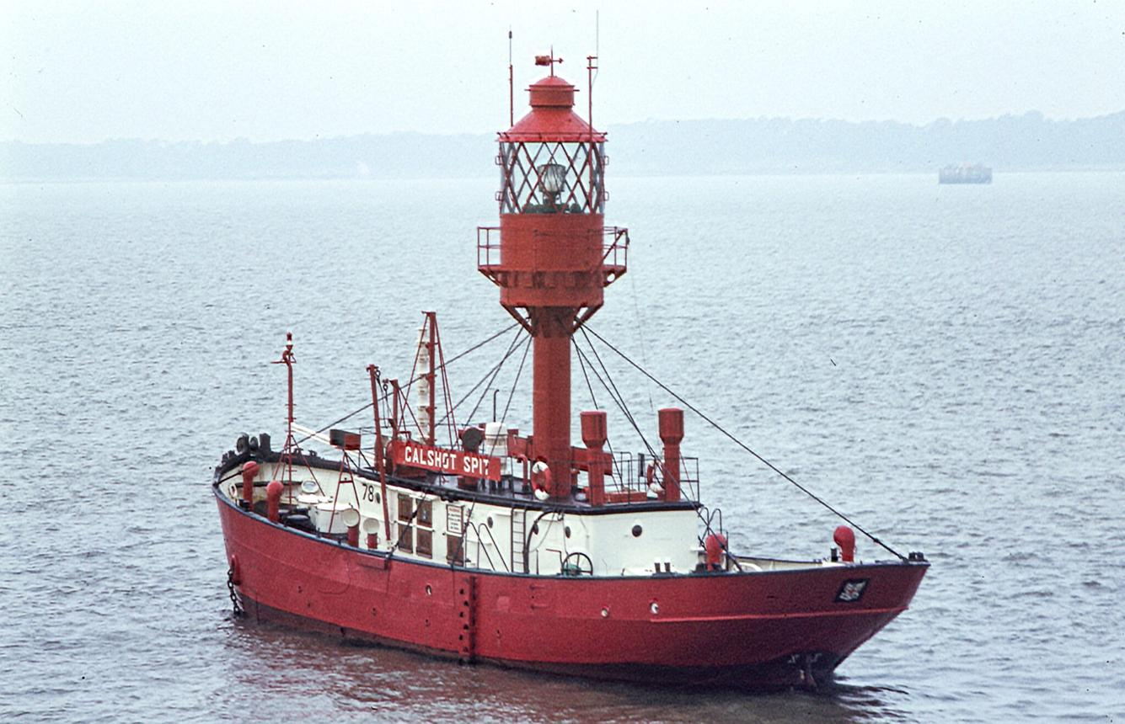
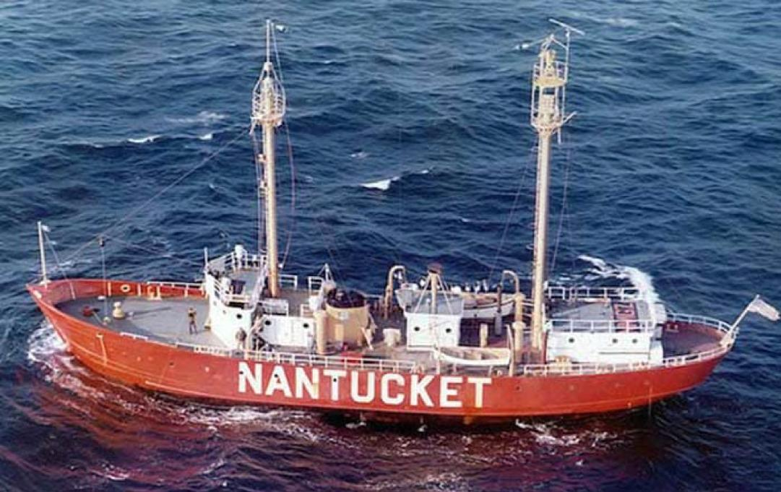
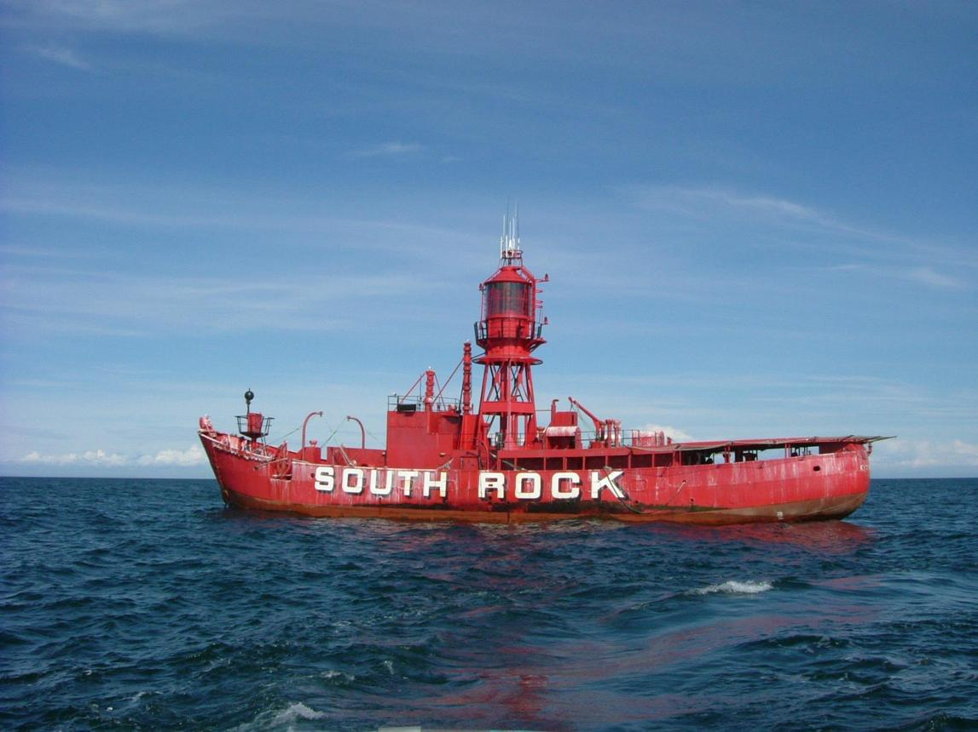
7
Why would you need a lightship?
Sometimes you cannot easily build a lighthouse at the required location—for example:
- Very deep water
- Dangerous offshore area
- A shallow reef/bank
- Important shipping route far from land
- Temporary navigation requirement
So instead of constructing a lighthouse there, a specially equipped vessel is positioned at that location.
For example:
LAND
🏠
Lighthouse
|
|
~~~~~~~~~~~~~~~~~~|~~~~~~~~~~~~~~~~ SEA

🚢
LIGHTSHIP
💡

🚢 Ship
The lightship essentially says to approaching ships:
"There is an important navigation point/hazard here. Use my position/light as a reference."
In your DGLL EOI
When the document says DGLL manages "Lighthouses, Lightships, Light Beacons, Buoys...", it means DGLL's Aids to Navigation infrastructure isn't limited to buildings called lighthouses. It includes different types of physical navigation aids.
So for this project, lightships are another type of AtoN asset whose operational/maintenance data may ultimately need to be brought into the central analytics platform.
Simple difference:
Lighthouse | Lightship
Fixed structure | Ship/vessel
Usually on land/coast | Located offshore
Cannot move easily | Can be relocated
Provides navigation light/signals | Provides navigation light/signals
Permanent installation | Can be deployed/relocated as required
In one line:
👉 A lightship is a floating lighthouse.

