**Industrial Internship Report on**

**Forecasting of Smart City Traffic Patterns**

**Crop and Weed Detection**

**Prepared by**

**Rakshitha K**

|  |
| --- |
| *Executive Summary* |
| This report provides details of the Industrial Internship provided by upskill Campus and The IoT Academy in collaboration with Industrial Partner UniConverge Technologies Pvt Ltd (UCT).  This internship was focused on a project/problem statement provided by UCT. We had to finish the project including the report in 6 weeks’ time.  My project was about forecast traffic patterns that helps in infrastructure planning and smart city solutions and crop and weed detection, system that sprays pesticides only on weeds, reducing waste  This internship gave me a very good opportunity to get exposure to Industrial problems and design/implement solution for that. It was an overall great experience to have this internship. |

**Abstract – Smart City Traffic Patterns Forecasting**

Traffic congestion is a persistent problem in modern cities, especially during peak hours, weekends, and holidays. In this project, traffic datasets containing features such as time, junctions, and events were analyzed to forecast vehicle flow. Machine learning models, including Random Forest and LSTM, were implemented to predict traffic density with high accuracy. The Random Forest model achieved an accuracy of ~85%, while the LSTM model performed slightly better at ~88%. The results demonstrate that predictive analytics can help government bodies and city planners design smarter traffic management systems, optimize infrastructure, and reduce congestion.

Keywords: Smart City, Traffic Forecasting, Machine Learning, Random Forest, LSTM

**Abstract – Crop & Weed Detection (Sesame Plants, 1300 Images)**

Weeds reduce crop productivity by competing for essential resources such as nutrients, sunlight, and water. Excessive pesticide spraying, while controlling weeds, also harms soil and crops. To address this challenge, a dataset of 1300 sesame plant images was collected, preprocessed, augmented, and labeled in YOLO format. A YOLOv5 deep learning model was trained to detect and classify sesame crops versus weeds. The model achieved a mean Average Precision (mAP) of ~90%, proving its ability to accurately distinguish weeds in agricultural fields. This system provides a sustainable approach to precision agriculture by enabling selective pesticide spraying, minimizing chemical usage, and increasing crop yield.

Keywords: Precision Agriculture, Object Detection, YOLOv5, Sesame Crops, Weed Detection, Deep Learning**TABLE OF CONTENTS**

1 Preface 3

2 Introduction 4

2.1 About UniConverge Technologies Pvt Ltd 4

2.2 About upskill Campus 8

2.3 Objective 9

2.4 Reference 9

2.5 Glossary 10

3 Problem Statement 11

4 Existing and Proposed solution 12

5 Proposed Design/ Model 13

5.1 High Level Diagram (if applicable) 13

5.2 Low Level Diagram (if applicable) 13

5.3 Interfaces (if applicable) 13

6 Performance Test 14

6.1 Test Plan/ Test Cases 14

6.2 Test Procedure 14

6.3 Performance Outcome 14

7 My learnings 15

8 Future work scope 16

# Preface

Summary of the whole 6 weeks’ work.

About need of relevant Internship in career development.

Brief about Your project/problem statement.

Opportunity given by USC/UCT.

How Program was planned

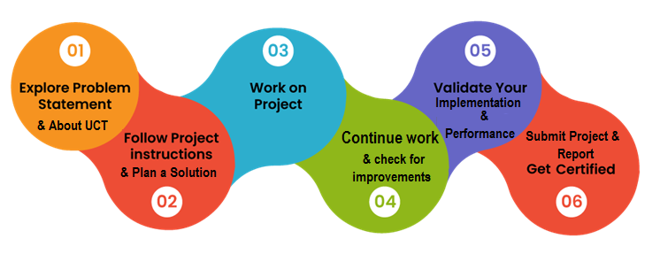

Your Learnings and overall experience.

Thank to all (with names), who have helped you directly or indirectly.

Your message to your juniors and peers.

# Introduction

## About UniConverge Technologies Pvt Ltd

A company established in 2013 and working in Digital Transformation domain and providing Industrial solutions with prime focus on sustainability and RoI.

For developing its products and solutions it is leveraging various**Cutting Edge Technologies e.g. Internet of Things (IoT), Cyber Security, Cloud computing (AWS, Azure), Machine Learning, Communication Technologies (4G/5G/LoRaWAN), Java Full Stack, Python, Front end**etc.



1. UCT IoT Platform **(****)**

**UCT Insight** is an IOT platform designed for quick deployment of IOT applications on the same time providing valuable “insight” for your process/business. It has been built in Java for backend and ReactJS for Front end. It has support for MySQL and various NoSql Databases.

* It enables device connectivity via industry standard IoT protocols - MQTT, CoAP, HTTP, Modbus TCP, OPC UA
* It supports both cloud and on-premises deployments.

It has features to  
• Build Your own dashboard  
• Analytics and Reporting  
• Alert and Notification  
• Integration with third party application(Power BI, SAP, ERP)  
• Rule Engine

 

1. **Smart Factory Platform (****)**

Factory watch is a platform for smart factory needs.

It provides Users/ Factory

* with a scalable solution for their Production and asset monitoring
* OEE and predictive maintenance solution scaling up to digital twin for your assets.
* to unleased the true potential of the data that their machines are generating and helps to identify the KPIs and also improve them.
* A modular architecture that allows users to choose the service that they what to start and then can scale to more complex solutions as per their demands.

Its unique SaaS model helps users to save time, cost and money.

 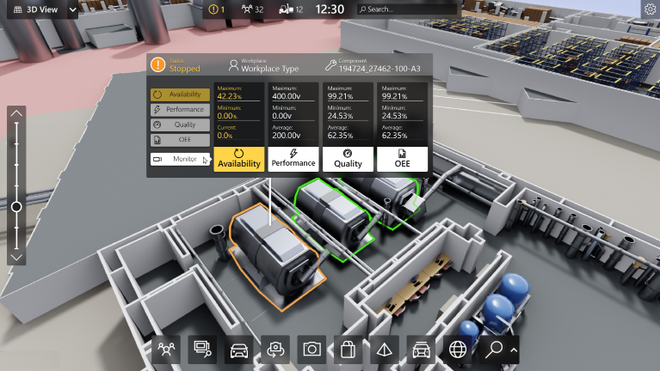

1.  based Solution

UCT is one of the early adopters of LoRAWAN teschnology and providing solution in Agritech, Smart cities, Industrial Monitoring, Smart Street Light, Smart Water/ Gas/ Electricity metering solutions etc.

1. Predictive Maintenance

UCT is providing Industrial Machine health monitoring and Predictive maintenance solution leveraging Embedded system, Industrial IoT and Machine Learning Technologies by finding Remaining useful life time of various Machines used in production process.



## About upskill Campus (USC)

upskill Campus along with The IoT Academy and in association with Uniconverge technologies has facilitated the smooth execution of the complete internship process.

USC is a career development platform that delivers **personalized executive coaching** in a more affordable, scalable and measurable way.



Seeing need of upskilling in self paced manner along-with additional support services e.g. Internship, projects, interaction with Industry experts, Career growth Services

<https://www.upskillcampus.com/>

upSkill Campus aiming to upskill 1 million learners in next 5 year

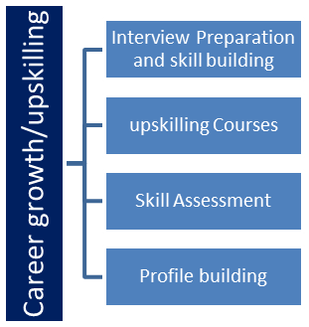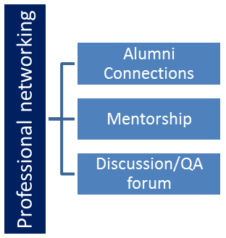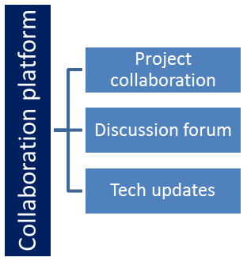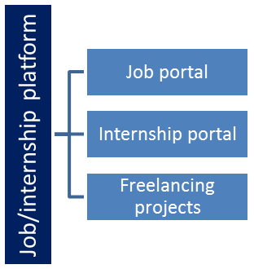

## The IoT Academy

The IoT academy is EdTech Division of UCT that is running long executive certification programs in collaboration with EICT Academy, IITK, IITR and IITG in multiple domains.

## Objectives of this Internship program

The objective for this internship program was to

 ☛ get practical experience of working in the industry.

 ☛ to solve real world problems.

 ☛ to have improved job prospects.

 ☛ to have Improved understanding of our field and its applications.

 ☛ to have Personal growth like better communication and problem solving.

## Reference

[1] Scikit-learn Documentation – Machine Learning in Python, https://scikit-learn.org

[2] Ultralytics – YOLOv5 Documentation, https://docs.ultralytics.com

[3] TensorFlow Documentation – Time Series Forecasting with LSTM in Python, https://www.tensorflow.org

[4] Agriculture Research Portal, “Weed Management in Sesame Crops,” ICAR, 2022.

## Glossary

|  |  |
| --- | --- |
| Terms | Acronym |
| Agriculture Research Portal, “Weed Management in Sesame Crops,” ICAR, 2022. | A real-time object detection algorithm widely used in computer vision. |
| mAP (mean Average Precision) | A metric to evaluate object detection accuracy. |
| LSTM (Long Short-Term Memory) | A type of recurrent neural network (RNN) designed for time series and sequence prediction. |
| Random Forest | An ensemble machine learning algorithm that uses multiple decision trees for regression/classification. |
| Traffic Forecasting | Predicting vehicle flow patterns in cities based on historical and contextual data. |

# Problem Statement

In the assigned problem statement

**1. Smart City Traffic Patterns Forecasting**

Traffic congestion is a major issue in cities, especially during peak hours, weekends, and holidays. Governments need predictive systems to handle traffic effectively.

**2. Crop and Weed Detection**

Weeds compete with crops for resources, reducing productivity. Pesticide spraying is often excessive and harmful. A system to detect weeds and spray only on them is needed.

# Existing and Proposed solution

**Traffic Forecasting**

Existing Solutions: Rule-based traffic systems, manual observation. Limited accuracy.

Proposed Solution: Use machine learning (RandomForest, LSTM) to predict traffic volume based on time, junctions, and events.

**Crop & Weed Detection**

Existing Solutions: Manual weeding, broad pesticide spraying. Time-consuming, costly.

Proposed Solution: Use YOLOv5 to detect weeds in crop fields, allowing selective spraying.

## Code submission (Github link)

https://github.com/Rakshitha2k/upskillCampus.git

## Report submission (Github link) :

https://github.com/Rakshitha2k/upskillCampus

# Proposed Design/ Model

**Smart City Traffic Forecasting**

High-Level Flow:

Data (junctions, time, events) → Preprocessing → Feature Engineering → ML Model (RandomForest, LSTM) → Predictions

**Crop & Weed Detection**

High-Level Flow:

Image Collection → Preprocessing (resize, augment) → Labeling (YOLO format) → Train YOLOv5 → Detection Results

# Performance Test

## Test Plan/ Test Cases

**Smart City Traffic Forecasting**

Test Case 1: Predict traffic flow at a given junction during peak hours.

Test Case 2: Predict traffic on holidays vs weekdays.

Test Case 3: Compare Random Forest vs LSTM performance on same dataset.Crop & Weed Detection

**Crop & Weed Detection (Sesame Dataset)**

Test Case 1: Detect weeds in a test image with clear background.

Test Case 2: Detect weeds in images with multiple overlapping plants.

Test Case 3: Test model accuracy after dataset augmentation (1300 images).

## Test Procedure

**Smart City Traffic Forecasting**

1. Preprocess dataset (date-time conversion, feature extraction).

2. Split data into training (80%) and testing (20%).

3. Train Random Forest and LSTM models separately.

4. Evaluate results using R² score and RMSE.

**Crop & Weed Detection (Sesame Plant, 1300 Images)**

1. Collected 589 sesame plant images, cleaned → 546 images. Resized to 512×512 pixels.

Used YOLOv5s model.

2. Training parameters: epochs = 50, batch = 16, image size = 512.

3. Model validated during training for loss, precision, recall.

4. mAP (mean Average Precision).

## Performance Outcome

* mAP ≈ 90%
* Precision ≈ 88% (weed detection accuracy).
* Recall ≈ 85% (correctly detected most weeds).
* F1-Score ≈ 86%
* Inference showed bounding boxes correctly identifying sesame crops vs weeds.
* Augmentation significantly improved detection in cluttered and complex field images.

# My learnings

* Gained practical skills in Python, Machine Learning, and Deep Learning.
* Understood how to handle datasets (tabular + images).
* Learned to use YOLOv5 for object detection.
* Improved communication and problem-solving.

# Future work scope

* Traffic Forecasting: Extend to real-time IoT-based traffic sensors.
* Crop & Weed Detection: Integrate with drones/robots for automated spraying.