🩺 XSepsisNet
AI Explainability Report
Predicted Sepsis Risk: 24.72%

🔍 Why did the model make this prediction?
Time | Clinical Parameter | Model Direction | Explanation
Hour 6 | Base Excess | 🟢 Lower / opposite direction | 🟢 Contributed in the opposite direction to the predicted risk
Hour 6 | Bicarbonate | 🟢 Lower / opposite direction | 🟢 Contributed in the opposite direction to the predicted risk
Hour 6 | Mean Arterial Pressure | 🔴 Higher risk | 🔴 Contributed toward higher predicted sepsis risk
Hour 6 | Diastolic Blood Pressure | 🟢 Lower / opposite direction | 🟢 Contributed in the opposite direction to the predicted risk
Hour 3 | Systolic Blood Pressure | 🔴 Higher risk | 🔴 Contributed toward higher predicted sepsis risk
Hour 6 | Lactate | 🔴 Higher risk | 🔴 Contributed toward higher predicted sepsis risk
Hour 6 | WBC | 🟢 Lower / opposite direction | 🟢 Contributed in the opposite direction to the predicted risk
Hour 6 | Platelets | 🔴 Higher risk | 🔴 Contributed toward higher predicted sepsis risk
Hour 6 | Heart Rate | 🔴 Higher risk | 🔴 Contributed toward higher predicted sepsis risk
Hour 6 | Chloride | 🔴 Higher risk | 🔴 Contributed toward higher predicted sepsis risk

💬 Simple Interpretation
🔴 Factors contributing toward higher predicted risk: Mean Arterial Pressure, Systolic Blood Pressure, Lactate, Platelets, Heart Rate.
🟢 Factors contributing in the opposite direction: Base Excess, Bicarbonate, Diastolic Blood Pressure, WBC.

📋 Input Quality
Some clinical measurements may be unavailable for this prediction. The model explanation should therefore be interpreted together with the available clinical information.

👨‍⚕️ Clinical Review Suggestions
- Mean Arterial Pressure: Review blood-pressure and overall hemodynamic status, especially if the finding persists or worsens.
- Systolic Blood Pressure: Review the blood-pressure trend and overall hemodynamic status.
- Lactate: Review lactate in clinical context and consider serial measurement when clinically appropriate.
- Platelets: Review platelet trend together with the overall clinical and laboratory picture.
- Heart Rate: Review heart-rate trend and assess it together with perfusion and the wider clinical picture.
- Overall sepsis assessment: If sepsis is clinically suspected, follow the hospital's established sepsis screening and evaluation pathway.
- Reassessment: Interpret this prediction together with clinical examination, trends, laboratory results and other available information.

📊 Feature Importance
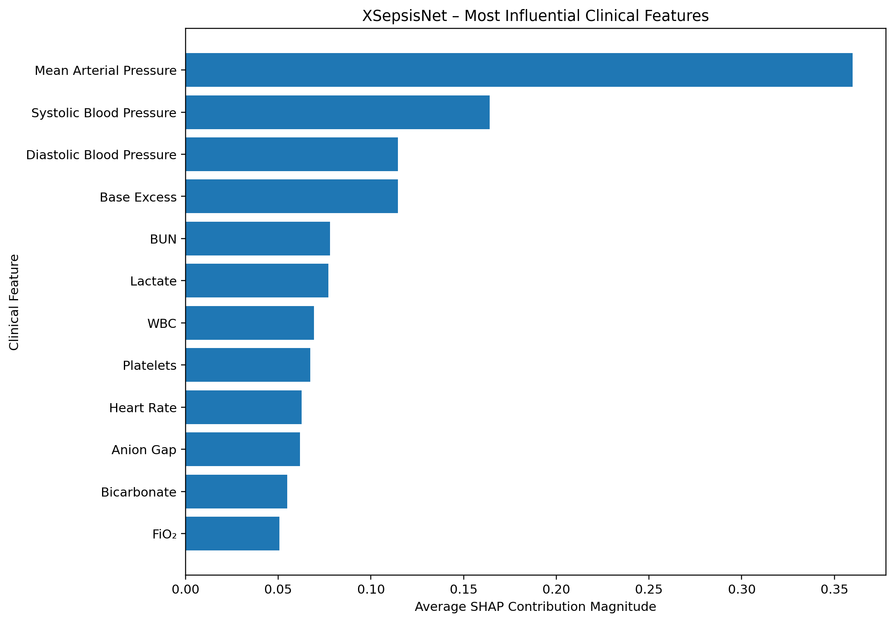

ℹ️ Important Note
This report explains how the trained BiLSTM used the available input features. SHAP contribution direction does not by itself mean that a laboratory value or vital sign is medically abnormal. Clinical interpretation requires the actual patient measurement, appropriate reference information and clinical context.
⚠️ This is an AI-assisted prediction and explanation, not a medical diagnosis or treatment instruction.

