XSepsisNet
AI Explainability Report
Predicted Sepsis Risk: 7.68%

Why did the model make this prediction?
Time | Clinical Parameter | Model Direction | Explanation
Hour 6 | Base Excess | [OPPOSITE DIRECTION] | Contributed in the opposite direction to the predicted risk
Hour 6 | Bicarbonate | [OPPOSITE DIRECTION] | Contributed in the opposite direction to the predicted risk
Hour 6 | Diastolic BP | [OPPOSITE DIRECTION] | Contributed in the opposite direction to the predicted risk
Hour 6 | Mean Arterial Pressure | [HIGHER RISK] | Contributed toward higher predicted sepsis risk
Hour 6 | Anion Gap | [OPPOSITE DIRECTION] | Contributed in the opposite direction to the predicted risk
Hour 6 | Lactate | [OPPOSITE DIRECTION] | Contributed in the opposite direction to the predicted risk
Hour 6 | Platelets | [OPPOSITE DIRECTION] | Contributed in the opposite direction to the predicted risk
Hour 6 | Mean Arterial Pressure (missing) | [HIGHER RISK] | Contributed toward higher predicted sepsis risk
Hour 6 | WBC | [OPPOSITE DIRECTION] | Contributed in the opposite direction to the predicted risk
Hour 3 | Systolic BP | [HIGHER RISK] | Contributed toward higher predicted sepsis risk

Simple Interpretation
[HIGHER RISK] Factors contributing toward higher predicted risk: Mean Arterial Pressure, Mean Arterial Pressure (missing), Systolic BP.
[OPPOSITE DIRECTION] Factors contributing in the opposite direction: Base Excess, Bicarbonate, Diastolic BP, Anion Gap, Lactate.

Input Quality
Some clinical measurements may be unavailable for this prediction. 173 of 234 entered values were blank. The model explanation should therefore be interpreted together with the available clinical information.

Clinical Review Suggestions
- Mean Arterial Pressure: Review blood-pressure and overall hemodynamic status, especially if the finding persists or worsens.
- Systolic BP: Review the blood-pressure trend and overall hemodynamic status.
- Overall sepsis assessment: If sepsis is clinically suspected, follow the hospital's established sepsis screening and evaluation pathway.
- Reassessment: Interpret this prediction together with clinical examination, trends, laboratory results and other available information.

Feature Importance
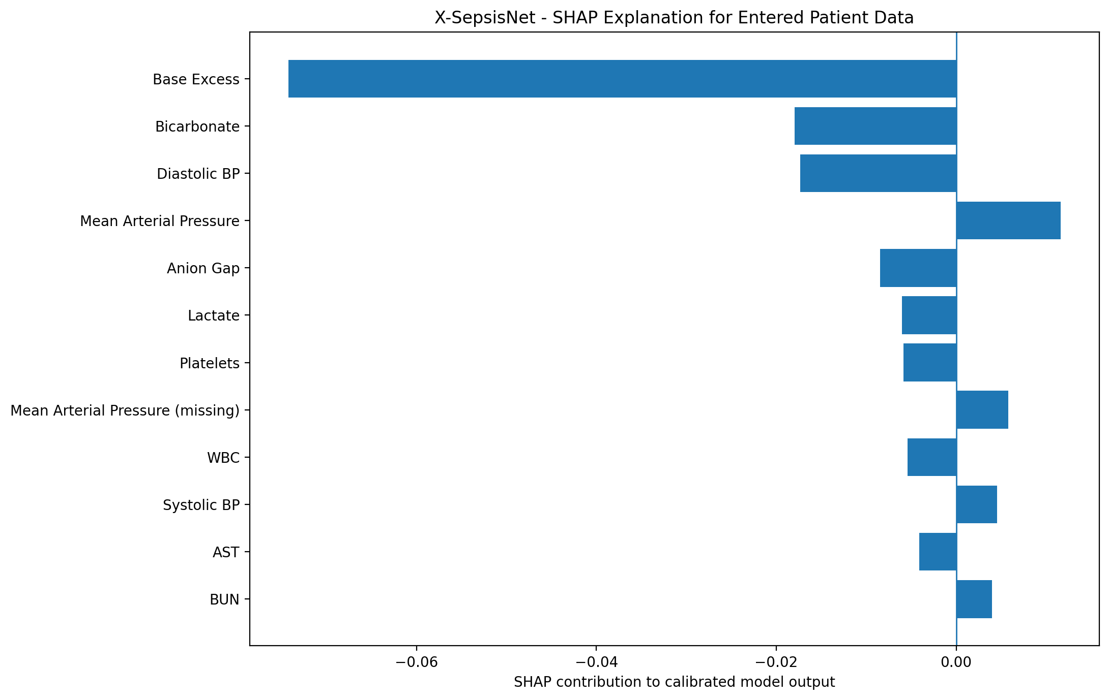

Hourly Clinical Measurements
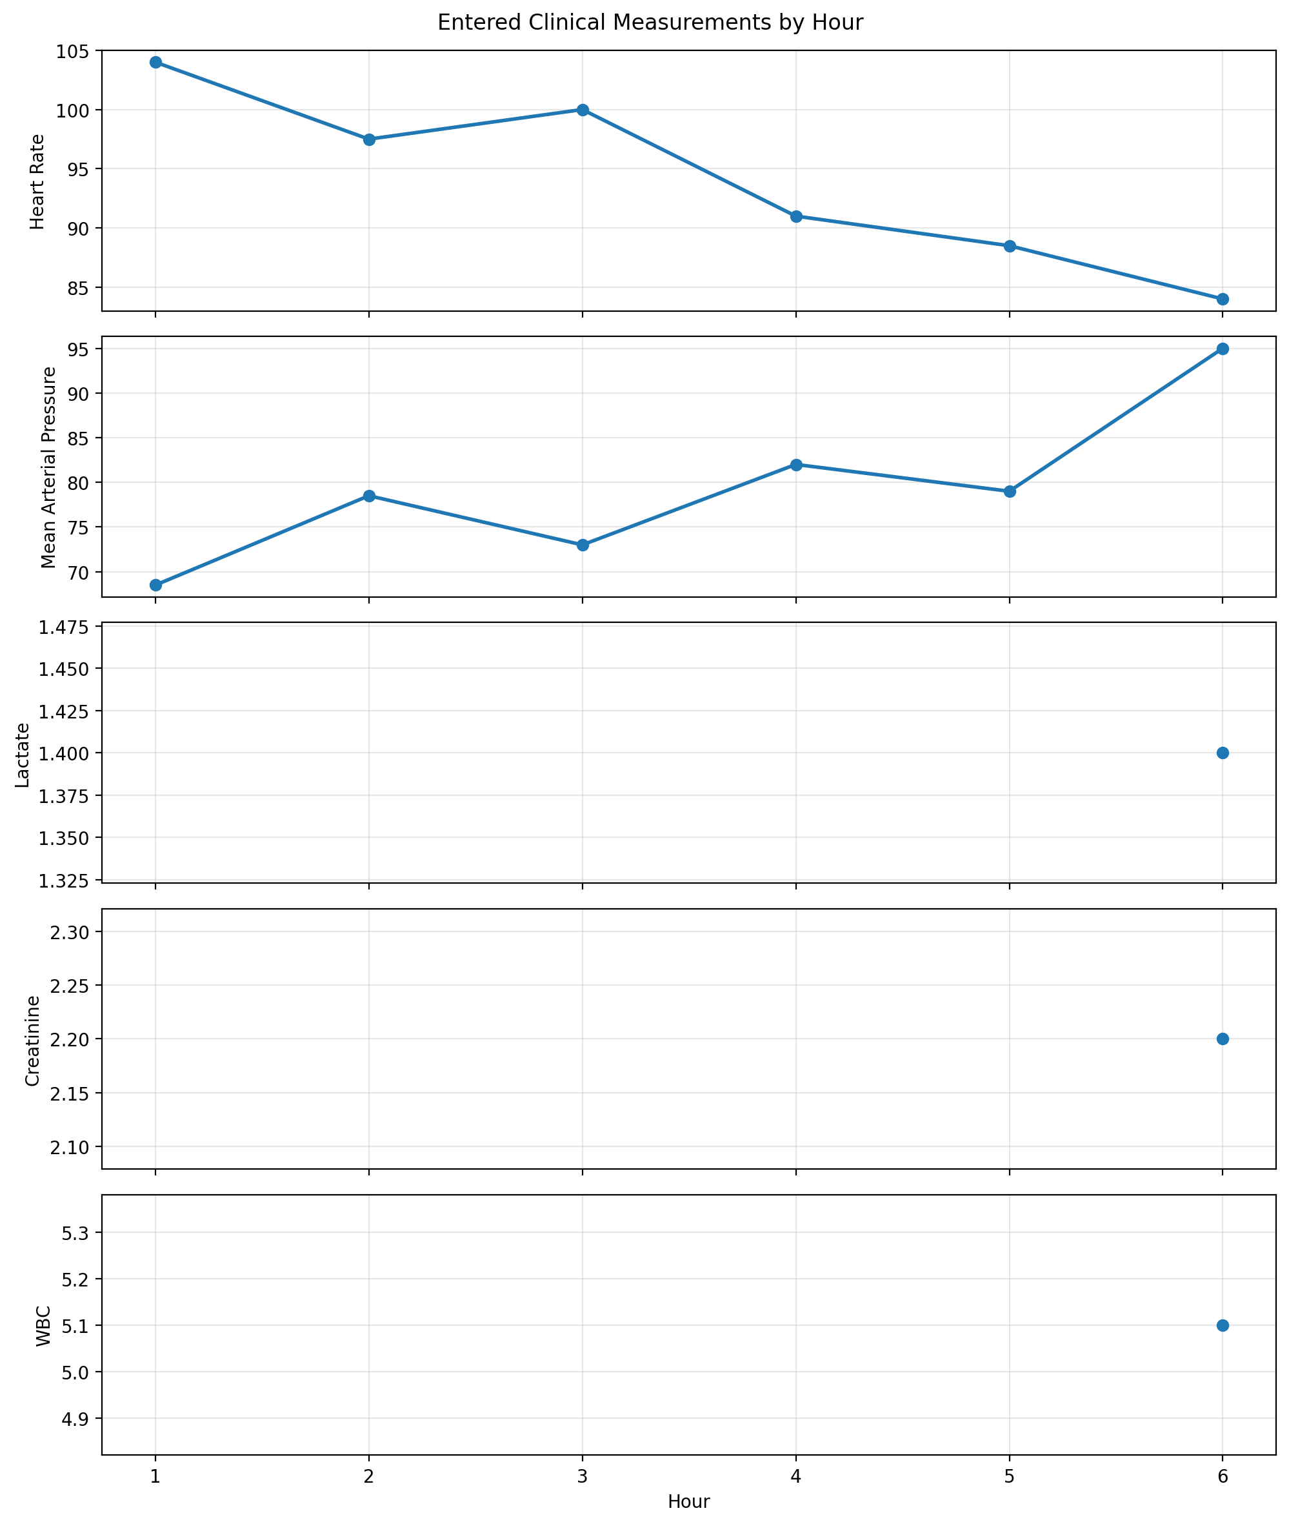

Important Note
This report explains how the trained BiLSTM used the available input features. SHAP contribution direction does not by itself mean that a laboratory value or vital sign is medically abnormal. Clinical interpretation requires the actual patient measurement, appropriate reference information and clinical context.
This is an AI-assisted prediction and explanation, not a medical diagnosis or treatment instruction.

