XSepsisNet
AI Explainability Report
Predicted Sepsis Risk: 36.26%

Why did the model make this prediction?
Time | Clinical Parameter | Model Direction | Explanation
Hour 6 | Lactate | [HIGHER RISK] | Contributed toward higher predicted sepsis risk
Hour 6 | Base Excess | [HIGHER RISK] | Contributed toward higher predicted sepsis risk
Hour 5 | Hematocrit | [HIGHER RISK] | Contributed toward higher predicted sepsis risk
Hour 5 | Platelets | [OPPOSITE DIRECTION] | Contributed in the opposite direction to the predicted risk
Hour 6 | Mean Arterial Pressure | [HIGHER RISK] | Contributed toward higher predicted sepsis risk
Hour 5 | Anion Gap | [HIGHER RISK] | Contributed toward higher predicted sepsis risk
Hour 5 | Potassium | [HIGHER RISK] | Contributed toward higher predicted sepsis risk
Hour 5 | Hemoglobin | [HIGHER RISK] | Contributed toward higher predicted sepsis risk
Hour 2 | pCO2 | [HIGHER RISK] | Contributed toward higher predicted sepsis risk
Hour 4 | Heart Rate | [HIGHER RISK] | Contributed toward higher predicted sepsis risk

Simple Interpretation
[HIGHER RISK] Factors contributing toward higher predicted risk: Lactate, Base Excess, Hematocrit, Mean Arterial Pressure, Anion Gap.
[OPPOSITE DIRECTION] Factors contributing in the opposite direction: Platelets.

Input Quality
Some clinical measurements may be unavailable for this prediction. 80 of 234 entered values were blank. The model explanation should therefore be interpreted together with the available clinical information.

Clinical Review Suggestions
- Lactate: Review lactate in clinical context and consider serial measurement when clinically appropriate.
- Mean Arterial Pressure: Review blood-pressure and overall hemodynamic status, especially if the finding persists or worsens.
- Heart Rate: Review heart-rate trend together with perfusion and the wider clinical picture.
- Overall sepsis assessment: If sepsis is clinically suspected, follow the hospital's established sepsis screening and evaluation pathway.
- Reassessment: Interpret this prediction together with clinical examination, trends, laboratory results and other available information.

Feature Importance
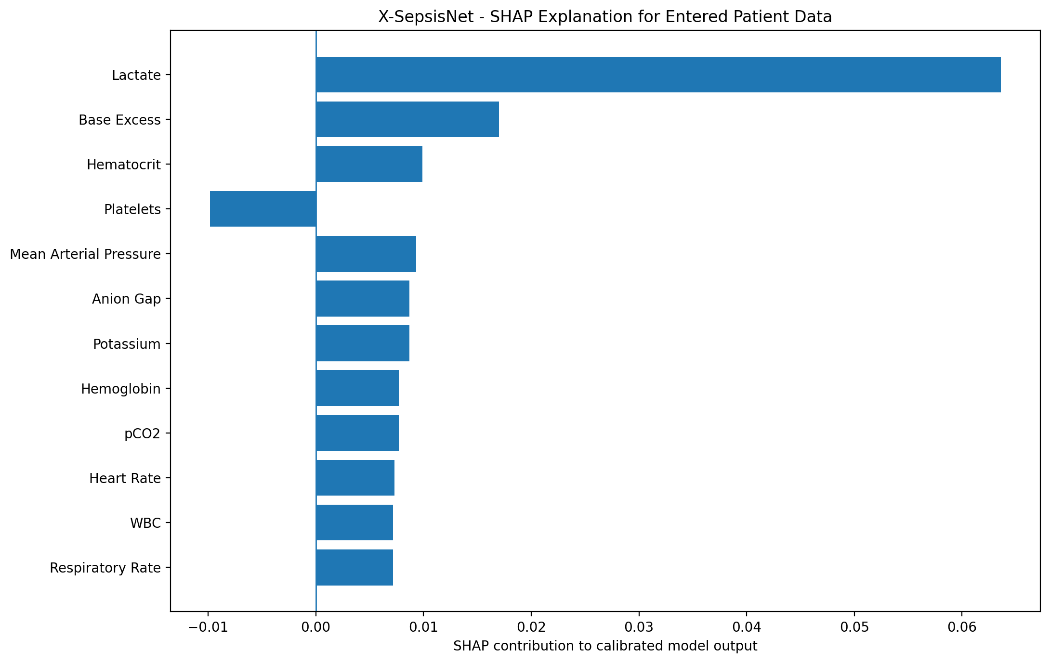

Hourly Clinical Measurements
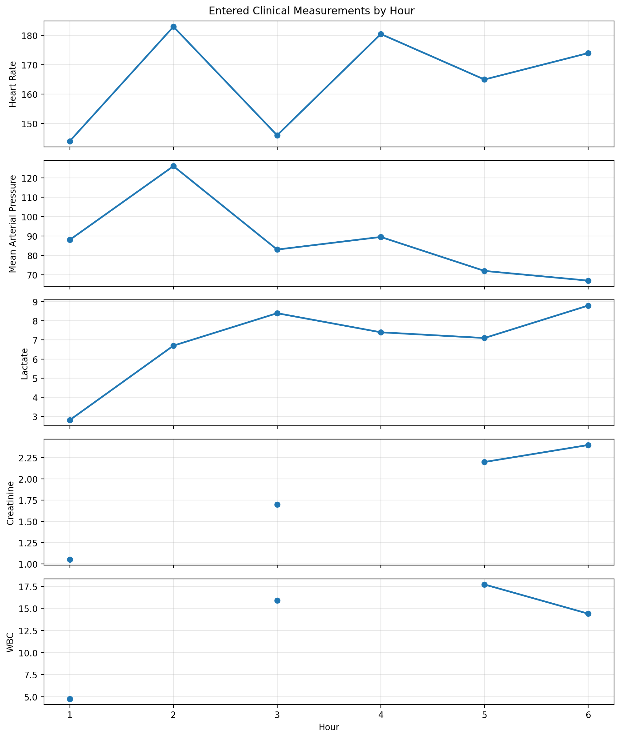

Important Note
This report explains how the trained BiLSTM used the available input features. SHAP contribution direction does not by itself mean that a laboratory value or vital sign is medically abnormal. Clinical interpretation requires the actual patient measurement, appropriate reference information and clinical context.
This is an AI-assisted prediction and explanation, not a medical diagnosis or treatment instruction.

