Inside Sales Analysis Project Report
Project Question/Objective
Analyze the inside sales dataset and generate insights on:
- Sales performance by Region
- Sales performance by Product
- Comparison of Actual sales vs Target sales
- Regional contribution share in sales
Create:
- A Dashboard
- Visual Story using Region, Product, and Sales Comparison charts
Step-by-Step Implementation Guide
Step 1: Data Connection & Preparation
1. Open Tableau Desktop
2. Connect to "Text file" and select `Inside_Sales.csv`
3. Verify data types are correctly identified
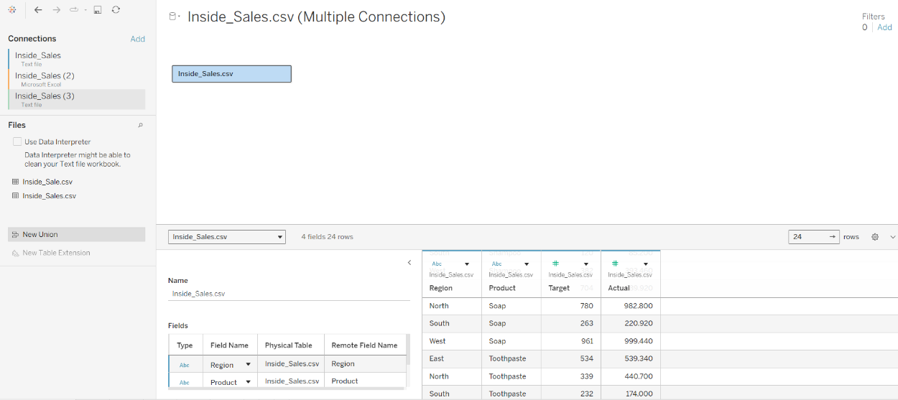
Data successfully loaded into Tableau with proper field recognition
Step 2: Sales by Product Visualization
- Create new worksheet
- Drag Product → Rows
- Drag Actual → Columns
- Click Sort descending based on SUM(Actual)
- Rename sheet → "Sales by Product"
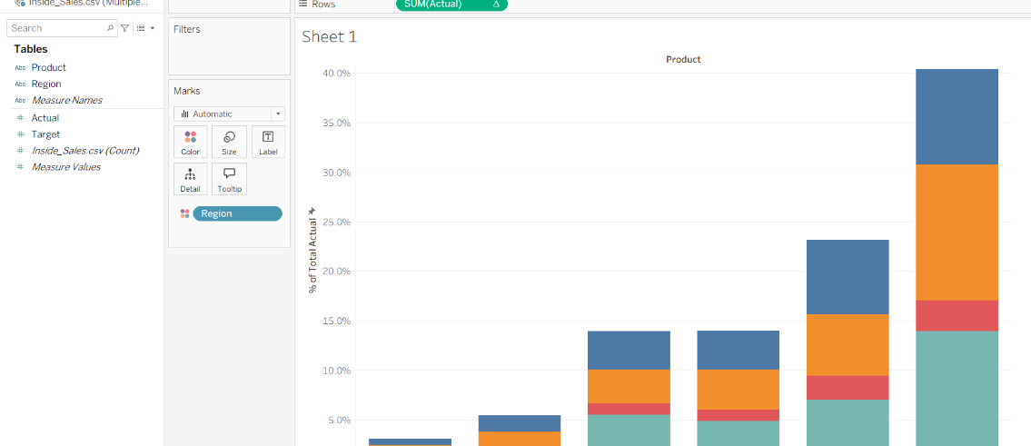
This view displays highest selling product at the top based on actual sales
Step 3: Actual vs Target Sales Comparison (Grouped Bars)
- Create new worksheet
- Drag Product → Rows
- Drag Measure Values → Columns
- Drag Measure Names → Filters → select only ✔ Actual, ✔ Target
- Set Marks → Bar chart
- Set Measure Names → Color (two colored bars per product)
- Go to Label → Show mark labels
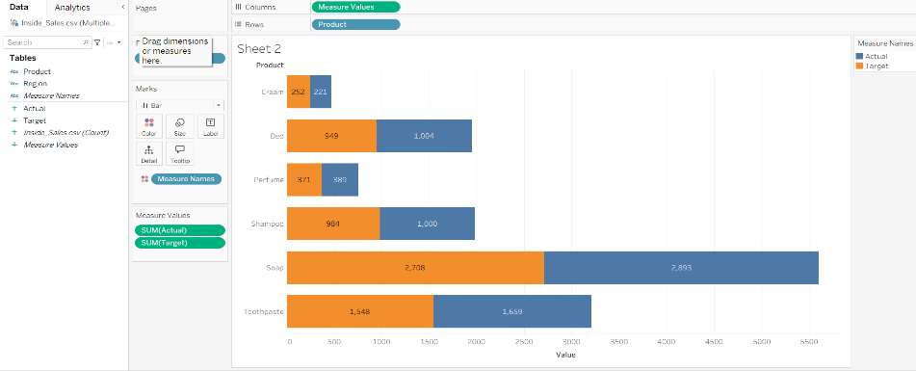
- Rename sheet → "Actual vs Target by Product"
Caption: shows two side-by-side bars comparing Actual sales and Target values
Step 4: Largest Selling Regions (Treemap)
- Drag Region → Color
- Drag Region → Label
- Drag Actual → Size (ensure it shows SUM)
- Click Show Me → Treemap
- In Label add:
Region
SUM(Actual)
- Format SUM(Actual → 0 decimals + enable comma)
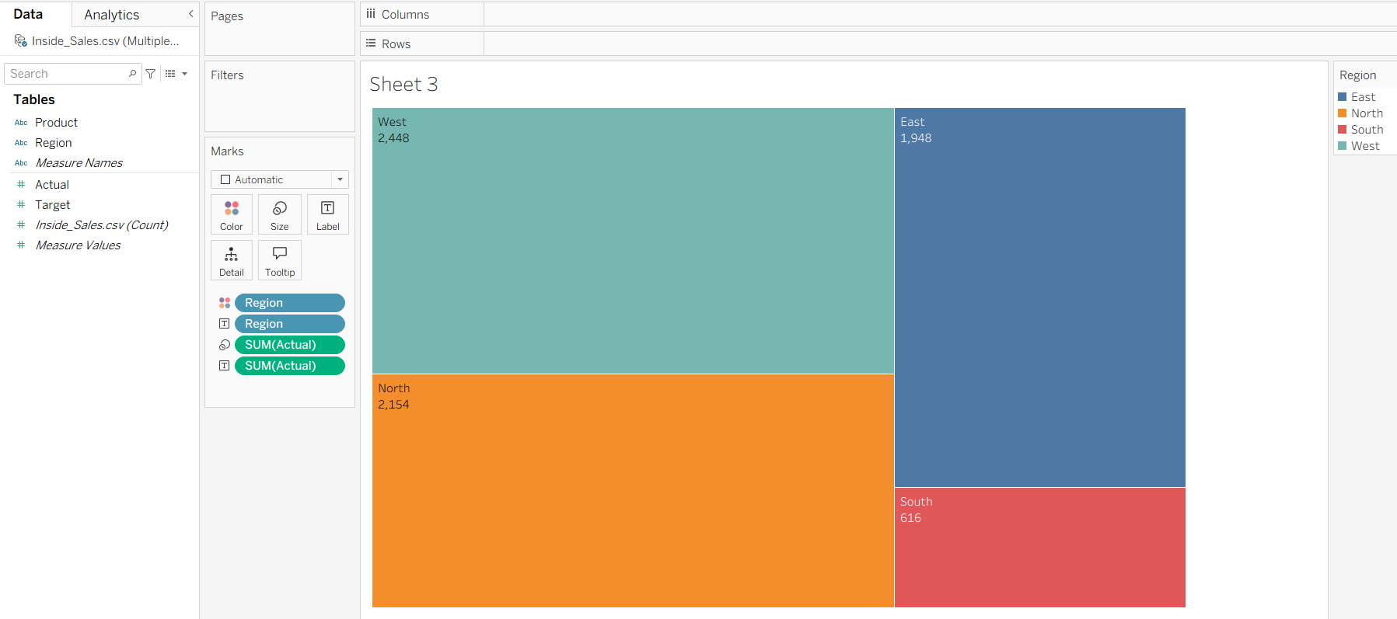
Treemap automatically highlights the largest selling region using the biggest box size, showing regional contribution clearly.
Step 5: Packed bubble to show product sales
- Drag Product → Detail (Marks card).
- Drag Actual → Size.
- On Marks card change Mark Type → Circle.
- Go to Show Me → click Packed Bubbles
- Drag Product → Label
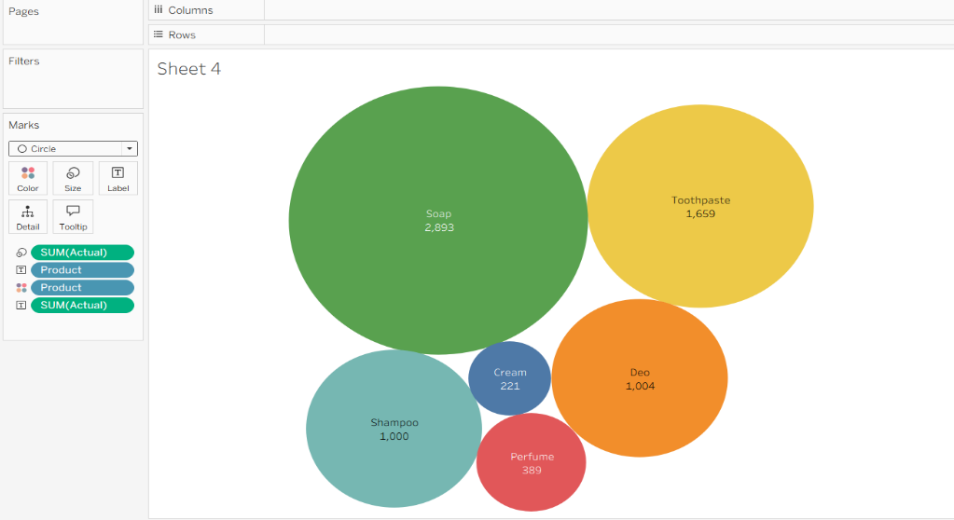
Shows the creation a packed bubble where bubble size = product sales
Step 6 : Side-by-side circle chart to compare Actual vs Target for different products
- Drag Product → Rows.
- Drag Measure Names → Columns.
- Drag Measure Values → Size on the Marks card.
- Filter Measure Names to only Actual and Target.
- On Marks card, change Mark Type → Circle.
- Drag Measure Names → Color.
- Drag Measure Values → Label.
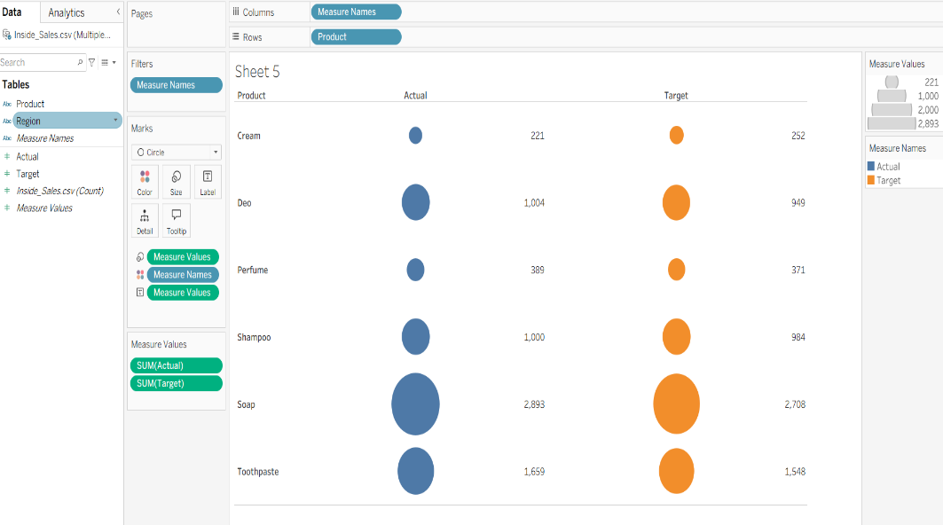
shows two circles side-by-side per product (Actual vs Target) sized by their values.
Step 6: Build Interactive Dashboard
- Click New Dashboard
- Drag sheets:
  - Sales by Product
  - Actual vs Target by Product
  - Treemap (Region Sales)
  - Region Distribution chart
- Arrange neatly
- Add Dashboard title → "Inside Sales Performance Overview"
- Enable Filter Actions
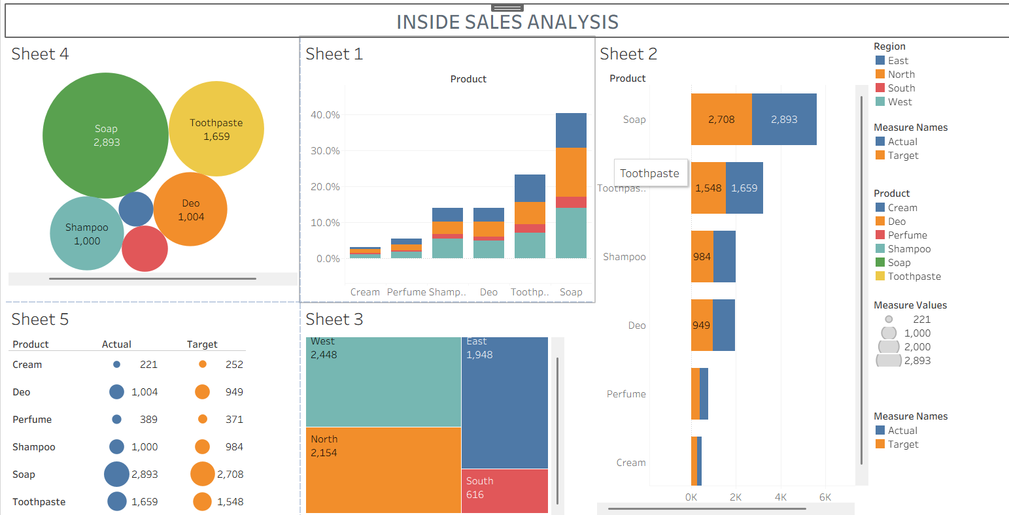
Interactive dashboard allowing cross-filtering between all views
Tools Used
- Tableau Desktop / Tableau Public
- Inside_Sales.csv dataset for analysis
- Excel dataset fields (Region, Product, Target, Actual)
Files Created
- Inside_Sales_Dashboard.twbx
- Project Analysis Report Document

