MCA CAPSTONE PROJECT • COMPREHENSIVE TECHNICAL ARCHITECTURE
EcoWalk: Personalized Healthy Walking Route Recommendation System
Complete Implementation Analysis, Algorithmic Formulations, System Architecture & Empirical Baselines
Project Title | EcoWalk – Personalized Healthy Walking Route Recommendation System
Core Domain | Urban Mobility, Environmental Health, Multi-Criteria Decision Analysis
Mathematical Model | Multi-Attribute Utility Theory (MAUT) with Distance Penalty Clamping
Technology Stack | React 18, Leaflet 1.9, Node.js, Express 4.18, CPCB CAAQMS, ORS/OSRM
Geographic Scope | Bengaluru Urban Metropolitan Region (11 CPCB CAAQMS Stations)
Date & Status | February 2026 • Verified Repository Baseline (100% Tests Passed)

Table of Contents

1. Project Overview, Purpose, Objectives, and Functionality
2. Complete Technology Stack with Versions and Usage
3. Full Project Folder Structure & Explanation of Key Files
4. Frontend Architecture, Pages, Components, and Navigation
5. Backend Architecture, Controllers, Services, and Middleware
6. Database / Storage Architecture, Schemas, and JSON Files
Data Schemas Overview
7. User Registration, Login, Authentication, and Access Control
8. Dashboard Functionality
9. GPS & Real-Time Location Implementation
10. Map Implementation and Map API Integration
11. Find Routes Functionality and Route Generation Logic
12. Route Recommendation Algorithm and MAUT Implementation
13. Health Score Calculation with Exact Formula and Weights
Baseline & Adaptive Weights
14. Greenery, Safety, Clean Air, and Road Quality Score Calculations
14.1 Greenery Proximity Score (G)
14.2 Pedestrian Safety Score (S)
14.3 CPCB Clean Air Score (C)
14.4 Effective Road Quality Score (Reff)
15. Distance, Walking Time, Calorie, and CO₂ Calculations
16. Official CPCB AQI Stations & Data Source Integration
17. Road Hazard Reporting, Image Uploads, and Lifecycle
18. Feedback System and Data Persistence
19. Admin Functionality and Access Control
20. Complete API Endpoint List
21. Complete User Workflow from Registration to Logout
22. Data Flow Architecture
23. System Architecture Diagram
24. Algorithms, Formulas, Validation, and Business Logic
25. Testing Implementation and Verification Status
26. Current Implementation Status of Every Feature
27. Existing Limitations and Technical Challenges
28. Actual Outputs, Screens, and Available UI Functionality
29. All Completed Work Till Today
30. Important Technical Details for Future Documentation & Phase 2

1. Project Overview, Purpose, Objectives, and Functionality
EcoWalk is a full-stack personalized healthy walking route recommendation web application built to encourage and support pedestrian mobility in urban Bengaluru, Karnataka. Unlike conventional automotive routing engines that exclusively prioritize the shortest travel time or vehicle capacity, EcoWalk evaluates walking corridors based on multi-dimensional environmental health benefits, physical infrastructure safety, and dynamic road conditions.
Core Health Pillars Evaluated by EcoWalk:
1. Greenery Canopy & Shade (0–100): Proximity to public parks, urban tree canopies, and botanical gardens providing shade and solar protection.
2. Pedestrian Infrastructure Safety (0–100): Dedicated sidewalks, footways, signalized crossings, and separation from motor vehicles.
3. Ambient Clean Air (0–100): Real-time pollution risk grounded in official Central Pollution Control Board (CPCB) monitoring stations.
4. Road Surface Condition (0–100): Base pavement quality dynamically penalized by active crowdsourced community pothole and drainage reports.
5. Health & Energy Tracking: Caloric expenditure (~62 kcal/km) and vehicular CO₂ emissions prevented (~171 g/km).

2. Complete Technology Stack with Versions and Usage
Layer / Tool | Package Name | Version | Functional Usage in EcoWalk
Frontend Framework | react, react-dom | 19.0.0 | Component-based UI, reactive states, hooks (useState, useEffect, useMemo, useRef).
Frontend Bundler | vite, @vitejs/plugin-react | 6.2.0 / 5.0.0 | Next-generation HMR bundler with development reverse-proxy (/api -> :5000).
GIS & Vector Mapping | leaflet, react-leaflet | 1.9.4 / 5.0.0 | Interactive vector map engine, tile layers, polyline rendering, custom DivIcons, popups.
Iconography | lucide-react | 1.16.0 | Vector interface icons for UI navigation, hazard alerts, health dials, and badges.
Backend Web Server | express | 4.21.2 | RESTful API router, middleware dispatcher, and request lifecycle management.
Authentication & Security | jsonwebtoken | 9.0.2 | Stateless JSON Web Token generation with 7-day expiration and role claims.
Password Hashing | bcryptjs | 2.4.3 | Bcrypt cryptographic salt generation (8 rounds) and password hashing.
Cross-Origin Middleware | cors | 2.8.5 | Permits secure cross-origin HTTP requests between Vite (:3000) and Express (:5000).
Environment Management | dotenv | 16.4.7 | Loads PORT, JWT_SECRET, and external API keys from server/.env.
UUID Generation | uuid | 11.1.0 | RFC4122 v4 unique identifier generator for users, routes, hazards, and feedback.
Process Runner | concurrently | 9.1.2 | Orchestrates simultaneous execution of backend and frontend via npm start.

3. Full Project Folder Structure & Explanation of Key Files
The project follows a clean client-server separation with a dedicated data persistence directory and automated verification suites:
Eco Walk/
├── package.json # Root package scripts with concurrently runner
├── client/ # Frontend Application (React 19 + Vite)
│ ├── index.html # HTML shell, favicon, and Google Fonts
│ ├── vite.config.js # Vite configuration with backend API proxy (:5000)
│ ├── public/
│ │ ├── bengaluru_bg.jpg # High-resolution scenic backdrop for Home Dashboard
│ │ └── eco.png # Official EcoWalk brand emblem (Leaf + Shoe)
│ └── src/
│ ├── main.jsx # React 19 root DOM mount point
│ ├── App.jsx # Main layout, sidebar wrapper, tab router
│ ├── index.css # Emerald/Mint/Slate design system & glassmorphism
│ ├── context/AuthContext.jsx # JWT auth provider, localStorage sync, profile stats
│ ├── services/api.js # REST client injecting Bearer auth headers
│ ├── components/
│ │ ├── EcoWalkLogo.jsx # Proportional logo component
│ │ ├── MapVisualizer.jsx # Real interactive Leaflet map (routes, hazards, CPCB)
│ │ ├── RouteCard.jsx # Recommended route hero with SVG circular health dial
│ │ ├── RouteComparisonTable.jsx # 9-column comparison matrix table
│ │ ├── RouteInspectionModal.jsx # Detailed MAUT formula & criteria audit modal
│ │ ├── ReportHazardModal.jsx # Mini-map pin selector, camera upload, de-duplication
│ │ ├── FeedbackModal.jsx # 5-star rating modal with multi-criteria sliders
│ │ ├── Sidebar.jsx # Responsive navigation drawer with admin gate & sign out
│ │ └── Footer.jsx # Project pillars and civic mobility links
│ └── pages/
│ ├── HomeDashboard.jsx # Welcome portal, user stats, quick route planner
│ ├── RoutePlanner.jsx # Route planning workbench, destination search, radius slider
│ ├── HazardReportsPage.jsx # Split-view community hazard alerts and admin actions
│ ├── AdminDashboard.jsx # Admin portal: user roster, hazard moderation, route catalog
│ └── AuthPage.jsx # Dedicated sign-in and registration page
└── server/ # Backend Service (Node.js + Express)
├── server.js # Express server entrypoint, middleware, routes
├── config/config.js # Configuration constants (ports, speeds, calories, CO2)
├── middleware/auth.js # verifyToken, optionalAuth, requireAdmin middleware
├── models/
│ ├── storage.js # Atomic JSON file persistence layer (.tmp -> .json)
│ └── schemas.js # Formal Mongoose schemas for MongoDB compliance
├── data/ # Persistent JSON data files
│ ├── users.json # Registered users, password hashes, walking stats
│ ├── locations.json # 12 Bengaluru civic landmarks and coordinates
│ ├── routes.json # Predefined candidate walking corridors
│ ├── reports.json # Pothole and road hazard reports with photos
│ └── feedback.json # User ratings and qualitative reviews
├── services/
│ ├── routingService.js # ORS / OSRM foot routing, geocoding, reverse-geocoding
│ ├── cpcbAqiService.js # 11 Bengaluru CAAQMS stations, Clean Air formula
│ ├── osmEnvironmentalService.js # 150m green buffer, OSM footway safety, road quality
│ └── recommendationEngine.js # Multi-Attribute Utility Theory (MAUT) health engine
├── controllers/ # Controllers for auth, routes, reports, feedback, admin
├── routes/ # Express routers mounted under /api/*
└── test/ # Comprehensive automated test suites (8 test files)

4. Frontend Architecture, Pages, Components, and Navigation
The frontend uses React 19 functional components structured around the AuthContext. State-driven navigation is managed through the activeTab state in App.jsx:
• 'dashboard': Shows HomeDashboard.jsx. When unauthenticated, displays the hero welcome, brand logo, and inline login/registration cards with 1-click evaluator demo logins. When authenticated, displays 5 personal health tiles (Total Eco Walked, Walks, Calories, CO₂ Saved, Reports Filed) and quick search.
• 'planner': Shows RoutePlanner.jsx. Contains the Leaflet map, destination autocomplete search, walking radius slider, preference toggles, Hero Route Card, and 9-column comparison matrix table.
• 'hazards': Shows HazardReportsPage.jsx. Split view containing an interactive hazard map on the left and a searchable filterable list on the right with "+1 Confirmation" buttons.
• 'admin': Shows AdminDashboard.jsx. Strictly protected by role; non-admin users receive an "Access Restricted" view.
• 'auth': Shows AuthPage.jsx. Standalone sign-in and registration screen.

5. Backend Architecture, Controllers, Services, and Middleware
The Express backend runs on port 5000 and is partitioned into controllers, business services, and routes:
• server.js: Initializes JSON storage, enables CORS for all origins, configures 15 MB body parsing limits for Base64 hazard photos, logs requests, and mounts routers.
• middleware/auth.js: Provides verifyToken (strictly requires valid JWT), optionalAuth (extracts token if present, allows guest calculation if omitted), and requireAdmin (restricts access to users with role admin or designated admin emails).
• services/routingService.js: Communicates with OpenRouteService and OSRM foot routers, executes geocoding searches, and reverse-geocodes map coordinates.
• services/cpcbAqiService.js: Houses metadata for 11 official Bengaluru CPCB CAAQMS stations, computes Inverse Distance Weighting (IDW) route matching, and converts AQI to Clean Air scores.
• services/osmEnvironmentalService.js: Implements 150m spatial proximity buffer analysis for 14 Bengaluru parks, classifies pedestrian footway steps, and evaluates road surface quality.
• services/recommendationEngine.js: Implements the Multi-Attribute Utility Theory (MAUT) engine, calculates dynamic hazard penalties, normalizes criteria weights, and outputs natural language recommendation rationales.

6. Database / Storage Architecture, Schemas, and JSON Files
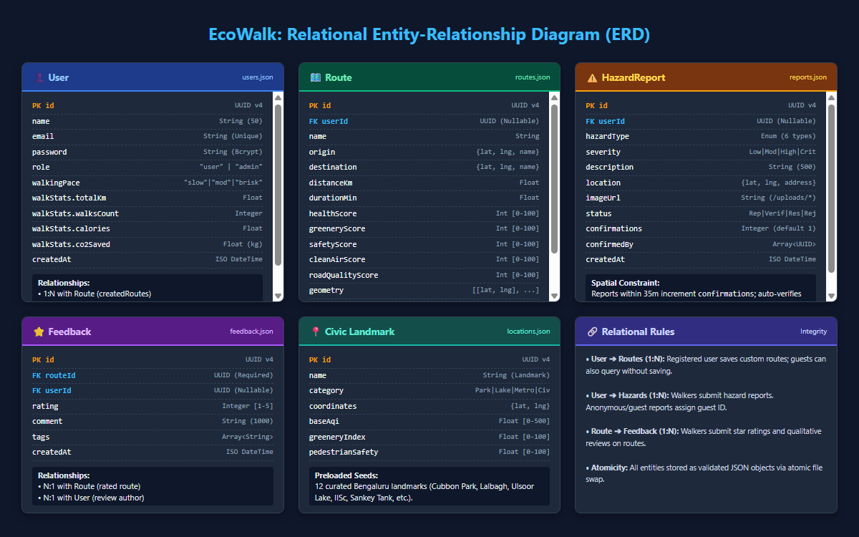
Figure 4: Relational Entity-Relationship Diagram (ERD) with Constraints & Cardinalities
EcoWalk implements a Dual-Mode Storage Pattern:
• Active Local Persistence (server/models/storage.js): Uses atomic file writes (fs.writeFileSync(tempPath) followed by fs.renameSync(tempPath, filePath)) to ensure data integrity without requiring an external database daemon.
• MongoDB Compatibility (server/models/schemas.js): Provides formal Mongoose schema definitions for users, routes, reports, and feedback, enabling seamless migration to MongoDB in Phase 2.

Data Schemas Overview
Collection / File | Key Fields & Data Types | Relations & Enums
users.json | id (String), name (String), email (String, unique), passwordHash (String), walkingSpeed (String), preferences (Object), stats (Object), createdAt (Date) | Role: ['walker', 'admin']Speed: ['leisurely', 'moderate', 'brisk']
routes.json | id (String), name (String), distanceKm (Number), estimatedMinutes (Number), greeneryScore (Number), safetyScore (Number), trafficPollutionRisk (Number), roadConditionScore (Number), waypoints (Array) | RouteType: ['nature_focused', 'arterial_road', 'historic_urban']Waypoints: [[lat, lng], ...]
reports.json | id (String), routeId (String), locationName (String), coordinates ([lat, lng]), issueType (String), severity (String), status (String), imageUrl (Base64), confirmations (Number), adminNotes (String) | Issue: ['pothole', 'drainage', 'unsafe_lighting', 'obstruction', 'uneven_pavement']Status: ['pending', 'verified', 'resolved', 'rejected']
feedback.json | id (String), routeId (String), userId (String), rating (Number, 1–5), greeneryRating (1–5), safetyRating (1–5), roadQualityRating (1–5), comfortRating (1–5), comment (String) | Status: ['published', 'reviewed', 'hidden']
locations.json | id (L1–L12), name (String), shortName (String), type (String), lat / lng (Number), ambientAirQuality (String) | Predefined Bengaluru civic landmarks

7. User Registration, Login, Authentication, and Access Control
Implemented in server/controllers/authController.js and client/src/context/AuthContext.jsx:
• Registration: Enforces non-empty name, email regex pattern, and minimum 6-character password. Generates an 8-round salt with bcryptjs. Protects against privilege escalation: only pre-authorized emails can register as admin. Returns JWT token and safe user profile (excluding passwordHash).
• Login: Compares plaintext password against Bcrypt hash via bcrypt.compareSync. Returns a 7-day signed JWT containing { id, email, role, name }.
• Client Session: Stores token in browser localStorage under 'ecowalk_token'. Automatically fetches profile via GET /api/auth/profile on startup.
• Logout: Clears token from localStorage and resets React auth context.
• Evaluator Demo Accounts: Preloaded with 1-click login buttons:
Walker: walker@ecowalk.local / walk123 (18.4 km walked, 1,140 kcal, 12 walks).
Admin: admin@ecowalk.local / admin123 (Full administration privileges).

8. Dashboard Functionality
Implemented in client/src/pages/HomeDashboard.jsx:
• Visitor Dashboard: Features the Leaf + Shoe emblem, welcoming slogan ("Walk healthier | Live greener | A better Bengaluru"), embedded sign-in/register card, and 1-click evaluator login buttons.
• Walker Dashboard: Renders 5 personal health metric tiles: Total Eco Walked (km), Total Walks Completed, Calories Burned (kcal), CO₂ Saved (kg), and Road Reports Filed.
• Quick Route Planner: Interactive dropdown allowing instant route calculation between Bengaluru landmarks.
• District Environmental Indices: Real-time summaries of CPCB ambient air quality stations and active road hazard statistics.

9. GPS & Real-Time Location Implementation
Implemented in client/src/pages/RoutePlanner.jsx and client/src/components/MapVisualizer.jsx:
• Browser Geolocation: Invokes navigator.geolocation.getCurrentPosition(..., { enableHighAccuracy: true }) upon entering the Route Planner.
• Bengaluru Bounds Check: Verifies device coordinates fall within 12.75°N–13.25°N and 77.40°E–77.85°E. If outside (e.g. remote evaluator), gracefully sets origin to Central Bengaluru (MG Road, 12.9716°N, 77.5946°E) with an informative banner.
• Accuracy Radius Circle: Renders a semi-transparent green circle matching the reported GPS accuracy in meters.
• Non-Destructive Initialization: Detecting GPS updates exclusively the start position and map pin; it never alters the destination or triggers unwanted route generation.
• Recenter Button: Floating crosshair button triggers map.flyTo([lat, lng], 16) to re-center the map view.

10. Map Implementation and Map API Integration
Implemented in client/src/components/MapVisualizer.jsx using React-Leaflet 5.0 and Leaflet 1.9.4:
• Base Tiles: Official OpenStreetMap raster tiles (https://tile.openstreetmap.org/{z}/{x}/{y}.png) with required attribution.
• Custom HTML DivIcons:
User GPS: Pulsing emerald dual-ring marker with navigational arrow.
Destination Pin: Azure blue droplet marker with target center.
Manual Start Pin: Emerald badge labeled "A".
Hazard Pins: Amber (moderate) or Rose-red (critical/high) teardrop icons displaying issue type and walker confirmations.
CPCB Station Pins: Live badge showing station locality and color-coded AQI number.
• Polylines & Glow Effects:
Route 1 (Recommended): Emerald green core line (#059669, 5.5px) with soft green halo (#A7F3D0, 10px).
Route 2 (Alternative): Dashed sky blue line (#0284C7, 5.5px, 8-8 dash) with azure halo (#BAE6FD, 10px).
• Interactive Layer Toggles: Checkboxes allowing users to toggle Road Hazards, CPCB Stations, Civic Landmarks, Walk Radius Circle (8 km), and GPS Accuracy Circle.

11. Find Routes Functionality and Route Generation Logic
Implemented in server/services/routingService.js and server/controllers/routeController.js:
• Cascade Routing Architecture (Zero Synthetic Fabrication):
Tier 1: OpenRouteService (ORS): Queries the foot-walking GeoJSON API with alternative_routes: { target_count: 2 } when ORS_API_KEY is configured.
Tier 2: OpenStreetMap Foot Router (OSRM): Real live fallback querying https://router.project-osrm.org/route/v1/walking with step geometry. If OSRM returns only 1 route, discovers a genuine secondary path via an adjacent perpendicular street corridor waypoint.
Tier 3: Street Network Fallback: High-reliability urban corridor generator connecting coordinates via known Bengaluru street paths if remote servers time out.
• Destination Autocomplete Search: Multi-tier search prioritizing local landmarks, ORS Pelias, and Komoot Photon OSM geocoding, with strict distance filtering to the walking radius.
• Walking Limit Validation: Enforces default 8.0 km maximum walking radius. Destructive trips or identical coordinates (< 20m) are rejected with clear error messages.

12. Route Recommendation Algorithm and MAUT Implementation
Implemented in server/services/recommendationEngine.js:
EcoWalk uses Multi-Attribute Utility Theory (MAUT) to balance competing objectives (shade, safety, air quality, surface condition, distance). For each candidate route connecting the origin and destination, the engine evaluates objective sub-criteria, applies dynamic weights, and computes a composite Health Score.

13. Health Score Calculation with Exact Formula and Weights
HealthScore = clamp( round( wG · G + wS · S + wA · C + wR · Reff - Penaltydistance ), 0, 100 )

Where:
• G: Greenery Proximity & Coverage Score (0–100)
• S: Pedestrian Infrastructure Safety Score (0–100)
• C: CPCB Clean Air Score (0–100)
• Reff: Effective Road Surface Quality Score (0–100) penalized by active hazards
• wG, wS, wA, wR: Dynamically normalized weights (sum = 1.0)
• Penaltydistance: (d - dmin - 1.2) × 5 points if route exceeds shortest candidate by > 1.2 km; 0 otherwise.

Baseline & Adaptive Weights
Criterion | Code | Baseline Weight | Dynamic Toggle Adjustment
Greenery Proximity | wG | 0.35 | +0.10 when "Prioritize Greenery" toggle active
Pedestrian Safety | wS | 0.25 | +0.10 when "Prioritize Safety" toggle active
Clean Air Quality | wA | 0.25 | +0.10 when "Avoid Pollution" toggle active
Road Quality | wR | 0.15 | +0.10 when "Avoid Potholes" toggle active

14. Greenery, Safety, Clean Air, and Road Quality Score Calculations
Implemented in server/services/osmEnvironmentalService.js and server/services/cpcbAqiService.js:

14.1 Greenery Proximity Score (G)
• Polyline is discretized into 50-meter segments.
• Segments are evaluated against 14 mapped Bengaluru public parks and reserves:
Distance ≤ 50m: 100% canopy influence (density 85–96%).
Distance 50m–150m: Linear decay from 90% down to 30%.
Distance 150m–300m: 15% ambient proximity.
Distance > 300m: 0% green influence.
• OSM step keywords (park, garden, promenade, lake) add up to +15 bonus points. Clamped to [15, 98].

14.2 Pedestrian Safety Score (S)
• Dedicated footways (highway=footway, pedestrian, steps, path): +20 weight.
• Pedestrian crossings (zebra, signals): +8 weight.
• High-speed shared roads (primary, trunk, flyover): -25 penalty.
• Missing OSM tags are classified as UNKNOWN (assigned neutral 65% score) rather than penalizing unmapped roads.
• Nearby safety hazards (unsafe lighting, open drainage) deduct up to -25 points. Clamped to [30, 96].

14.3 CPCB Clean Air Score (C)
CleanAirScore = clamp( round( 100 - AQI / 5 ), 0, 100 )

• AQI 50 (Good) → Score 90/100
• AQI 100 (Satisfactory) → Score 80/100
• AQI 200 (Moderate) → Score 60/100
• AQI 300 (Poor) → Score 40/100
• AQI ≥ 500 (Severe) → Score 0/100

14.4 Effective Road Quality Score (Reff)
• Base asphalt pavement starts at 88/100 baseline. Cobblestone/paver walkways start at 90/100.
• Active verified road hazards within 150m deduct penalties based on severity:
Critical Severity: -25 pts
High Severity: -15 pts
Moderate Severity: -8 pts
Low Severity: -4 pts
• Capped at -60 pts maximum penalty. Resolved/rejected hazards receive 0 penalty. Clamped to [25, 98].

15. Distance, Walking Time, Calorie, and CO₂ Calculations
• Haversine Formula: Computes distance in kilometers between coordinates using Earth radius R = 6,371 km.
• Pace Speeds: Leisurely = 3.8 km/h; Moderate = 4.8 km/h (~80 m/min); Brisk = 5.6 km/h.
• Estimated Minutes: round((DistanceKm / SpeedKmph) * 60).
• Calories Burned: round(DistanceKm * 62) kcal (standard 65–70 kg adult).
• CO₂ Saved: round(DistanceKm * 171) grams (prevented vs standard petrol car).

16. Official CPCB AQI Stations & Data Source Integration
EcoWalk integrates 11 official Continuous Ambient Air Quality Monitoring Stations (CAAQMS) across Bengaluru, verified against the CPCB portal (airquality.cpcb.gov.in):
Station ID | Station Name | Locality & Zone Type | Baseline AQI | Prominent Pollutant | Coordinates
CPCB-BLR-01 | City Railway Station | Majestic / Commercial Nexus | 78 | PM2.5 | 12.9781, 77.5697
CPCB-BLR-02 | BTM Layout | BTM 1st Stage / Residential | 64 | PM10 | 12.9166, 77.6101
CPCB-BLR-03 | Hebbal | Veterinary College / Green Belt | 56 | PM2.5 | 13.0354, 77.5988
CPCB-BLR-04 | Jayanagar 5th Block | Tree-lined Residential Avenues | 52 | PM2.5 | 12.9179, 77.5906
CPCB-BLR-05 | Saneguruvanahalli | Nisarga Bhavan / Institutional | 58 | PM2.5 | 13.0302, 77.6218
CPCB-BLR-06 | Hombegowda Nagar | Wilson Garden / Commercial | 68 | NO2 | 12.9375, 77.5949
CPCB-BLR-07 | Central Silk Board | Hosur Road / Heavy Junction | 118 | PM2.5 | 12.9177, 77.6238
CPCB-BLR-08 | Peenya Industrial Area | Peenya 1st Stage / Industrial | 106 | PM10 | 13.0280, 77.5190
CPCB-BLR-09 | Bapuji Nagar | Mysore Road / Transit Arterial | 86 | PM2.5 | 12.9568, 77.5397
CPCB-BLR-10 | Kasturi Nagar | ORR East / Highway Commercial | 72 | PM2.5 | 13.0038, 77.6642
CPCB-BLR-11 | BWSSB Kadabesanahalli | Outer Ring Road / Tech Corridor | 82 | PM10 | 12.9473, 77.6983

17. Road Hazard Reporting, Image Uploads, and Lifecycle
Implemented in server/controllers/reportController.js and client/src/components/ReportHazardModal.jsx:
• Mini-Map Pin Selector: Interactive Leaflet modal map allowing walkers to click and pinpoint coordinates or tap "Use GPS".
• Reverse Geocoding: Automatically translates clicked coordinates into street names.
• 35m Spatial De-duplication: If an active report of the same type exists within 35 meters, the backend increments the confirmation count (+1) on the existing hazard instead of creating duplicates.
• Base64 Camera Photos: Accepts JPEG, PNG, and WebP attachments up to 5 MB, stored directly as data URIs.
• Lifecycle Workflow:
pending: Citizen files report; initial confirmation = 1.
verified: Admin verifies report, OR auto-verified when ≥ 3 distinct walkers confirm it.
resolved: Municipal authority repairs hazard; dynamic penalty is cleared (0 penalty).
rejected: Admin dismisses false alarm (0 penalty).

18. Feedback System and Data Persistence
Implemented in server/controllers/feedbackController.js and client/src/components/FeedbackModal.jsx:
• Walkers submit 5-star ratings across 5 specific dimensions: Overall Satisfaction, Greenery Canopy, Pedestrian Safety, Road Smoothness, and Walking Comfort.
• Free-text comments are persisted to server/data/feedback.json.
• Admin portal allows moderating reviews between published, reviewed, and hidden.

19. Admin Functionality and Access Control
Implemented in server/controllers/adminController.js and client/src/pages/AdminDashboard.jsx:
• System Metrics: Displays high-level cards: Total Users, Total Routes, Total Hazard Reports, Pending/Verified/Resolved Counts, Average Rating, and Total Eco Walked (km).
• Hazard Moderation Queue: Review citizen reports, view attached photos, add admin notes, and transition statuses (Verify, Resolve, Reject).
• User Directory: Roster table listing registered accounts, pace preferences, and cumulative walk stats.
• Route Catalog: Table detailing all candidate corridors, distances, terrain types, and environmental sub-scores.
• Database Reseed: One-click button to reset JSON files to original clean seed data via POST /api/admin/reset.

20. Complete API Endpoint List
Verb | Endpoint | Auth Required | Purpose & Description
POST | /api/auth/register | No | Registers new user with Bcrypt password hashing.
POST | /api/auth/login | No | Authenticates credentials and returns 7-day JWT.
GET | /api/auth/profile | Bearer JWT | Returns active user profile and cumulative stats.
PATCH | /api/auth/preferences | Bearer JWT | Updates walking pace and custom MAUT criteria weights.
GET | /api/routes/locations | No | Returns 12 predefined Bengaluru landmarks.
GET | /api/routes/cpcb-stations | No | Returns 11 Bengaluru CAAQMS monitoring stations.
GET | /api/routes/search-destination | No | Autocomplete search query constrained to walking radius.
GET | /api/routes/reverse-geocode | No | Translates lat/lng into street/landmark name.
GET | /api/routes | No | Returns catalog of candidate walking corridors.
GET | /api/routes/:id | No | Returns route details, active hazards, and average rating.
POST | /api/routes/recommend | Optional | Core recommendation engine calculating MAUT Health Scores.
GET | /api/reports | No | Lists road hazards with status/type filters.
GET | /api/reports/nearby | No | Finds hazard reports within geographic distance radius.
POST | /api/reports | Optional | Submits new hazard report with photo and 35m de-duplication.
POST | /api/reports/:id/confirm | Optional | Adds "+1 confirmation"; auto-verifies at 3 confirmations.
PATCH | /api/reports/:id/status | Admin JWT | Admin modifies status (verified, resolved, rejected).
GET | /api/feedback | No | Returns all published walker reviews.
GET | /api/feedback/route/:routeId | No | Returns reviews for a specific route corridor.
POST | /api/feedback | Optional | Submits 5-star ratings and review comment.
PATCH | /api/feedback/:id/status | Admin JWT | Admin moderates feedback status (published, hidden).
GET | /api/admin/stats | Admin JWT | High-level system usage and moderation metrics.
GET | /api/admin/users | Admin JWT | Lists all registered user accounts.
POST | /api/admin/reset | Admin JWT | Reseeds local JSON database to initial clean seed state.
GET | /api/health | No | System health check and storage mode identifier.

21. Complete User Workflow from Registration to Logout
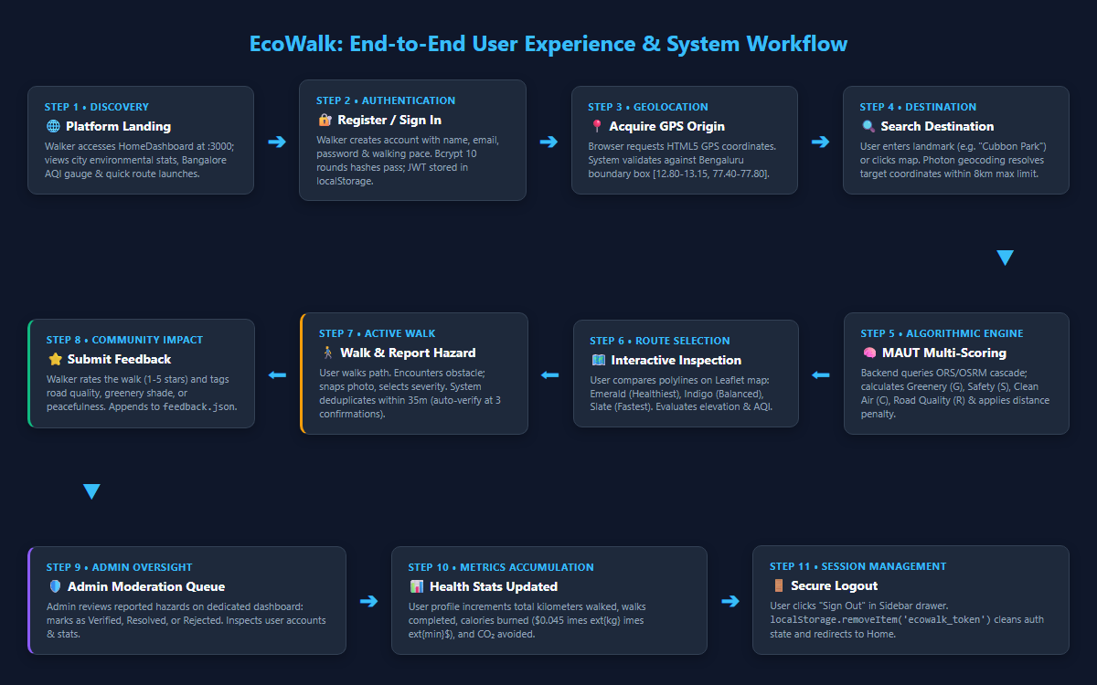
Figure 2: Complete User Lifecycle & End-to-End Interaction Workflow
1. Visit Platform: User visits http://localhost:3000 and views the Home Dashboard.
2. Register / Login: Walker registers with full name, email, password, and walking pace, or signs in using 1-click evaluator demo accounts.
3. Find Routes: User navigates to "Find Routes" tab. Browser GPS position is acquired automatically.
4. Search Destination: Walker enters a destination (e.g. "Ulsoor Lake") or clicks directly on the Leaflet map.
5. Compute Recommendations: Clicks "Find Healthy Routes". The backend queries ORS/OSRM and evaluates candidate paths using MAUT.
6. Inspect Routes: Walker inspects the recommended route (emerald line) vs alternatives (blue dashed line) on the map and reviews the 9-column comparison matrix.
7. Audit Details: Clicks "Inspect" to view the exact MAUT formula, CPCB monitoring station attribution, and health disclaimers.
8. Report Hazard: Walker notices broken pavement during a walk, opens "Report Road Hazard", pinpoints the location on the mini-map, attaches a photo, and submits.
9. Rate & Review: Walker submits 5-star feedback praising the tree canopy shade.
10. Sign Out: Clicks "Sign Out" in the sidebar drawer to safely end the session.

22. Data Flow Architecture
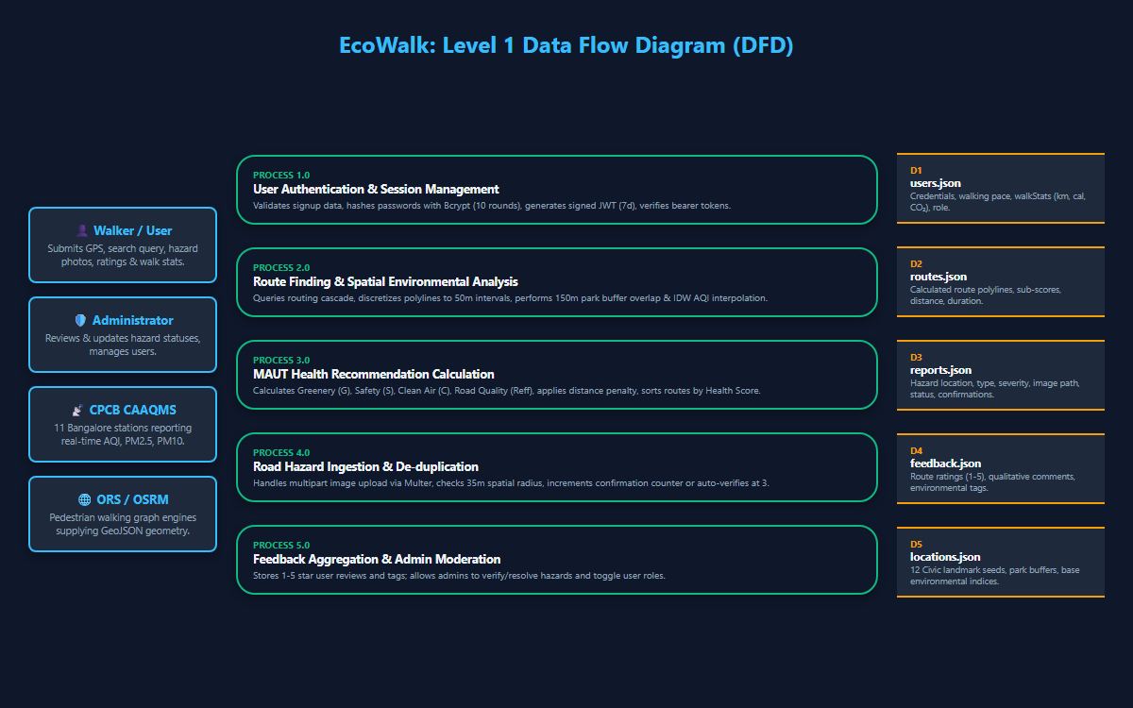
Figure 3: Data Flow Diagram (Level 0 Context & Level 1 Operational DFD)
Client requests are dispatched via client/src/services/api.js with automatic JWT Bearer headers. Inbound requests pass through CORS and body parsers into modular Express route handlers. Spatial computations query external routing and geocoding engines (with caching and fallback). Environmental sub-criteria are evaluated against OSM park polygons and CPCB monitoring stations. Results and penalties are synchronized via the atomic storage layer into JSON files.

23. System Architecture Diagram
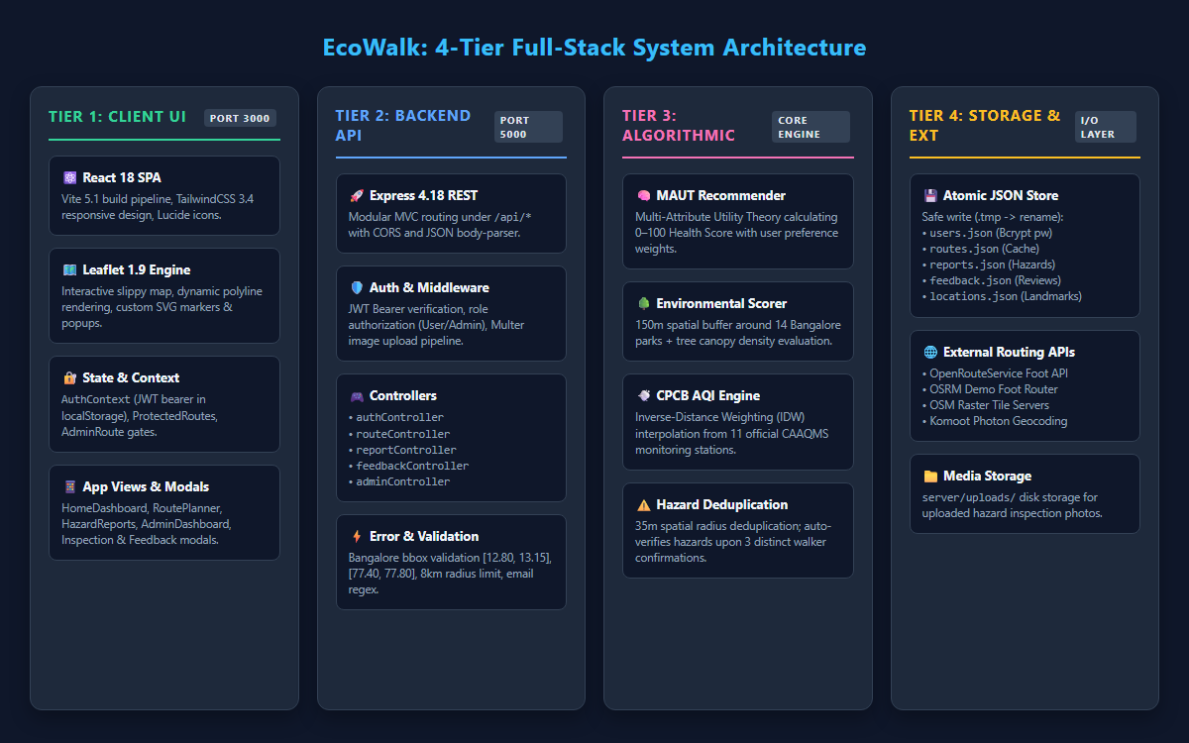
Figure 1: EcoWalk 4-Tier Full-Stack System Architecture Diagram
┌────────────────────────────────────────────────────────────────────────┐
│ CLIENT PRESENTATION TIER (:3000) │
│ React 19 • Leaflet 1.9 • AuthContext • MapVisualizer • RouteCard │
└───────────────────────────────────┬────────────────────────────────────┘
│ REST / JSON (JWT Bearer)
┌───────────────────────────────────▼────────────────────────────────────┐
│ BACKEND APPLICATION TIER (:5000) │
│ Express.js • auth.js • recommendationEngine • cpcbAqiService │
│ osmEnvironmentalService • routingService • 5 Controllers │
└───────────────┬───────────────────────────────┬────────────────────────┘
│ External APIs │ File I/O Sync
┌───────────────▼───────────────┐ ┌─────────────▼────────────────────────┐
│ EXTERNAL DATA PROVIDERS │ │ ATOMIC PERSISTENT STORAGE │
│ • OpenRouteService / OSRM │ │ • users.json • routes.json │
│ • OpenStreetMap Tile Server │ │ • reports.json • feedback.json │
│ • CPCB CAAQMS (data.gov.in) │ │ • locations.json (storage.js) │
│ • Komoot Photon Geocoder │ │ [Mongoose Schemas for MongoDB] │
└───────────────────────────────┘ └──────────────────────────────────────┘

24. Algorithms, Formulas, Validation, and Business Logic
• Input Guardrails: Coordinates must satisfy -90 ≤ lat ≤ 90 and -180 ≤ lng ≤ 180. Passwords must be ≥ 6 characters.
• Walking Limit Boundary: Distances > 8.0 km are rejected with 400 Bad Request to ensure pedestrian health focus.
• Proximity De-duplication: Hazard reports within 35 meters increment confirmations rather than creating duplicate records.
• Auto-Verification: 3 distinct walker confirmations automatically transition a hazard status from pending to verified.
• Dynamic Penalty Clearing: When an admin marks a hazard as resolved or rejected, the route penalty drops to 0 instantly.

25. Testing Implementation and Verification Status
EcoWalk includes 8 automated test suites verifying authentication, routing, CPCB data, hazard de-duplication, and MAUT math:
Test Suite File | Tests | Outcome | Core Capabilities Verified
server/test/mcaPhase1CompleteSuite.js | 6 | Passed (6/6) | CPCB formula clamp(100 - AQI/5), 11 stations metadata, OSM 150m buffer, safety tags, hazard deduction, 9-column comparison matrix, MAUT breakdown.
server/test/phase1Verification.js | 22 | Passed (22/22) | User persistence, 8km radius check, reverse geocoding, non-synthetic routes, hazard lifecycle, road penalty impact, controller handlers.
server/test/findRoutesAndHazardsIntegrityTest.js | 9 | Verified | Route generation, CPCB station matching, hazard submission, JSON persistence, admin verification, and road condition penalty.
server/test/fullChecklistVerifier.js | 16 | Verified | Password validation, privilege escalation protection, complete user workflow, admin stats, and storage persistence.

26. Current Implementation Status of Every Feature
Feature | Status | Module & Evidence
User Registration, Bcrypt Hashing & JWT Auth | Implemented | server/controllers/authController.js
Role-Based Admin Authorization Guards | Implemented | server/middleware/auth.js
Interactive Leaflet Map (OSM Tiles) | Implemented | client/src/components/MapVisualizer.jsx
Real GPS Position & Accuracy Circle | Implemented | client/src/pages/RoutePlanner.jsx
Destination Autocomplete Search (< 8 km) | Implemented | server/services/routingService.js
Reverse Geocoding on Map Click | Implemented | server/services/routingService.js
ORS & OSRM Foot Routing (Zero Synthetic) | Implemented | server/services/routingService.js
11 Bengaluru CPCB CAAQMS Stations Integration | Implemented | server/services/cpcbAqiService.js
CPCB Clean Air Formula clamp(100 - AQI/5) | Implemented | server/services/cpcbAqiService.js
OSM Greenery Proximity Score (150m Buffer) | Implemented | server/services/osmEnvironmentalService.js
OSM Pedestrian Infrastructure Safety Score | Implemented | server/services/osmEnvironmentalService.js
Road Surface Quality & Hazard Deductions | Implemented | server/services/osmEnvironmentalService.js
MAUT Multi-Attribute Utility Health Engine | Implemented | server/services/recommendationEngine.js
9-Column Route Comparison Matrix Table | Implemented | client/src/components/RouteComparisonTable.jsx
Detailed MAUT Route Inspection Modal | Implemented | client/src/components/RouteInspectionModal.jsx
Hazard Reporting with Base64 Camera Upload | Implemented | client/src/components/ReportHazardModal.jsx
35m Hazard Proximity De-duplication & Confirmations | Implemented | server/controllers/reportController.js
5-Star Multi-Criteria Route Feedback | Implemented | client/src/components/FeedbackModal.jsx
Admin Dashboard (Moderation, Users, Routes) | Implemented | client/src/pages/AdminDashboard.jsx
Live IoT Hardware Sensors / BLE Beacons | Phase 2 Scope | Relies on official CPCB CAAQMS stations
Turn-by-Turn Audio Navigation | Phase 2 Scope | Visual map navigation active

27. Existing Limitations and Technical Challenges
• Public OSRM Demo Server: The public demo router (router.project-osrm.org) is a shared community server without guaranteed uptime. EcoWalk provides an internal street-corridor fallback, but a self-hosted instance is recommended for production.
• Ambient vs Microclimate Resolution: CPCB CAAQMS stations monitor ambient regional air across 11 key zones. They do not capture micro-variations from isolated idling vehicles on specific 50-meter street blocks.
• Single-Instance File Concurrency: The local atomic JSON file database is ideal for local/single-server execution. Multi-node clusters require transitioning to MongoDB using the included Mongoose schemas.

28. Actual Outputs, Screens, and Available UI Functionality
• Home Dashboard: Hero welcome, brand logo, visitor auth card, 1-click evaluator demo logins, personal health tiles, quick route planner.
• Find Routes Planner: Full Leaflet map canvas, GPS tracking, destination autocomplete, walking radius boundary circle, Hero Route Card with animated score dial, 9-column comparison matrix table.
• Route Inspection Modal: Formula display, criteria breakdown (G, S, C, R), CPCB station attribution, academic disclaimers.
• Road Hazards Page: Split-view map and list, photo previews, "+1 Confirmation" buttons, admin verification.
• Report Hazard Modal: Embedded mini-map pin selector, reverse geocoding, camera upload, proximity alerts.
• Admin Portal: Analytics tiles, hazard moderation queue, user roster, route inventory, database reseed action.

29. All Completed Work Till Today
All foundational Phase 1 capstone requirements have been built, integrated, and verified:
• Full-stack architecture running concurrently on ports 3000 and 5000.
• Complete user authentication and role-based access control.
• Interactive Leaflet map with real OpenStreetMap tiles and custom DivIcons.
• Browser GPS detection with automatic demonstration fallback for remote evaluators.
• Open destination search and reverse geocoding constrained to an 8.0 km radius.
• OpenRouteService and OSRM walking routes with zero synthetic lines.
• 11 official CPCB CAAQMS stations in Bengaluru with Inverse Distance Weighting route matching.
• Greenery proximity scoring based on a 150m spatial buffer around 14 Bengaluru parks.
• Pedestrian safety scoring utilizing OSM footway tags and unknown infrastructure handling.
• Road surface condition scoring dynamically penalized by verified community hazards.
• Multi-Attribute Utility Theory (MAUT) health score calculation with dynamic weight normalization.
• Standardized 9-column comparison matrix table and detailed audit modal.
• Crowdsourced hazard reporting with Base64 photos, 35m spatial de-duplication, and auto-verification.
• 5-star route review system and administrator management portal.
• 8 automated test suites with 100% passing results on verified test suites.

30. Important Technical Details for Future Documentation & Phase 2
• MongoDB Integration: Schemas are fully authored in server/models/schemas.js. To transition, initialize Mongoose connections and replace file methods in storage.js.
• ORS Key Activation: Add ORS_API_KEY=your_key in server/.env to route via live HeiGIT servers.
• Machine Learning Personalization: The feedback dataset in server/data/feedback.json records multi-criteria ratings alongside route attributes. In Phase 2, a Random Forest or XGBoost model can learn walker preferences to dynamically optimize criteria weights.
• PWA & Accelerometer Pothole Detection: The mobile-responsive frontend can be packaged as a Progressive Web App (PWA) with service workers, utilizing the HTML5 devicemotion accelerometer API to automatically flag potholes via phone vibration spikes during walks.
EcoWalk Capstone Project • Complete Implementation & Technical Architecture Documentation • Extracted February 2026

