**Advanced Web Engineering**

**Assignment Component 3, January 2022**

**Laravel Project**

**Final Laravel Application**

Name: Rakshya Lama Moktan

Student Id: 77227218

**Features**

* Cart System
* Wish list System
* Searching/Sorting using Query Scope
* Stripe Payment
* Email Verification using Mail trap
* Password Reset using Mail trap
* Password Reset Notification for newly created users by admin through mail trap
* Mail Subscription through mailchimp
* Route based authorization using Custom Middleware
* View based authorization using Gates (can/cannot)
* Fake data through factories/seeder
* Session based flash messages for controller actions

**Video Link:** <https://www.loom.com/share/32fd57d9cbbb4029b7e91d4d9f11676a?from_recorder=1&focus_title=1>

**Version Control through Git**

Git Link: <https://github.com/tbc-bsc-l6/component-2-Rakshya8.git>

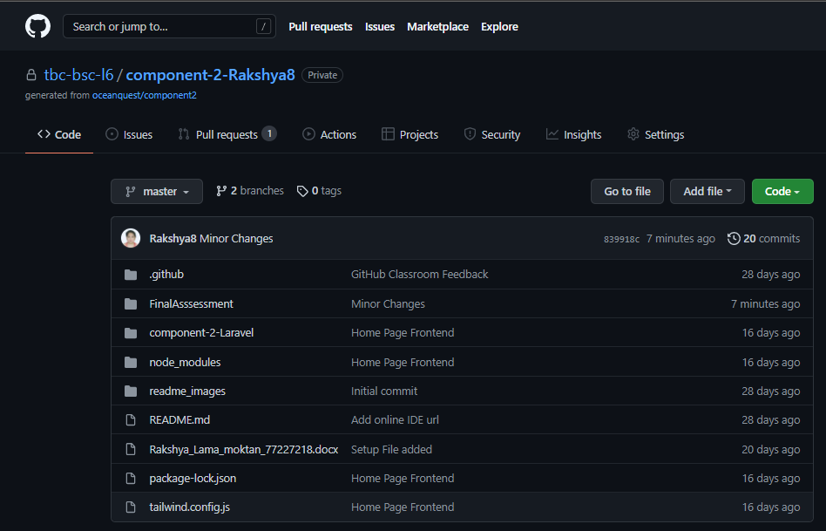

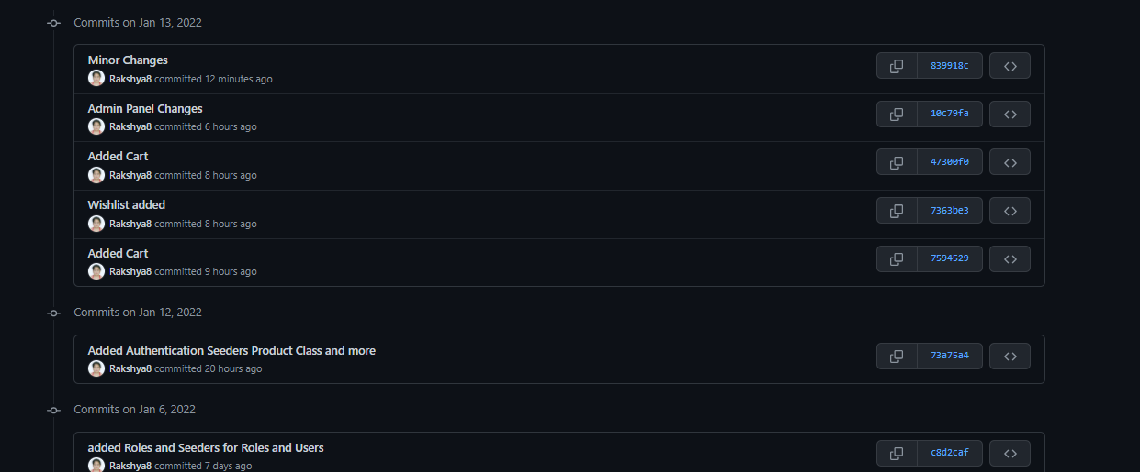

**Gates**

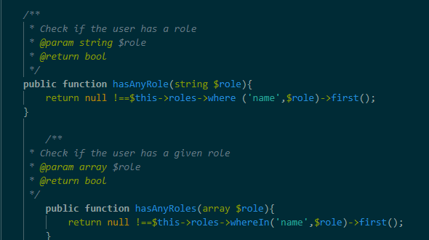

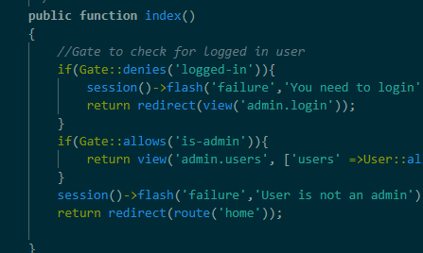

**Middleware**

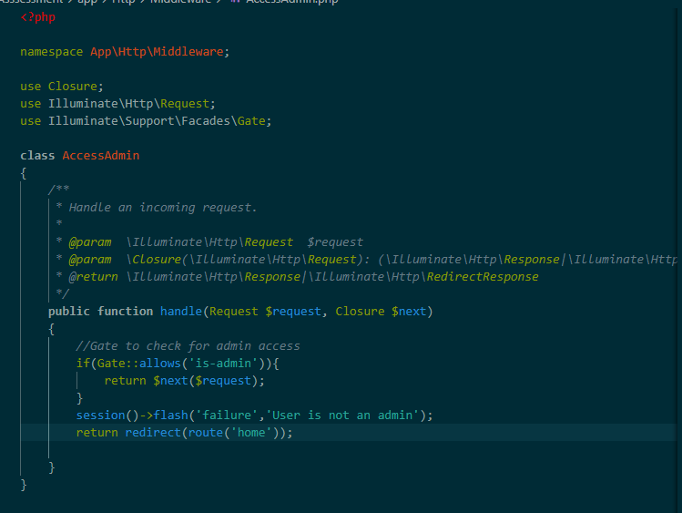

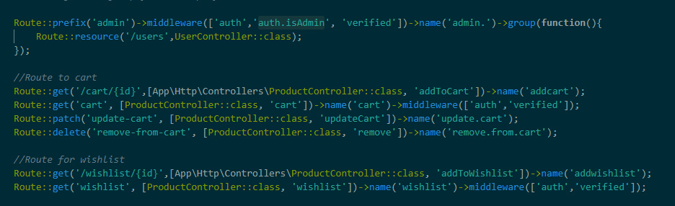

**Service Providers**

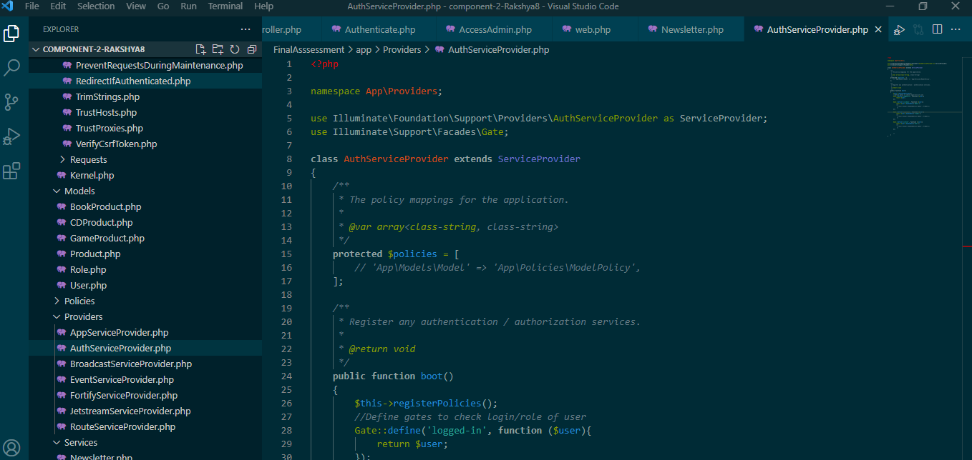

**Mailtrap**

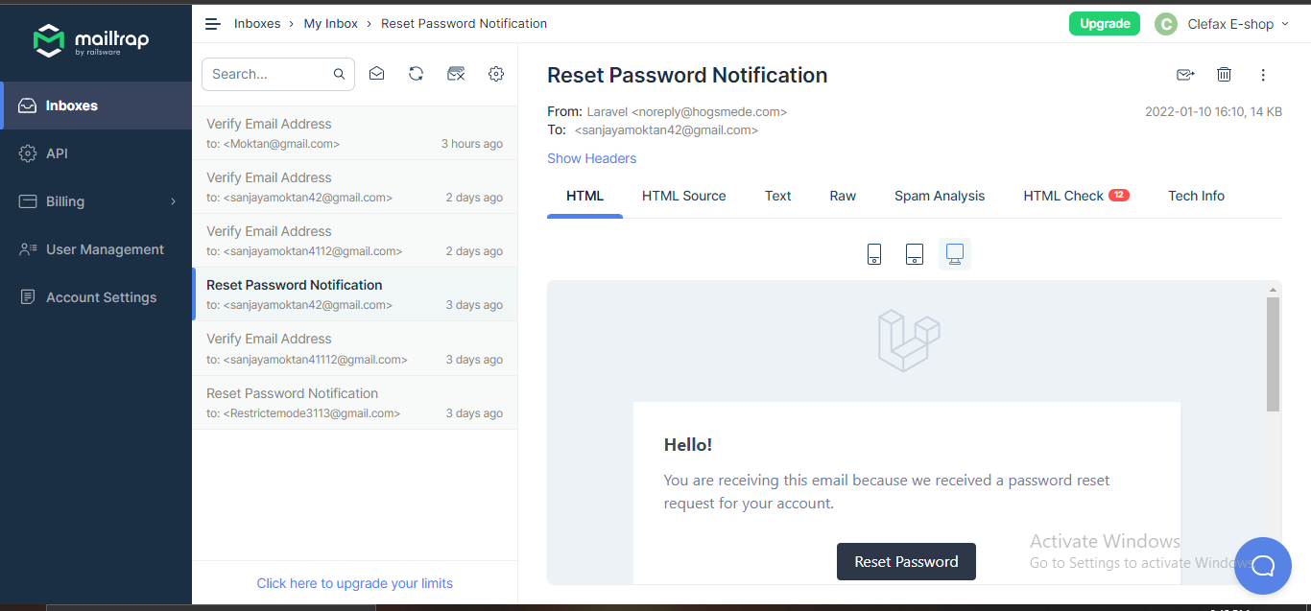

**MailChimp**

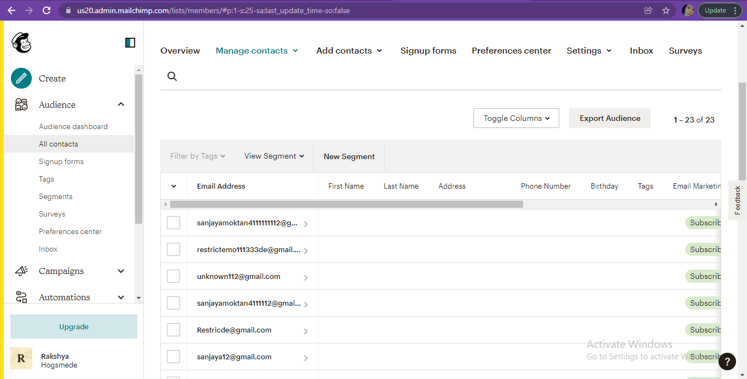

**Stripe**

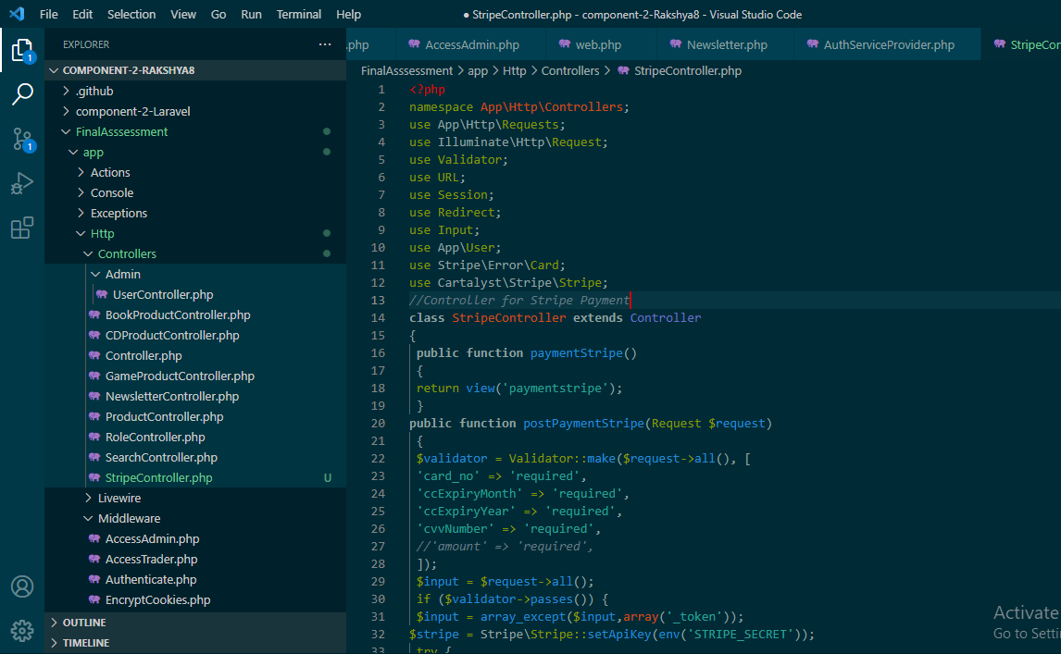

**Admin View**

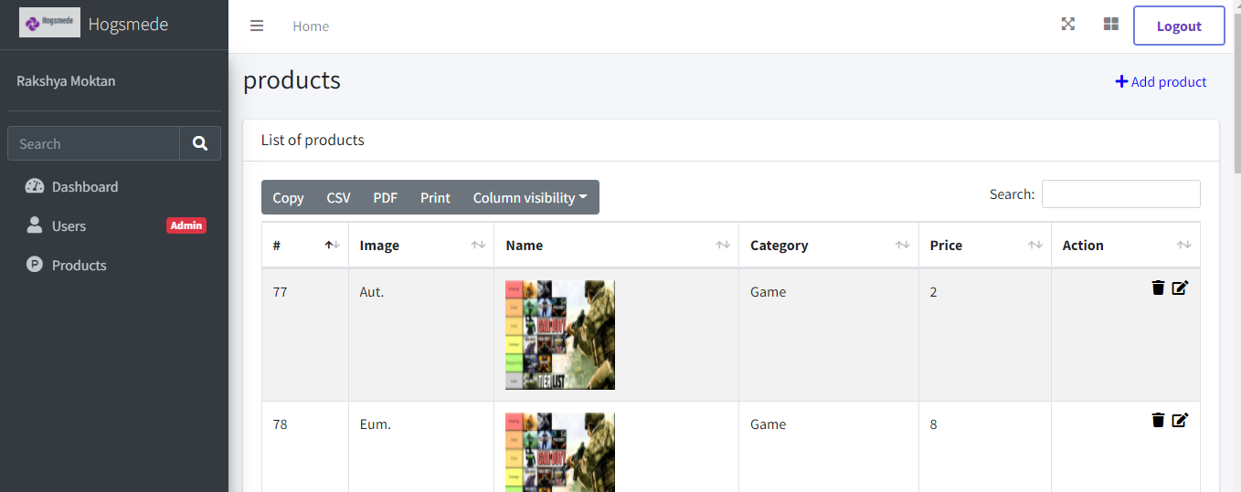

**Middleware in action with Flash Message**

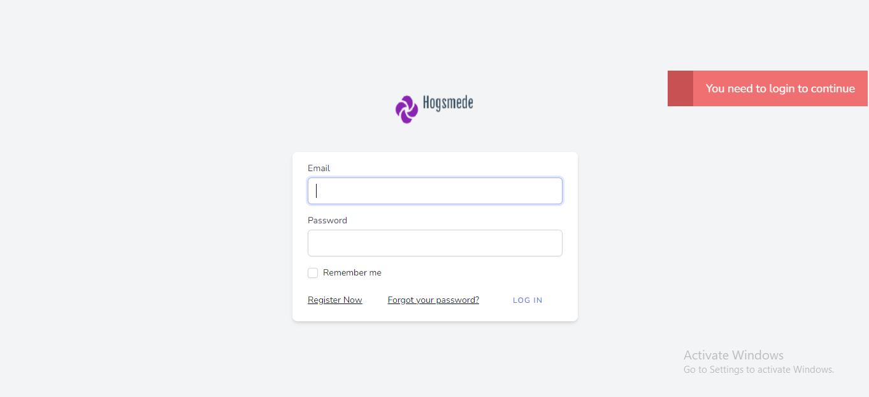

**Factory/Seeder**

