**Advanced Web Engineering**

**Assignment Component 2**

**Laravel View Route Controller**

**December 2021**

Name: Rakshya Lama Moktan

Student ID: 77227218

Section: C

Contents

Git Interface 3

Git Commit 3

Route List 4

CRUD Operations: 4

Create and Read: 4

Update / Edit / Delete: When we click on select button edit form Display as shown below, where we can Update and delete information: 5

Edit/Update: When we click on Update button then below entered date will be updated. 5

This form shows updated data in book form: 6

ADD New: When we click on ADD NEW button then below entered date will be Added in the CD form. 6

This form shows Added new data in CD form: 7

DELETE: When we clicked on Select button then below Form Display with DELETE button option where we can delete data from CD Form. 7

This shows that data was deleted from CD Form. 8

My Git Project Link: - https://github.com/tbc-bsc-l6/component-2-Rakshya8.git 8

# Git Interface

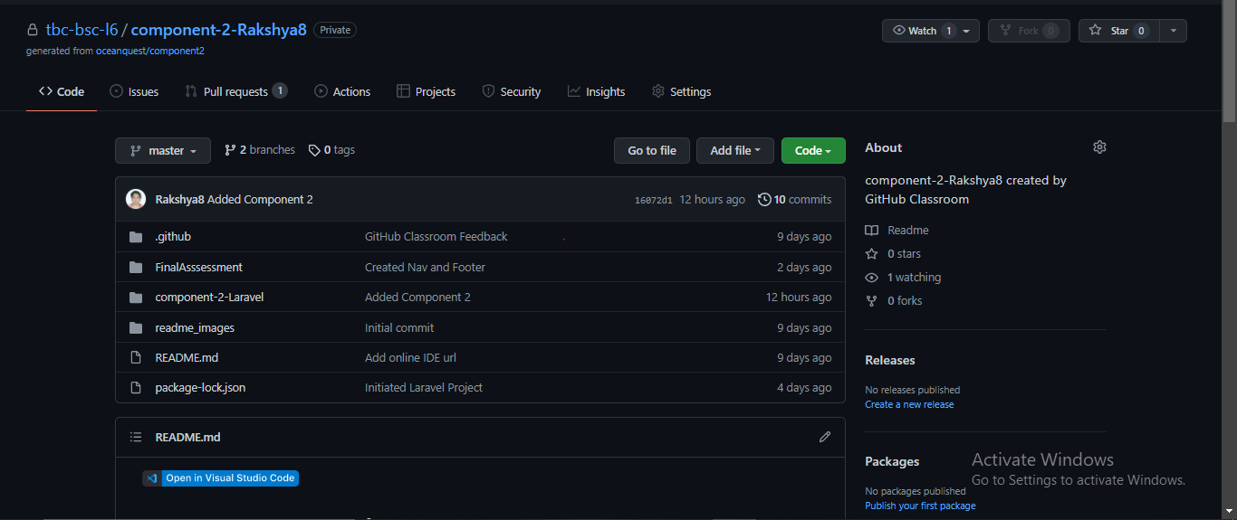

## Git Commit

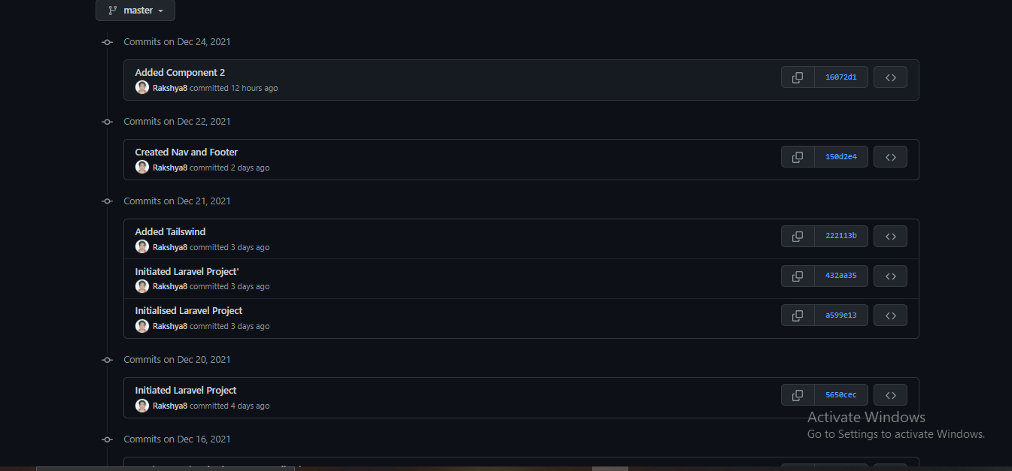

# Route List

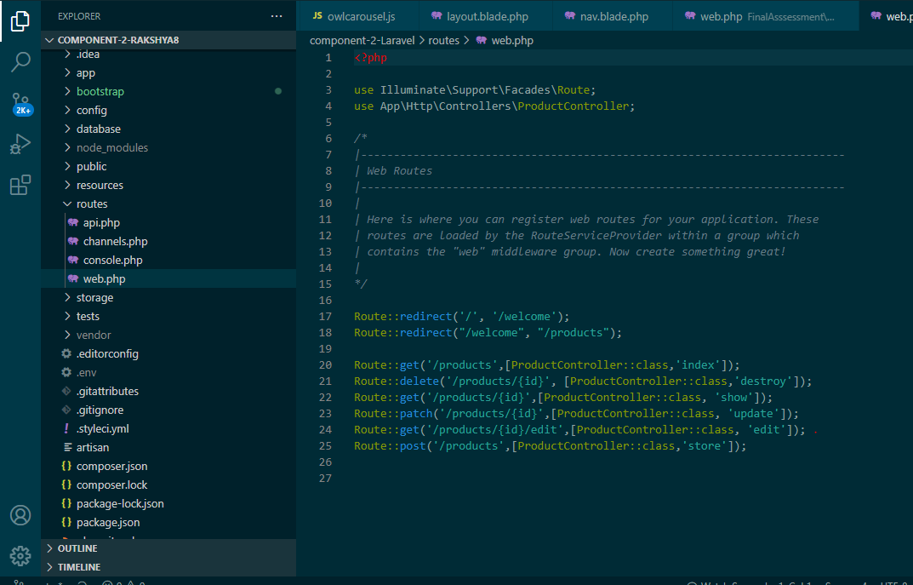

# CRUD Operations:

## Create and Read:

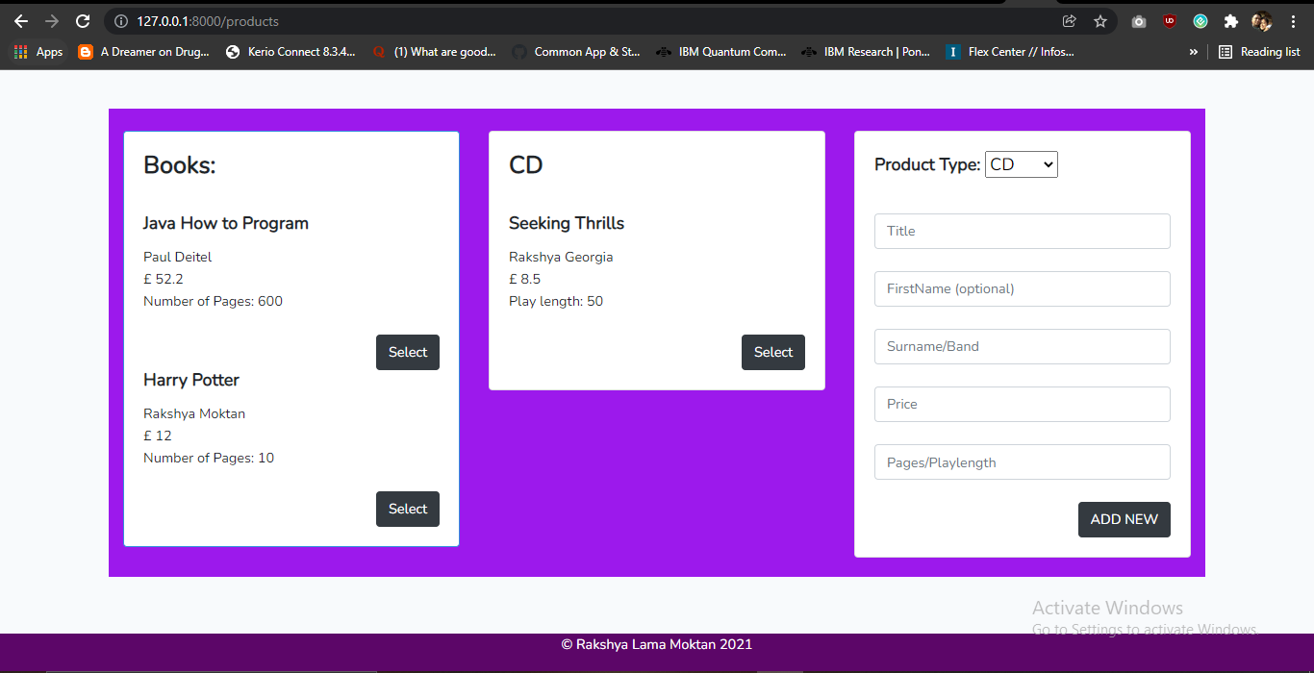

## Update / Edit / Delete: When we click on select button edit form Display as shown below, where we can Update and delete information:

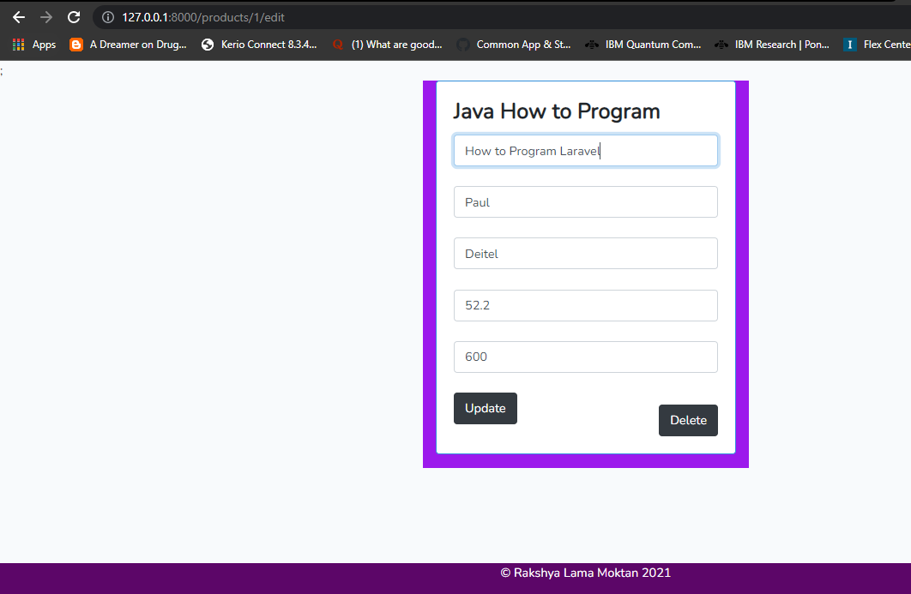

## Edit/Update: When we click on Update button then below entered date will be updated.

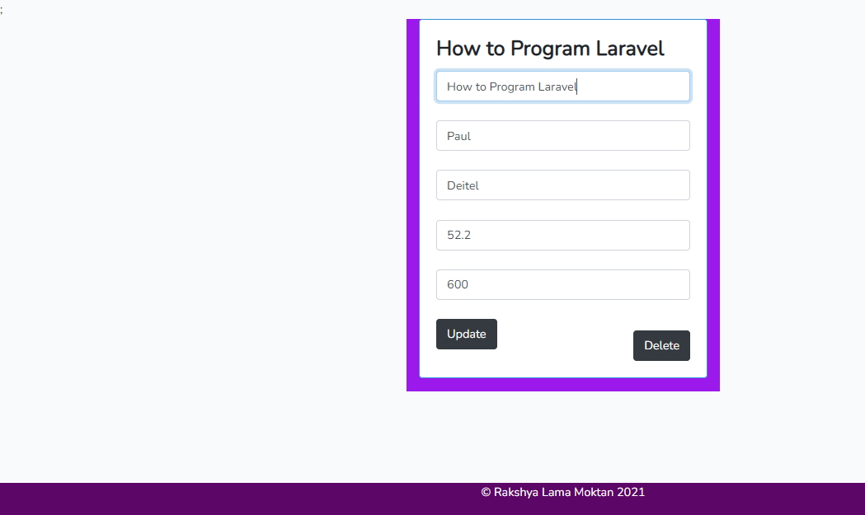

## This form shows updated data in book form:

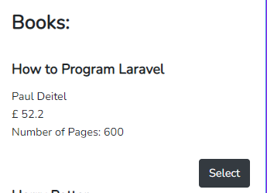

## ADD New: When we click on ADD NEW button then below entered date will be Added in the CD form.

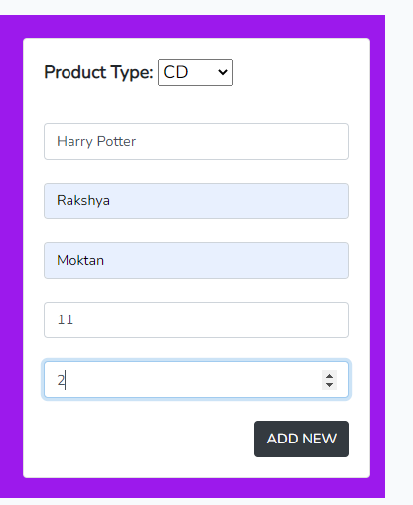

## This form shows Added new data in CD form:

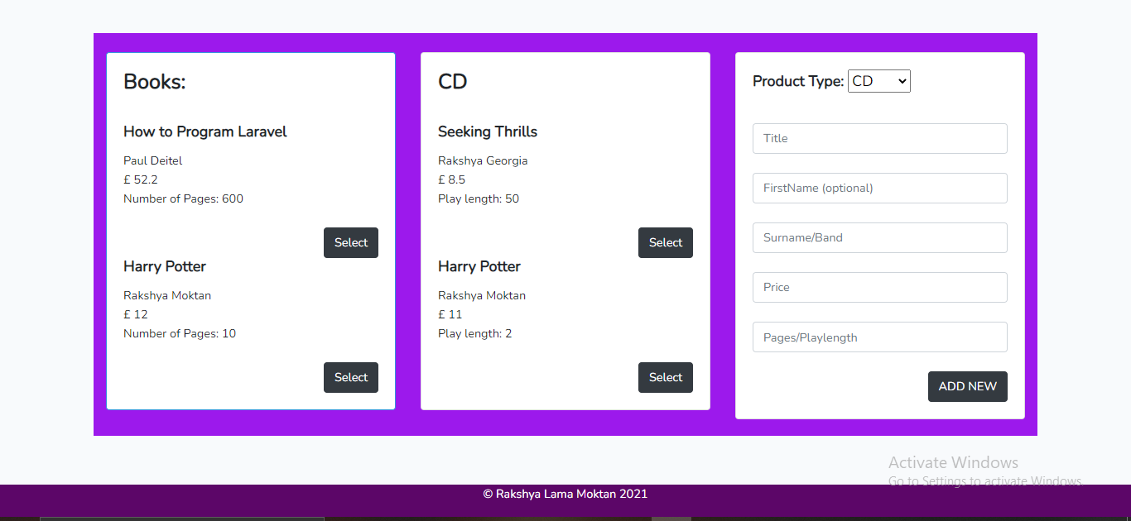

## DELETE: When we clicked on Select button then below Form Display with DELETE button option where we can delete data from CD Form.

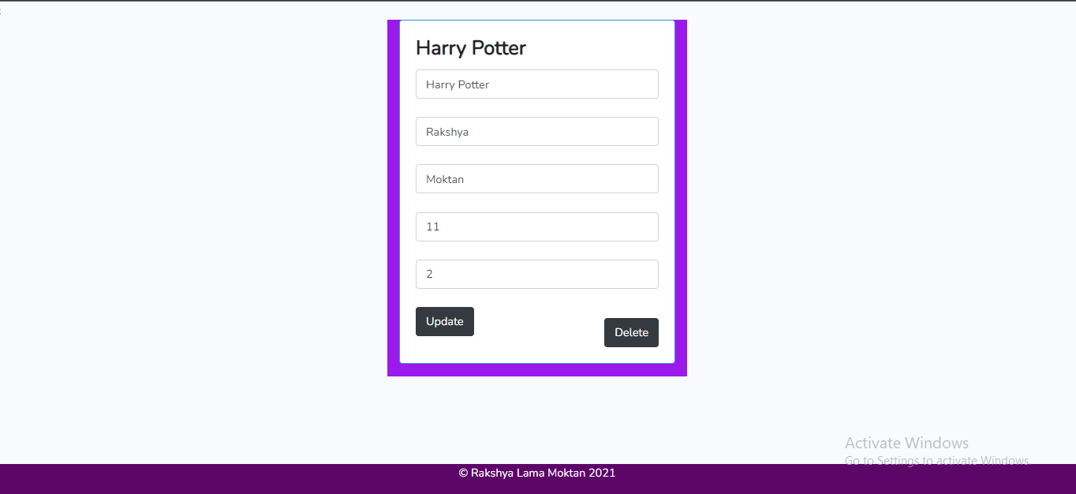

## This shows that data was deleted from CD Form.

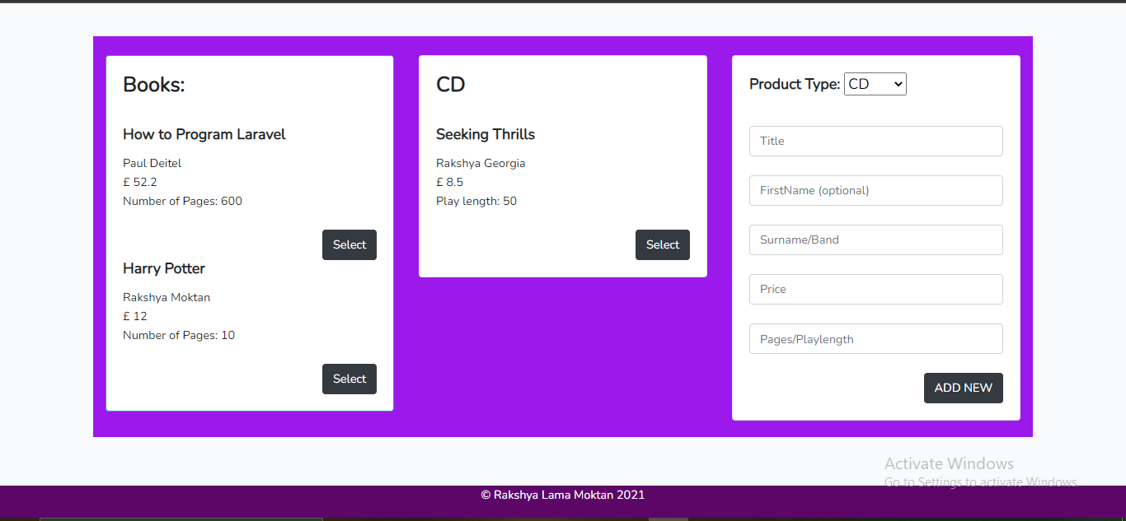

# My Git Project Link: - https://github.com/tbc-bsc-l6/component-2-Rakshya8.git