**Php Version in CMD**

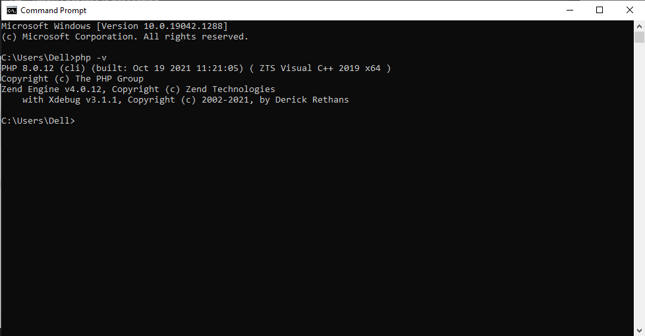

**PHP Version in Xamp Shell**

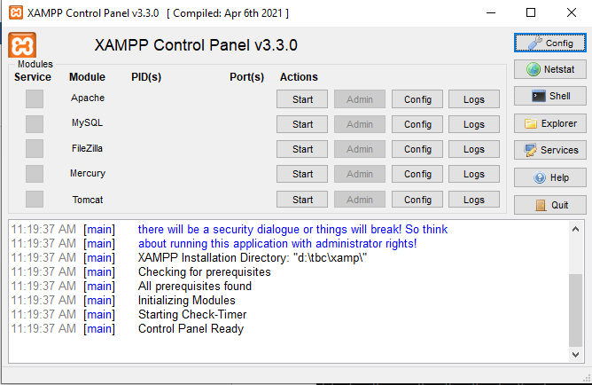

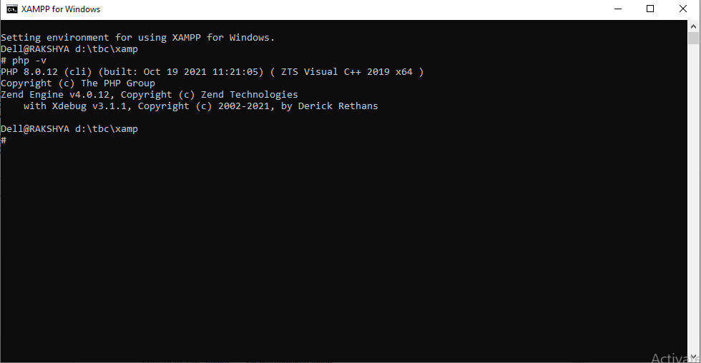

**X Debug in PHP CMD Shell**



**X Debug in PHP Xamp Shell**



**X Debug in Visual Studio Code**

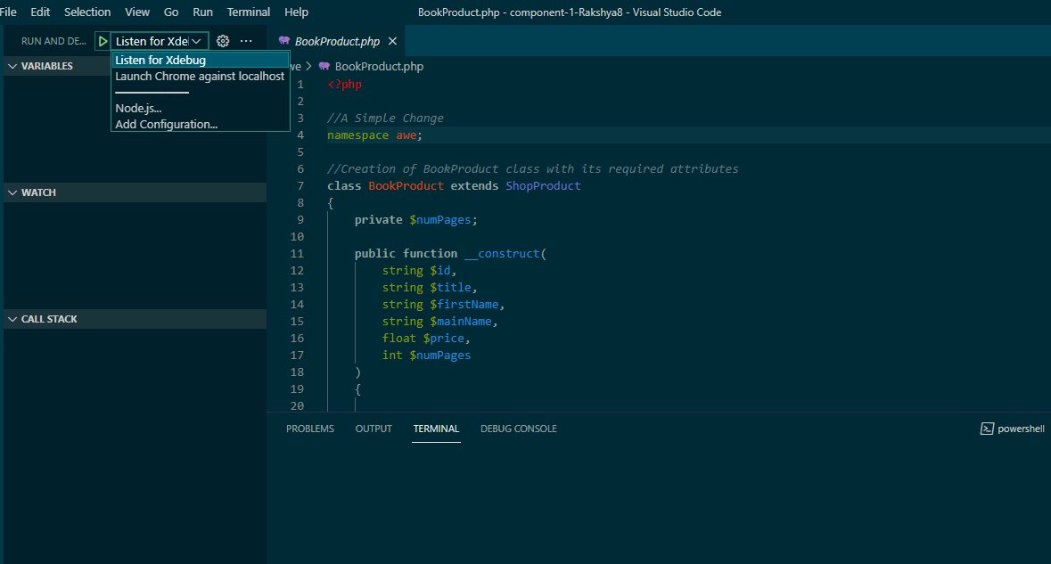

**Repo Link:** <https://github.com/tbc-bsc-l6/component-1-Rakshya8.git>

**Cloned Project in Visual Studio Code**

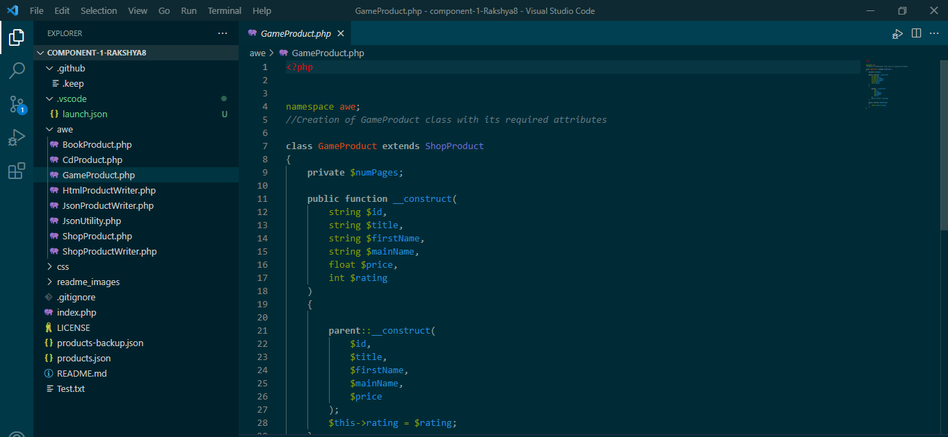

**Updated Website**

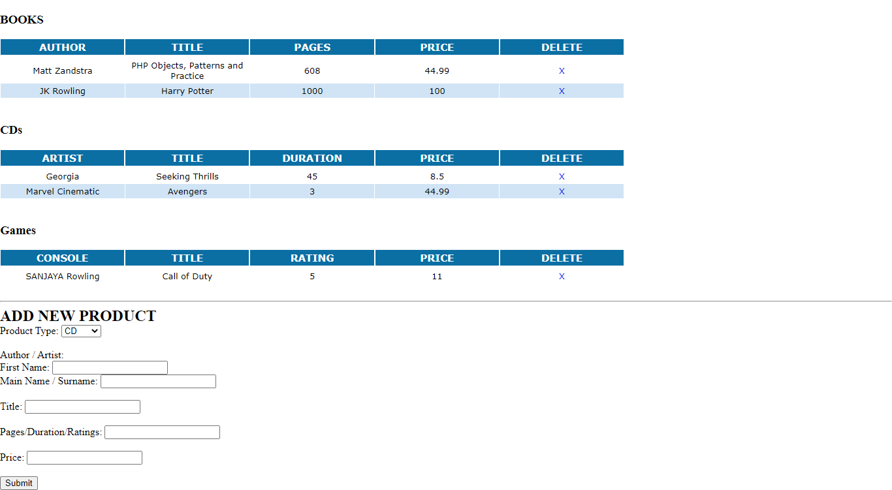

**Adding a new Game Product**

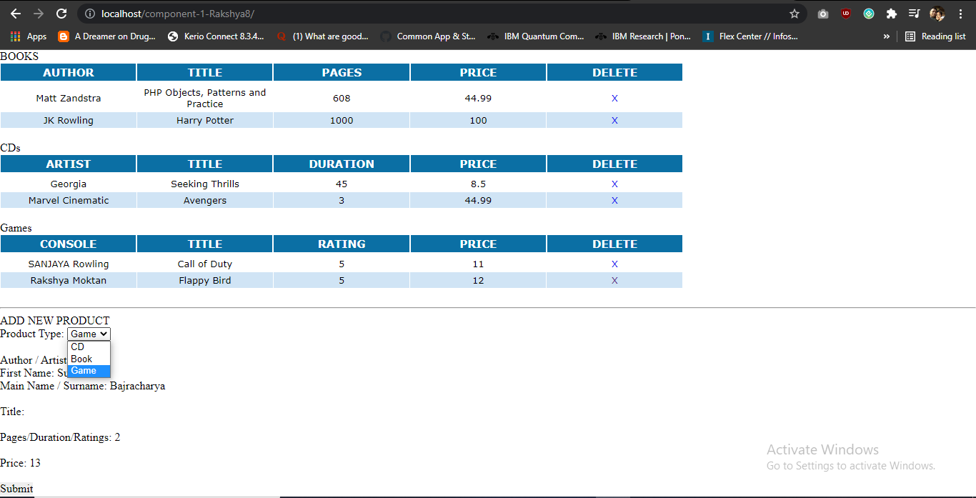

**Updating of Game Product List**

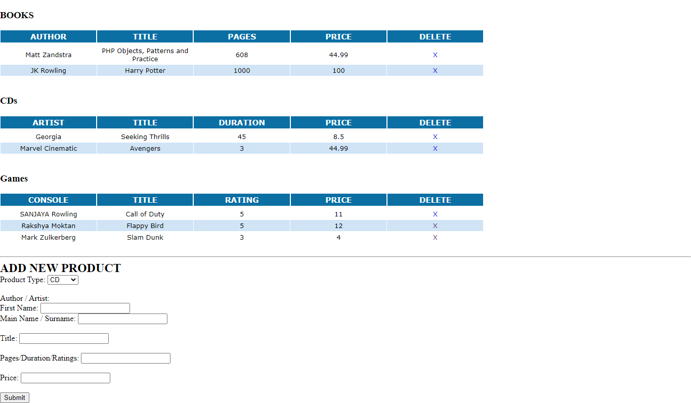

**Deleting a game product**

