

Advanced Software Engineering

Submitted To Resham Pun

By Rakshya Lama Moktan(L6) C7227218

TABLE OF CONTENT

1. Version Control 5

2. Basic Commands Execution 6

a. Circle 6

b. Rectangle 6

c. Triangle 7

d. Pen Command 7

e. Fill command 8

f. MoveTo Command 8

g. DrawTo Command 9

h. Polygon Command 9

i. Rotate 10

j. Flash Command 10

3. Save and load 10

a. Save commands into text file 10

b. Load commands 12

4. Command validation check 13

a. Valid commands and execution 13

b. Invalid Parameter Execution 14

c. Invalid Command Execution 14

5. If Endif/ Then Command 15

a. When the correct code is entered inside if endif 15

b. When the correct code is entered inside if then 15

c. When the variable is not declared 16

d. When condition inside if is not complete 16

e. When condition does not match 17

f. When if command is not closed 17

g. When endif is found before if command 18

6. Variable Command 18

a. When correct variable is declared. 18

b. When the variable is incorrectly declared. 19

c. When the same variable is declared again. 19

7. Variable Operation Command 20

a. When the variable operation is correct. 20

b. When the variable is not present 20

8. Loop command 21

a. When valid loop command is run 21

b. When the counter variable is not declared. 21

c. When the loop is not closed 22

d. When the counter variable is not handled 22

9. Method Command 23

a. When the method declaration is valid. 23

b. When parameter is Numeric 23

c. When same method is declared twice 24

d. When method call has different parameters than declaration 24

e. When the name of method is invalid 25

1. Method name starting with number 25

2. Method name containing invalid characters 25

f. When method syntax is invalid 26

g. When method is not closed 26

h. When method is closed before or without method 27

10. Singleton Design Pattern 27

11. Unit Testing 29

a. Testing valid drawing commands 29

1. Working process of this test 32

i. If Wrong Parameter is Passed, test fails. 32

ii. If Parameter is Passed Correctly 33

2. Screenshots of valid commands test 33

i. Run, Clear, Reset 33

ii. MoveTo Command 34

iii. DrawTo Command 35

iv. Fill 36

v. Pen 36

vi. Rectangle 37

vii. Triangle 38

viii. Polygon 39

ix. Rotate 40

x. Circle 41

b. If Endif/Then Command 42

1. Testing Code 44

2. Test Summary 44

c. Loop Command 45

1. Testing Code 47

2. Test Summary 47

d. Method Command 48

1. Test Code 50

2. Test Summary 50

e. Variable Command 51

1. Test Code 53

2. Test Summary 53

f. Screenshot of all test passed 54

12. Uml Diagram 55

# Version Control

Commits with description in GitHub.

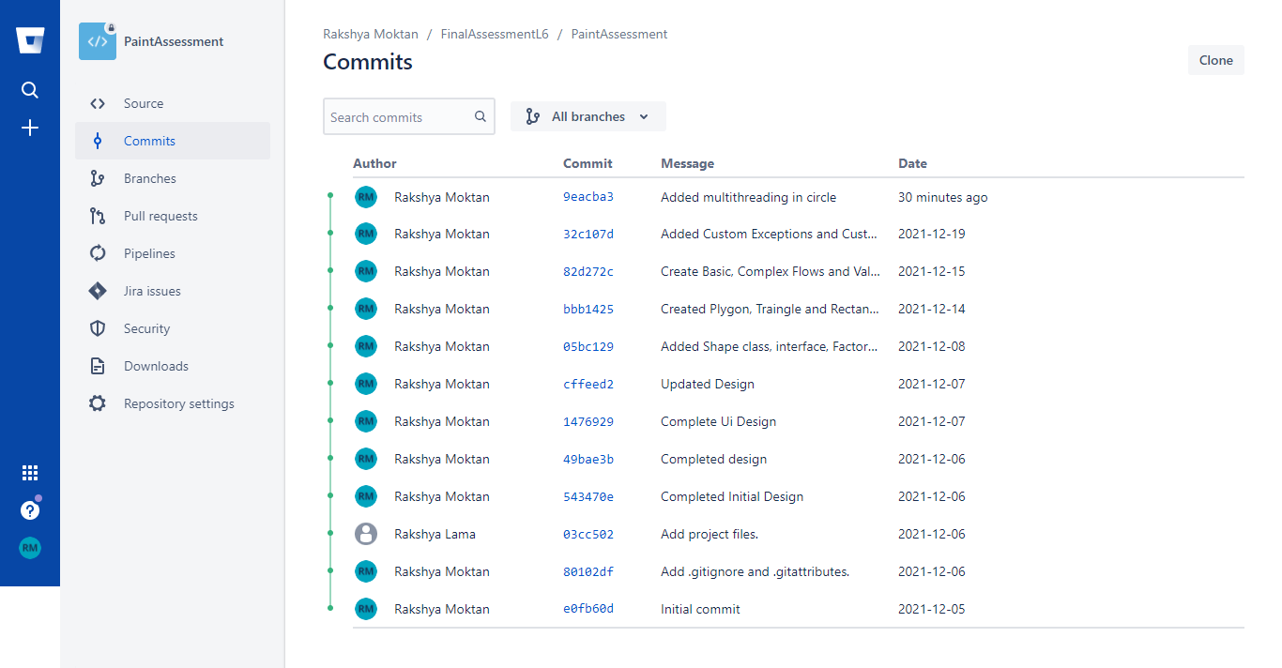

# Basic Commands Execution

## Circle

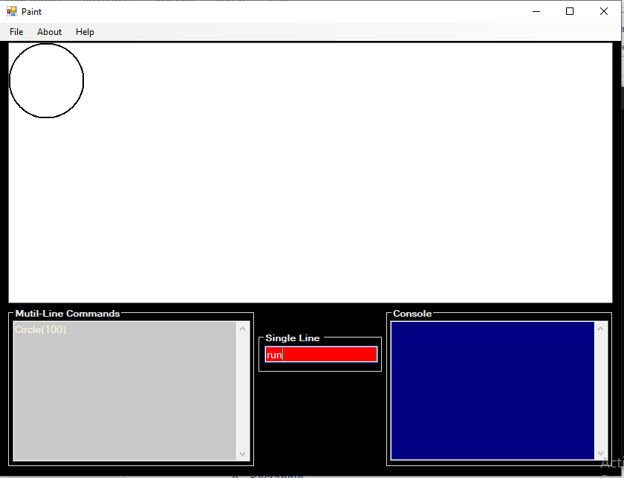

## Rectangle

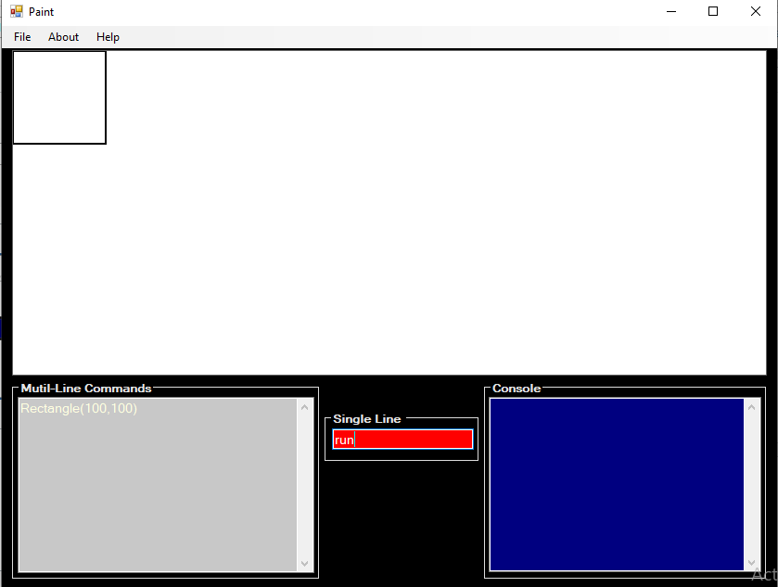

## Triangle

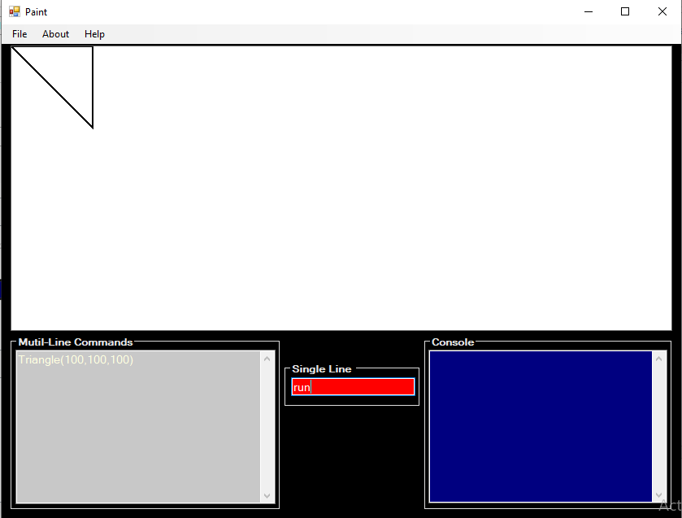

## Pen Command

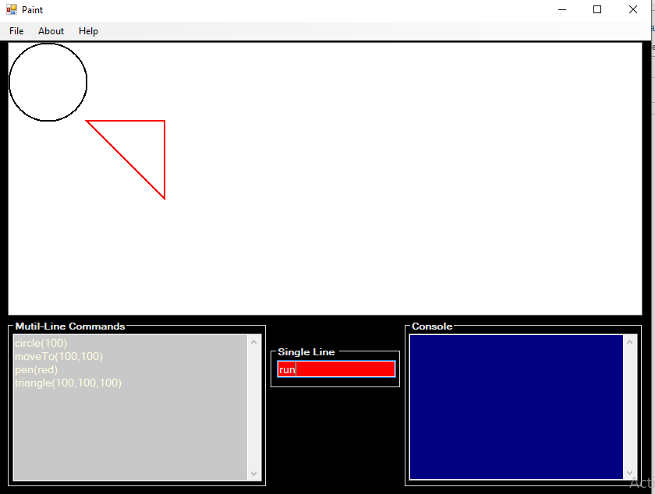

## Fill command

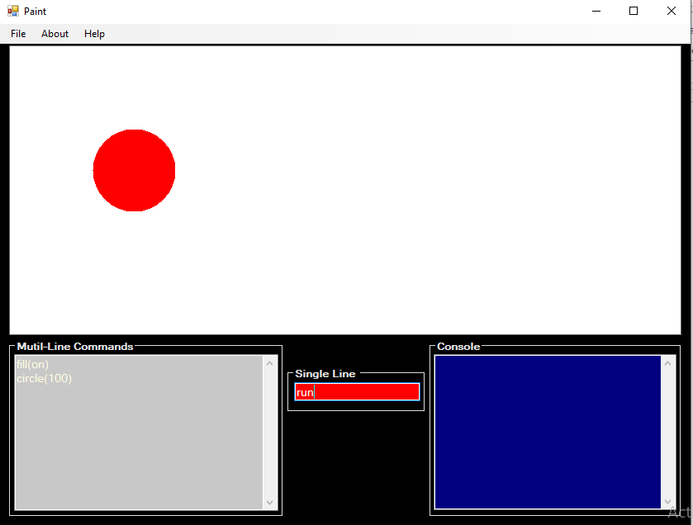

## MoveTo Command

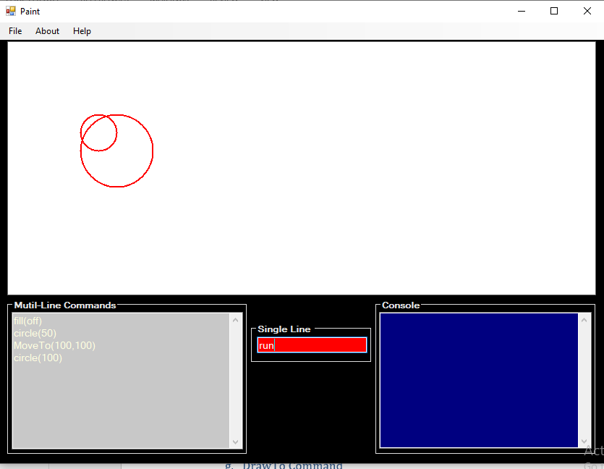

## DrawTo Command

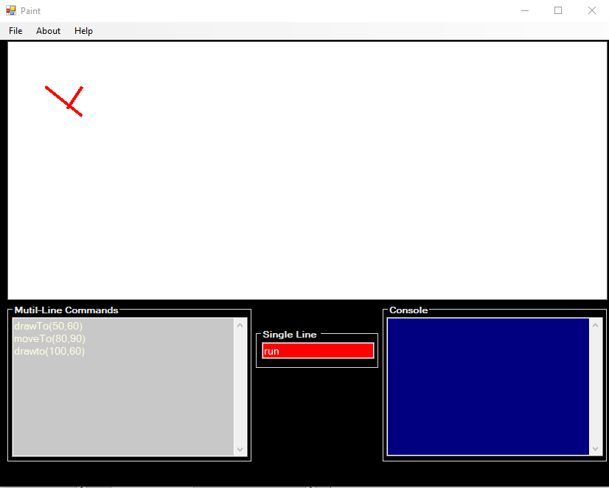

## Polygon Command

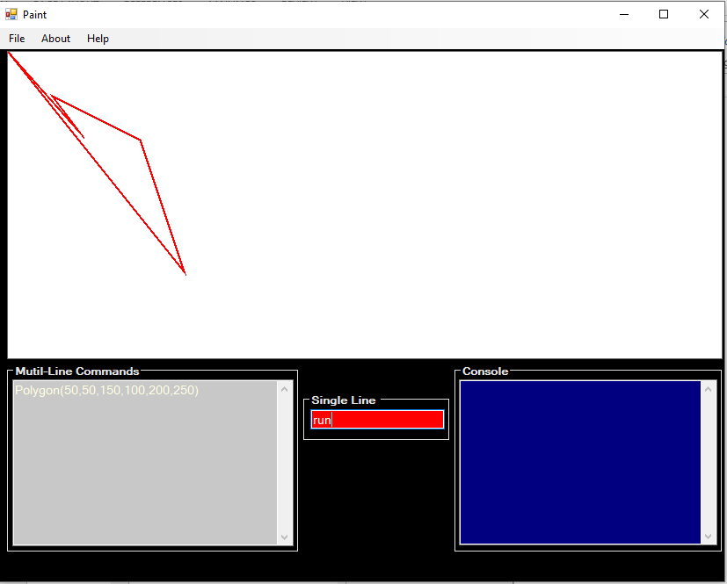

## Rotate

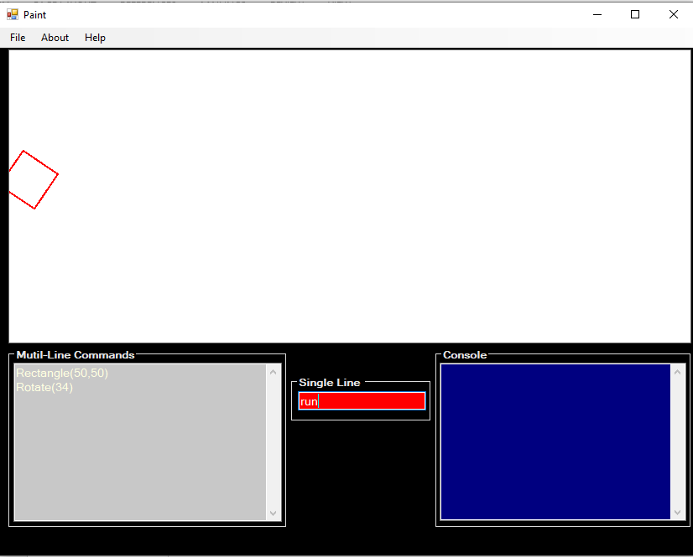

## Flash using Multithreading

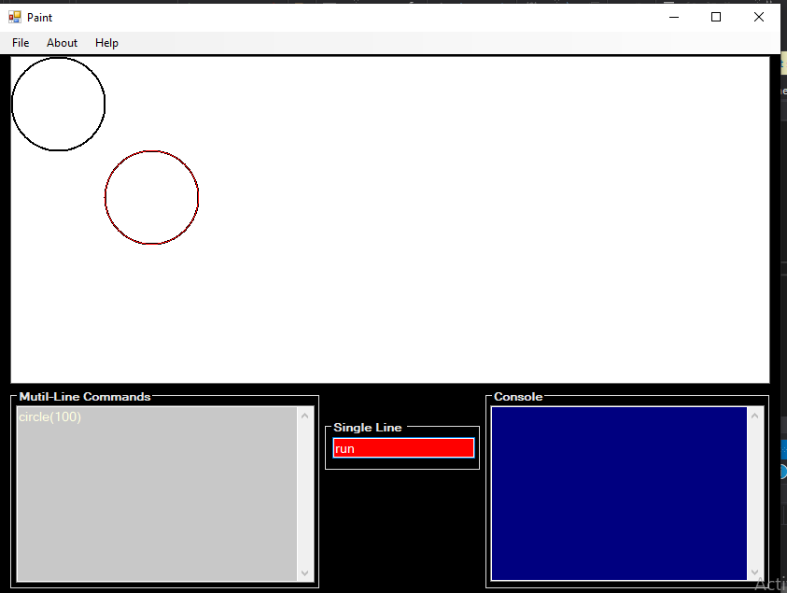

# Save and load

### Save commands into text file

Step 1: Click on save button

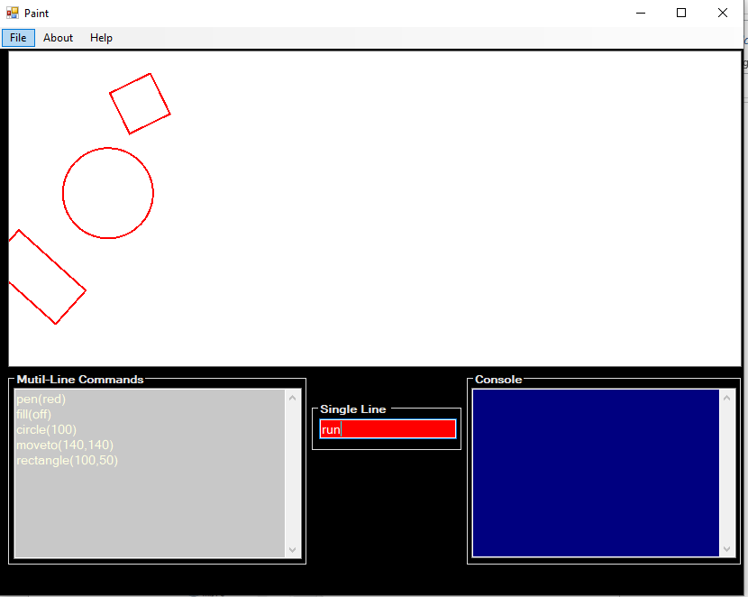

Step 2: Save Dialog Box to save file

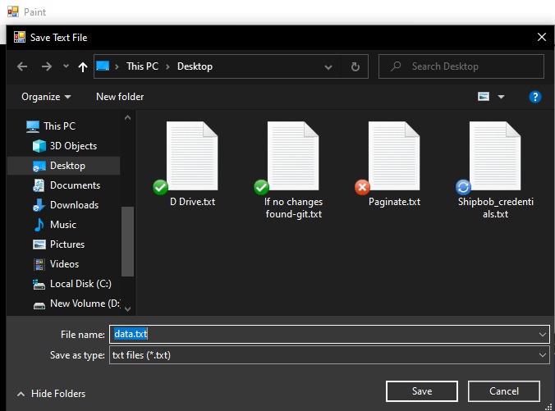

Step 3: Saved successfully.

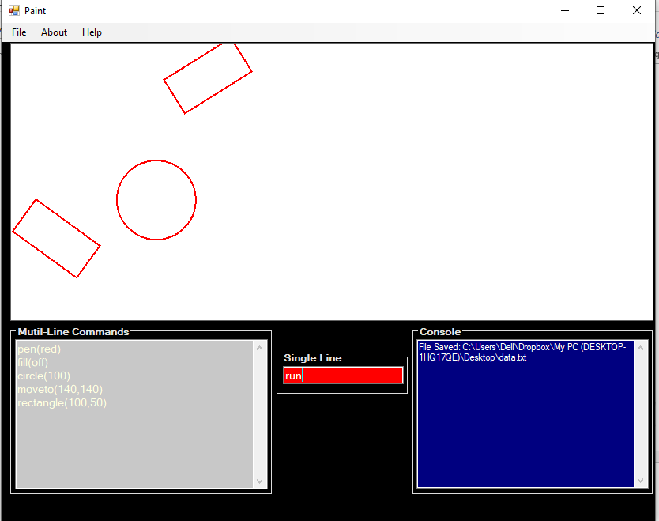

### Load commands

Step 1: Click on load button to open text file containing commands

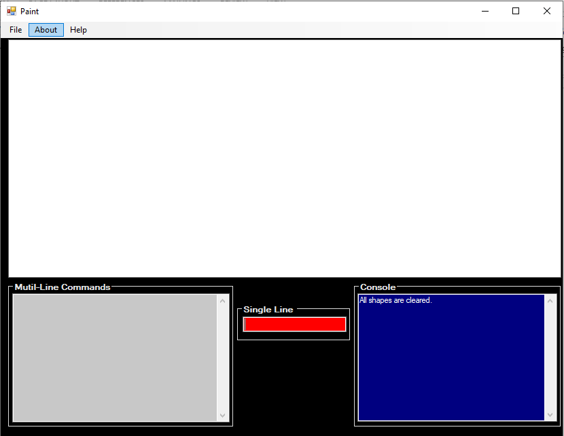

Step 2: Choose file from open dialog box and click open

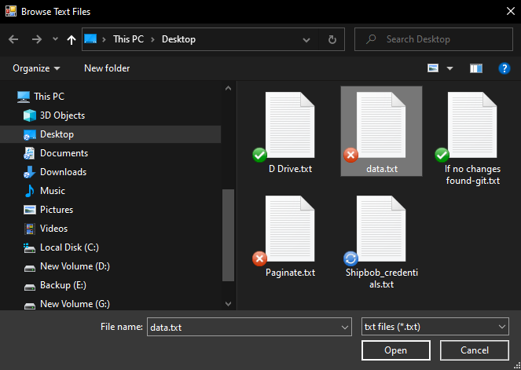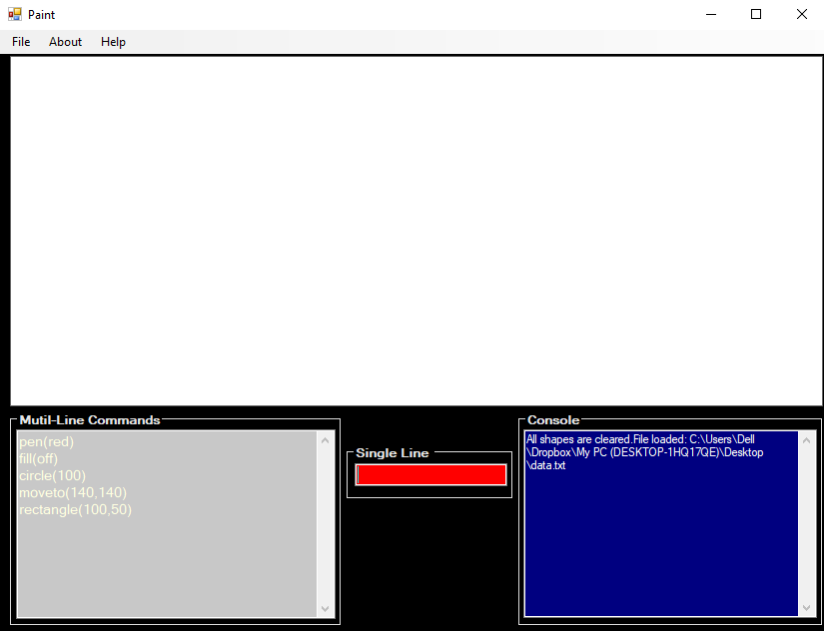

Step 3: File loaded and read successfully



# Command validation check

### Valid commands and execution

When valid commands are entered the commands are executed properly with no errors in console.

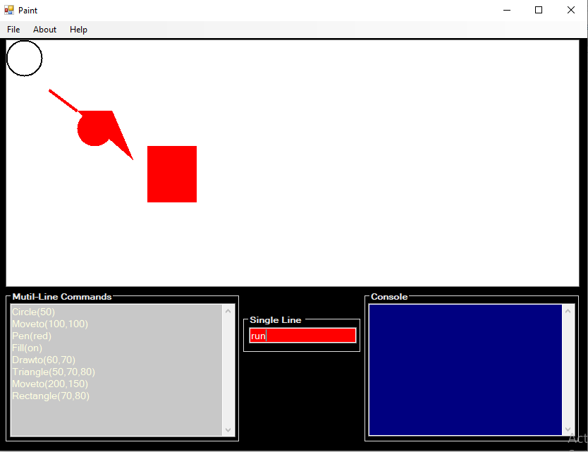

### Invalid Parameter Execution

When invalid commands are entered, error message with respective nature of error is shown in console.

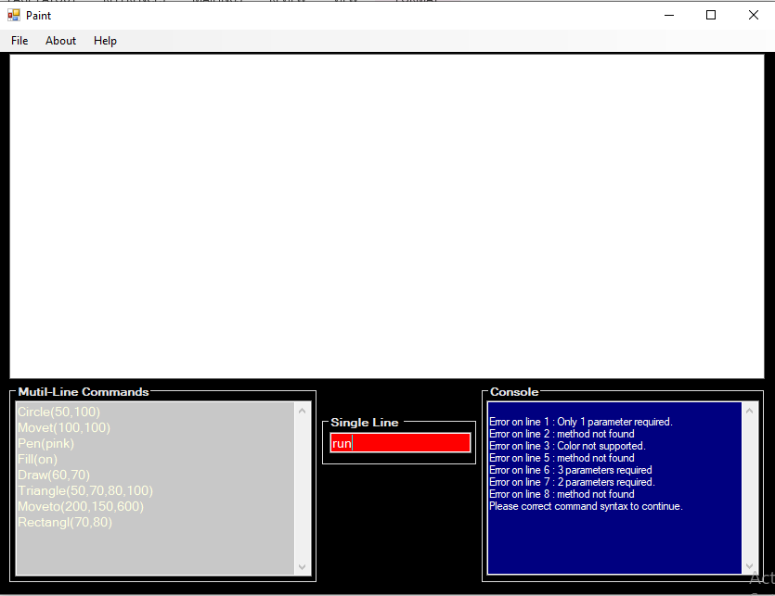

## Invalid Command Execution

When invalid command is passed then error is shown in console

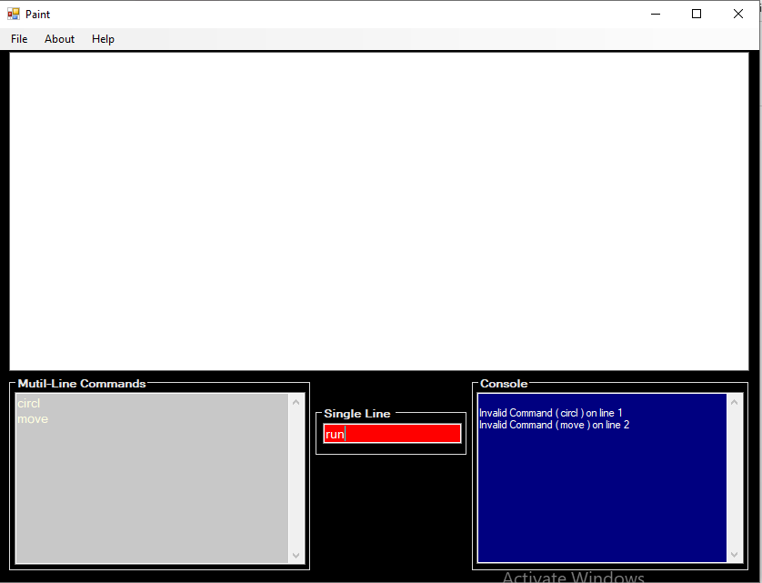

# If Endif/ Then Command

## When the correct code is entered inside if endif

If the condition is matched, the statements inside the if else endif run successfully.

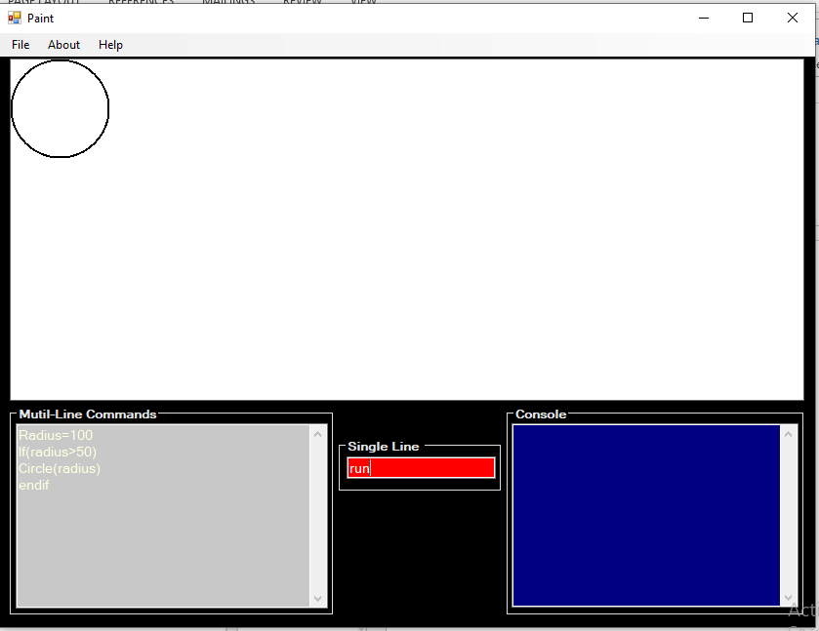

## When the correct code is entered inside if then

The statement after then is run successfully.

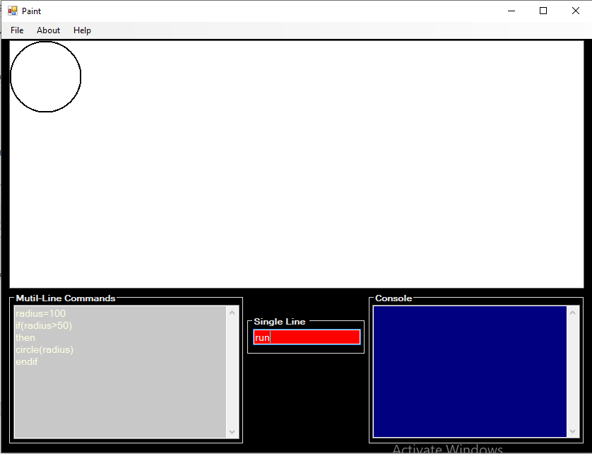

## When the variable is not declared

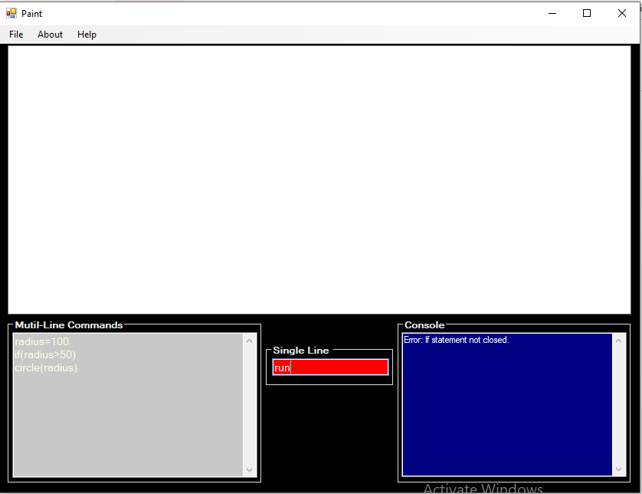If the variable is not declared, the error is shown on console.

## When condition inside if is not complete

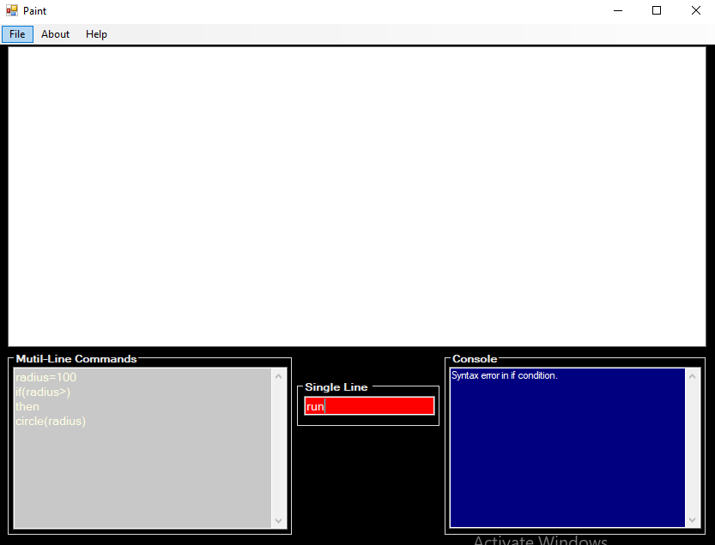

## When condition does not match

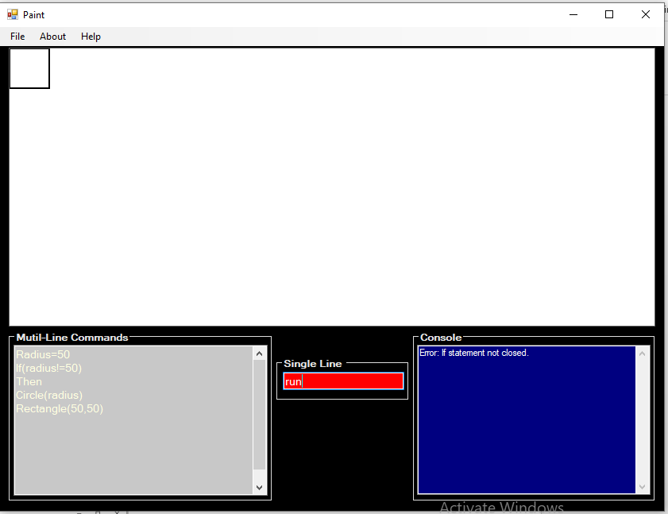

The statement inside the if does not run and other statements are executed.

## When if command is not closed

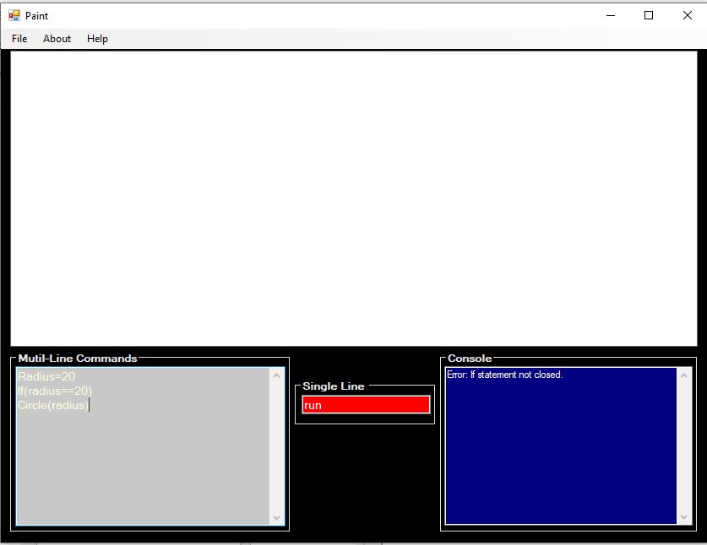

## When endif is found before if command

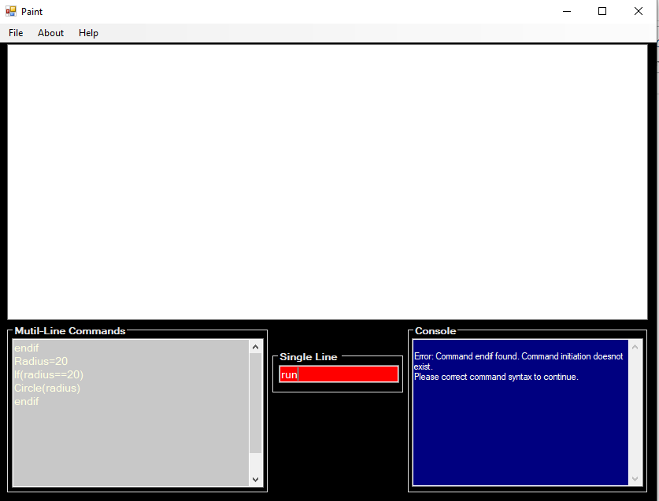

# Variable Command

## When correct variable is declared.

The code runs successfully. 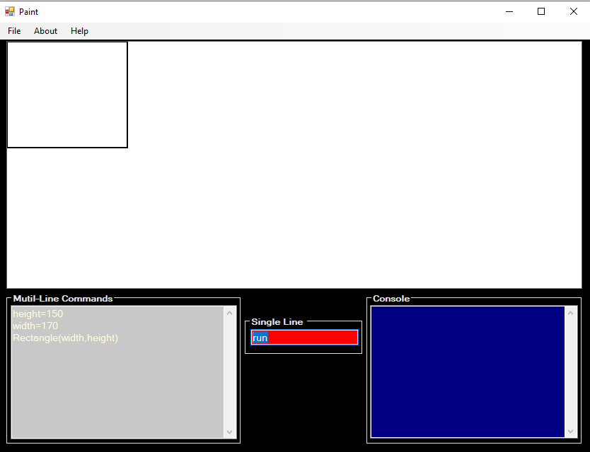

## When the variable is incorrectly declared.

Invalid declaration validation is shown on console.

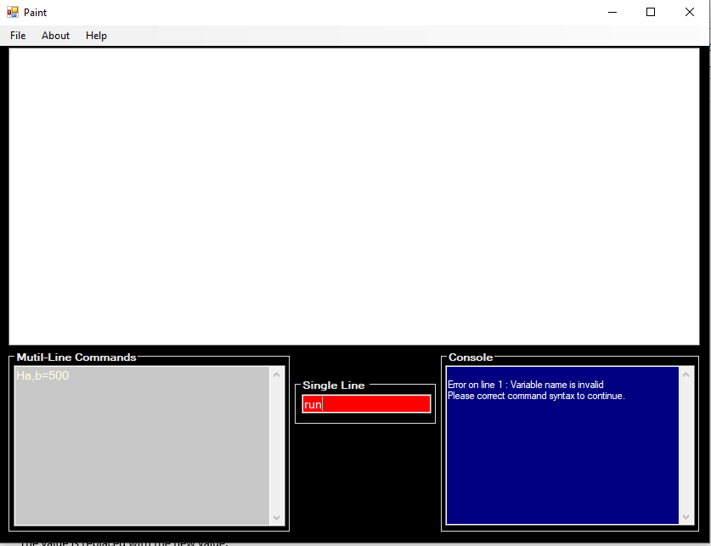

## When the same variable is declared again.

The value is replaced with the new value.

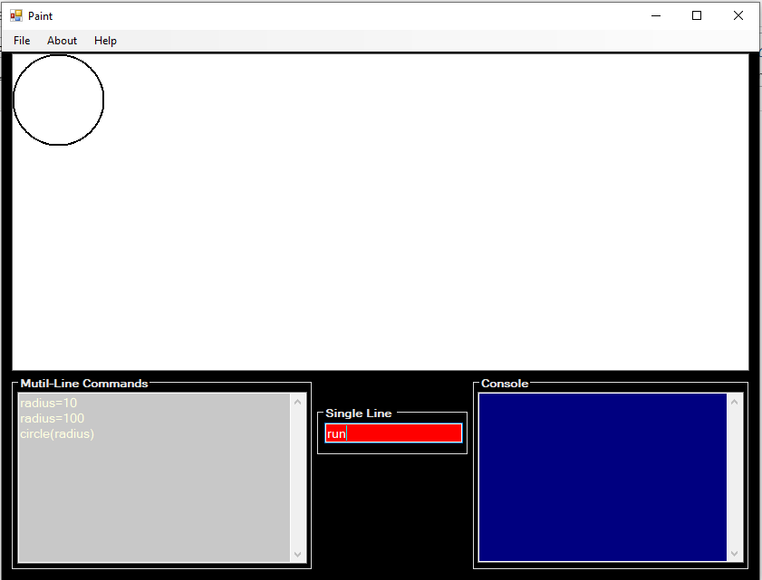

# Variable Operation Command

## When the variable operation is correct.

The value of variable is changed accordingly. 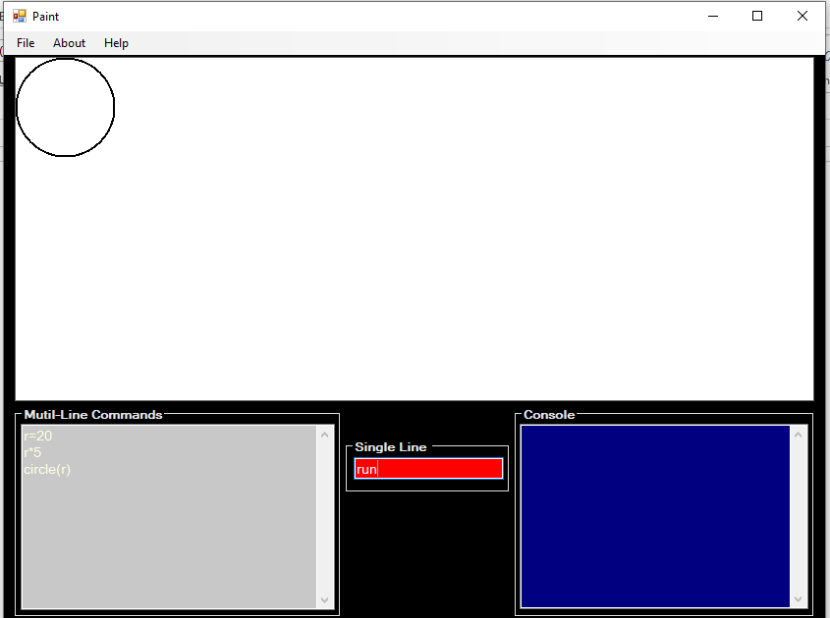

## When the variable is not present

When the variable is not present the validation is shown on the console.

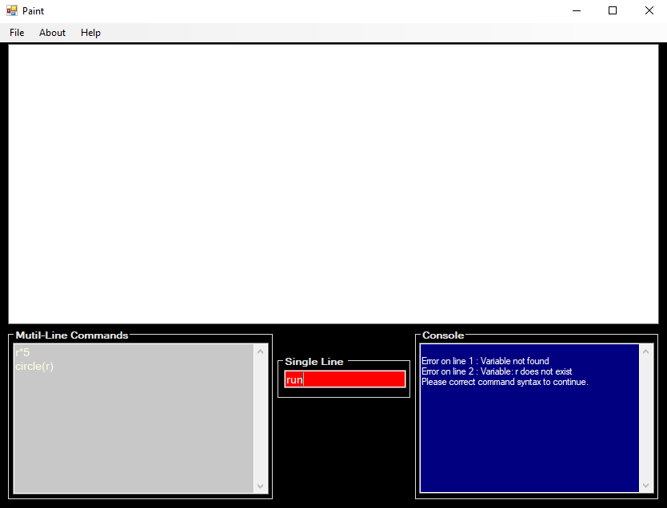

# Loop command

## When valid loop command is run

The statement run successfully.

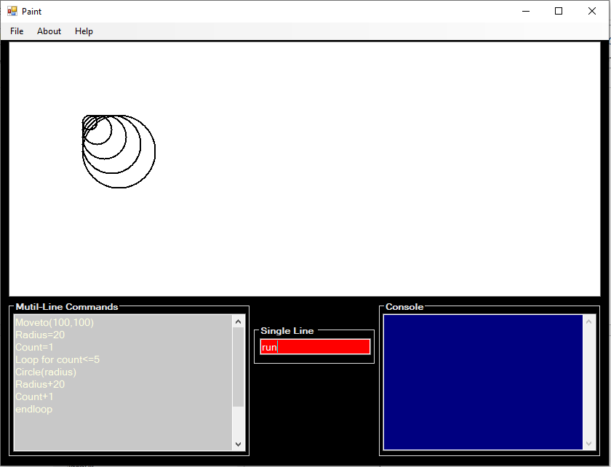

## When the counter variable is not declared.

The error on the declaration of loop is shown in console.

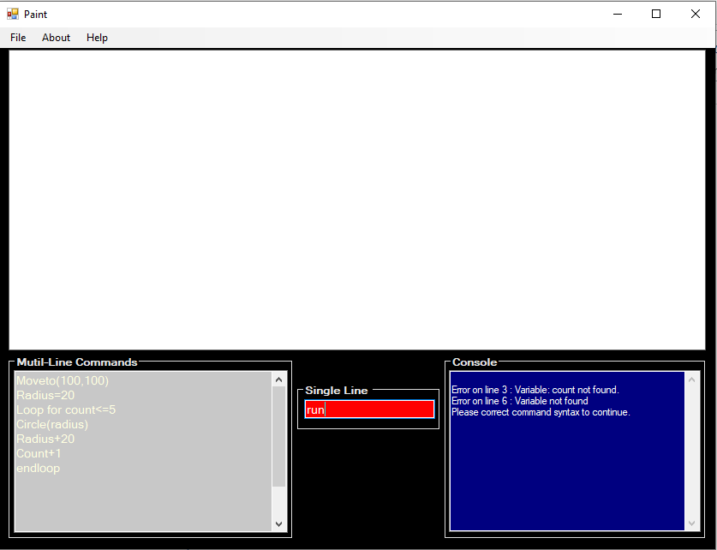

## When the loop is not closed

Validation of loop not closed is shown in the console.

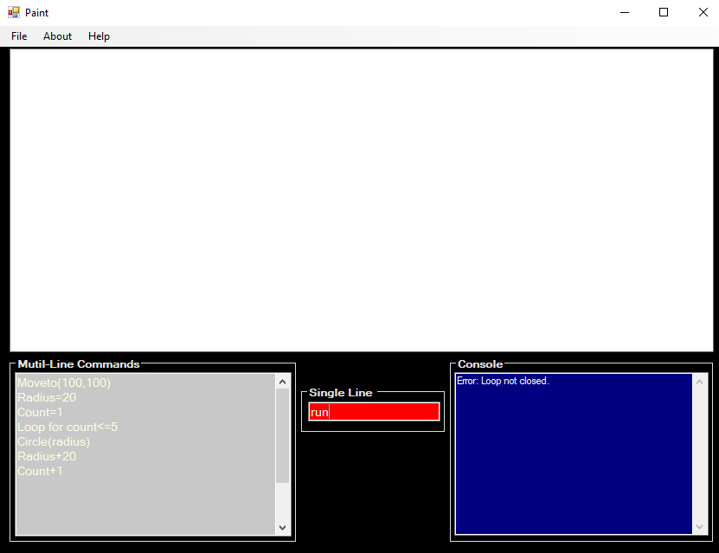

## When the counter variable is not handled

Validation showing that the counter variable is not handled is show in console.

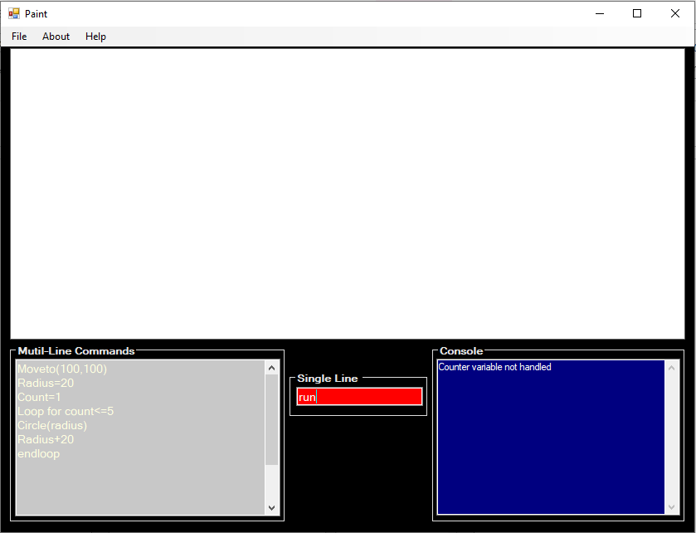

# Method Command

## When the method declaration is valid.

The method called works successfully. 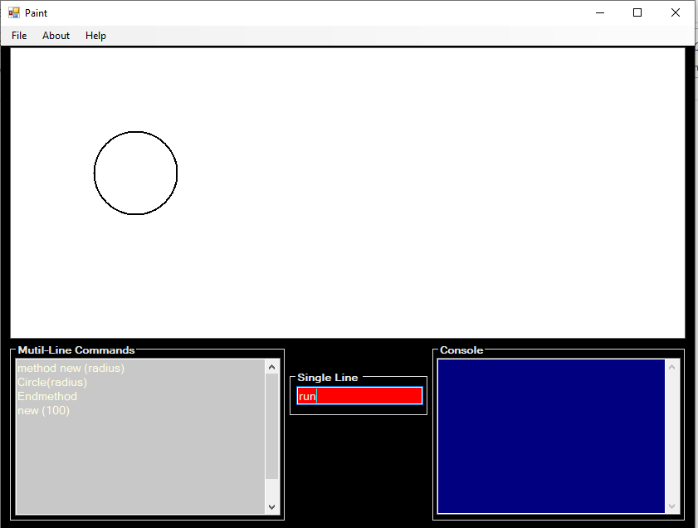

## When parameter is Numeric

Validation showing that the parameter cannot be numeric is shown in console.

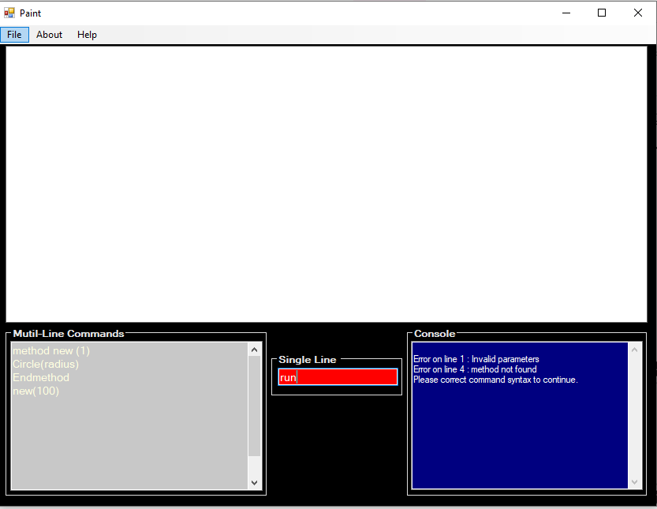

## When same method is declared twice

Validation showing that the method has already been declared and cannot be declared again is displayed in console.

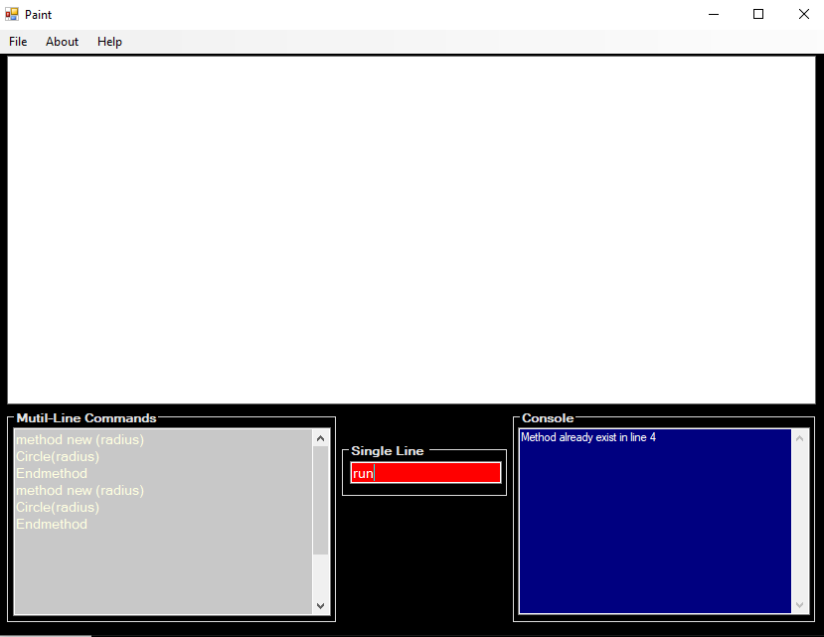

## When method call has different parameters than declaration

Validation showing that the method with similar parameter does not exist is displayed on console.

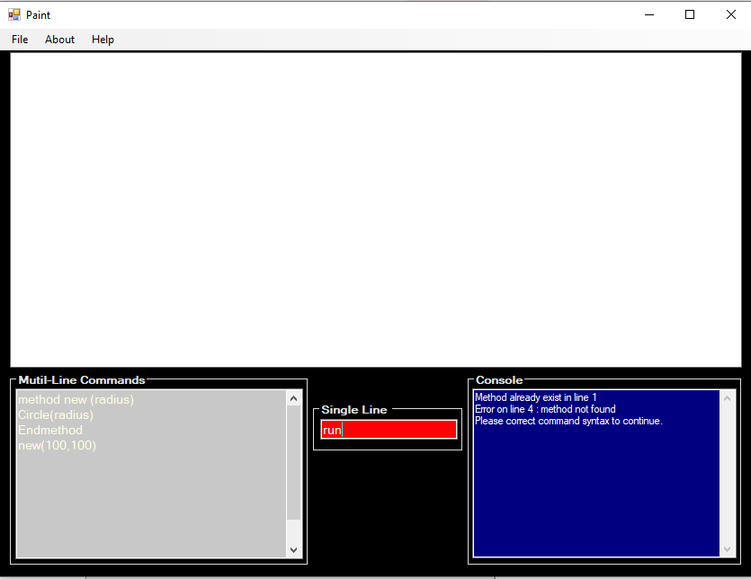

## When the name of method is invalid

### Method name starting with number

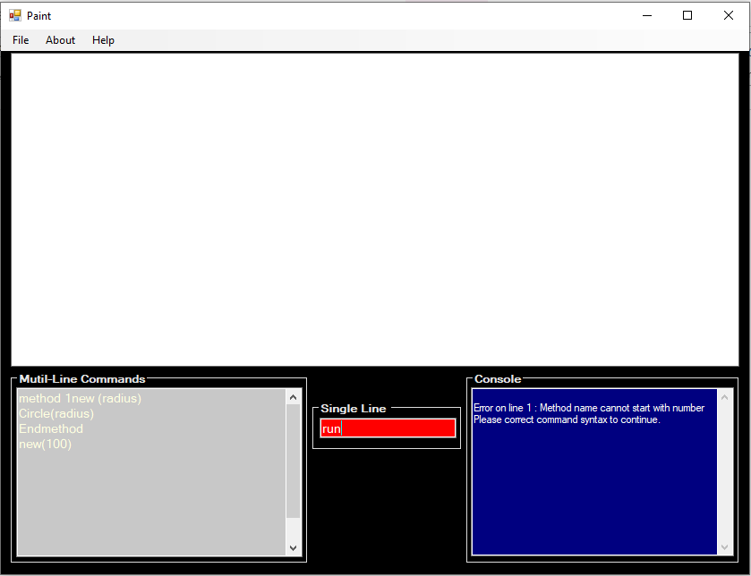

### Method name contains invalid characters

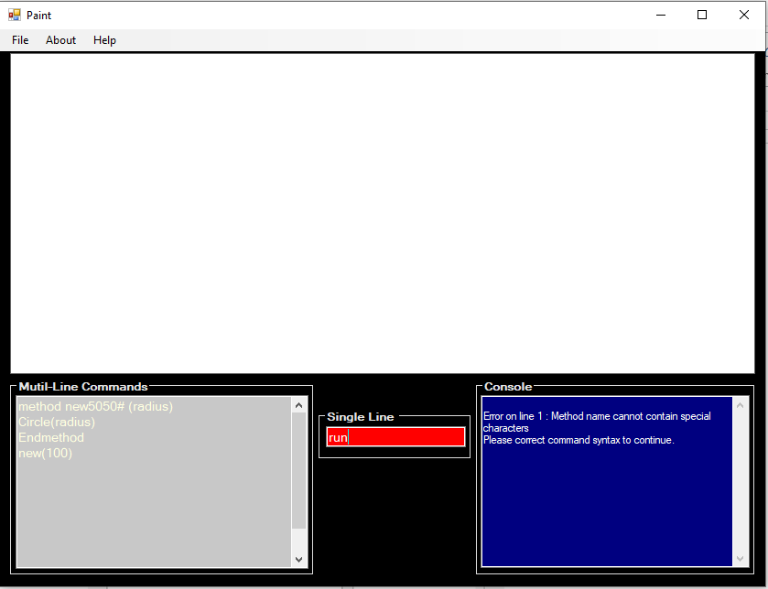

## When method syntax is invalid

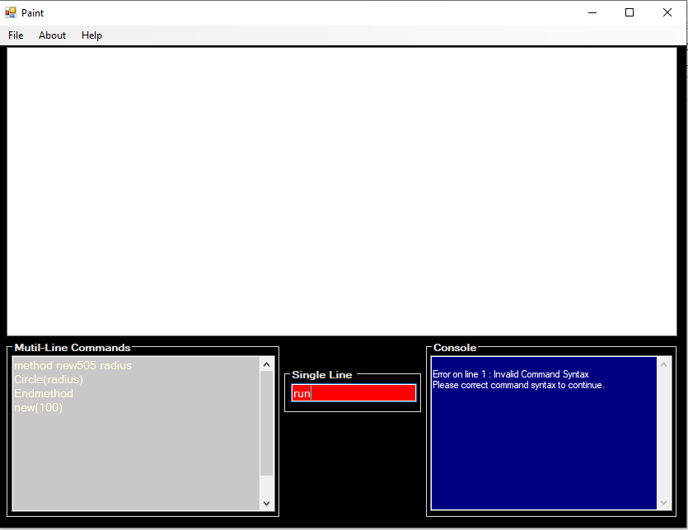

## When method is not closed

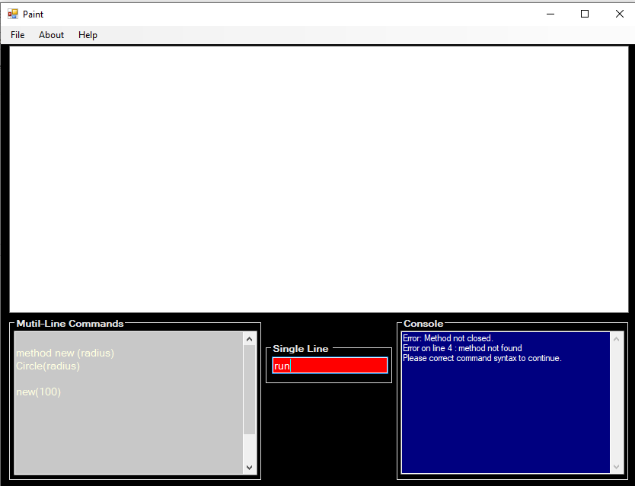

## When method is closed before or without method

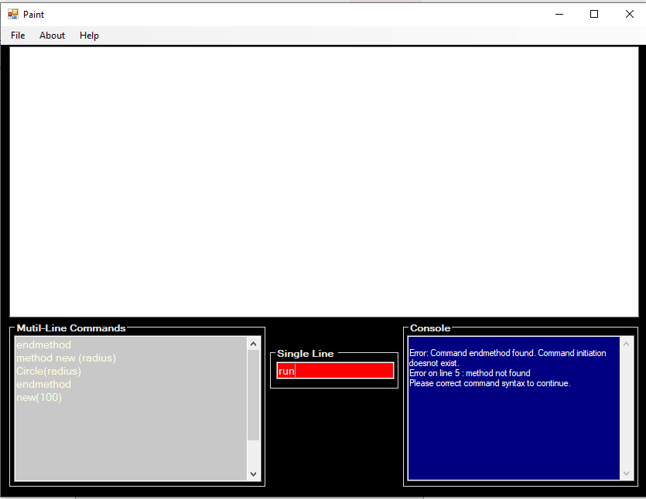

# Singleton Design Pattern

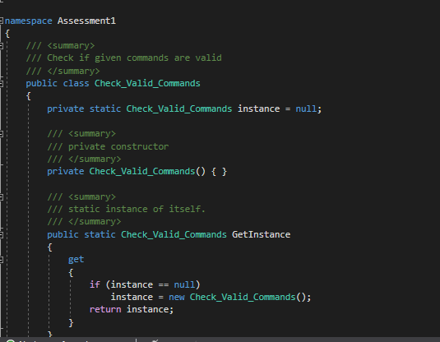 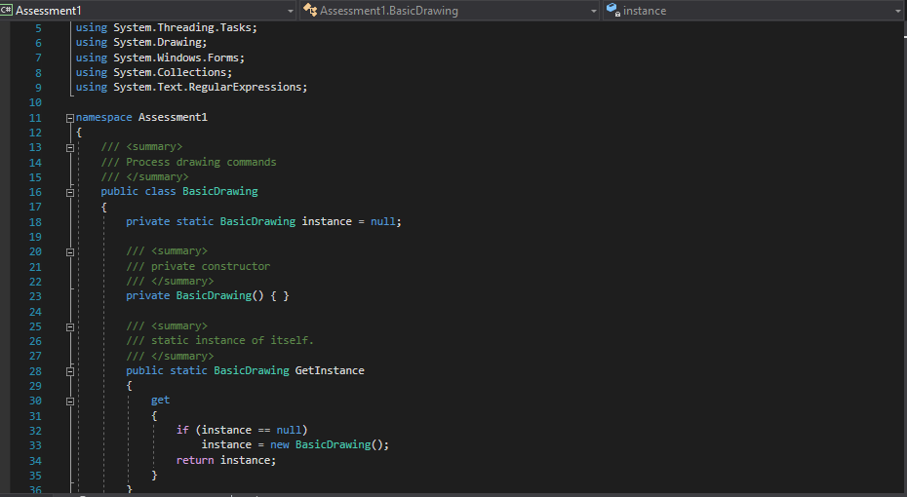



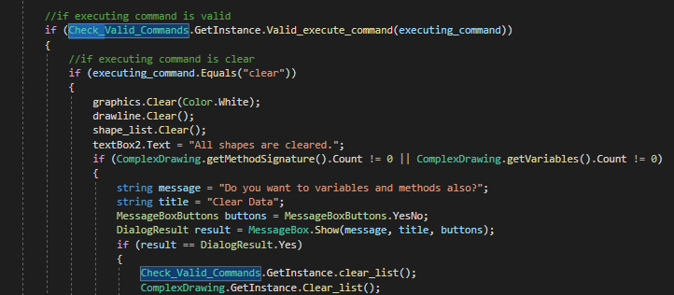

# Unit Testing

## Testing valid drawing commands

|  |  |  |  |  |  |  |  |  |  |  |  |  |  |  |  |  |  |  |  |  |  |  |  |  |  |  |  |  |  |  |  |  |  |
| --- | --- | --- | --- | --- | --- | --- | --- | --- | --- | --- | --- | --- | --- | --- | --- | --- | --- | --- | --- | --- | --- | --- | --- | --- | --- | --- | --- | --- | --- | --- | --- | --- | --- |
| **Test Case ID** | | | **001** | | **Test Case Description** | | | | | | | | **Valid Command Check** | | | | | | | | | | | | | | | | | | | | |
| **Created By** | | | **Rakshya** | | **Review By** | | | | | | | | **Rakshya** | | | | | | | | |  | | |  | | |  | | |
|  |  |  | |  | |  | | | |  | |  | | |  | | |  | |  |  | |  | | |  | | |
|  |  |  | |  | |  | | | |  | |  | | |  | | |  | |  |  | |  | | |  | | |
| **Tester's Name** | | | **Rakshya Lama Moktan** | | | | **Date Tested** | | | | | | | **January 16th 2020** | | | | | **Test Case[Pass/Fail/Not]** | | | | | | **Pass** | | | | | | |
|  |  |  | |  | |  | | | |  | |  | | |  | | |  | |  |  | |  | | |  | | |
|  |  |  | |  | |  | | | |  | |  | | |  | | |  | |  |  | |  | | |  | | |
|  |  |  | |  | |  | | | |  | |  | | |  | | |  | |  |  | |  | | |  | | |
| **S#** | **Prerequisites** | | | | | | | | | |  | | **S#** | | | **Test Data** | | | | | | | |  | | |  | | |
| 1 | Visual Studio | | | | | | | | | |  | | 1 | | | Instance of Check_Valid_Commands Class | | | | | | | |  | | |  | | |
| 2 | Unit Testing Class | | | | | | | | | |  | | 2 | | | string[] commands = {“run”, “clear”,”reset”} | | | | | | | |  | | |  | | |
| 3 |  | | | | | | | | | |  | | 3 | | | Moveto (20,30), moveto(20,y), movto(20,30) | | | | | | | |  | | |  | | |
| 4 |  | | | | | | | | | |  | | 4 | | | Drawto (20,30), drawto(20,x), drwtos(20,30) | | | | | | | |  | | |  | | |
|  |  | | | | | | | | | |  | | 5 | | | Fill (on), fill (on,off), filsl (on) | | | | | | | |  | | |  | | |
|  |  | | | | | | | | | |  | | 6 | | | Pen (red), pen(nocolor), pn(red) | | | | | | | |  | | |  | | |
|  |  | | | | | | | | | |  | | 7 | | | Rectangle (20,30), rectangle (2t,30,40), rectanglesc(20,30) | | | | | | | |  | | |  | | |
|  |  | | | | | | | | | |  | | 8 | | | Triangle(20,40,50), triangle(40,50), triang(20,40,50) | | | | | | | |  | | |  | | |
|  |  | | | | | | | | | |  | | 9 | | | Polygon (20,40,50,60), polygon (40,50), polgon(20,30,40,50) | | | | | | | |  | | |  | | |
|  |  | | | | | | | | | |  | | 10 | | | Rotate(20), rotate(xy,200), rotae(20) | | | | | | | |  | | |  | | |
|  |  | | | | | | | | | |  | | 11 | | | Circle (20), circle (20,3y), circ (20) | | | | | | | |  | | |  | | |
|  |  |  | |  | |  | | | |  | |  | | |  | | |  | |  |  | |  | | |  | | |
|  |  |  | |  | |  | | | |  | |  | | |  | | |  | |  |  | |  | | |  | | |
| **Test Scenario** |  |  | | **Commands are passed to command checking methods. Methods validates and returns Boolean value.** | | | | | | | | | | | | | | | | | | | | | | | | | | | | |
|  |  |  | |  | | | |  | |  | |  | | |  | | |  | |  |  | |  | | |  | | |
|  |  |  | |  | | | |  | |  | |  | | |  | | |  | |  |  | |  | | |  | | |
| **Step #** | **StepDetails** | | | | | | | | **Expected Results** | | | | | | | | **Actual Results** | | | | | **Pass/Fail/Not executed/ Suspended** | | | | | | | | | | |
|
| 1 | Pass variable commands to valid_execute_command | | | | | | | | Run = True  Reset = True  Clear = True | | | | | | | | As Expected | | | | | Pass | | | | | | | | | | |
| 2 | Pass moveto commands to check_command | | | | | | | | Moveto(20,30) = True Moveto(20,y) = False Movto(20,30) = False | | | | | | | | As Expected | | | | | Pass | | | | | | | | | | |
| 3 | Pass drawto commands to check_command | | | | | | | | Drawto (20,30) = True Drawto(20,x) = False Drwtos(20,30) = False | | | | | | | | As Expected | | | | | Pass | | | | | | | | | | |
| 4 | Pass fill commands to check_command | | | | | | | | Fill (on) = True Fill (on,off) = False Filsl (on) = False | | | | | | | | As Expected | | | | | Pass | | | | | | | | | | |
| 5 | Pass pen commands to check_command | | | | | | | | Pen (red) = True  pen(nocolor) = False  pn(red) = False | | | | | | | | As Expected | | | | | Pass | | | | | | | | | | |
| 6 | Pass rectangle command to check_command | | | | | | | | Rectangle (20,30) = True  rectangle (2t,30,40) =False  rectanglesc(20,30) = False | | | | | | | | As Expected | | | | | Pass | | | | | | | | | | |
| 7 | Pass triangle command to check_command | | | | | | | | Triangle(20,40,50) = True  triangle(40,50) = False  triang(20,40,50) =False | | | | | | | | As Expected | | | | | Pass | | | | | | | | | | |
| 8 | Pass polygon command to check_command | | | | | | | | Polygon (20,40,50,60) = True  polygon (40,50) =False  polgon(20,30,40,50) = False | | | | | | | | As Expected | | | | | Pass | | | | | | | | | | |
| 9 | Pass rotate command to check_command | | | | | | | | Rotate(20) = True  rotate(xy,200) =False  rotae(20) = False | | | | | | | | As Expected | | | | | Pass | | | | | | | | | | |
| 10 | Pass circle command to check_command | | | | | | | | Circle (20) = True  circle (20,3y) = False  circ (20) = False | | | | | | | | As Expected | | | | | Pass | | | | | | | | | | |

### Working process of this test

#### If Wrong Parameter is Passed, test fails.

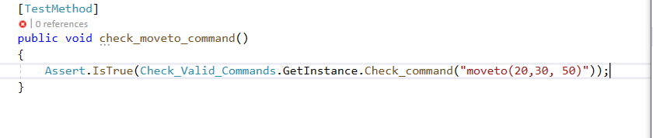



#### If Parameter is Passed Correctly

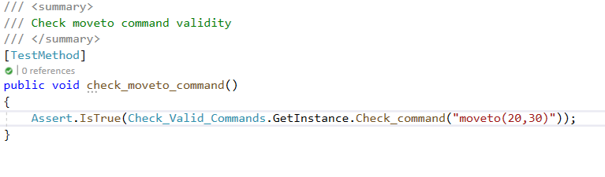

### Screenshots of valid commands test

#### Run, Clear, Reset

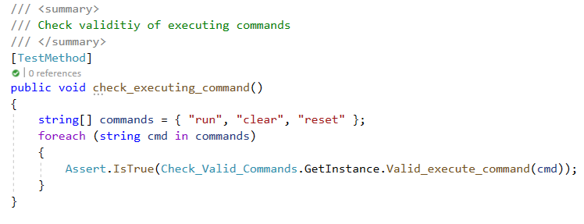

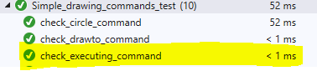

#### MoveTo Command

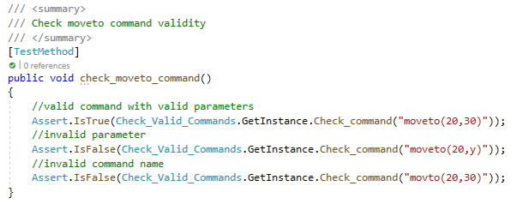



#### DrawTo Command

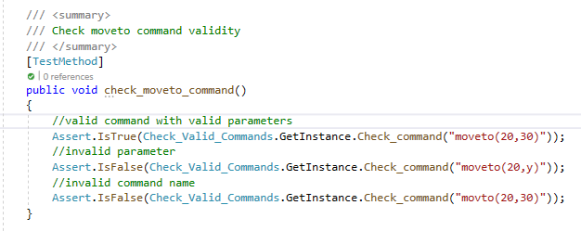

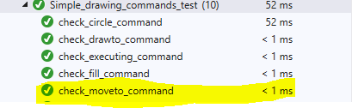

#### Fill

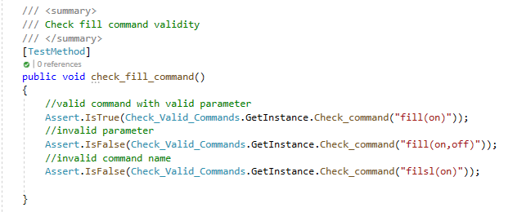

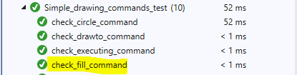

#### Pen

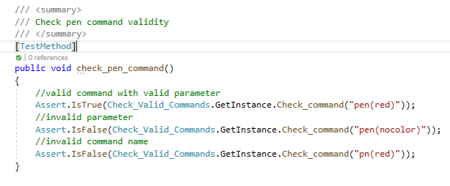

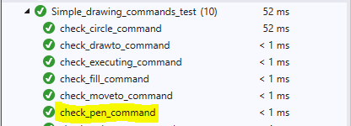

#### Rectangle

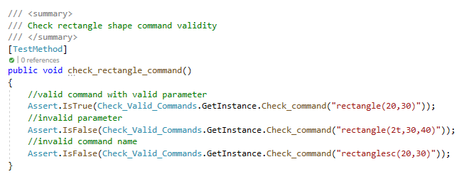

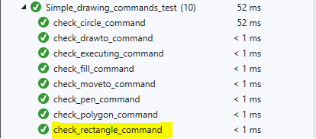

#### Triangle

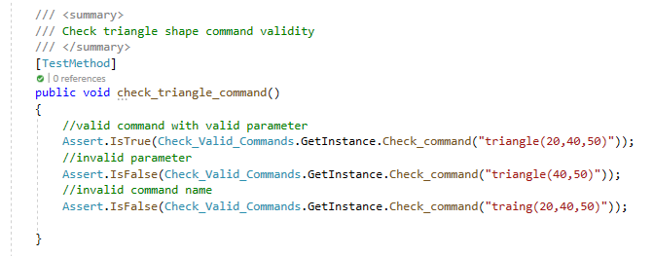

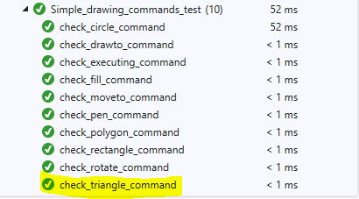

#### Polygon

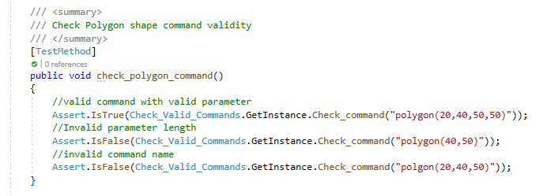

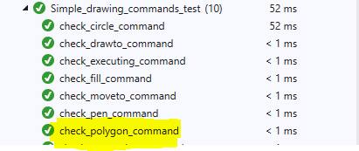

#### Rotate

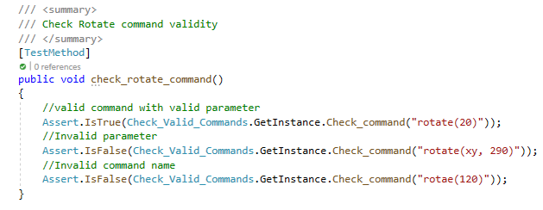

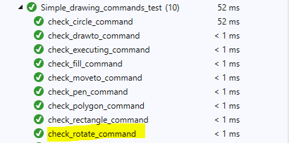

#### Circle

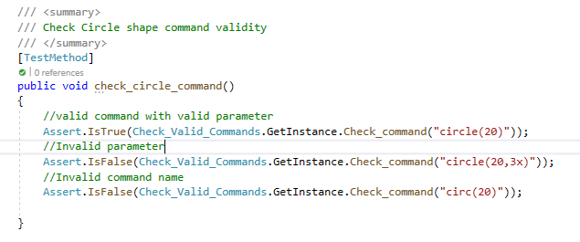



## If Endif/Then Command

|  |  |  |  |  |  |  |  |  |  |  |  |  |  |  |  |  |  |  |  |  |  |  |  |  |  |  |  |  |  |  |  |  |  |
| --- | --- | --- | --- | --- | --- | --- | --- | --- | --- | --- | --- | --- | --- | --- | --- | --- | --- | --- | --- | --- | --- | --- | --- | --- | --- | --- | --- | --- | --- | --- | --- | --- | --- |
| **Test Case ID** | | | **002** | | **Test Case Description** | | | | | | | | **If Command Check** | | | | | | | | | | | | | | | | | | | | |
| **Created By** | | | **Rakshya** | | **Review By** | | | | | | | | **Rakshya** | | | | | | | | | |  | | |  | | |  | | | | |
|  |  |  | |  | |  | | |  | | |  | | |  | |  | | |  |  |  | | | | |  | | |
|  |  |  | |  | |  | | |  | | |  | | |  | |  | | |  |  |  | | | | |  | | |
| **Tester's Name** | | | **Rakshya Lama Moktan** | | | | **Date Tested** | | | | | | | **January 16th 2020** | | | | **Test Case[Pass/Fail/Not]** | | | | | | | **Pass** | | | | | | |
|  |  |  | |  | |  | | |  | | |  | | |  | |  | | |  |  |  | | | | |  | | |
|  |  |  | |  | |  | | |  | | |  | | |  | |  | | |  |  |  | | | | |  | | |
|  |  |  | |  | |  | | |  | | |  | | |  | |  | | |  |  |  | | | | |  | | |
| **S#** | **Prerequisites** | | | | | | | | |  | | | **S#** | | | **Test Data** | | | | | | | |  | | | |  | | |
| 1 | Visual Studio | | | | | | | | |  | | | 1 | | | Instance of Check_Valid_Commands Class | | | | | | | |  | | | |  | | |
| 2 | Unit Testing Class | | | | | | | | |  | | | 2 | | | Instance of ComplexDrawing Class | | | | | | | |  | | | |  | | |
|  |  | | | | | | | | |  | | | 3 | | | Objject of form1 class | | | | | | | |  | | | |  | | |
|  |  | | | | | | | | |  | | | 4 | | | String var = “radius = 10” | | | | | | | |  | | | |  | | |
|  |  | | | | | | | | |  | | | 5 | | | string[] text = {  "if (radius==10)\nthen\ncircle (radius)",  "if (radius==10)\ncircle (radius)\nendif"  }; | | | | | | | |  | | | |  | | |
|  |  | | | | | | | | |  | | | 6 | | | String if_command = “if (radius==10)” | | | | | | | |  | | | |  | | |
|  |  | | | | | | | | |  | | | 7 | | | Int line_found_in = 1 | | | | | | | |  | | | |  | | |
|  |  |  | |  | |  | | |  | | |  | | |  | |  | | |  |  |  | | | | |  | | |
|  |  |  | |  | |  | | |  | | |  | | |  | |  | | |  |  |  | | | | |  | | |
| **Test Scenario** |  |  | | **Commands are passed to command checking methods. Methods validates and returns Boolean value.** | | | | | | | | | | | | | | | | | | | | | | | | | | | | |
|  |  |  | |  | | | |  |  | | |  | | |  | |  | | |  |  |  | | | | |  | | |
|  |  |  | |  | | | |  |  | | |  | | |  | |  | | |  |  |  | | | | |  | | |
| **Step #** | **StepDetails** | | | | | | | | | | **Expected Results** | | | | | | | | **Actual Results** | | | | **Pass/Fail/Not executed/ Suspended** | | | | | | | | | |
|
| 1 | Pass variable var to Check_Valid_Commands.GetInstace.check_variable | | | | | | | | | | Method returns true | | | | | | | | As Expected | | | | Pass | | | | | | | | | |
| 2 | Pass variable var to ComplexDrawing.GetInstace.run_variable_command | | | | | | | | | | Variable is created and method returns true | | | | | | | | As Expected | | | | Pass | | | | | | | | | |
| 3 | Pass each element in array to Check_Valid_Commands.Check_if_command | | | | | | | | | | Method returns true | | | | | | | | As Expected | | | | Pass | | | | | | | | | |
| 4 | Pass each element in array, array, line_found_in, form1 object to ComplexDrawing.GetInstance.run_if_command | | | | | | | | | | Method returns true | | | | | | | | As Expected | | | | Pass | | | | | | | | | |

### Testing Code

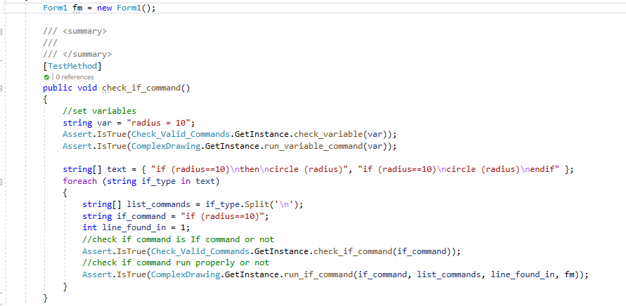

### Test Summary



Test is successful.

## Loop Command

|  |  |  |  |  |  |  |  |  |  |  |  |  |  |  |  |  |  |  |  |  |  |  |  |  |  |  |  |  |  |  |  |  |  |
| --- | --- | --- | --- | --- | --- | --- | --- | --- | --- | --- | --- | --- | --- | --- | --- | --- | --- | --- | --- | --- | --- | --- | --- | --- | --- | --- | --- | --- | --- | --- | --- | --- | --- |
| **Test Case ID** | | | **003** | | **Test Case Description** | | | | | | | | **Loop Command Check** | | | | | | | | | | | | | | | | | | | | |
| **Created By** | | | **Rakshya** | | **Review By** | | | | | | | | **Rakshya** | | | | | | | | | |  | | |  | | |  | | | | |
|  |  |  | |  | |  | | |  | | |  | | |  | |  | | |  |  |  | | | | |  | | |
|  |  |  | |  | |  | | |  | | |  | | |  | |  | | |  |  |  | | | | |  | | |
| **Tester's Name** | | | **Rakshya Lama Moktan** | | | | **Date Tested** | | | | | | | **January 16th 2020** | | | | **Test Case[Pass/Fail/Not]** | | | | | | | **Pass** | | | | | | |
|  |  |  | |  | |  | | |  | | |  | | |  | |  | | |  |  |  | | | | |  | | |
|  |  |  | |  | |  | | |  | | |  | | |  | |  | | |  |  |  | | | | |  | | |
|  |  |  | |  | |  | | |  | | |  | | |  | |  | | |  |  |  | | | | |  | | |
| **S#** | **Prerequisites** | | | | | | | | |  | | | **S#** | | | **Test Data** | | | | | | | |  | | | |  | | |
| 1 | Visual Studio | | | | | | | | |  | | | 1 | | | Instance of Check_Valid_Commands Class | | | | | | | |  | | | |  | | |
| 2 | Unit Testing Class | | | | | | | | |  | | | 2 | | | Instance of ComplexDrawing Class | | | | | | | |  | | | |  | | |
|  |  | | | | | | | | |  | | | 3 | | | Object of form1 class | | | | | | | |  | | | |  | | |
|  |  | | | | | | | | |  | | | 4 | | | string[] variable = { "count = 1", "radius = 20" }; | | | | | | | |  | | | |  | | |
|  |  | | | | | | | | |  | | | 5 | | | string text = "loop for count <=5\ncircle (radius)\nradius+10\ncount+1\nendloop"; | | | | | | | |  | | | |  | | |
|  |  | | | | | | | | |  | | | 6 | | | string loop_command = "loop for count <=5"; | | | | | | | |  | | | |  | | |
|  |  | | | | | | | | |  | | | 7 | | | int line_found_in = 1; | | | | | | | |  | | | |  | | |
|  |  |  | |  | |  | | |  | | |  | | |  | |  | | |  |  |  | | | | |  | | |
|  |  |  | |  | |  | | |  | | |  | | |  | |  | | |  |  |  | | | | |  | | |
| **Test Scenario** |  |  | | **Commands are passed to command checking methods. Methods validates and returns Boolean value.** | | | | | | | | | | | | | | | | | | | | | | | | | | | | |
|  |  |  | |  | | | |  |  | | |  | | |  | |  | | |  |  |  | | | | |  | | |
|  |  |  | |  | | | |  |  | | |  | | |  | |  | | |  |  |  | | | | |  | | |
| **Step #** | **StepDetails** | | | | | | | | | | **Expected Results** | | | | | | | | **Actual Results** | | | | **Pass/Fail/Not executed/ Suspended** | | | | | | | | | |
|
| 1 | Pass variable var to Check_Valid_Commands.GetInstace.check_variable | | | | | | | | | | Method returns true | | | | | | | | As Expected | | | | Pass | | | | | | | | | |
| 2 | Pass variable var to ComplexDrawing.GetInstace.run_variable_command | | | | | | | | | | Variable is created and method returns true | | | | | | | | As Expected | | | | Pass | | | | | | | | | |
| 3 | Pass text to Check_Valid_Commands.check_loop | | | | | | | | | | Method returns true | | | | | | | | As Expected | | | | Pass | | | | | | | | | |
| 4 | Pass variable loop_command, text, line_found_in, form1 object to ComplexDrawing.GetInstance.run_loop_command | | | | | | | | | | Method returns true | | | | | | | | As Expected | | | | Pass | | | | | | | | | |

### Testing Code

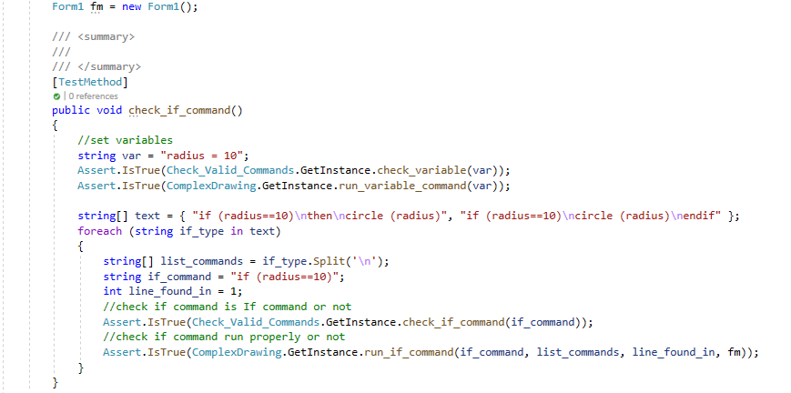

### Test Summary

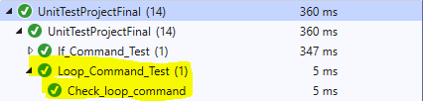

Test is successful.

## Method Command

|  |  |  |  |  |  |  |  |  |  |  |  |  |  |  |  |  |  |  |  |  |  |  |  |  |  |  |  |  |  |  |  |  |  |
| --- | --- | --- | --- | --- | --- | --- | --- | --- | --- | --- | --- | --- | --- | --- | --- | --- | --- | --- | --- | --- | --- | --- | --- | --- | --- | --- | --- | --- | --- | --- | --- | --- | --- |
| **Test Case ID** | | | **004** | | **Test Case Description** | | | | | | | **Method Command Check** | | | | | | | | | | | | | | | | | | | | | |
| **Created By** | | | **Rakshya** | | **Review By** | | | | | | | **Rakshya** | | | | | | | | | | |  | | |  | | |  | | | | |
|  |  |  | |  | |  | | |  | |  | | |  | | |  | | |  |  |  | | | | |  | | |
|  |  |  | |  | |  | | |  | |  | | |  | | |  | | |  |  |  | | | | |  | | |
| **Tester's Name** | | | **Rakshya Lama Moktan** | | | | **Date Tested** | | | | | | **January 16th 2020** | | | | | **Test Case[Pass/Fail/Not]** | | | | | | | **Pass** | | | | | | |
|  |  |  | |  | |  | | |  | |  | | |  | | |  | | |  |  |  | | | | |  | | |
|  |  |  | |  | |  | | |  | |  | | |  | | |  | | |  |  |  | | | | |  | | |
|  |  |  | |  | |  | | |  | |  | | |  | | |  | | |  |  |  | | | | |  | | |
| **S#** | **Prerequisites** | | | | | | | | |  | | **S#** | | | **Test Data** | | | | | | | | |  | | | |  | | |
| 1 | Visual Studio | | | | | | | | |  | | 1 | | | Instance of Check_Valid_Commands Class | | | | | | | | |  | | | |  | | |
| 2 | Unit Testing Class | | | | | | | | |  | | 2 | | | Instance of ComplexDrawing Class | | | | | | | | |  | | | |  | | |
|  |  | | | | | | | | |  | | 3 | | | Object of form1 class | | | | | | | | |  | | | |  | | |
|  |  | | | | | | | | |  | | 4 | | | string[] method_text = { "method test ()\ncircle (100)\nendmethod", "method test1 (radius, width, height)\ncircle (radius)\nrectangle (width, height)\nendmethod" }; | | | | | | | | |  | | | |  | | |
|  |  | | | | | | | | |  | | 5 | | | String method_line = "method test ()"; | | | | | | | | |  | | | |  | | |
|  |  | | | | | | | | |  | | 6 | | | String method_line = "method test1 (radius, width, height)"; | | | | | | | | |  | | | |  | | |
|  |  | | | | | | | | |  | | 7 | | | int method_found_in = 1; | | | | | | | | |  | | | |  | | |
|  |  | | | | | | | | |  | | 8 | | | string[] method_call = { "test ()", "test1 (10,20,30)" }; | | | | | | | | |  | | | |  | | |
|  |  |  | |  | |  | | |  | |  | | |  | | |  | | |  |  |  | | | | |  | | |
|  |  |  | |  | |  | | |  | |  | | |  | | |  | | |  |  |  | | | | |  | | |
| **Test Scenario** |  |  | | **Commands are passed to command checking methods. Methods validates and returns Boolean value.** | | | | | | | | | | | | | | | | | | | | | | | | | | | | |
|  |  |  | |  | | | |  |  | |  | | |  | | |  | | |  |  |  | | | | |  | | |
|  |  |  | |  | | | |  |  | |  | | |  | | |  | | |  |  |  | | | | |  | | |
| **Step #** | **StepDetails** | | | | | | | | | | | | | | | **Expected Results** | | | **Actual Results** | | | | **Pass/Fail/Not executed/ Suspended** | | | | | | | | | |
|
| 1 | Pass variable method_line to Check_Valid_Commands.GetInstance.check_method | | | | | | | | | | | | | | | Method returns true | | | As Expected | | | | Pass | | | | | | | | | |
| 2 | Pass variable method_line, command list, method_found_in, form1 object to ComplexDrawing.GetInstance.run_method_command | | | | | | | | | | | | | | | Method returns true | | | As Expected | | | | Pass | | | | | | | | | |
| 3 | Pass method_call to Check_Valid_Commands.GetInstance.check_methodcall | | | | | | | | | | | | | | | Method returns true | | | As Expected | | | | Pass | | | | | | | | | |
| 4 | Pass method_call, form1 object to ComplexDrawing.GetInstance.run_method_call | | | | | | | | | | | | | | | Method returns true | | | As Expected | | | | Pass | | | | | | | | | |

### Test Code

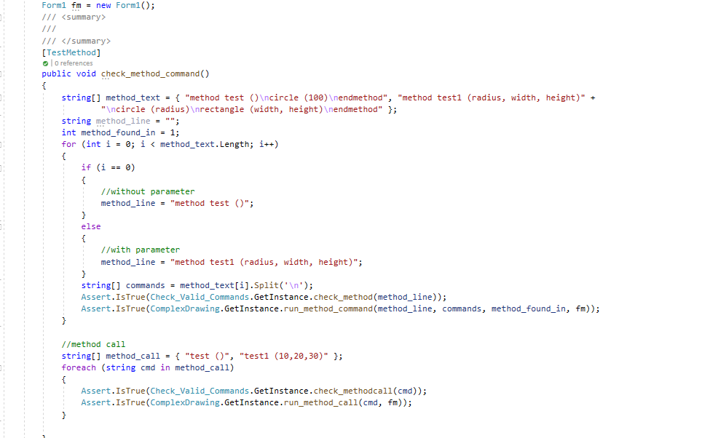

### Test Summary

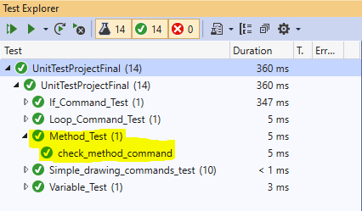

## Variable Command

|  |  |  |  |  |  |  |  |  |  |  |  |  |  |  |  |  |  |  |  |  |  |  |  |  |  |  |  |  |  |  |  |  |  |
| --- | --- | --- | --- | --- | --- | --- | --- | --- | --- | --- | --- | --- | --- | --- | --- | --- | --- | --- | --- | --- | --- | --- | --- | --- | --- | --- | --- | --- | --- | --- | --- | --- | --- |
| **Test Case ID** | | | **005** | | **Test Case Description** | | | | | | | **Variable Command Check** | | | | | | | | | | | | | | | | | | | | | |
| **Created By** | | | **Rakshya** | | **Review By** | | | | | | | **Rakshya** | | | | | | | | | | |  | | |  | | |  | | | | |
|  |  |  | |  | |  | | |  | |  | | |  | | |  | | |  |  |  | | | | |  | | |
|  |  |  | |  | |  | | |  | |  | | |  | | |  | | |  |  |  | | | | |  | | |
| **Tester's Name** | | | **Rakshya Lama Moktan** | | | | **Date Tested** | | | | | | **January 16th 2020** | | | | | **Test Case[Pass/Fail/Not]** | | | | | | | **Pass** | | | | | | |
|  |  |  | |  | |  | | |  | |  | | |  | | |  | | |  |  |  | | | | |  | | |
|  |  |  | |  | |  | | |  | |  | | |  | | |  | | |  |  |  | | | | |  | | |
|  |  |  | |  | |  | | |  | |  | | |  | | |  | | |  |  |  | | | | |  | | |
| **S#** | **Prerequisites** | | | | | | | | |  | | **S#** | | | **Test Data** | | | | | | | | |  | | | |  | | |
| 1 | Visual Studio | | | | | | | | |  | | 1 | | | Instance of Check_Valid_Commands Class | | | | | | | | |  | | | |  | | |
| 2 | Unit Testing Class | | | | | | | | |  | | 2 | | | Instance of ComplexDrawing Class | | | | | | | | |  | | | |  | | |
|  |  | | | | | | | | |  | | 3 | | | Object of form1 class | | | | | | | | |  | | | |  | | |
|  |  | | | | | | | | |  | | 4 | | | string[] text = { "width = 10", "rectangle=50", "height= 5" }; | | | | | | | | |  | | | |  | | |
|  |  | | | | | | | | |  | | 5 | | | string[] operation_text = { "width+10", "rectangle-20", "height*5", "height/5" }; | | | | | | | | |  | | | |  | | |
|  |  |  | |  | |  | | |  | |  | | |  | | |  | | |  |  |  | | | | |  | | |
|  |  |  | |  | |  | | |  | |  | | |  | | |  | | |  |  |  | | | | |  | | |
| **Test Scenario** |  |  | | **Commands are passed to command checking methods. Methods validates and returns Boolean value.** | | | | | | | | | | | | | | | | | | | | | | | | | | | | |
|  |  |  | |  | | | |  |  | |  | | |  | | |  | | |  |  |  | | | | |  | | |
|  |  |  | |  | | | |  |  | |  | | |  | | |  | | |  |  |  | | | | |  | | |
| **Step #** | **StepDetails** | | | | | | | | | | | | | | | **Expected Results** | | | **Actual Results** | | | | **Pass/Fail/Not executed/ Suspended** | | | | | | | | | |
|
| 1 | Pass text from string array text to Check_valid_Commands.GetInstance.check_variable | | | | | | | | | | | | | | | Method returns true | | | As Expected | | | | Pass | | | | | | | | | |
| 2 | Pass text from string array text to ComplexDrawing.GetInstance.run_variable_command | | | | | | | | | | | | | | | Variable is created and method returns true | | | As Expected | | | | Pass | | | | | | | | | |
| 3 | Pass text from string array operation_text to Check_valid_Commands.GetInstance.check_variable | | | | | | | | | | | | | | | Method returns true | | | As Expected | | | | Pass | | | | | | | | | |
| 4 | Pass text from string array operation_text, form1 object to ComplexDrawing.GetInstance.runVariableOperation | | | | | | | | | | | | | | | Variable value are changed and Method returns true | | | As Expected | | | | Pass | | | | | | | | | |

### Test Code

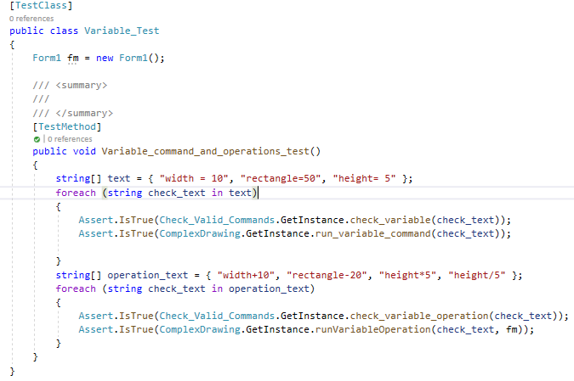

### Test Summary

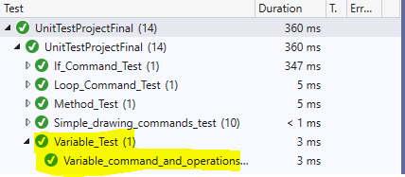

## Screenshot of all test passed

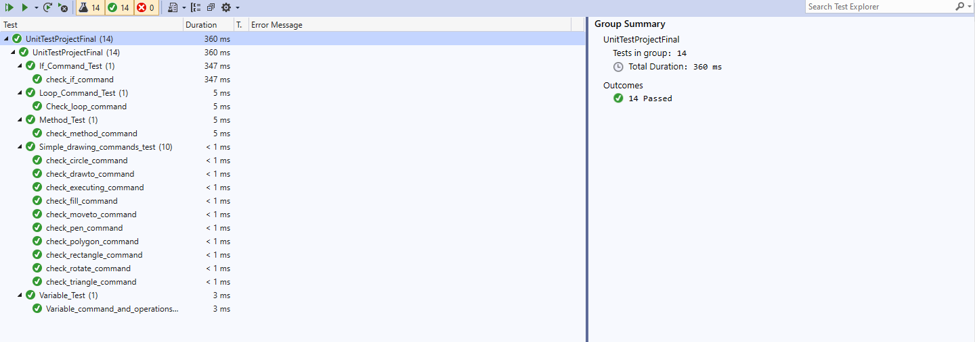

# Uml Diagram

