CO215 Assignment-3
Roll number: CSB23017
Name: Raktim Ranjan Handique
Session: Spring Year:2025

Objective:
To understand the working of a data path by integrating a minimal set of components in a simulation environment.
Exercise:
- Integrating the already designed ALU (Assignment-1) into a data-path as shown in the diagram below in a logic simulator environment.
- Performing the following operations and writing the steps taken:
- R3 ← R1
- R3 ← R1 + R2
- R3 ← R1 AND R2
- R1 ← R1 + 2
- Carrying out the operations for at least three different values in R1, R2, R3 and demonstrate the results.
- Preparing a report containing the Objectives, Exercise Details, the Observations and the Learnings.

Details of work
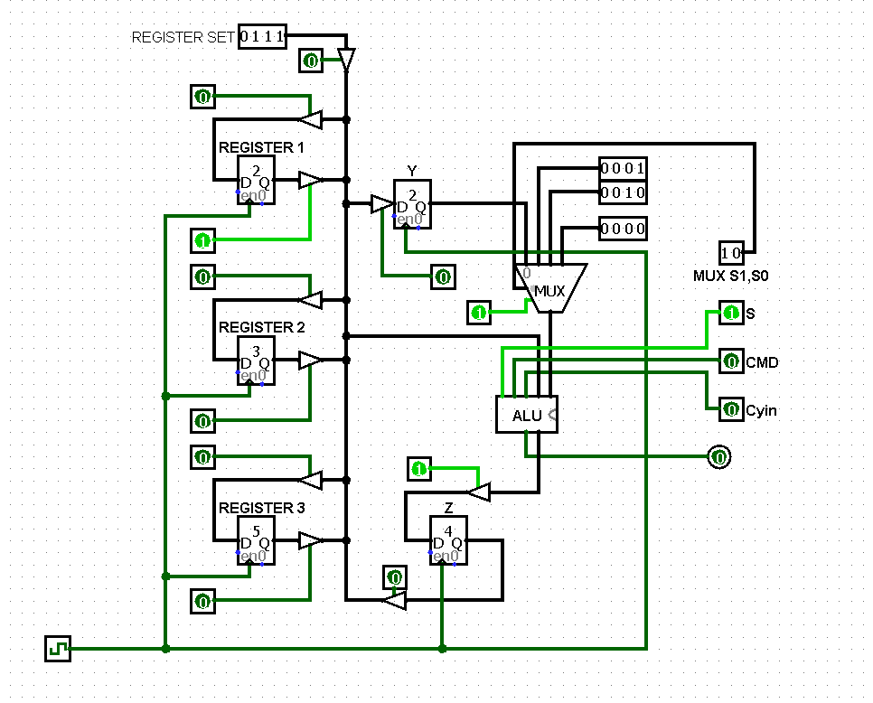

After the circuit was complete, few operations were performed to test the workings of the circuit. The following operations were carried out-
- R3 ← R1
R1_{Out}, R3_{in}
- R3 ← R1 + R2
R1_{out}, Y_{in}, ,
R2_{out}, Z_{in ,} MUX-00, CMD-0
Z_{out}, R3_{in}
- R3 ← R1 AND R2
R1_{out}, Y_{in}, ,
R2_{out}, Z_{in ,} MUX-00, CMD-1
Z_{out}, R3_{in}
- R1 ← R1 + 2
R1_{out}, MUX-10, CMD-0, Z_{in}
Z_{out}, R1_{in}
Based on these operations, the observation table below was filled out with appropriate values

Operation | R1 | R2 | R3 | Cmd1Cmd0 | S1S0 | Remarks
R3 ← R1 | R1_{Out} | - | R3_{in} | 00 | - | The data from R1 flows to R3
R3 ← R1 + R2 | R1_{out} | - | - | 00 | 00 | The data from R1 flows to buffer Y
 | - | R2_{out} | - | 01 | 00 | The Value of R2 is added to the value of buffer Y and is stored in buffer Z
 | - | - | R3_{in} | 00 | - | The value of the buffer Z flows to R3
R3 ← R1 AND R2 | R1_{out} | - | - | 00 | 00 | The data from R1 flows to buffer Y
 | - | R2_{out} | - | 10 | 00 | Logical AND is performed on value of R2 and the value of buffer Y and is stored in buffer Z
 | - | - | R3_{in} | 00 | - | The value of the buffer Z flows to R3
R1 ← R1 + 2 | R1_{out} | - | - | 01 | 10 | The value of R1 is added with 2 and stored in Z
 | R1_{in} | - | - | 00 | 00 | Value of Z is stored in R1

