Step3:

The syntax to create the repository is:  
**svnadmin create <Repo_name>**  
Example: svnadmin create Shipment

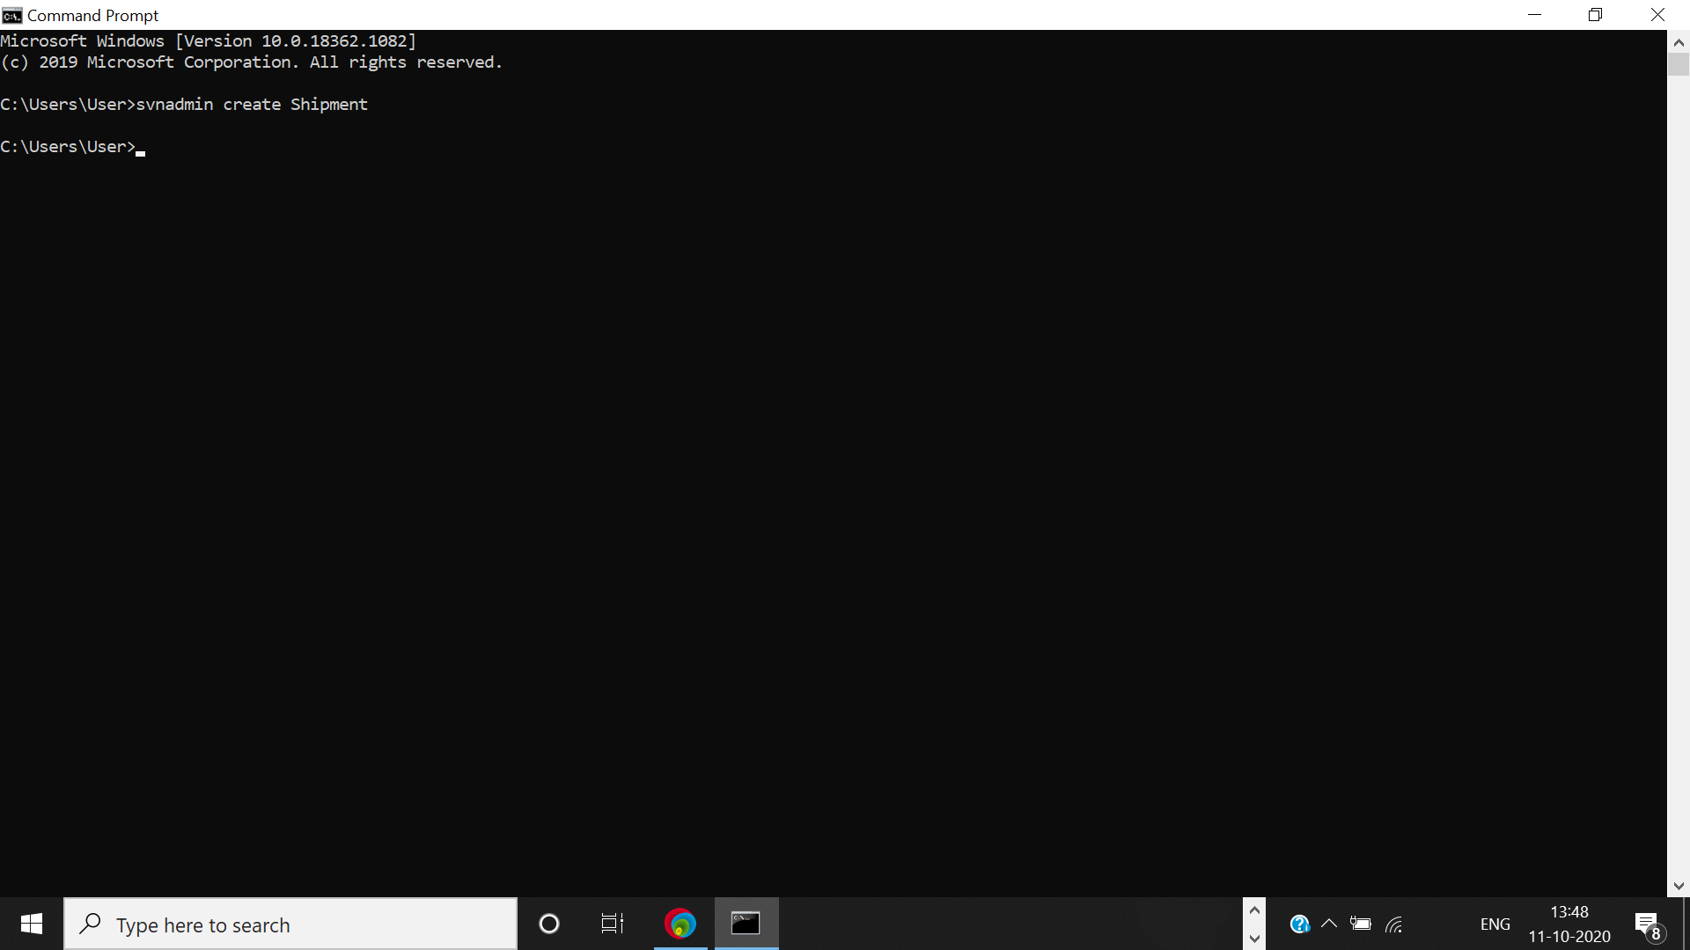

Step4: Navigate to the repository.  
If you have created the repository inside C:\ with the name Shipment, then navigate to C: \Shipment

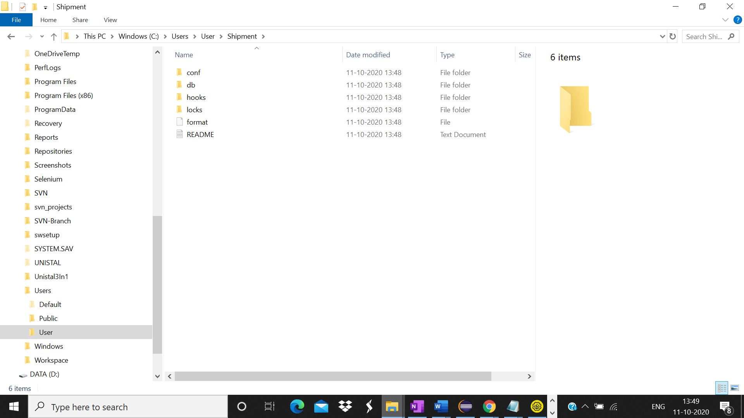

Step6:

In the command prompt, enter the following command  
svn ls <Repo_path>  
Example: svn ls file:///C:/Shipment  
No files or directories are listed.

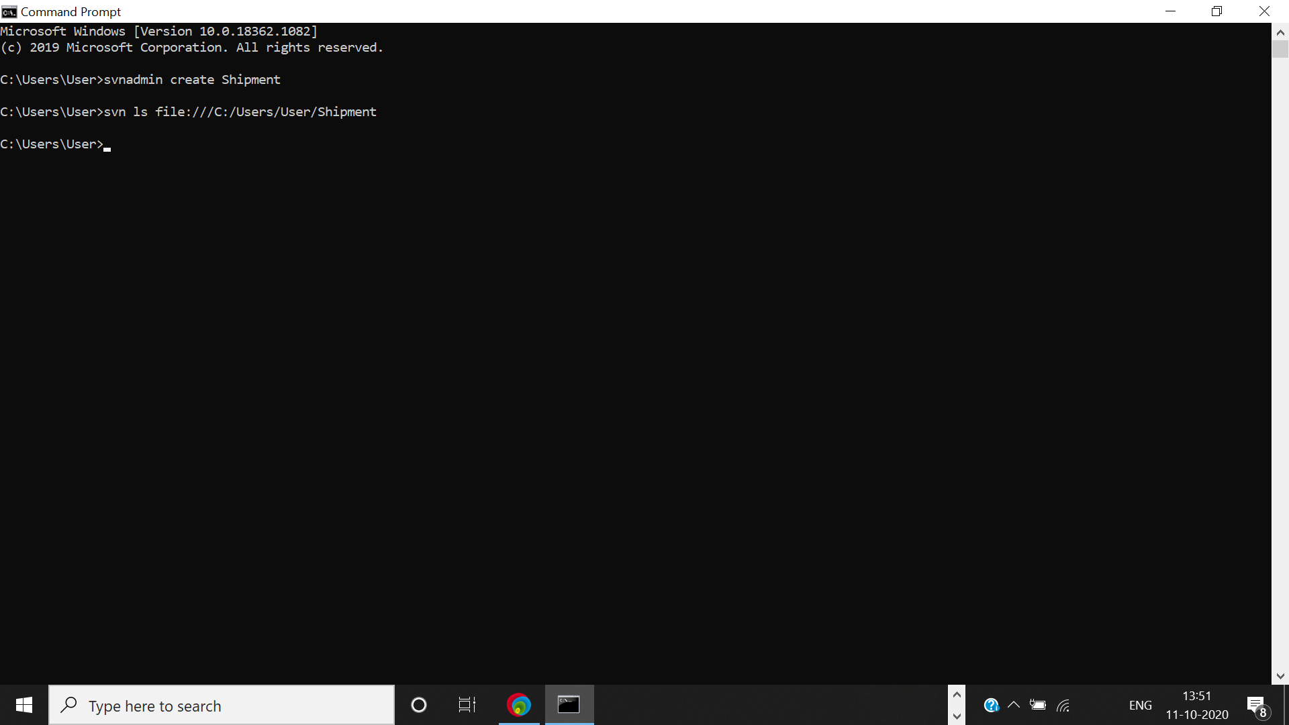

Step7:

Create a new directory named as trunk.  
In the command prompt, enter the syntax to create a directory  
svn mkdir <repo_url followed by directory name> -m “commit message”  
Example:  
svn mkdir file:///C:/svn_repository/trunk -m "commit trunk"

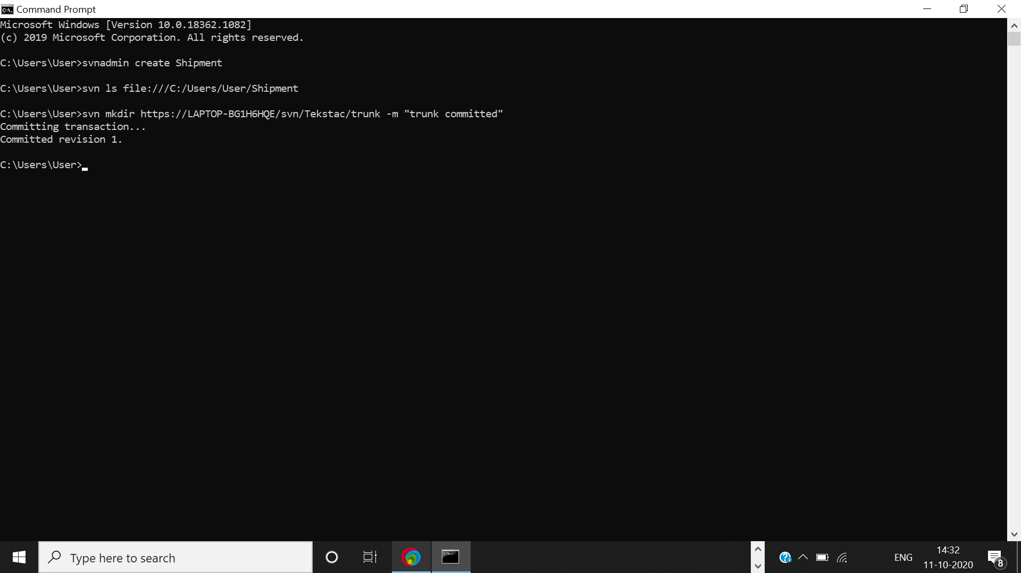

Step8:

|  |  |
| --- | --- |
| The explorer doesn’t display the created directory, so in-order to verify if the directory is created or not  enter the following command in the command prompt: svn ls <Repo_path> Example: svn ls file:///C:/Shipment The trunk directory gets listed. |  |

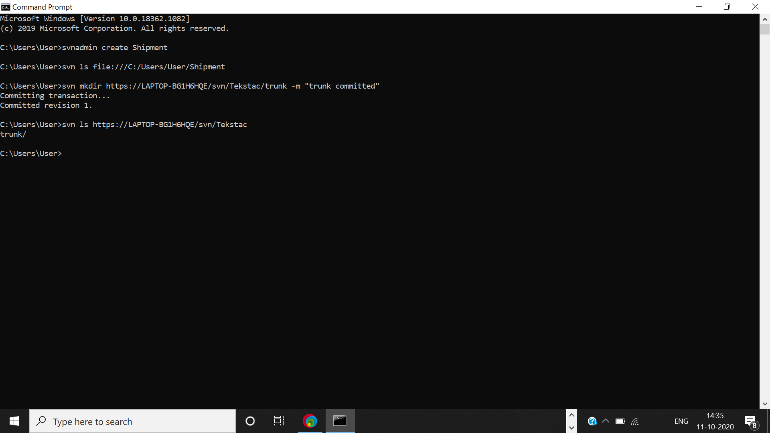

Step10:

List the directories in the repository as specified in step 7

The tag, trunk and branch directories should be listed.

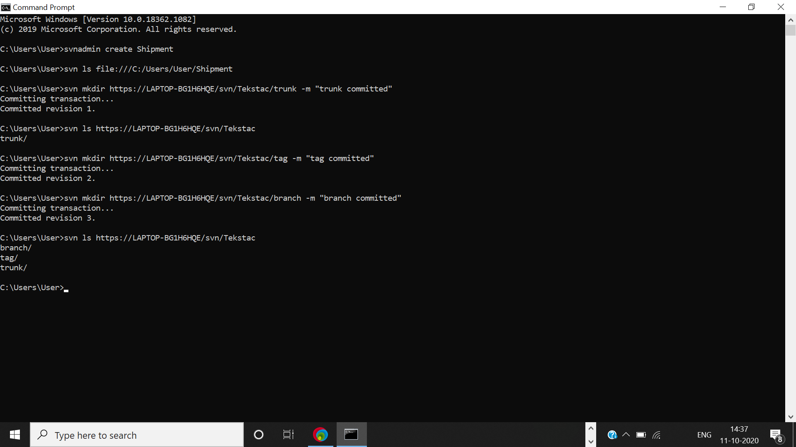

Step13:

|  |  |
| --- | --- |
| In command prompt enter the following syntax to check out the project. **Syntax:** svn checkout <REPO_URL> |  |

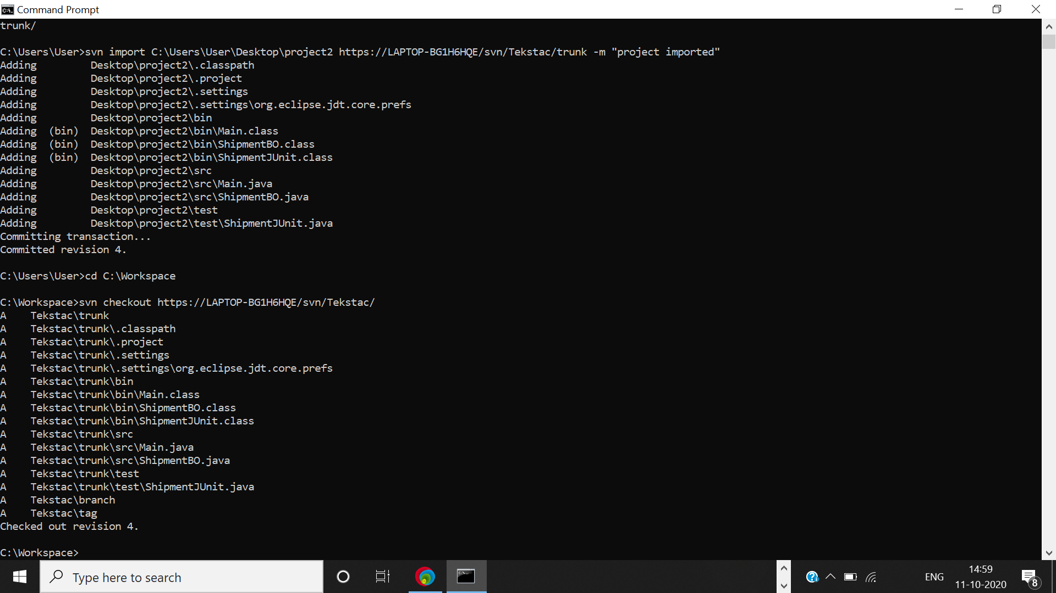

Step14:

Open the project in the workspace and do the following changes:  
In src/Main.java file update line no 10 as follows:  
**System.*out*.println("Enter the mode the shipment");**

and save the file

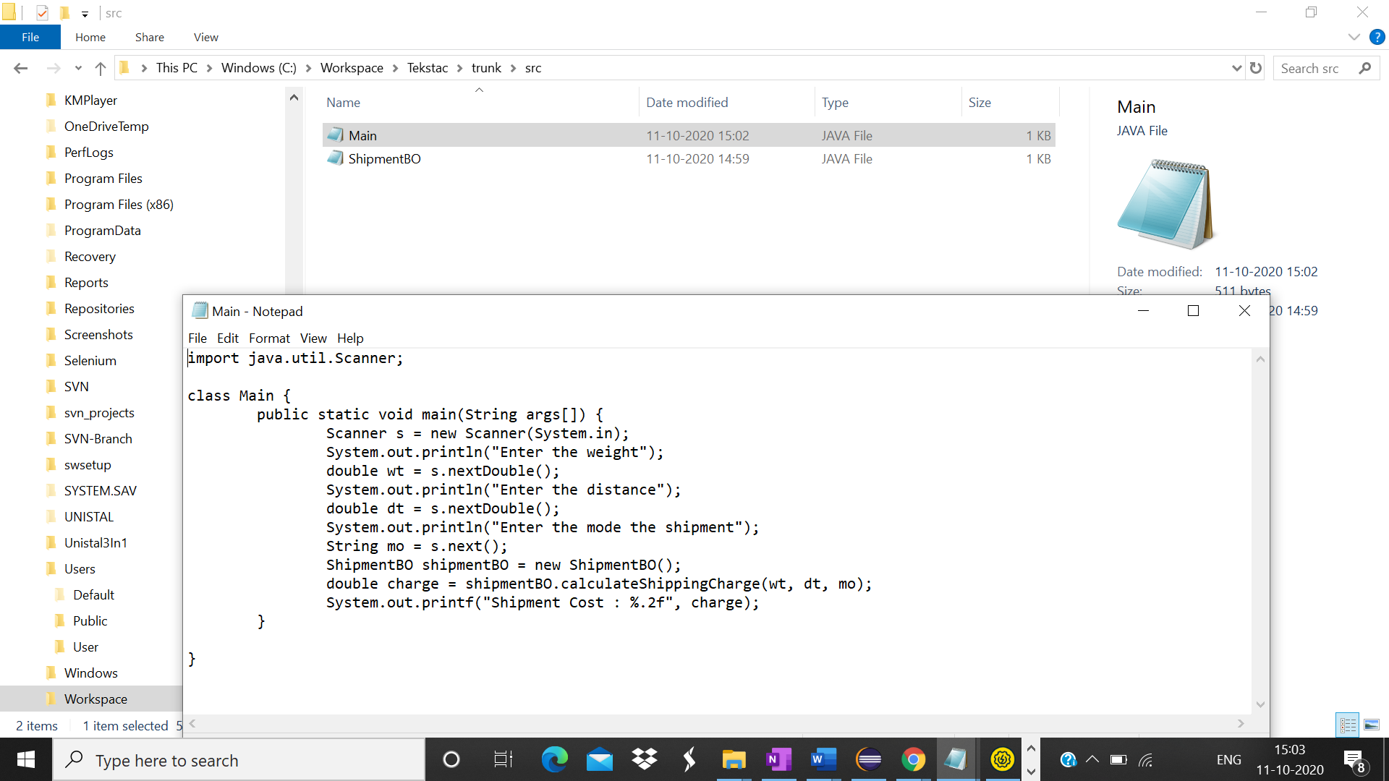

Step15:

In the command prompt, navigate to the project in the workspace and enter  
svn status

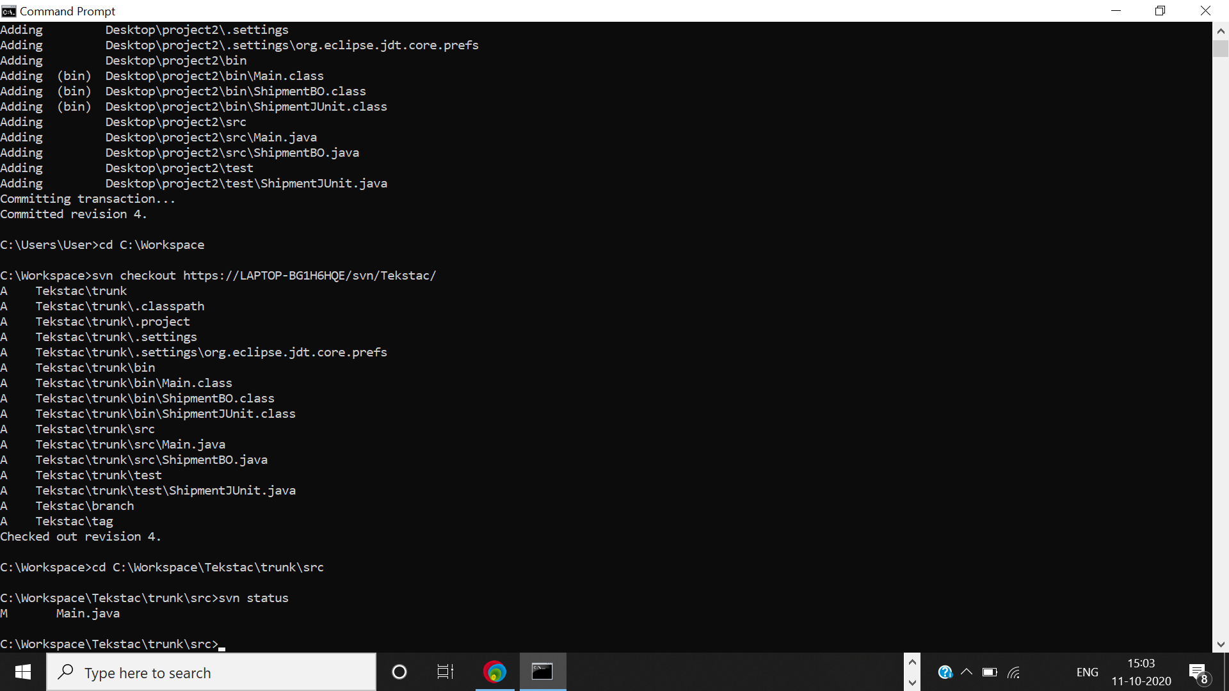

Step16:

In the command prompt, enter svn diff <Filename with extension> The differences are displayed in the console.  
**Example** svn diff src/Main.java

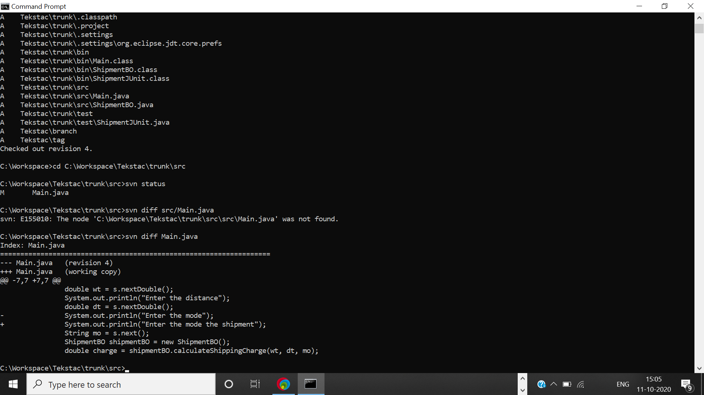

Step17:

In the command prompt, enter  
svn commit -m "commit message"

