CSS Box Model, Display & Units
Class 4 notes. Every element on a page is a box. This class is about what those boxes are made of, how to size them without surprises, how they lay out, and what the units really mean.
Class: 4 · Builds on: your CSS selectors and properties
Why this matters: Once you can style elements, the next question is layout: how big is a box, and where does it sit? Every element on a page is a rectangular box, and almost every layout bug comes from misjudging that box. Get the box model, box-sizing, and units straight here and CSS layout stops feeling random.

What you should be able to do after this
- Name the four layers of the box model and what each one does
- Use margin and padding shorthand and read the clockwise order
- Style borders (solid, dashed, dotted) and round corners with border-radius
- Explain why box-sizing: border-box makes widths predictable
- Control overflow, and tell block from inline behaviour
- Pick the right unit, and always know what a relative unit is relative to

What's inside
1. Every element is a box
2. Margin and padding: the shorthand
3. Borders and rounded corners
4. box-sizing: the width gotcha
5. overflow: when content is too big for the box
6. display: block vs inline
7. CSS units: fixed and relative

1. Every element is a box
In one line: From the outside in: margin, border, padding, content.
Think of it like: A gift in a parcel. The content is the gift, padding is the bubble wrap around it, the border is the box walls, and the margin is the gap to the next parcel on the shelf.
Key points
- content is the actual text or image, the innermost layer.
- padding is space inside the box, between the content and the border. It shares the background colour.
- border is the wall drawn around the padding.
- margin is space outside the box that pushes other boxes away. It is always transparent.
- You can see all four layers on any element in the browser: right-click, choose Inspect, and look at the coloured layers in the panel on the right.
- A box needs a height and width to actually show up, otherwise there is nothing to fill.
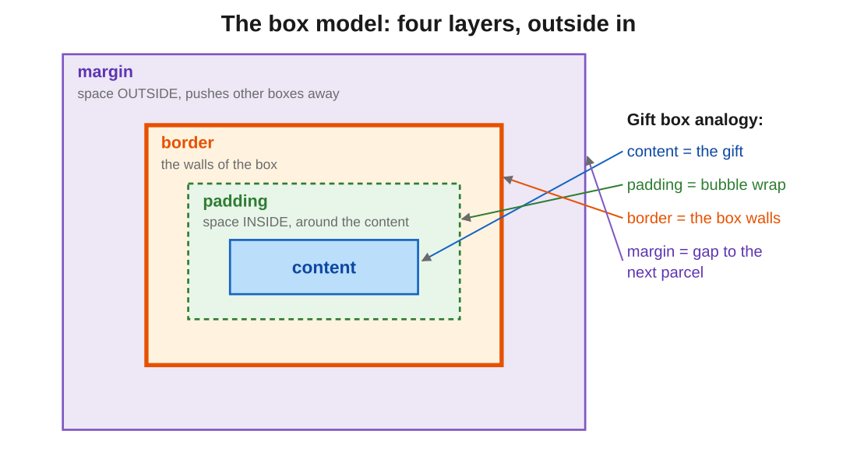
Figure 1: the four layers nested, with the gift-parcel analogy mapped on. Padding is inside the wall, margin is outside it.
In the exam: The distinction they test: padding is INSIDE the border, margin is OUTSIDE it. If you can say which one adds space between content and border (padding) and which pushes neighbours away (margin), you have the whole model.
Code walkthrough
.box {
width: 200px;
height: 100px;
background-color: red;
}
Line by line
- .box targets every element with the class box.
- width: 200px sets the content box to 200 pixels wide.
- height: 100px sets it 100 pixels tall.
- background-color: red paints the content and padding area red so you can actually see the box on screen.
What you see: A red rectangle on the page, 200px wide by 100px tall. Without width and height it would collapse to nothing visible.

2. Margin and padding: the shorthand
In one line: One line can set all four sides. The number of values you pass decides which sides.
Key points
- Four values run clockwise: top, right, bottom, left. So margin: 10px 20px 30px 40px is top 10, right 20, bottom 30, left 40.
- Three values: top, then left-and-right together, then bottom.
- Two values: top-and-bottom, then left-and-right. Great for margin: 0 auto to centre a fixed-width box.
- One value applies to all four sides at once.
- You can also set one side directly with margin-top, margin-right, margin-bottom, margin-left.
- All of this applies to padding the same way, just swap the word: padding: 10px 20px 30px 40px behaves identically.
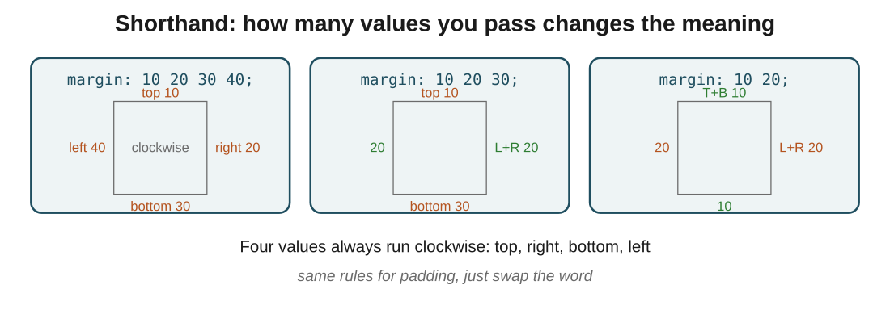
Figure 2: the same property with four, three and two values. Watch which sides each count fills in.
In the exam: The clockwise order is exam gold: top, right, bottom, left. Read it like a clock starting at 12. If a question gives four values, walk them clockwise and you cannot get it wrong.
Code walkthrough
.container {
background-color: lightgreen;
margin: 20px 30px;
padding: 10px 20px 30px 40px;
}
Line by line
- .container targets every element with class container.
- background-color: lightgreen paints the padding + content area green.
- margin: 20px 30px gives the box 20px top and bottom, 30px left and right (two-value form).
- padding: 10px 20px 30px 40px is the four-value form: 10 top, 20 right, 30 bottom, 40 left (clockwise).
What you see: A green box with a small gap above and below (20px), a bigger gap left and right (30px), and uneven padding inside pushing the content down and to the right the most.

3. Borders and rounded corners
In one line: border is the wall around the padding: give it a width, a style, and a colour.
Key points
- Shorthand syntax is always three parts: border: 2px solid red; = width, style, colour.
- Styles you'll use most: solid, dashed, dotted. There are more, but these carry 90% of pages.
- Aim one side with border-top, border-right, border-bottom, border-left. Same three-part value for each.
- border-radius rounds the corners. One value rounds all four; individual corners like border-top-right-radius round just one.
- Border sits between padding and margin: rounding the border also visually clips the padded background inside it.
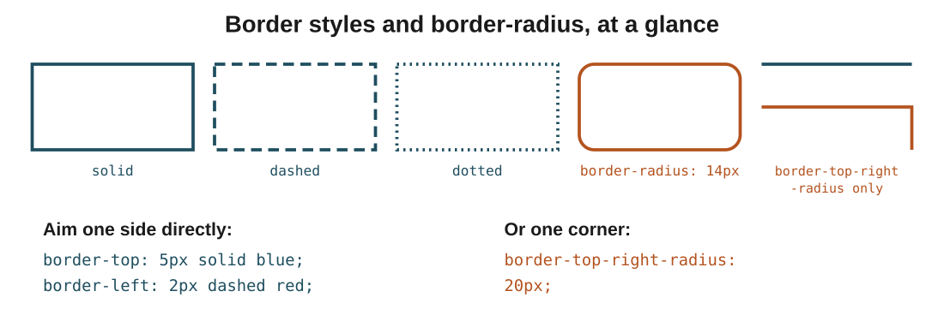
Figure 3: three border styles (solid, dashed, dotted), plus what border-radius does. The last box shows rounding one corner only.
In the exam: Border shorthand is always width, style, colour. If a question shows border: red solid 2px and asks what's wrong, the answer is the order: it should be 2px solid red.
Code walkthrough
.container {
border-top: 5px solid blue;
border-left: 2px solid tomato;
border-right: 6px dashed black;
border-bottom: 5px solid yellow;
border-top-left-radius: 20px;
border-bottom-left-radius: 30px;
}
Line by line
- Each border-* line styles one side independently: blue top, tomato left, dashed black right, yellow bottom.
- The two border-*-radius lines round only the left corners: 20px on top-left, 30px on bottom-left.
- The right corners keep their sharp 90-degree angles because we did not touch them.
What you see: A box with four differently coloured sides (blue, tomato, black-dashed, yellow), with the left side rounded into a soft curve and the right side still square. Colourful, and a good way to prove each side is independent.

4. box-sizing: the width gotcha
In one line: By default, padding and border add ON TOP of width. border-box folds them in.
Key points
- Default is content-box: width sizes only the content, so padding and border make the box bigger than the number you set.
- So width: 200px with 20px padding and 5px border actually renders at 250px on screen. This is where layouts silently drift.
- box-sizing: border-box makes width the total: padding and border eat inward, and the box stays exactly the width you set.
- Most developers set border-box on everything as the very first CSS rule, for exactly this reason.
- Nothing about your padding or border changes; only what the width number counts changes.
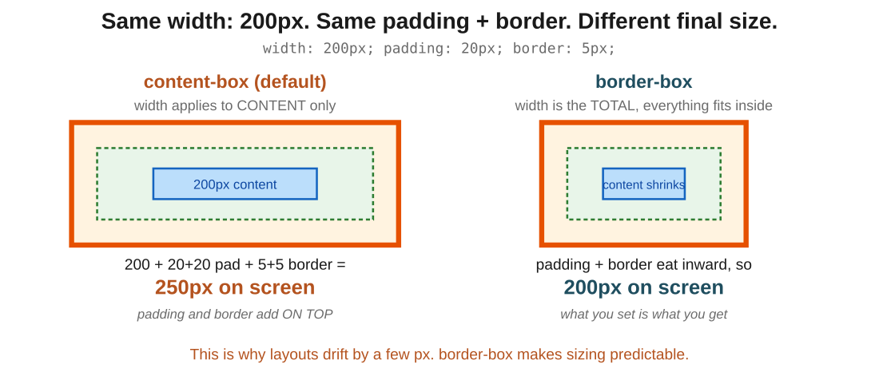
Figure 4: same width, same padding and border, two box-sizing values. content-box swells to 250px; border-box stays at 200px.
In the exam: The reasoning that answers any box-sizing question: content-box adds padding and border on top of width, border-box includes them. If you can compute 200 + padding + border for content-box, you understand it.
Code walkthrough
.box-a { width: 200px; padding: 20px; border: 5px solid red;
box-sizing: content-box; }

.box-b { width: 200px; padding: 20px; border: 5px solid blue;
box-sizing: border-box; }
Line by line
- Both boxes ask for width: 200px, the same padding: 20px, and the same 5px border.
- .box-a uses content-box: width applies to content only, so padding (20+20) and border (5+5) get added on top.
- .box-b uses border-box: width is the total, so padding and border eat inward and content shrinks.
What you see: .box-a renders at 250px on screen (200 + 40 padding + 10 border). .box-b renders at 200px on screen, exactly what you asked for. The content inside .box-b is narrower to make room.

5. overflow: when content is too big for the box
In one line: When content doesn't fit its box, overflow decides what happens.
Key points
- visible (default): the extra content spills out of the box and overlaps whatever is nearby.
- hidden: the overflow is clipped and simply not shown.
- scroll: adds scrollbars, and they show even when not needed.
- auto: adds scrollbars only when content actually overflows. The tidiest choice.
- Aim a single direction with overflow-x or overflow-y when you only want one scrollbar.
- The container itself keeps its designated size; only what happens to the extra content changes.
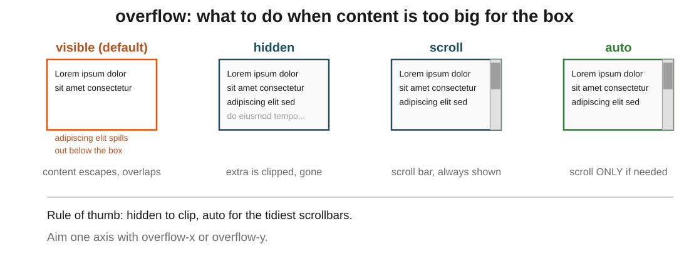
Figure 5: the same overflowing text under all four values. visible escapes; hidden clips; scroll always shows a bar; auto only when needed.
In the exam: The pair they compare: scroll always shows scrollbars, auto shows them only when needed. If a question mentions an unnecessary scrollbar on short content, the culprit is scroll, not auto.
Code walkthrough
.container {
border: 2px solid tomato;
width: 200px;
height: 200px;
overflow: hidden;
}
Line by line
- .container gets a visible tomato border so we can see its edges.
- width: 200px and height: 200px fix its size. Content longer than this will not fit.
- overflow: hidden tells the browser to clip anything beyond that box. No scrollbar, no spill: just gone.
What you see: A square box, 200 by 200, with as much text as fits shown inside. Everything beyond is cut off at the border, invisibly. Change hidden to auto and you get a scrollbar instead, only if the text actually overflows.

6. display: block vs inline
In one line: block elements stack and take the full width; inline elements flow in a line and ignore width and height.
Key points
- block (div, p, h1): starts on a new line, takes the full width available, and respects width, height and all four margins.
- inline (span, a): sits in the text flow, only as wide as its content, and ignores width and height.
- For inline elements, vertical margin and padding don't push neighbours around; only left and right do.
- inline-block is the bridge: flows inline like text, but accepts width, height, and full margins like a block.
- display: none removes the element from the page entirely, as if it were never there.
- img is a special case: it's inline in the flow, but you can set its width and height.
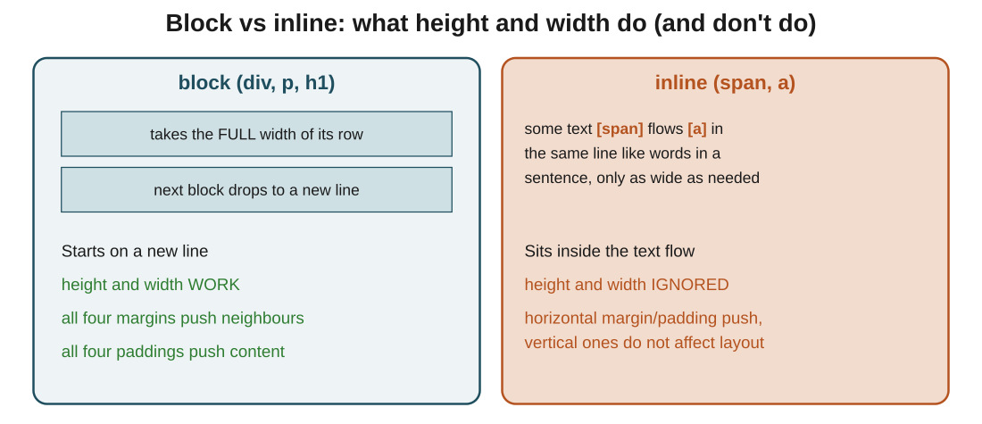
Figure 6: block claims the whole row and stacks; inline sits inside a line of text and won't take a size. inline-block gives you both.
In the exam: The classic true or false: "inline elements respect width and height." False. That is exactly why inline-block exists. If you know inline ignores width and height, you'll catch the trap.
Code walkthrough
p { border: 2px solid red; height: 50px; width: 50px; }
span { border: 2px solid blue; height: 50px; width: 50px; }

/* now upgrade the span */
span { display: inline-block; }
Line by line
- p is a block element, so height: 50px and width: 50px both apply. The paragraph becomes a small red square.
- span is inline, so those width and height values are silently ignored. The blue border just hugs the text.
- The last rule sets display: inline-block on the span.
- Now the span still flows in the sentence like text, but width and height take effect and it becomes a 50 by 50 blue box.
What you see: Before the last rule: a small red square (the p) and a thin blue border wrapping the span text, no matter what width you set. After the last rule: the span becomes a 50 by 50 blue box sitting inline with the surrounding text.

7. CSS units: fixed and relative
In one line: px is fixed. Relative units scale, and the only question is: relative to WHAT?
Key points
- px is a fixed dot count. It never changes, so it's good for precise things like border widths and small buttons.
- % is relative to the parent element. width: 50% is half the parent's width.
- For font-size in %, the base is the parent's font size. 150% of a 16px parent means 24px.
- For padding and margin in %, the base is always the parent's WIDTH, even for top and bottom. This is the surprise.
- vw and vh are relative to the viewport (the window). 100vh is exactly the screen height.
- rem is relative to the root font size (the <html> element). If root is 16px, 1rem is 16px and 2rem is 32px.
- Fixed values give you precise control; relative units let a layout adapt to phones and monitors instead of breaking.
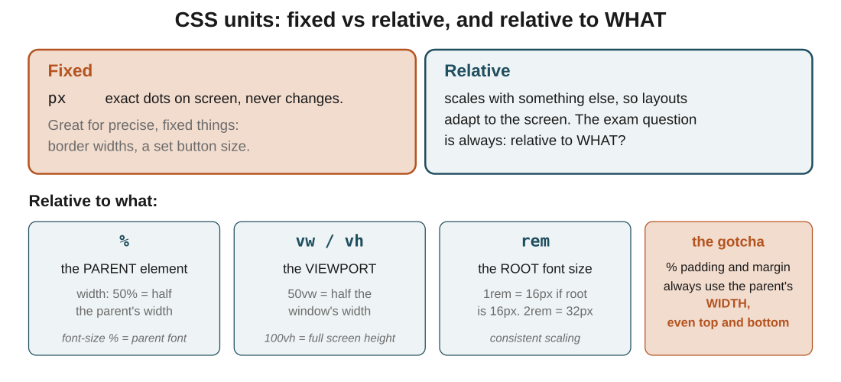
Figure 7: fixed vs relative, and the reference each relative unit uses. The question is always relative to what: parent, viewport, or root.
In the exam: The one they love: a percentage padding or margin is relative to the parent's WIDTH, even for top and bottom. It surprises everyone, which is what makes it a great trick question.
Code walkthrough
.container { display: flex; width: 400px; }
.sidebar { width: 25%; background-color: lightcoral;
padding: 10%; margin: 10%; }
Line by line
- .container is 400px wide (fixed) and lays its children in a row with display: flex.
- .sidebar asks for width: 25%: 25% of the parent's 400px = 100px wide.
- padding: 10% looks like it should be 10% of the sidebar's own 100px, but it's not: it's 10% of the parent's WIDTH = 40px on every side.
- Same trick for margin: 10%: another 40px on every side, pushing the sidebar around inside the container.
What you see: A pink sidebar that ends up much bigger than you'd guess, because the padding and margin are calculated from the 400px parent, not from the sidebar itself. This is why fixed values are often more predictable for spacing.

The big picture: what it all comes down to
If it all clicks here, the rest follows: the core ideas, in plain terms.
- Every element is a box with four layers: content, then padding (inside), then border, then margin (outside).
- Shorthand runs clockwise from the top: top, right, bottom, left. Fewer values just mirror sides.
- border is always three parts, width, style, colour; border-radius rounds the corners.
- By default width sizes only content, so padding and border make the box bigger. border-box folds them in so width is the true total.
- overflow handles content that doesn't fit: visible spills, hidden clips, scroll always bars, auto bars only when needed.
- block stacks and takes full width and respects size; inline flows and ignores width/height; inline-block does both.
- Units are fixed (px) or relative, and relative always begs one question: relative to the parent (%), viewport (vw/vh), or root (rem)?

Quick recap
- The box model is content, padding, border, margin, from the inside out.
- Padding is space inside the border; margin is space outside it.
- Shorthand values go clockwise: top, right, bottom, left.
- Border shorthand is width, style, colour. border-radius rounds corners.
- box-sizing: border-box includes padding and border in the width, so sizes stay predictable.
- overflow controls spill: visible, hidden, scroll (always), auto (when needed).
- block takes the full row and respects width/height; inline flows and ignores them; inline-block bridges both.
- px is fixed; %, vw/vh, and rem are relative to the parent, the viewport, and the root.

Try it yourself
- Draw the box model from memory and label which layers are inside the border and which is outside.
- Give a box width: 200px, padding: 25px, border: 5px, and work out its rendered width with content-box, then with border-box.
- Style one container with a different colour and style on each of its four borders, then round two corners.
- Put lots of text in a fixed-height div and try all four overflow values, noting which one shows a scrollbar only when needed.
- Take a span, set a width (nothing happens), then add display: inline-block and watch the width take effect.
- Build a sidebar at width: 25% inside a 400px container, then set its padding and margin to 10% and confirm the surprise (parent's width, not the sidebar's).

