CSS Flexbox & Media Queries
Class 5 notes. Flexbox is how you actually lay things out in modern CSS: rows, columns, centering, spacing, responsive wrapping. Media queries are how you make it adapt to any screen.
Class: 5 · Builds on: your CSS from Class 4 (box model, display, units)
Why this matters: Before flexbox, laying out a row of items and centering them vertically was famously painful. Flexbox turned that into one line of CSS. This class is where CSS layout stops feeling like a fight. Once you can think in terms of a container, a main axis, and a cross axis, most layouts become five properties away.

What you should be able to do after this
- Explain what display: flex actually does and how it changes children
- Read a flex container in terms of main axis and cross axis
- Use justify-content and align-items to place items exactly where you want
- Make a layout responsive with flex-wrap
- Rearrange items with order, and control how they shrink and grow
- Write media queries to serve different styles at different screen sizes

What's inside
1. What flexbox is
2. Main axis and cross axis
3. justify-content: spacing along the main axis
4. align-items: placement along the cross axis
5. flex-wrap: making layouts responsive
6. Order, shrink, and grow: control per item
7. Media queries: styles per screen size

1. What flexbox is
In one line: display: flex turns a parent into a flex container; its direct children become flex items you can arrange with a handful of properties.
Think of it like: Think of a Bollywood dance formation. The choreographer sets the pattern (the container), and every dancer (a child element) automatically falls into that pattern. You don't tell each dancer where to stand; you set the formation and they line up.
Key points
- display: flex is written on the parent (the container), not on the children.
- As soon as it is set, direct children stop stacking as blocks and start lining up on one axis.
- The default axis is horizontal: items flow left to right in a single row.
- Every rule you learn from here (justify-content, align-items, flex-wrap, ...) is a property of the container or of an item, arranging things inside that formation.
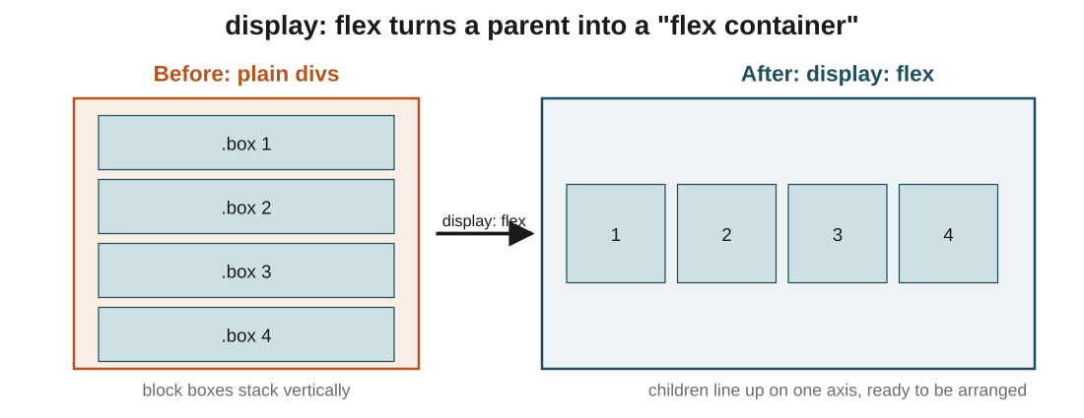
Figure 1: same four boxes, before and after display: flex. Blocks that used to stack vertically now line up in a row, ready to be arranged.
In the exam: The default value of flex-direction is row, so items line up horizontally the moment you write display: flex. If a question asks what direction items take by default, the answer is a row across the main axis.
Code walkthrough
.container {
background-color: tomato;
border: 2px solid black;
height: 500px;
display: flex;
}
.box {
height: 100px;
width: 100px;
background-color: dodgerblue;
margin: 10px;
}
Line by line
- .container gets a red-orange background and a black border so we can see its edges.
- display: flex on .container is the switch: its children stop being blocks and become flex items.
- .box styles every child: 100 by 100 pixels, blue, with 10px margin around it.
- Without display: flex, four .box children would stack vertically down the tomato area.
What you see: A tall tomato rectangle with four blue 100x100 squares sitting side by side in a row along the top, each with a 10px gap. Change one line (display: flex) and the four squares would instead stack top-to-bottom.

2. Main axis and cross axis
In one line: Every flexbox rule is written against two axes: the main axis items line up along, and the cross axis perpendicular to it.
Key points
- flex-direction: row (default) puts the main axis horizontal (left to right), and the cross axis vertical.
- flex-direction: column flips it: the main axis becomes vertical (top to bottom), cross axis horizontal.
- row-reverse and column-reverse run the main axis backwards.
- This is the single most important idea in flexbox: the algorithm does not care about 'horizontal' or 'vertical', only 'main' and 'cross'.
- justify-content always acts on the main axis. align-items always acts on the cross axis. Change flex-direction and their effects swap directions automatically.
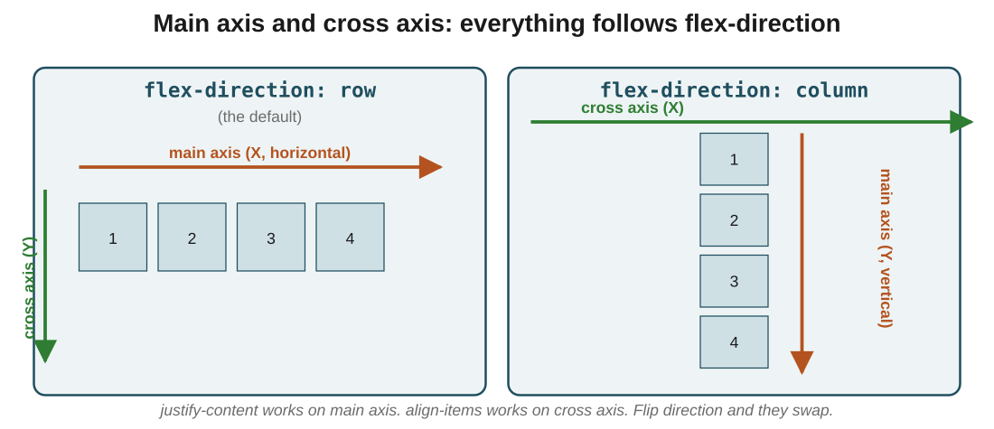
Figure 2: the same rules, two directions. In row, the main axis is horizontal; in column, it's vertical. The cross axis is whichever one is left over.
In the exam: The stock swap they test: if flex-direction: row, the main axis is the X axis (horizontal). If flex-direction: column, the main axis is the Y axis (vertical). Never memorise this; picture the arrow along which items line up, and that is the main axis.

3. justify-content: spacing along the main axis
In one line: justify-content decides how items are distributed along the main axis (horizontally by default).
Key points
- flex-start (default): items pack at the start of the container.
- flex-end: items pack at the end.
- center: items pack in the middle.
- space-between: first and last items sit at the edges, gaps split evenly between the rest.
- space-around: equal space around each item (so the outside gaps are half the inside gaps).
- space-evenly: all gaps (including at the edges) are equal.
- For a row layout, all of this happens horizontally. Flip to column and it happens vertically.
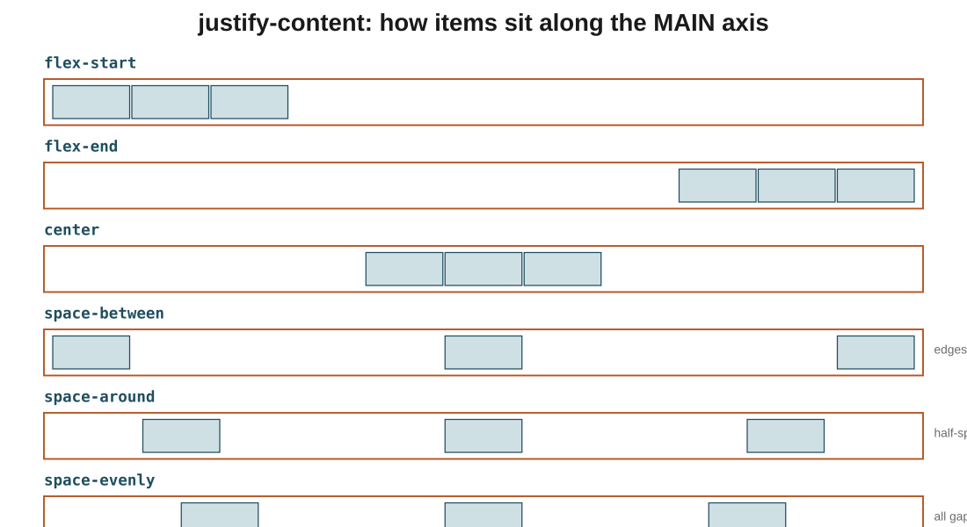
Figure 3: the same three items shown under all six values. The distinction between space-around and space-evenly is the edge gap.
In the exam: The reasoning: justify-content controls the main axis. If the layout is a row, that's horizontal. If it's a column, that's vertical. So justify-content: center does not always mean horizontally centred; it means centred on whichever axis is currently the main one.
Code walkthrough
.container {
display: flex;
justify-content: center;
height: 500px;
}
Line by line
- display: flex on .container makes it a flex container.
- justify-content: center places all flex items in the middle of the main axis.
- Since flex-direction was not set, it's row, so 'center' means horizontally centred.
- The container's height is 500px, but justify-content does not care about vertical position, only main-axis position.
What you see: The row of items sits horizontally centred in the container, with no space between them (they still pack together, just in the middle instead of pushed to the left).

4. align-items: placement along the cross axis
In one line: align-items decides how items sit along the cross axis (vertical by default for a row).
Think of it like: Think of a class group photo. Some students are tall, some short. align-items decides whether they all line up by the tops of their heads (flex-start), the soles of their feet (flex-end), their midpoints (center), the writing on their name tags (baseline), or whether everyone stands on tiptoes to match the tallest (stretch).
Key points
- flex-start: items align to the start of the cross axis (top for a row).
- flex-end: items align to the end (bottom for a row).
- center: items are centred on the cross axis.
- baseline: items align by their text baselines, so different font sizes still sit on the same invisible line.
- stretch (default): items stretch to fill the container along the cross axis, as long as no explicit height is set on them.
- Pair justify-content: center with align-items: center and you have the one-line answer to 'how do I centre this thing both ways?'
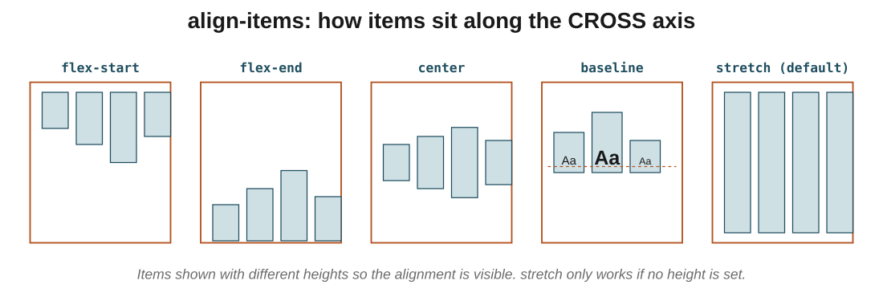
Figure 4: four items of different heights, five ways to align them on the cross axis. baseline is the one that makes different font sizes line up neatly.
In the exam: The distinction that gets tested: justify-content is main axis, align-items is cross axis. If you can name which axis each one controls, you can predict any combination without memorising.
Code walkthrough
.container {
display: flex;
justify-content: center;
align-items: center;
height: 500px;
}
Line by line
- display: flex opens the flex container.
- justify-content: center centres items on the main (horizontal) axis.
- align-items: center centres them on the cross (vertical) axis.
- Together these two lines are the modern way to centre anything in CSS, in both directions, on one container.
What you see: Items sit dead centre in the container: horizontally centred by justify-content, vertically centred by align-items. The famous 'centre a div' problem, solved in two lines.

5. flex-wrap: making layouts responsive
In one line: By default, flex items squeeze onto one line. flex-wrap: wrap lets them fall onto new lines when there isn't room.
Key points
- nowrap (default): items stay on one line even if it means shrinking them past their set width.
- wrap: when there is not enough room, extra items flow to a new line and keep their intended size.
- wrap-reverse: same as wrap, but new lines stack above the first line instead of below.
- This is the property that makes a flex layout responsive: on a big screen, cards sit in a row; on a phone, they wrap onto multiple lines automatically.
- Combine flex-wrap: wrap with justify-content and align-items to get a grid-like layout that reflows on its own.
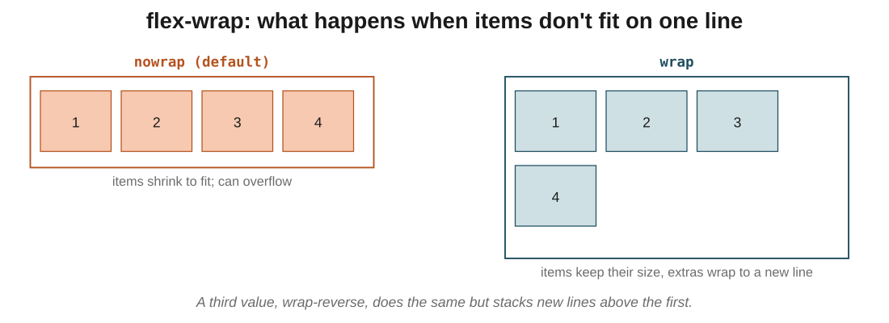
Figure 5: same four items, same container width. nowrap squeezes them; wrap drops the fourth item onto a new line at its true size.
In the exam: The one they compare: nowrap forces items to squeeze onto one line (they may overflow or shrink); wrap keeps them their true size and moves the extras to a new line. Reach for wrap the moment you care about small screens.
Code walkthrough
.container {
display: flex;
flex-direction: row;
justify-content: center;
align-items: center;
flex-wrap: wrap;
}
.box {
height: 200px;
width: 200px;
margin: 10px;
}
Line by line
- The container is a flex row, centred both ways.
- flex-wrap: wrap tells items to move to a new line if they cannot fit.
- Each .box is a fixed 200 by 200 square with 10px margin.
- On a wide screen, four boxes fit in one row. Shrink the browser and the fourth (then third) box drops onto a new line, without shrinking.
What you see: A grid that reflows: four boxes in a row on desktop, then two rows of two as the window narrows, then a single column on a phone. All without a media query.

6. Order, shrink, and grow: control per item
In one line: Most flex properties live on the container; order, flex-shrink, and flex-grow live on individual items.
Think of it like: The order property is like a Christopher Nolan edit. In *Memento* the scenes were shot in normal order, then re-cut into a new sequence for the audience. HTML is the shot order; order is the edit that decides what the viewer sees when.
Key points
- order sets a display position for one item. Default is 0. Items with lower order appear first; higher order moves an item further along.
- order does not change the HTML: only the display order shifts. Screen readers still read the original DOM order.
- flex-shrink decides how much an item shrinks when space is tight. Default is 1. Setting it to 2 means that item shrinks twice as fast as its siblings.
- flex-shrink: 0 on an item locks its size: it will never shrink, even if space runs out.
- flex-grow is the opposite: when there is extra space, higher values take a bigger share of it. Default is 0 (do not grow).
- You can set all three on any flex item to override how it behaves inside the container.
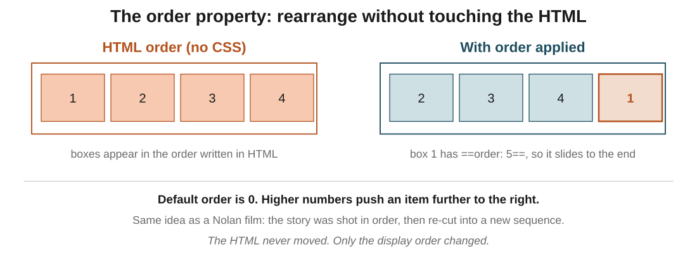
Figure 6: box 1 is first in the HTML but has order: 5, so it slides to the end of the visual row. The HTML is untouched.
In the exam: The gotcha to remember: order is visual only. If your page's meaning depends on the sequence (a form, a story), do not rely on order to fix a wrong HTML order, because screen readers ignore it and follow the DOM.
Code walkthrough
.box1 { order: 4; }
.box3 { order: 2; }
/* box2 and box4 have the default order: 0 */
Line by line
- .box1 gets order: 4. Highest value, so it goes last.
- .box3 gets order: 2. Second-highest, so it goes just before box1.
- .box2 and .box4 keep the default order: 0. They tie, so they appear in their HTML order: box2 first, then box4.
- Final visual sequence: box2, box4, box3, box1.
What you see: The row appears as box2, box4, box3, box1. Nothing was moved in the HTML: the browser just re-sequenced the display based on the order numbers.

7. Media queries: styles per screen size
In one line: A @media rule wraps CSS that only applies when the screen matches a condition (usually a width).
Think of it like: A chef writing recipes for different diners: same dish, adjusted for who's eating. Or a film: the same movie is cut differently for a phone, a tablet, and a cinema screen. Media queries are the CSS version of that.
Key points
- @media (max-width: 600px) { ... } applies the styles inside when the viewport is 600px or narrower (phone-sized).
- @media (min-width: 601px) and (max-width: 900px) { ... } covers the range in between (tablet).
- @media (min-width: 901px) { ... } applies for anything wider (desktop).
- General styles outside any media query are the base: they apply everywhere unless a media query overrides them.
- You can query more than width: orientation, prefers-color-scheme, and more, but width is the workhorse.
- The order of min-width and max-width defines a breakpoint: the screen size at which your layout switches.
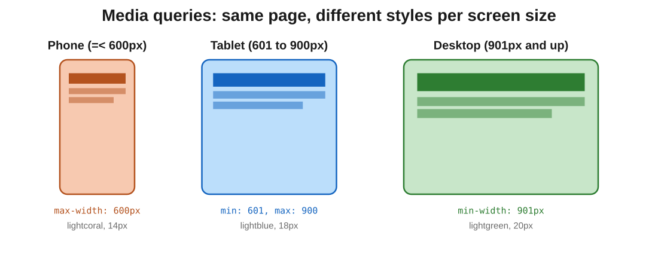
Figure 7: three breakpoints, three different looks. The same HTML picks a different set of styles depending on how wide the screen is.
In the exam: The direction of the comparator is where mistakes live: max-width: 600px means '600 or less' (target small screens); min-width: 600px means '600 or more' (target big ones). If you get it backwards, your phone styles show up on desktop, which is a classic five-minute debug.
Code walkthrough
body { font-size: 16px; margin: 20px; }

@media (max-width: 600px) {
body { font-size: 14px; background: lightcoral; }
}

@media (min-width: 601px) and (max-width: 900px) {
body { font-size: 18px; background: lightblue; }
}

@media (min-width: 901px) {
body { font-size: 20px; background: lightgreen; }
}
Line by line
- The base rule sets the body to 16px text with 20px margin. This runs everywhere unless overridden.
- @media (max-width: 600px): on phones, override to 14px text and a lightcoral background.
- @media (min-width: 601px) and (max-width: 900px): on tablets, 18px text on lightblue.
- @media (min-width: 901px): on desktops, 20px text on lightgreen.
- Only one media block matches at a time, so the browser picks the one that fits the current screen width.
What you see: Load the page and resize the browser. Below 600px it turns lightcoral with small text; between 601 and 900 it turns lightblue with medium text; wider than that, lightgreen with large text. Same HTML, three visual states.

The big picture: what it all comes down to
If it all clicks here, the rest follows: the core ideas, in plain terms.
- display: flex on a parent turns it into a flex container; its direct children line up along one axis and become arrangeable.
- Every flex rule is written against two axes: the main axis (whichever direction items flow) and the cross axis perpendicular to it. flex-direction picks which is which.
- justify-content places items along the main axis; align-items places them along the cross axis. Together they solve most centring problems in two lines.
- flex-wrap: wrap is what makes flex layouts responsive: items keep their size and move to a new line instead of squeezing.
- Most flex properties live on the container, but order, flex-shrink, and flex-grow give individual items their own say.
- @media rules let one stylesheet serve every screen size. Base styles run everywhere; each media block overrides them only when its condition matches.

Quick recap
- display: flex on the parent creates a flex container; children become flex items on one axis.
- flex-direction picks the main axis; the cross axis is whichever one is perpendicular.
- justify-content controls the main axis; align-items controls the cross axis.
- flex-wrap: wrap lets items fall to a new line so layouts stay usable on small screens.
- order rearranges items visually without changing the HTML; flex-shrink and flex-grow control how they resize.
- Media queries apply styles only when the screen matches a condition, usually a min-width or max-width breakpoint.

Try it yourself
- Take four boxes in a container, apply display: flex, then cycle through every value of justify-content and watch the row rearrange.
- Set the container to flex-direction: column and repeat: notice which properties now act vertically and which now act horizontally.
- Centre a single box both horizontally and vertically using just justify-content: center and align-items: center on the parent.
- Add flex-wrap: wrap, then narrow the browser window and watch items fall onto new lines instead of squeezing.
- Give the first box order: 5 and the third box order: 1, and predict the new sequence before running it.
- Write three media queries (phone, tablet, desktop) that change the background colour, then resize the browser to see them fire.

