CSS Animations & Keyframes
Class notes on making elements move, fade, rotate, and bounce with pure CSS. No JavaScript required.
Class: CSS animations · Builds on: your CSS positioning and transforms
Why this matters: A live interface feels alive because it moves. Buttons that fade on hover, a spinner that says the app is thinking, a modal that slides in instead of blinking into existence, small motions like these are the difference between a page that feels rough and a page that feels polished. CSS animations let you build all of it without a single line of JavaScript, straight from your stylesheet.

What you should be able to do after this
- Explain what an animation is at the browser level: interpolated frames between a start and an end
- Define stages with @keyframes, using either from/to or percentages
- Control timing with animation-duration, animation-delay, and animation-iteration-count
- Shape movement with animation-direction and animation-timing-function
- Collapse a rule into one line with the animation shorthand
- Use animation-fill-mode and animation-play-state for polish
- Build three classic animations: a rotating loader, a moving box, a bouncing ball
- Choose between a transition and an animation for a given effect

What's inside
1. What an animation actually is
2. @keyframes: the stages of an animation
3. The core timing properties
4. animation-direction: forward, backward, or bouncing
5. animation-timing-function: the pacing curve
6. Shorthand, fill-mode, and play-state
7. Three classic animations
8. Transitions vs Animations: when to use which

1. What an animation actually is
In one line: You define a start and an end; the browser draws every frame in between.
Think of it like: A ball rolling across a room. It doesn't teleport from one wall to the other, it moves through every point along the way. A CSS animation is the same idea: give the browser the two ends of a journey, and it fills in the middle for you, sixty frames a second.
Key points
- You never write the intermediate frames yourself. You describe the destinations, and the browser handles the smooth movement.
- This is called interpolation: computing the values between two given values so the transition looks continuous.
- An animation can change almost any CSS property: colour, size, position, rotation, opacity, and dozens more.
- The three things you'll always specify: what changes (the @keyframes), which element it applies to (animation-name), and how long it takes (animation-duration).
- This is different from transition, which needs a state change (a hover, a click) to fire. Animations start on their own.
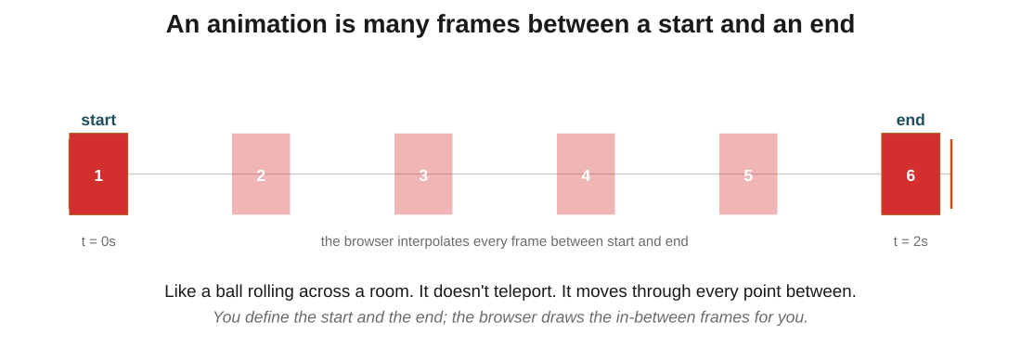
Figure 1: the browser interpolates the frames between the start box and the end box. You only wrote positions 1 and 6.
In the exam: The most important distinction of the whole class: you tell the browser what should change, not how. You never write the frames in between; the browser figures those out. If a question asks 'who computes the intermediate frames?', the answer is always the browser.
Code walkthrough
.box {
width: 100px;
height: 100px;
background-color: red;
animation-name: moveBox;
animation-duration: 2s;
}

@keyframes moveBox {
from { transform: translateX(0); }
to { transform: translateX(300px); }
}
Line by line
- .box gets a size, colour, and two animation properties: which animation to run, and how long it should take.
- animation-name: moveBox links this element to the @keyframes block below.
- animation-duration: 2s says the whole animation takes 2 seconds.
- @keyframes moveBox defines two stages: start (from) at translateX 0, end (to) at translateX 300px.
- The browser generates every position between 0px and 300px over the 2 seconds, smoothly.
What you see: A red 100x100 box that slides smoothly to the right by 300 pixels over 2 seconds, then stops. Without the animation, it would just sit at its starting position.

2. @keyframes: the stages of an animation
In one line: @keyframes gives your animation a name and defines what should be true at each stage.
Key points
- from and to are the simplest form: two stages, start and end. Perfect when the animation is 'A becomes B'.
- Percentages let you add stages in the middle: 0%, 25%, 50%, 75%, 100%. Use these the moment you need more than two states.
- from is exactly the same as 0%. to is exactly the same as 100%. Different syntax, identical behaviour.
- The name you give the @keyframes block (@keyframes moveBox) is what you reference from an element's animation-name. They must match.
- You can put any CSS property inside a keyframe stage: colour, transform, opacity, width, top, most things are animatable.
- You are not limited to a small number of stages. You can define dozens of percentage steps for complex animations.
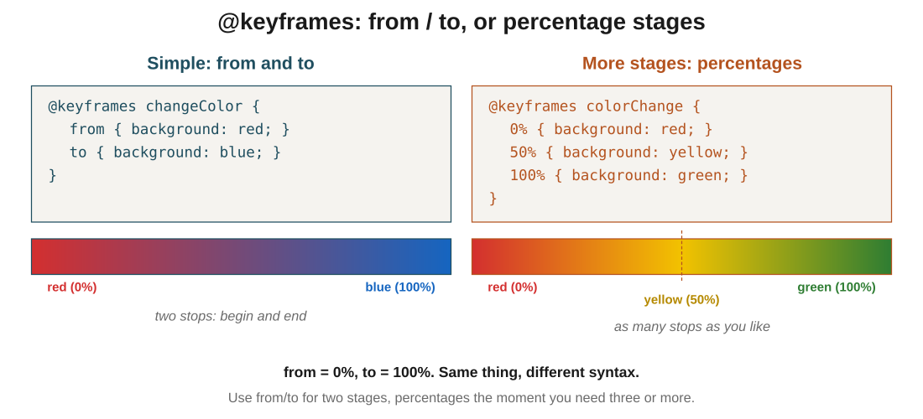
Figure 2: from/to defines two stops (red to blue). Percentages give you more (red through yellow to green). The colour bars show what interpolation looks like.
In the exam: The pair to remember: from ≡ 0%, and to ≡ 100%. If a question shows you a keyframe block using one style, you should be able to convert it to the other.
Code walkthrough
@keyframes colorChange {
0% { background-color: red; }
50% { background-color: yellow; }
100% { background-color: green; }
}

.box { animation: colorChange 5s; }
Line by line
- @keyframes colorChange defines three stages by percentage.
- 0% (the very start): background is red.
- 50% (halfway through the 5 seconds, so at 2.5s): background has become yellow.
- 100% (the end, at 5s): background is green.
- Between stages, the browser smoothly interpolates the colour. So at 25% you'd see red-orange; at 75% you'd see yellow-green.
What you see: A box that smoothly cycles through red, orange, yellow, yellow-green, green over 5 seconds. Then it snaps back to whatever colour was defined outside the animation.

3. The core timing properties
In one line: Four properties control when and how many times the animation runs: name, duration, delay, iteration-count.
Key points
- animation-name: which keyframe block to use. Must match a @keyframes identifier.
- animation-duration: how long one pass through the keyframes takes. 3s (three seconds) or 500ms (half a second). Remember: 1000ms = 1s.
- animation-delay: how long the browser waits before starting. animation-delay: 2s means nothing happens for 2 seconds after the CSS loads.
- animation-iteration-count: how many times to run. 3 for three passes; infinite to loop forever.
- A negative delay is a neat trick: animation-delay: -1s on a 3s animation means the animation starts as if 1 second had already passed.
- Without animation-iteration-count, the animation runs exactly once.
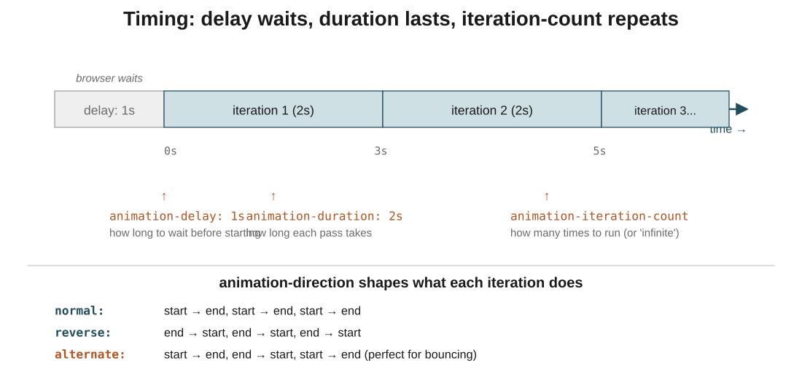
Figure 3: the timeline of an animation. Delay is the wait before starting; duration is one pass; iteration-count is how many passes.
In the exam: The one they love to test: 1000 milliseconds = 1 second. Both 2s and 2000ms are the same. And a value with no unit is invalid, animation-duration: 2 does nothing.
Code walkthrough
.box {
animation-name: pulse;
animation-duration: 2s;
animation-delay: 1s;
animation-iteration-count: 3;
}
Line by line
- The animation is called pulse (defined in a @keyframes pulse block somewhere).
- animation-duration: 2s means each pulse takes 2 seconds.
- animation-delay: 1s means the browser waits 1 second after the page loads before starting.
- animation-iteration-count: 3 means the pulse plays 3 times in a row, then stops.
What you see: The page loads and the box sits still for 1 second. Then it pulses for 2 seconds, three times in a row, taking 6 seconds total. Then it stops. Total wall-clock time from load to done: 7 seconds (1s delay + 3 × 2s).

4. animation-direction: forward, backward, or bouncing
In one line: animation-direction decides what each iteration looks like: start-to-end, end-to-start, or alternating.
Key points
- normal (default): every iteration runs from start (0%) to end (100%). Play, snap back, play again.
- reverse: every iteration runs backwards (100% to 0%). Same snap-back, but the movement direction is inverted.
- alternate: iterations flip. First goes start-to-end, second goes end-to-start, third goes start-to-end, and so on. This is the natural fit for bouncing effects.
- alternate-reverse: like alternate, but starts backwards. So first iteration is end-to-start, second is start-to-end, and it keeps flipping.
- alternate looks smoother than normal for loops, because there is no jarring snap-back at the end of each pass.
- animation-direction only matters if the animation runs more than once, or the effect would be invisible.
In the exam: The reasoning for choosing alternate over normal: with normal, the element jumps back to its start position instantly at the end of each iteration, which looks glitchy. With alternate, it eases back naturally. For any looping animation, alternate usually looks better.
Code walkthrough
.box {
animation-name: moveBox;
animation-duration: 2s;
animation-iteration-count: infinite;
animation-direction: alternate;
}
Line by line
- animation-name: moveBox picks the movement.
- animation-duration: 2s means each pass takes 2 seconds.
- animation-iteration-count: infinite keeps it running forever.
- animation-direction: alternate flips the direction each iteration: forward, back, forward, back, ...
What you see: The box slides right in 2 seconds, then slides back left in 2 seconds, then right again, and never stops. No snap. Perfect for a bouncing or breathing effect.

5. animation-timing-function: the pacing curve
In one line: animation-timing-function controls how the animation is paced between stages. Same time, same distance, different feel.
Think of it like: Think of a car driving across a bridge. linear is cruise control: steady speed the whole way. ease-in is the car pulling away from a stop. ease-out is the car braking to a stop. ease-in-out is both: gentle start and gentle stop. The car covers the same distance in the same time, but the trip feels completely different.
Key points
- linear: constant speed from start to end. Every frame moves the same distance. Feels mechanical.
- ease (default): slow start, quick middle, slow end. The safe default; most things feel natural with it.
- ease-in: starts slow and keeps accelerating. Good for elements that should feel like they're pulling away.
- ease-out: starts fast, brakes into the end. Good for elements landing into their final position.
- ease-in-out: slow at both ends, fast through the middle. The most polished-feeling default for two-state transitions.
- These change the pacing, not the total time or distance. A 2-second animation is 2 seconds long no matter which function you pick.
- For loaders that spin at a steady rate, linear is what you want. For anything organic, an ease function usually wins.
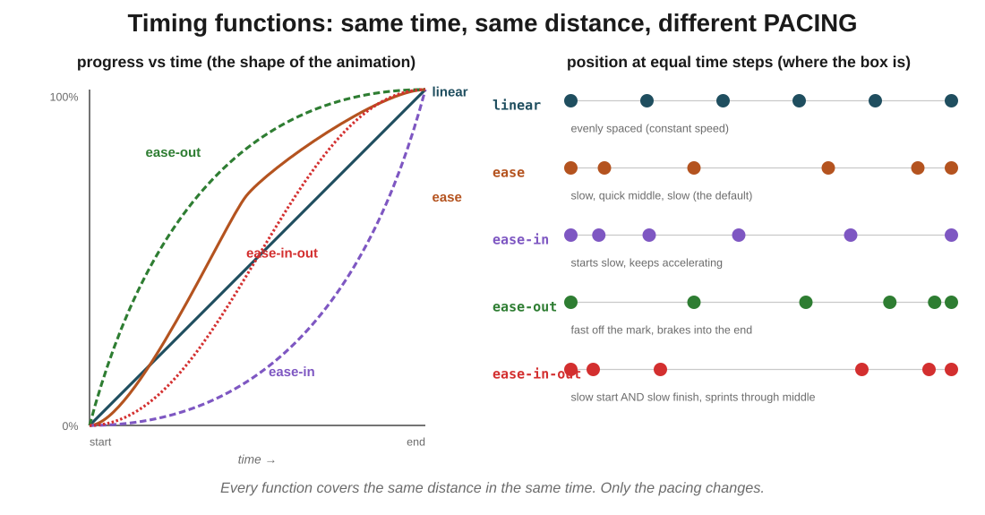
Figure 4: the curves show progress over time; the dots show where the box actually is at equal time slices. ease-out's dots cluster at the end because that's when the animation slows down.
In the exam: The distinction to lock in: the timing function doesn't change the total time. All four boxes above take the same duration; they just spend that time differently. If a question implies linear is 'faster' or ease-in-out is 'slower', that's the trap.
Code walkthrough
.linear { animation-timing-function: linear; }
.ease-in { animation-timing-function: ease-in; }
.ease-out { animation-timing-function: ease-out; }
.ease-in-out { animation-timing-function: ease-in-out; }

@keyframes moveBox {
from { transform: translateX(0); }
to { transform: translateX(500px); }
}
Line by line
- Four boxes, each with the same @keyframes (translate from 0 to 500px) and same duration.
- linear moves at a constant speed the whole way.
- ease-in starts slow, keeps speeding up: the box lingers near the start, then races to the finish.
- ease-out starts fast, slows into the end: the box shoots away and drifts into position.
- ease-in-out is symmetric: slow at both ends, fast in the middle.
What you see: Four boxes race side by side, all reaching the finish line at exactly the same instant, but each one moving through the middle differently. linear is the tortoise-and-hare judge (steady). ease-out looks the most polished for UI. ease-in-out is the go-to for two-state changes like modals opening.

6. Shorthand, fill-mode, and play-state
In one line: The animation shorthand collapses six properties into one line. fill-mode controls what state remains after the animation; play-state can pause it mid-run.
Key points
- Shorthand order: animation: name duration timing-function delay iteration-count direction;. Values are matched by position and type, not by keyword.
- animation: moveBox 3s ease-in-out 1s infinite alternate; is six separate animation-* lines compressed into one.
- animation-fill-mode: by default, an element snaps back to its pre-animation styles once the animation ends. forwards tells it to keep the final frame's styles. backwards applies the first frame's styles during the delay period.
- forwards is the one you'll use most. Without it, animations that reveal or move something visibly reset when they finish, which looks broken.
- animation-play-state: takes running or paused. Pair with :hover to pause animations when the user is looking at them.
- You can still add fill-mode and play-state alongside the shorthand: shorthand covers the six timing properties; these two are separate.
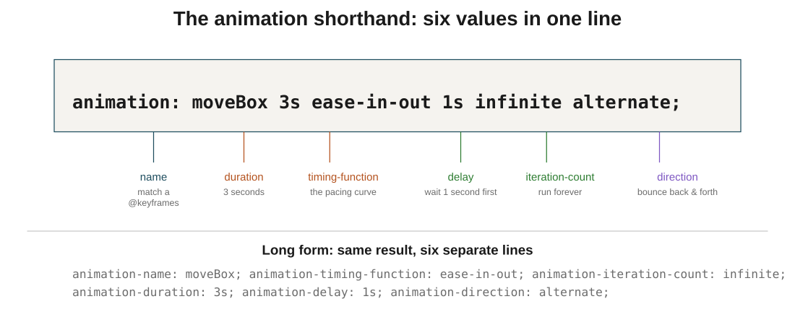
Figure 5: the six values in the shorthand, each pointed to. Same result as writing six separate animation-* lines.
In the exam: The one that surprises people: without animation-fill-mode: forwards, an element that animates from 0 to 300px will snap back to 0px the moment the animation ends. If your animation looks correct while running but resets at the end, that's what's missing.
Code walkthrough
.box {
animation: moveBox 3s ease-in-out 1s infinite alternate;
animation-fill-mode: forwards;
}

.box:hover {
animation-play-state: paused;
}
Line by line
- The shorthand sets six properties at once: name, duration, timing-function, delay, iteration-count, direction.
- animation-fill-mode: forwards keeps the final frame's styles applied after the animation ends (though with infinite, this rarely fires).
- animation-play-state: paused inside .box:hover freezes the animation when the mouse hovers over the box.
- When the mouse leaves, animation-play-state goes back to its default running and the animation resumes from where it stopped.
What you see: A box that bounces between two positions forever, with a slow start and end each way. Hover with your mouse and it freezes in place; move the mouse away and it continues from where it stopped. Great for animations you want the user to be able to inspect.

7. Three classic animations
In one line: The same three or four properties can build a rotating loader, a moving box, and a bouncing ball. These patterns cover most real UI animations.
Key points
- Rotating loader: a circle with a coloured top border, rotated from 0° to 360° infinitely and linearly. Every spinner in every app is a variant of this.
- Moving box: keyframes at 0%, 25%, 50%, 75%, 100% with different translate values. This builds any path-following animation.
- Bouncing ball: translateY from 0 to some distance, with direction: alternate and timing-function: ease-in-out. Add infinite for a heartbeat effect.
- The pattern: pick what to change (colour, position, rotation), decide the stages, pick a timing function, decide if it loops.
- Every complex animation is combinations of these three ideas. A card that fades in and slides up on hover? That's a bouncing ball with two properties instead of one. A pulsing button? A moving box that changes scale.
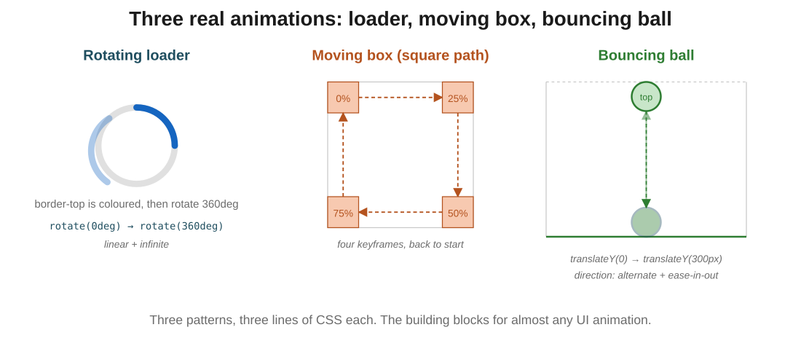
Figure 6: the shapes of the three classic animations. Loader rotates; box traces a square; ball goes up and down.
In the exam: The key choice for a spinner is timing-function: linear. Any of the ease functions makes the spinner speed up and slow down, which looks broken, a real spinner should rotate at a steady rate. Reach for linear whenever the animation is a rotation or a continuous loop.
Code walkthrough
/* the rotating loader */
.loader {
width: 50px;
height: 50px;
border: 5px solid lightgray;
border-top: 5px solid blue;
border-radius: 50%;
animation: rotateLoader 1s linear infinite;
}

@keyframes rotateLoader {
from { transform: rotate(0deg); }
to { transform: rotate(360deg); }
}
Line by line
- .loader is a 50x50 circle (thanks to border-radius: 50%).
- The border is grey on three sides and blue on top. When it rotates, only the blue arc appears to move.
- animation: rotateLoader 1s linear infinite runs the rotateLoader keyframes: 1 second per rotation, constant speed, forever.
- @keyframes rotateLoader rotates from 0deg to 360deg: a full turn each iteration.
What you see: A small circle where a blue arc appears to chase around the ring, one full revolution per second, forever. The classic spinner every website has. Change 1s to 0.5s and it spins twice as fast.

8. Transitions vs Animations: when to use which
In one line: Use a transition when a state change triggers the effect (like hover). Use an animation when the effect should run on its own or has more than two stages.
Key points
- transition waits for something to change: a hover, a click, a class toggle. Then it eases the change instead of snapping.
- animation starts automatically the moment the CSS loads. It doesn't wait for anything.
- A transition only knows two states: before and after. If you need multiple stages (0%, 25%, 50%, 100%), you need an animation.
- A transition is written on the property that will change: transition: color 1s; plus a :hover that changes the colour.
- An animation is written with @keyframes and an animation rule; the two work as a pair.
- Rough guide: buttons and hover effects → transition. Loaders, banners, pulsing icons, entrance animations → animation.
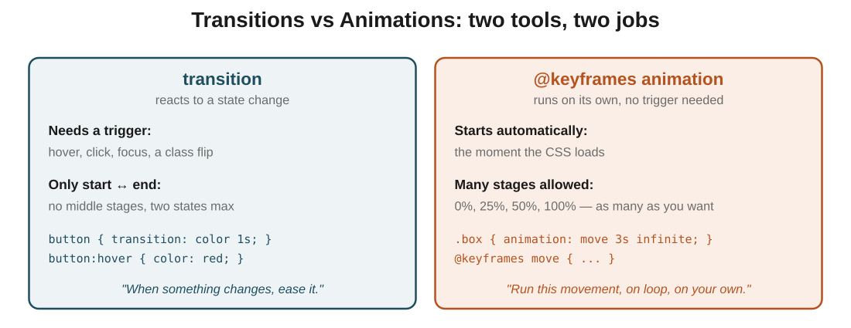
Figure 7: transitions need a trigger and only handle two states; animations run on their own and can have as many stages as you want.
In the exam: The exam version: 'A button changes colour when hovered' is a transition. 'A loader spins continuously' is an animation. If the effect is triggered by an interaction, transition. If it plays on its own, animation.

The big picture: what it all comes down to
If it all clicks here, the rest follows: the core ideas, in plain terms.
- An animation is the browser interpolating frames between the stages you define. You write the destinations; it draws the path.
- @keyframes defines those stages, using from/to for two, or percentages for more.
- The three timing properties: duration (how long a pass takes), delay (wait before starting), iteration-count (how many times).
- animation-direction shapes each iteration: normal, reverse, or alternate (which loops smoothly without snapping).
- animation-timing-function changes the pacing without changing the time: linear for steady, ease for natural, ease-in-out for polished.
- The animation shorthand collapses six properties into one readable line.
- animation-fill-mode: forwards stops the element from snapping back to its pre-animation state.
- Transition = reacts to a state change (hover, click). Animation = runs on its own, and can have many stages.

Quick recap
- An animation interpolates between stages defined in @keyframes; you don't write the frames in between.
- from and to are shortcuts for 0% and 100%; use percentages when you need more stages.
- animation-duration is how long one pass takes; animation-delay waits before starting; animation-iteration-count says how many times to run.
- animation-direction: alternate makes iterations flip forward and back, which is the natural loop for bouncing effects.
- animation-timing-function changes pacing, not total time: linear for spinners, ease-in-out for polish.
- The animation shorthand: name, duration, timing-function, delay, iteration-count, direction, in that order.
- animation-fill-mode: forwards keeps the final frame's styles applied after the animation ends.
- Transitions need a trigger like hover and only have two states; animations start on their own and can have many stages.

Try it yourself
- Make a red box slide right by 300px over 2 seconds using animation-name, animation-duration, and @keyframes with from and to.
- Rewrite the same animation using percentages, adding a middle stage at 50% where the box also turns blue.
- Add animation-iteration-count: infinite and animation-direction: alternate, then confirm the box bounces back and forth smoothly instead of snapping.
- Create four boxes side by side, each with a different animation-timing-function (linear, ease-in, ease-out, ease-in-out). Race them across the screen and observe the pacing differences.
- Build a rotating loader: a 50x50 circle with a coloured top border, rotating 360deg with linear timing and infinite iteration.
- Convert a set of six animation-* rules into the equivalent single animation shorthand line.
- Take an animation that visibly resets at the end, add animation-fill-mode: forwards, and confirm it now stays at its final state.
- Build a hover effect two ways: once as a transition on a button, once as an animation. Notice which one better fits which situation.

