Cascading, Specificity, Inheritance & Positioning
Class 7 notes. Why does one CSS rule beat another? How do styles pass from parent to child? And how do you position things on a page? Three ideas that explain almost every CSS surprise you'll hit.
Class: 7 · Builds on: your CSS from earlier classes
Why this matters: Two rules fight for the same element and one of them wins. Why? That single question is what this class answers. Once you can predict which rule wins, CSS stops feeling random. And once you can position elements exactly where you want them (relative to a parent, to the viewport, or to the scroll position), you can build almost any layout you can imagine.

What you should be able to do after this
- Explain how the cascade resolves conflicting styles
- Rank selectors by specificity using the four-number score
- Use !important responsibly and know why to avoid it
- Predict which properties are inherited from parent to child
- Position elements with static, relative, absolute, fixed, and sticky

What's inside
1. The cascade: how CSS resolves conflicts
2. Specificity: the four-tier hierarchy
3. Counting specificity: (inline, id, class, element)
4. !important: the escape hatch (and why to avoid it)
5. Inheritance: what children get from parents
6. Positioning: static (the default) and the position property
7. relative and absolute: the two workhorses
8. fixed and sticky: staying visible during scroll

1. The cascade: how CSS resolves conflicts
In one line: When multiple rules target the same element, the browser cascades through them in order and picks a winner using: origin > specificity > order.
Think of it like: The word 'cascade' means a waterfall. Styles flow downward from the browser's defaults, through your author styles, down to inline styles, and if two rules land in the same pool, the one that arrived later wins.
Key points
- Origin comes first. Browser defaults (the user-agent stylesheet) are the baseline. Your author styles (external `.css` files and internal `<style>` blocks) sit on top of those. Inline `style="..."` sits on top of those. !important sits above everything.
- Specificity breaks ties within an origin. If two author rules both match, the more specific one wins (whole next section).
- Order breaks ties at the same specificity. If two rules have the same specificity, the one written later in the CSS wins. This is what 'cascading' literally names.
- The user-agent stylesheet is why an unstyled <h1> is already big and bold. That's the browser's default, ready for you to override.
- You cannot see the user-agent stylesheet in your own files, but you can inspect it in DevTools: the 'user agent stylesheet' section shows what defaults are applying.
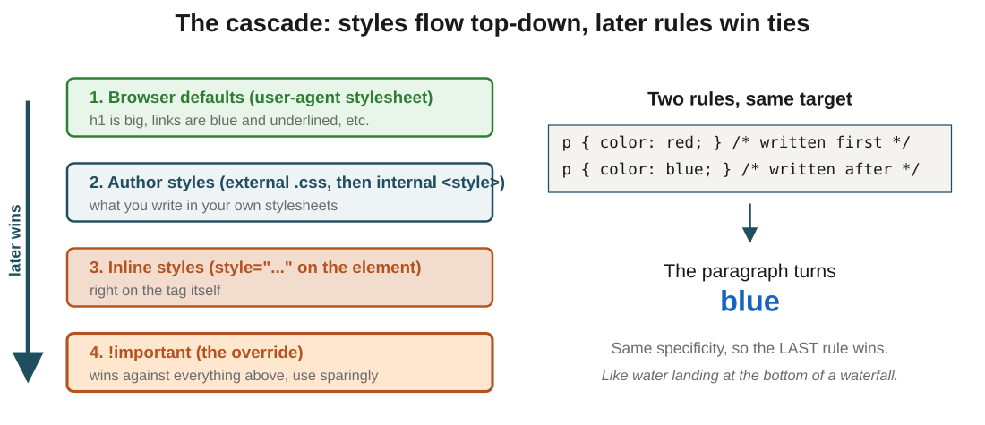
Figure 1: the cascade in layers. Sources are ranked bottom to top, and at the same rank the later-written rule wins.
In the exam: The mental model that works every time: origin, then specificity, then order. Walk down that list and you can predict any winner. If a rule you wrote isn't showing up, check in that order: is a higher-origin rule beating it? A more specific rule? A later rule with the same specificity?
Code walkthrough
/* two rules, same target, same specificity */
p { color: red; }
p { color: blue; }
Line by line
- Both rules target p elements.
- Both have the same specificity (0, 0, 0, 1).
- So the browser falls back to order: the rule written later wins.
- color: blue is the second rule, so it takes effect.
What you see: Every paragraph on the page renders in blue. Swap the order of the two rules and the paragraphs turn red instead. The rules didn't change; only their position did.

2. Specificity: the four-tier hierarchy
In one line: Selectors are ranked by type. From weakest to strongest: element < class < id < inline < !important.
Think of it like: A chain of command. A soldier follows a captain, a captain follows a general, and everyone follows a royal decree. An element rule is a soldier's order, a class is a captain's, an id is a general's, an inline style is a covert op straight from the palace, and !important is the royal decree that overrides everyone.
Key points
- Element / tag selectors (like p, h1, li) are the weakest. Rank contribution: 1 element.
- Class selectors (.favourite), plus attribute selectors and pseudo-classes, are next. Rank contribution: 1 class.
- Id selectors (#fruits) are stronger still. Rank contribution: 1 id.
- Inline styles (style="color: yellow" on the element itself) beat anything from a stylesheet.
- !important at the end of a declaration beats everything above, including inline styles.
- Higher rank always wins, no matter the order in the CSS. A rule with an id will beat a rule with only classes and elements every time.
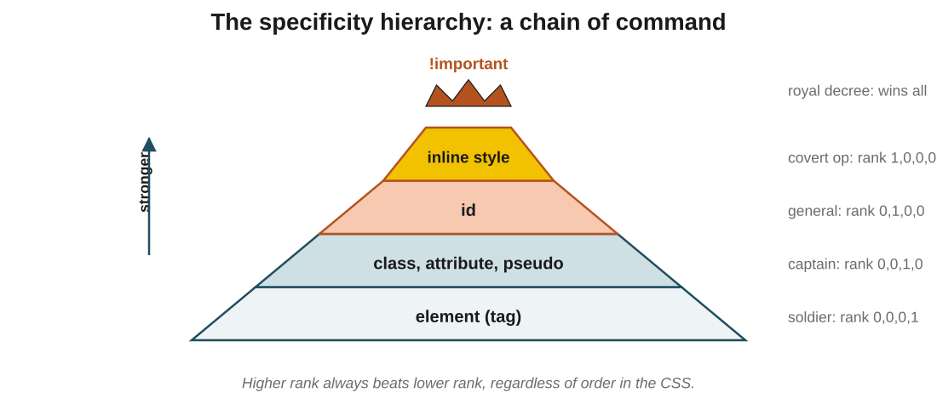
Figure 2: the specificity pyramid. Each tier beats every tier below it; !important sits above the whole hierarchy.
In the exam: The order they test constantly: !important > inline > id > class > element. Read it left to right and you have the answer to any 'which rule wins?' question.

3. Counting specificity: (inline, id, class, element)
In one line: Every selector gets a four-number score. Compare scores left to right, first higher number wins.
Key points
- Give every selector a tuple: (inline, ids, classes, elements). Count each type in the selector.
- For ul#fruits li.favourite: 0 inline, 1 id (#fruits), 1 class (.favourite), 2 elements (ul and li). Score: (0, 1, 1, 2).
- Compare left to right. The first column where two scores differ decides the winner.
- So (0, 1, 0, 0) beats (0, 0, 99, 99). One id beats any number of classes and elements.
- In DevTools, hover any selector to see its specificity: it'll show something like `(1,1,2)` (browsers usually skip the inline column and show three numbers).
- There is no 'partial credit'. A class either counts as one class or it doesn't; you can't stack them into an id.
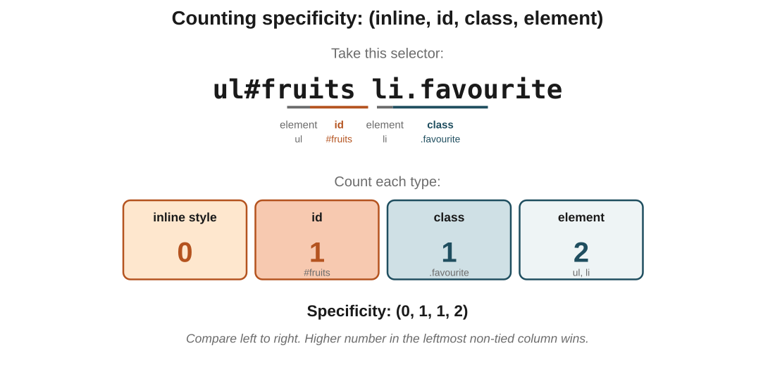
Figure 3: the selector ul#fruits li.favourite scored: 0 inline, 1 id, 1 class, 2 elements = (0, 1, 1, 2).
In the exam: The trap they love: 'element count keeps growing'. But a selector with 100 elements still loses to a selector with 1 class. The columns don't roll over; a higher number in a left column always wins, even if the right columns are massive.
Code walkthrough
ul#fruits li.favourite { color: red; }
ul#fruits li { color: blue; }
Line by line
- Score the first selector: 0 inline, 1 id (#fruits), 1 class (.favourite), 2 elements (ul, li) → (0, 1, 1, 2).
- Score the second: 0 inline, 1 id, 0 classes, 2 elements → (0, 1, 0, 2).
- Compare left to right: inline ties (0=0), id ties (1=1), class differs: 1 beats 0.
- So the first rule wins on the .favourite element; the second rule still styles the other list items.
What you see: The list item with class favourite renders in red; every other list item renders in blue. The .favourite rule wins because it has one extra class in its score.

4. !important: the escape hatch (and why to avoid it)
In one line: !important at the end of a declaration overrides normal specificity. It's powerful, and that's exactly why it's dangerous.
Key points
- Add !important to a value: color: blue !important;. That declaration now beats every normal rule, no matter how specific.
- The only thing that beats !important is another !important, and between two !important rules, normal specificity decides.
- It's meant for exceptional cases: overriding a third-party stylesheet you can't edit, forcing a critical style, marking a print-only rule.
- Overusing it makes CSS impossible to debug: every rule becomes 'the loudest voice wins' instead of a predictable hierarchy.
- The healthier fix is almost always to increase the specificity of your own selector or restructure the CSS.
In the exam: The reasoning behind the rule of thumb: once you use !important, the only way to override it is with another !important, which means it spreads through your CSS like a virus. Every future rule that touches that property has to use !important too. Avoid unless there's no alternative.
Code walkthrough
ul#fruits li.favourite { color: red; }
ul#fruits li { color: blue !important; }
Line by line
- Without !important, the first rule would win on .favourite items (score (0,1,1,2) beats (0,1,0,2)).
- But the second rule ends with !important, which promotes it above normal specificity.
- So the second rule wins on every list item, including the .favourite one.
What you see: Every list item renders in blue, including the one with class favourite. The .favourite rule's higher specificity is bypassed entirely by !important.

5. Inheritance: what children get from parents
In one line: Some CSS properties automatically pass from a parent to its children. Setting them once on a container styles everything inside.
Think of it like: Like a family surname. Children inherit it from their parents unless they explicitly change it. You don't have to give every child the name individually; it comes down the tree.
Key points
- Many typography properties are inherited by default: color, font-family, font-size, line-height, text-align.
- Most layout properties are not inherited: margin, padding, border, width, height. Setting them on a parent doesn't affect children.
- The rule of thumb: if a property would be surprising to reset on every child (like text colour), it's usually inherited. If it would be surprising to cascade (like margin), it's not.
- You can force inheritance with the inherit keyword: color: inherit tells an element to take whatever colour its parent has.
- The opposite is initial: it resets a property to its browser default. And unset does whichever of the two is right for the property.
- This is why setting font-family on the body usually styles the whole page: font-family is inherited, and every element ultimately lives inside body.
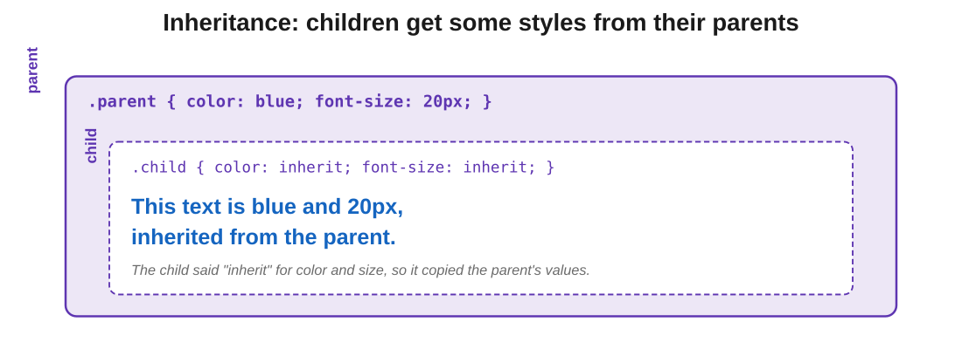
Figure 4: the child inherits colour and font-size from the parent because it explicitly asked for inherit.
In the exam: The distinction that gets tested: text properties inherit; box-model properties don't. If a question shows a parent with margin: 20px and asks whether children get it, the answer is no. Margin does not cascade.
Code walkthrough
.parent { color: blue; font-size: 20px; }
.child { color: inherit; font-size: inherit; }
Line by line
- .parent gets blue text at 20 pixels.
- .child uses the inherit keyword for both properties, explicitly telling the browser to copy from its parent.
- The child now takes color: blue and font-size: 20px from the parent.
What you see: Text inside a .child element renders in blue at 20px, matching its parent. Change the parent's colour to green, and the child follows automatically without touching its own rule.

6. Positioning: static (the default) and the position property
In one line: Every element has a position. The default is static, which means 'sit where the normal flow puts you'.
Key points
- position: static is the default. Elements stack in the order they appear in the HTML, top to bottom, left to right.
- With static, the top, right, bottom, and left properties have no effect. Trying to move a static element with them silently fails.
- To move an element, you first have to give it a non-static position: relative, absolute, fixed, or sticky.
- Once positioned, you use top, right, bottom, left to say where it should sit. What those offsets are measured against depends on which position value you chose.
- You can also use z-index to control stacking order once elements start overlapping, but only on non-static elements.
In the exam: The catch that traps everyone: top / right / bottom / left do nothing unless position is set to something other than static. If your offsets aren't taking effect, this is almost always why.
Code walkthrough
.normal-flow {
position: static;
top: 20px; /* has no effect */
left: 30px; /* has no effect */
}
Line by line
- position: static is the default, but writing it explicitly makes the intent clear.
- top: 20px and left: 30px look like they should move the element, but on a static element they are silently ignored.
- To make these actually move the element, you'd need to change position to something other than static.
What you see: The element sits exactly where the normal flow put it, as if the top and left values weren't there at all. This is the #1 'why isn't my CSS working?' bug for beginners.

7. relative and absolute: the two workhorses
In one line: relative nudges an element from its normal spot without leaving the flow. absolute rips it out of the flow and pins it to its nearest positioned ancestor.
Think of it like: Books on a shelf. relative is like leaning a book sideways: it moves visually, but the gap on the shelf is still reserved for it. absolute is like taking the book off the shelf entirely, holding it in mid-air, and the other books slide over to fill the gap.
Key points
- position: relative moves the element from its normal position using top / left / etc, but its original slot is preserved in the layout. Other elements don't shift.
- The bigger use of relative is as a positioning parent for something absolute inside it. It marks the container 'from which' absolute children measure their offsets.
- position: absolute removes the element from normal flow. Neighbours act as if it isn't there.
- An absolute element is positioned relative to its nearest positioned ancestor (an ancestor with position set to anything other than static). If there is no such ancestor, it's positioned against the viewport.
- That's why you often see the pattern .parent { position: relative; } paired with .child { position: absolute; }: the parent becomes the reference frame, the child positions inside it.
- top: 30px on an absolute element means 30px from the top of the reference frame, not 30px from wherever it would have been.
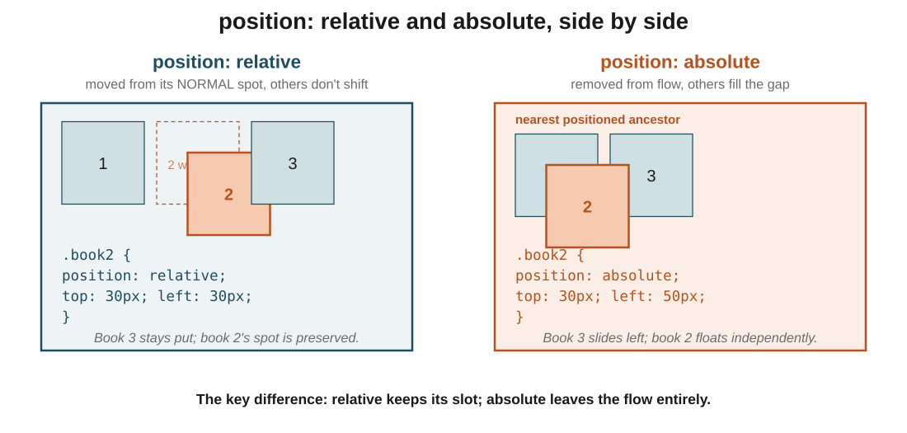
Figure 5: relative leaves an empty slot where book 2 used to sit; absolute lets book 3 slide left to fill the gap, and book 2 floats independently.
In the exam: The one that always gets tested: an absolute element positions against its nearest positioned ancestor. If no ancestor has position: relative (or absolute/fixed), it falls back to the viewport. That's usually the source of 'my absolute element is in the wrong place'.
Code walkthrough
.bookshelf { position: relative; } /* the reference frame */

.book2 {
position: absolute;
top: 30px;
left: 50px;
}
Line by line
- .bookshelf gets position: relative, which does nothing visible but marks it as the reference frame for any absolute children.
- .book2 gets position: absolute, so it's removed from the flow. Neighbours slide over to fill its gap.
- top: 30px places it 30 pixels below the top edge of .bookshelf.
- left: 50px places it 50 pixels from the left edge of .bookshelf.
What you see: Book 2 floats independently inside the bookshelf, 30px from its top and 50px from its left. Books 1 and 3 sit side by side as if book 2 wasn't there. Move the bookshelf, and book 2 moves with it.

8. fixed and sticky: staying visible during scroll
In one line: fixed pins to the viewport and never scrolls. sticky scrolls normally, then pins once it reaches a threshold.
Key points
- position: fixed is like absolute, but the reference is always the viewport. The element stays in the same spot on your screen no matter how far you scroll.
- Great for persistent UI: navigation bars, chat buttons, back-to-top buttons.
- position: sticky is a hybrid. The element scrolls with the page normally, but once it reaches a defined threshold (like top: 0), it sticks to that spot and stays visible as you keep scrolling.
- This is how the Zomato or Swiggy nav bar behaves: normal at the top of the page, then locked to the top as you scroll down through restaurants.
- sticky always needs a threshold (top, bottom, left, or right). Without one, it never becomes sticky.
- sticky respects its parent: it only sticks while its parent is visible. Once you scroll past the parent, the sticky element scrolls away too.
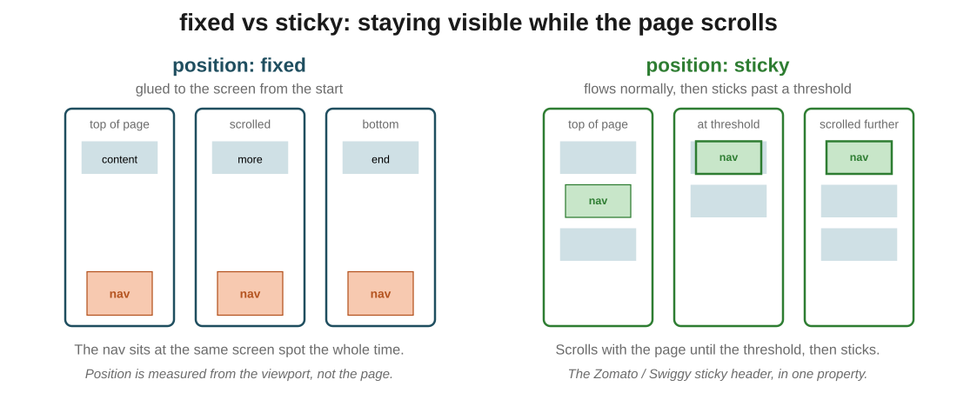
Figure 6: three snapshots as the user scrolls. fixed sits at the same screen position all along; sticky joins the top only after scrolling past its trigger.
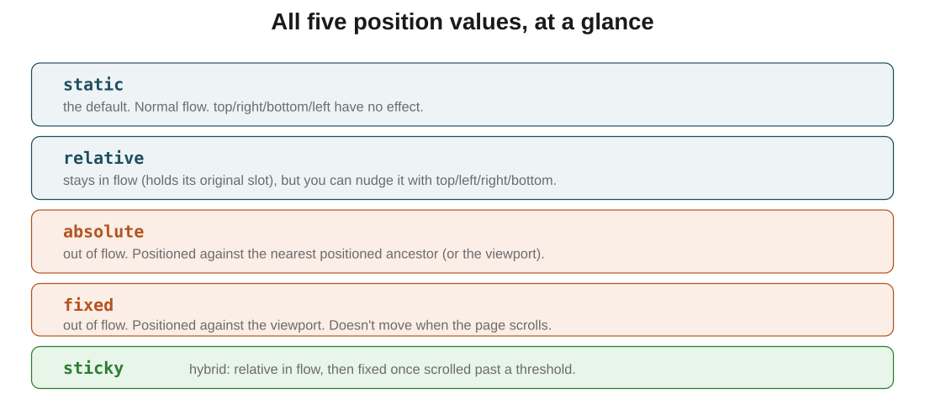
Figure 7: all five position values on one page. Use this as the reference card.
In the exam: The distinction: fixed is always anchored to the viewport. sticky is conditional: it acts relative until a threshold, then acts fixed. If you want a nav that's always visible from load, use fixed. If you want it to start where the HTML puts it and then lock in place, use sticky.
Code walkthrough
/* fixed: bottom-right, always visible */
#floating-btn {
position: fixed;
right: 4px;
bottom: 1px;
}

/* sticky: nav sticks to top after scrolling */
nav {
position: sticky;
top: 0;
}
Line by line
- #floating-btn is fixed, with right: 4px and bottom: 1px. It sits 4px from the right and 1px from the bottom of the viewport.
- As you scroll the page, the button doesn't move on screen. It's the classic 'chat with us' button pattern.
- nav gets position: sticky and top: 0.
- The nav scrolls with the page normally at first. Once its top edge would go above 0px from the viewport top, it sticks there and stays visible.
What you see: A small button anchored to the bottom-right of your screen, visible no matter where you scroll. And a nav bar that starts inline with the page but locks to the top once you scroll past it, like every modern app's header.

The big picture: what it all comes down to
If it all clicks here, the rest follows: the core ideas, in plain terms.
- The cascade picks a winner using three rules in order: origin, then specificity, then source order. Same specificity? The rule written later wins.
- Specificity is a four-number score (inline, id, class, element). Compare left to right; the first column where scores differ decides the winner.
- The ranking never changes: element < class < id < inline < !important. One id beats any number of classes.
- !important overrides normal specificity and should be a last resort, because it spreads and makes CSS unpredictable.
- Some properties inherit from parent to child (text properties like color, font); most layout properties (margin, padding, border) do not.
- position: static is the default. top/right/bottom/left need a non-static position to work.
- relative moves an element from its normal spot and holds its slot. absolute removes it from flow and positions it against the nearest positioned ancestor.
- fixed pins to the viewport (stays put during scroll). sticky is relative until a threshold, then fixed.

Quick recap
- The cascade resolves conflicts by origin, then specificity, then source order.
- Specificity scores selectors as (inline, id, class, element); the leftmost non-tied column wins.
- Element < class < id < inline; !important beats everything, but avoid it.
- Inherited properties (color, font, line-height) cascade from parent to child; box-model properties don't.
- The inherit keyword forces a property to copy from its parent.
- Static is the default position; top/left/right/bottom need a non-static position to take effect.
- Relative keeps its slot; absolute leaves the flow and positions against the nearest positioned ancestor.
- Fixed pins to the viewport; sticky is relative until it reaches a scroll threshold, then becomes fixed.

Try it yourself
- Write two rules for the same element, one after the other, and confirm the later one wins when specificity is tied.
- Score these selectors on paper: .test, h1.test, #try, h1. Then rank them from weakest to strongest and check your answer in DevTools.
- Take a rule that isn't winning, add !important, watch it win. Then remove !important and instead raise its specificity (add an id or a class) until it wins the honest way.
- Set color and font-family on the body, then confirm every child inherits them until you explicitly override one.
- Take four boxes in a container. Give the second one position: relative with top: 20px, and watch it move while its slot stays. Then switch to absolute and watch the others slide over.
- Build a navigation bar with position: sticky; top: 0 and scroll the page. Notice when it locks to the top.
- Add a back-to-top button with position: fixed; bottom: 20px; right: 20px and confirm it stays on screen no matter how far you scroll.

