Responsive Layout & CSS Grid
Class 6 notes. Grid is CSS's tool for laying out a whole page in two dimensions at once. This is where you stop centring divs and start drawing floor plans.
Class: 6 · Builds on: Flexbox and media queries from Class 5
Why this matters: Flexbox is brilliant at arranging a line of items. But real pages are grids: a header stretched across the top, a sidebar down the left, a footer along the bottom, content in the middle. Doing that with flexbox alone means nesting containers inside containers. Grid was built for exactly this: describe the whole layout in one place, then drop your elements into named zones. Once it clicks, most page layouts become five lines of CSS.

What you should be able to do after this
- Explain the difference between flexbox (one dimension) and grid (two dimensions)
- Turn any element into a grid container with display: grid
- Define columns and rows with grid-template-columns, grid-template-rows, and repeat()
- Use the fr unit to share available space in proportions instead of fixed pixels
- Space cells with gap, row-gap, column-gap
- Place items by line number (grid-column: 1 / 3) or by span (grid-column: span 2)
- Design whole page layouts with grid-template-areas and grid-area
- Decide when to reach for grid vs flexbox

What's inside
1. What a grid actually is
2. Turning on grid: display: grid and columns
3. The fr unit: fractions of leftover space
4. Rows, gaps, and repeat()
5. Item-level control: nth-of-type, justify-self, align-self
6. Placing items: grid lines and span
7. grid-template-areas: naming zones for whole-page layouts
8. Flexbox vs Grid: which one when

1. What a grid actually is
In one line: Flexbox arranges items on one axis. Grid arranges them on two axes at once: rows and columns.
Think of it like: Think of an old school notebook. Every page is already lined into rows and columns before you write anything. A grid layout is the same idea: define the rows and columns first, then drop content into the cells.
Key points
- Flexbox is one-dimensional: you pick a direction (row or column) and items line up along it.
- Grid is two-dimensional: you define rows and columns simultaneously, so items sit in cells.
- That two-dimensional nature is why grid can express things flexbox can't: a header spanning three columns, a sidebar spanning two rows, a footer stretched across the bottom.
- Grid was made for whole-page layouts. Flexbox is for the smaller pieces inside them. You'll often use both in the same page: grid for the big layout, flexbox inside a component.
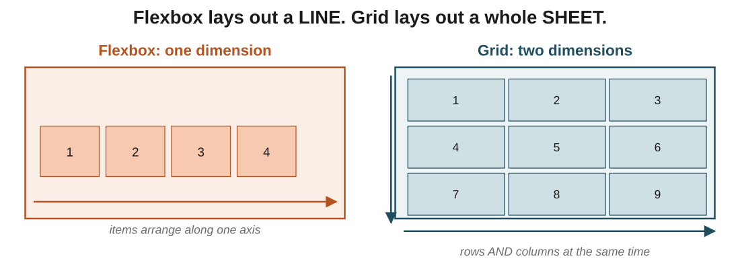
Figure 1: same nine items, arranged two ways. Flexbox pushes them into one line. Grid places them in a rows-and-columns matrix.
In the exam: The classic true-or-false: 'grid and flexbox do the same job.' False. Grid is two-dimensional (rows AND columns); flexbox is one. If a question mentions a page layout with both rows and columns fixed, the answer is grid.

2. Turning on grid: display: grid and columns
In one line: Write display: grid on the parent, then describe the columns with grid-template-columns.
Key points
- display: grid on the parent makes it a grid container; its direct children become grid items.
- Nothing visible changes until you tell it how many columns you want and how wide they are.
- grid-template-columns: 100px 100px 100px creates three columns, each 100 pixels wide. That's it: three values means three columns.
- The number of values you write is the number of columns. Four values, four columns.
- Rows form automatically as items overflow: nine items into three columns give you three rows.
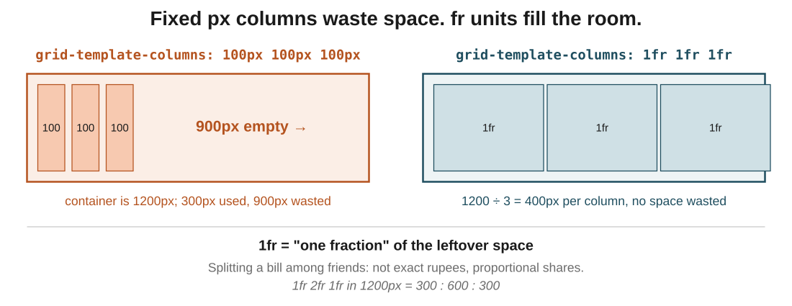
Figure 2: fixed px columns leave the rest of the container empty. The fr unit (next section) fixes this by using every pixel of the container.
In the exam: The number of values you pass to grid-template-columns IS the column count. grid-template-columns: 100px 100px is two columns; 100px 100px 100px 100px is four. There is no separate 'column count' property.
Code walkthrough
.container {
width: 1200px;
display: grid;
grid-template-columns: 100px 100px 100px;
border: 2px solid black;
}
.item {
background-color: dodgerblue;
padding: 20px;
}
Line by line
- .container is 1200px wide with a visible black border so we can see its edges.
- display: grid switches on grid layout. Direct children become grid items.
- grid-template-columns: 100px 100px 100px creates three columns, each 100px wide.
- .item styles every child: blue background, 20px padding.
- With nine children, we get three items per row and three rows total. But: 3 × 100 = 300px is used, and the container is 1200px, so 900px on the right sits empty.
What you see: A black-bordered box, 1200px wide, with three blue columns of 100px each on the left side. The remaining 900px of space on the right is completely blank. This is the problem the fr unit was designed to solve.

3. The fr unit: fractions of leftover space
In one line: 1fr means 'one share of the leftover space'. Use it to split a container proportionally, no calculator required.
Key points
- fr stands for fraction, and it means a share of the space that would otherwise be empty.
- 1fr 1fr 1fr splits the container into three equal shares. In a 1200px container, that's 400px each.
- 1fr 2fr 1fr means 1 + 2 + 1 = 4 total shares. Each share is 1200 ÷ 4 = 300px. So the columns get 300px, 600px, 300px.
- You can mix fr with fixed sizes: 200px 1fr 1fr fixes the first column at 200px and splits the leftover 1000px into two shares of 500px.
- This is the ergonomic upgrade over flexbox: no need to calculate percentages or use flex-grow with weights.
- Because fr fills the container, layouts automatically adapt if the container width changes.
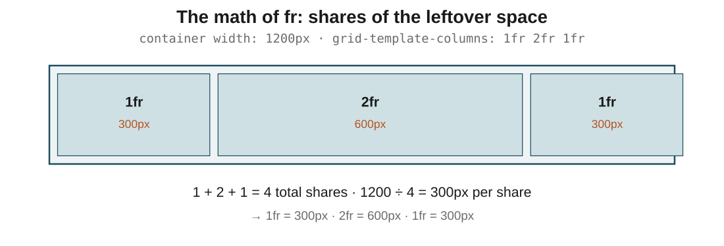
Figure 3: the math of 1fr 2fr 1fr in a 1200px container. Total shares = 4, one share = 300px, so columns get 300, 600, 300.
In the exam: The mental model that never fails: fr is a share, not a fixed size. Sum the numbers to get the denominator, then each column takes its fraction of the total. It's how you'd split a bill: three people, shares 1:2:1, four parts, you pay 25% or 50%.
Code walkthrough
.container {
width: 1200px;
display: grid;
grid-template-columns: 1fr 2fr 1fr;
}
Line by line
- display: grid switches to grid layout.
- grid-template-columns: 1fr 2fr 1fr defines three columns using fractions.
- Add the fractions: 1 + 2 + 1 = 4 total shares.
- The container is 1200px, so each share = 1200 ÷ 4 = 300px.
- Column widths follow: 300px, 600px, 300px. The middle column is twice as wide as either side column.
What you see: The container is filled edge to edge, no wasted space. The middle column is visibly twice as wide as the flanking ones. Resize the container and the columns re-share the new width automatically.

4. Rows, gaps, and repeat()
In one line: Rows work like columns (grid-template-rows). gap adds space between cells. repeat() saves typing.
Key points
- grid-template-rows: 1fr 2fr 1fr does for rows exactly what the column version does for columns: three rows, middle one twice as tall.
- column-gap: 20px adds 20px of horizontal space between columns. row-gap: 20px does the same vertically.
- gap: 20px is the shorthand for both at once. This is what you'll usually reach for.
- repeat(3, 1fr) is a shortcut for 1fr 1fr 1fr. For a 12-column grid, repeat(12, 1fr) is a lot friendlier than typing 1fr twelve times.
- You can mix repeat with plain values: 200px repeat(3, 1fr) is a fixed left column plus three equal ones.
- grid-auto-rows: 200px sets a default height for any row that gets created automatically when items overflow the explicit rows.
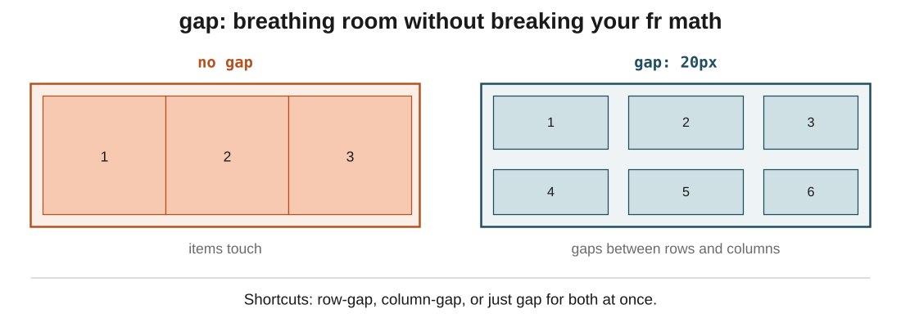
Figure 6: the same three items with and without gap. gap: 20px puts breathing room between cells without touching the fr math.
In the exam: One trap they set: gap is space between cells, not around them. It doesn't add margin to the outside of the grid. If you also want space around the whole container, use padding on the container.
Code walkthrough
.container {
display: grid;
grid-template-columns: repeat(3, 1fr);
grid-template-rows: 1fr 2fr 1fr;
gap: 20px;
}
Line by line
- grid-template-columns: repeat(3, 1fr) expands to 1fr 1fr 1fr: three equal columns.
- grid-template-rows: 1fr 2fr 1fr defines three rows; the middle one is twice as tall as the outer ones.
- gap: 20px adds 20px between every row and every column.
- Nine items drop into the 3 × 3 = 9 cells automatically, in row-first order (left to right, top to bottom).
What you see: A clean 3×3 grid, columns equal in width, middle row twice as tall as the top and bottom rows, and a consistent 20px gutter between every cell. This is the ergonomic sweet spot most real layouts settle on.

5. Item-level control: nth-of-type, justify-self, align-self
In one line: Most grid properties live on the container. A handful (justify-self, align-self) live on individual items to override their cell.
Key points
- .item:nth-of-type(2) targets only the second .item element. Great for tweaking one child without adding an extra class.
- justify-self positions an item horizontally inside its cell: start, end, center, stretch.
- align-self positions it vertically inside its cell: same four values.
- Set them on the item, not the container. The container's justify-items and align-items set defaults; justify-self and align-self override for one item.
- This is the grid version of what align-self does in flexbox: a single item breaks the container's rule.
In the exam: The pattern to remember: justify-* is always horizontal, align-* is always vertical. And *-items is on the container (setting a default for every child), while *-self is on one child (overriding just that one).
Code walkthrough
.item:nth-of-type(2) {
width: 100px;
height: 100px;
justify-self: center;
align-self: center;
}
Line by line
- .item:nth-of-type(2) picks out only the second .item on the page.
- width: 100px and height: 100px shrink it to a small square. Because grid items don't fill their cell unless stretched, this item is now smaller than the cell it sits in.
- justify-self: center centres it horizontally inside its cell.
- align-self: center centres it vertically inside its cell.
What you see: Item 2 shows up as a small 100x100 square, sitting dead centre in its grid cell, while every other item still fills its cell. The other items are untouched.

6. Placing items: grid lines and span
In one line: Every column and row edge is a numbered line. Place an item with grid-column: startLine / endLine, or use span to stretch it across cells.
Key points
- Grid lines run between cells. Three columns = four vertical lines, numbered 1 to 4. Three rows = four horizontal lines.
- grid-column: 1 / 3 places an item from column line 1 to column line 3. It occupies the first and second columns.
- grid-row: 1 / 3 does the same for rows: from row line 1 to row line 3, so it takes rows 1 and 2.
- The end line is exclusive: 1 / 3 means 'starts at line 1, ends at line 3' = spans cells 1 and 2. Not three cells.
- grid-column: span 2 is the friendly version: 'take up two column slots from wherever this item starts'. Same effect as 1 / 3 for an item starting at line 1.
- Use span when you care about how many cells, and use line numbers when you care about exactly which cells.
- You can see the line numbers in Chrome DevTools: inspect the grid container and enable the grid overlay.
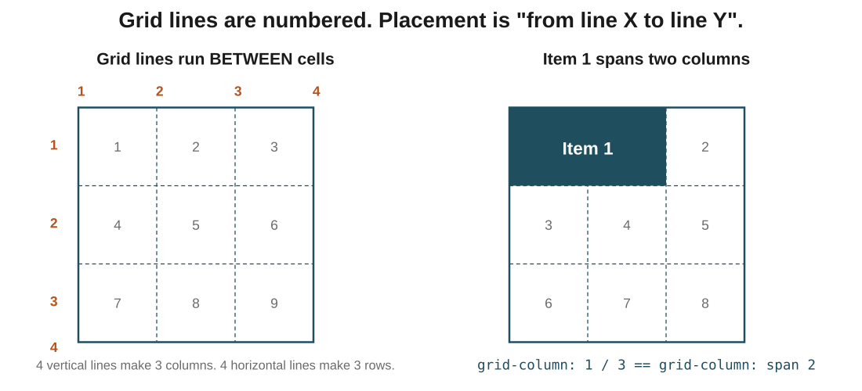
Figure 4: the numbered grid lines on the left, and item 1 spanning columns 1 to 3 on the right. Both grid-column: 1 / 3 and grid-column: span 2 produce the same result.
In the exam: The one that trips everyone: grid-column: 1 / 3 gives you 2 cells, not 3. The second number is where it ends, not the last cell it fills. If you count lines instead of cells, this stops feeling weird.
Code walkthrough
.item:nth-of-type(1) {
background: black;
grid-column: 1 / 3;
}

/* equivalent: */
.item:nth-of-type(1) {
grid-column: span 2;
}
Line by line
- .item:nth-of-type(1) targets the first item.
- grid-column: 1 / 3 places it from column line 1 to column line 3. That covers two cells (columns 1 and 2), because the end line is exclusive.
- The second block does the same thing with grid-column: span 2: 'starting from wherever, take two columns'.
- Both produce identical output. Use whichever reads clearer to you: line numbers are precise, span is friendlier.
What you see: Item 1 becomes a black rectangle spanning the full width of the first two columns. The other items shuffle to fill the remaining cells, in DOM order.

7. grid-template-areas: naming zones for whole-page layouts
In one line: Draw the layout as a grid of named zones, then map each element to its zone. This is where grid earns its reputation.
Think of it like: Think of a movie theatre floor plan: designated zones for the screen, the stalls, the balcony, the exits. Each zone has a name and a position. grid-template-areas does the same: name the zones on the parent, then each child says 'I'm in the header zone', 'I'm in the footer zone', and grid puts it there.
Key points
- grid-template-areas takes a grid of names as strings, one string per row.
- Each word in a string is one cell. Every string must have the same number of words (the same number of columns).
- Repeat a name to make a zone span cells. "top top top" means the top zone stretches across all three columns.
- On each child element, grid-area: top places it in the zone called 'top'. The name is your choice, and it must match the strings above.
- Combine grid-template-areas with grid-template-columns and grid-template-rows to control both the layout shape and the actual sizes. Areas name the zones; templates size them.
- This is the most readable way to write a page layout. Look at the CSS and you can almost see the page.
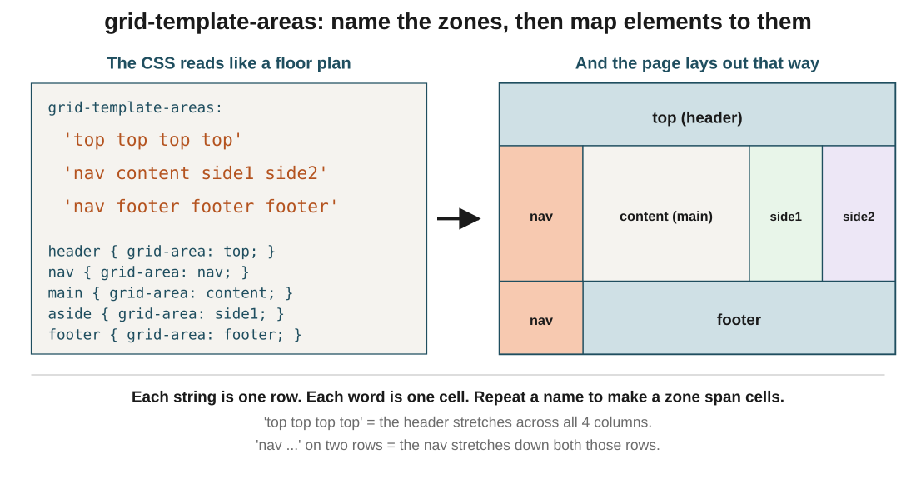
Figure 5: the CSS on the left literally looks like the layout on the right. Repeated names (top, nav, footer) stretch zones across cells.
In the exam: Two rules the exam tests: every row string must have the same number of columns (words), and a zone name must form a rectangle (you can't scatter the same name into an L-shape). If either is broken, the grid silently fails.
Code walkthrough
body {
display: grid;
grid-template-areas:
'top top top top'
'nav content side1 side2'
'nav footer footer footer';
grid-template-columns: 1fr 4fr 1fr 1fr;
grid-template-rows: 80px 1fr 70px;
}
header { grid-area: top; }
nav { grid-area: nav; }
main { grid-area: content; }
aside { grid-area: side1; }
div { grid-area: side2; }
footer { grid-area: footer; }
Line by line
- display: grid on the body makes the whole page a grid container.
- grid-template-areas defines the shape: 3 rows × 4 columns, with named zones. Repeated words merge cells into one zone.
- grid-template-columns: 1fr 4fr 1fr 1fr sizes the columns: a narrow nav, a wide content area, two narrow sidebars.
- grid-template-rows: 80px 1fr 70px sizes the rows: fixed-height header, flexible middle, fixed-height footer.
- Each child (header, nav, main, aside, div, footer) claims its zone by name using grid-area.
What you see: A complete page layout with a header stretched across the top, a full-height nav on the left (spans two rows), the main content in the middle, two narrow sidebars on the right, and a footer along the bottom. The exact shape from the source deck, rendered from readable CSS.

8. Flexbox vs Grid: which one when
In one line: Flexbox for one axis at a time; Grid for whole layouts with both axes.
Key points
- Reach for flexbox when the answer to 'how many dimensions?' is one. A navigation bar, a row of buttons, tag pills, centring a single item.
- Reach for grid when the answer is two. A page layout with header, sidebar, main and footer. A photo gallery. A dashboard.
- Flexbox is content-first: you let the items decide the layout. It works well when the number of items changes.
- Grid is layout-first: you draw the shape first, then drop content in. It works well when the layout is fixed but the content changes.
- It's not a choice you make once. Use both: grid for the outer page shape, flexbox inside each cell for the components.
- If you're only aligning a few things in a line, flexbox is lighter. If you find yourself nesting three flex containers to fake a grid, switch to grid.
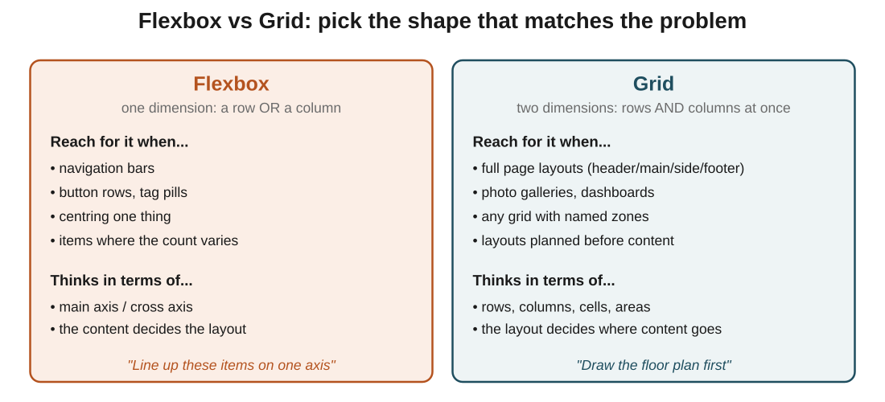
Figure 7: when to reach for each. Grid draws the floor plan; flexbox arranges the furniture inside one room.
In the exam: The one-line answer for any 'which should I use?' question: one axis, flexbox. Two axes, grid. Almost every real-world CSS layout uses both, and knowing which does what is the whole skill.

The big picture: what it all comes down to
If it all clicks here, the rest follows: the core ideas, in plain terms.
- Grid is two-dimensional: it lays out rows and columns at the same time, so it fits full-page layouts in a way flexbox can't.
- display: grid switches it on. grid-template-columns and grid-template-rows define the shape.
- fr units share the leftover space in proportions: add the numbers, divide the container, that's each share.
- gap (or row-gap / column-gap) adds space between cells without breaking your fr math.
- Items are placed by line number (grid-column: 1 / 3) or by span (grid-column: span 2). The end line is exclusive: 1 / 3 covers two cells.
- grid-template-areas lets you name zones and draw the layout with strings; each element then claims a zone with grid-area. Same-name cells must form a rectangle.
- justify-self / align-self on an item override the container's defaults for that one child.
- One axis, flexbox. Two axes, grid. Real pages use both: grid for the whole layout, flexbox inside the components.

Quick recap
- Grid arranges items in rows and columns at once; flexbox arranges them on one axis at a time.
- display: grid on the parent turns it into a grid container.
- grid-template-columns and grid-template-rows describe the shape; the number of values = the number of tracks.
- The fr unit shares leftover space proportionally: add the fractions, one share = container width / total.
- gap adds space between cells; row-gap and column-gap set each direction separately.
- grid-column: 1 / 3 places from line 1 to line 3 (two cells); grid-column: span 2 is the equivalent friendly form.
- grid-template-areas names zones as strings, and children map into them with grid-area.
- Flexbox for one-dimensional lines; grid for two-dimensional page layouts. Both together for real work.

Try it yourself
- Take nine boxes in a container, apply display: grid and grid-template-columns: 100px 100px 100px, then inspect. Notice the 900px of wasted space on the right.
- Switch to grid-template-columns: 1fr 1fr 1fr and confirm the columns now fill the container. Then try 1fr 2fr 1fr and predict the widths in a 1200px container before you check.
- Rewrite a 12-column grid using repeat(12, 1fr) and confirm the output is identical to typing 1fr twelve times.
- Take one item and give it grid-column: 1 / 3. Then swap in grid-column: span 2 and confirm the visual result is identical.
- Reproduce the layout from the source deck: header across the top, nav on the left spanning two rows, main content, two sidebars, footer across the bottom. Use grid-template-areas and grid-area only.
- Add gap: 20px to any of these layouts and confirm the fr math still works (the shares now divide the space between the gutters, not the whole container).

