1. 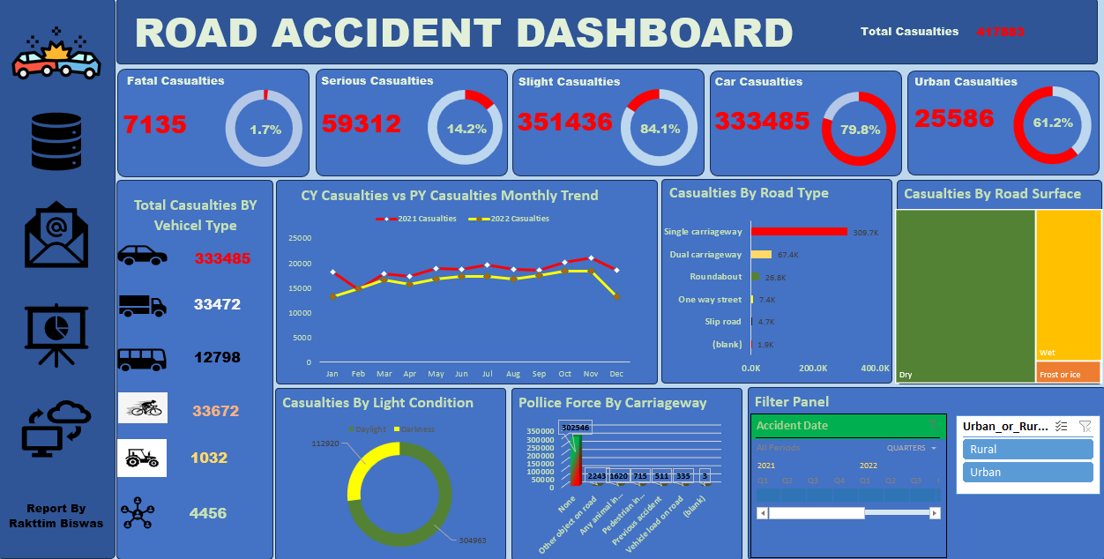Understand the data there are some error fast clean those error.
2. Insert Month, Year column .
3. Clients wants to create a Road Accident Dashboard for year 2021 and 2022 so that they can A have insight on the below requirements-
4. Primary KPI - Total Casualties taken place after the accident
5. Primary KPI's - Total Casualties & percentage of total with respect to accident severity and maximum casualties by type of vehicle
6. Secondary KPI's - Total Casualties with respect to vehicle type
7. Monthly trend showing comparison of casualties for Current Year and Previous Year
8. Maximum casualties by Road Type
9. Distribution of total casualties by Road Surface
10. Relation between Casualties by Area/ Location & by Day/Night

**STAKEHOLDERS**

Ministry of Transport

Road Transport Department

Police Force

Emergency Services Department

Road Safety Corps

Transport Operators

Traffic Management Agencies

Public

Media