**Assignment on Git and Github Introduction**

1.Screenshot of git Installation and version verifications

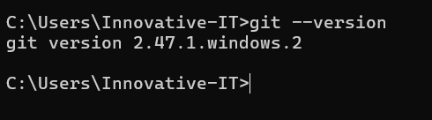

2. Screenshots of Git Configurations

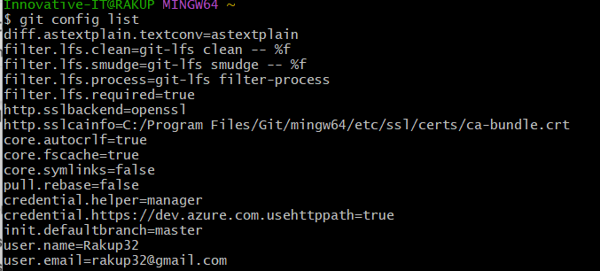

3. Screenshot of GitHub Profile

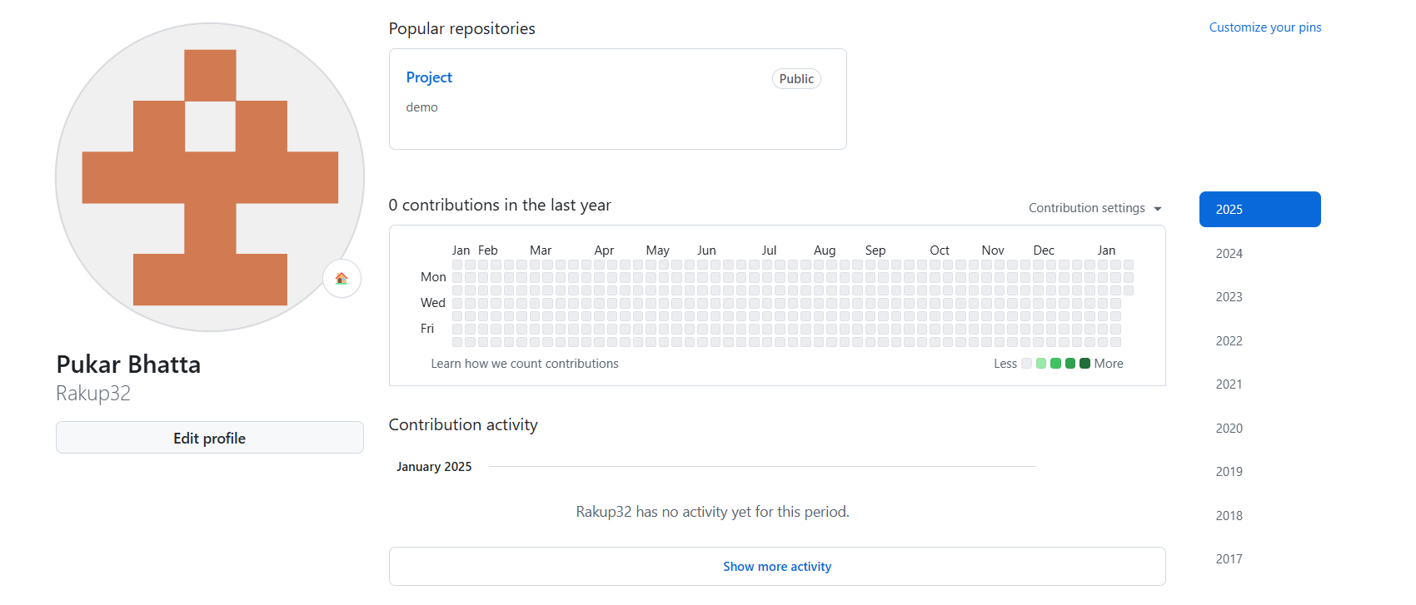

4. Screenshot of SSH key setup process

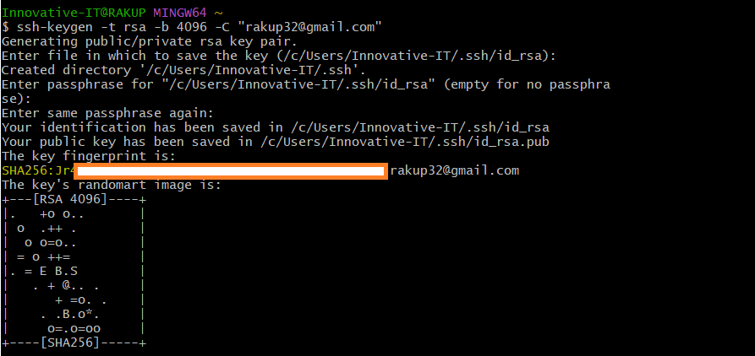

5. A link to your Github Repo

<https://github.com/Rakup32/NIC_Project>

6.Screenshots of the terminal commands used to clone, add, commit, push, create branches.

* Clone

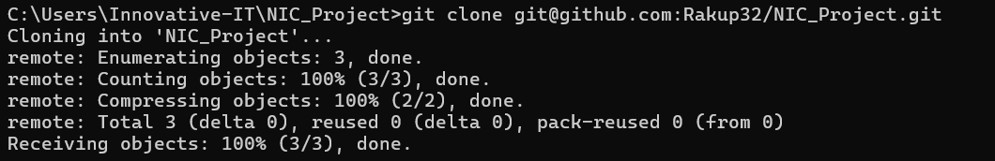

* Add

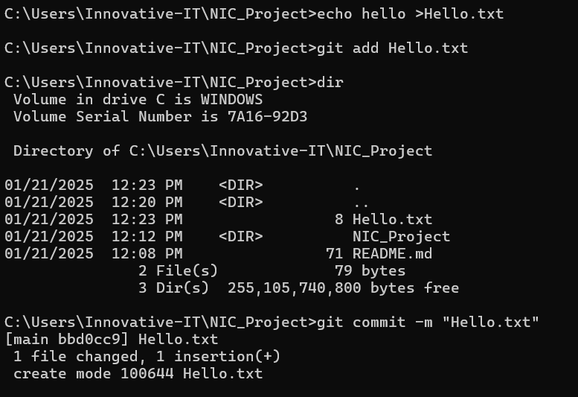

* Commit

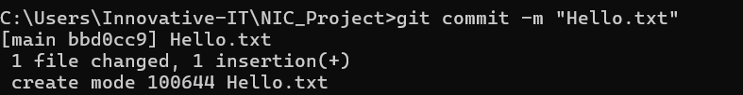

* Push

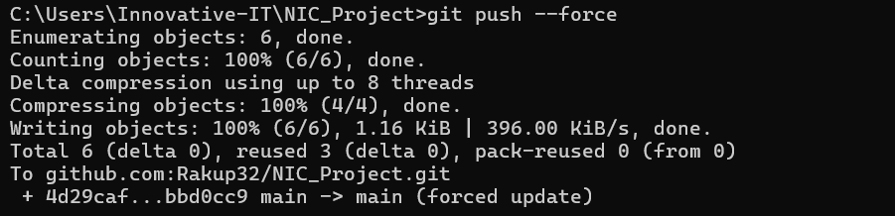

* Branchess

