Objective: a side-scrolling “Taiko No Tatsujin”-esque rhythm game, wherein keyboard keys scroll in from the right side along three distinct rows, requiring the player to either hit the corresponding key or, if along the top or bottom row, hold arrow keys whilst hitting in order to swap rows.

This end product presents several challenges – it involves syncing up the visual cycle of Processing to a rhythm, as well as drawing possibly thousands of notes in a single song with minimal (preferably <0.5ms) of lag to ensure all inputs are received correctly.

The game should be able to take external input from three files – a corresponding MP3, metadata and notechart file – to be able to load a custom-created chart.

Processing is poor at handling multiple key inputs – the requirement for an arrow key to be held whilst another key is pressed will likely be one of the largest challenges the engine will face.

Internal Structure of Note Loading and File Formatting
Each chart in the game will have a metadata file, likely in JSON format, that contains the song’s name, artist, and BPM.

In a separate CSV file, each line will contain a single note in the song, with three pieces of information. The first will be the timing of the note, indicated by a float that corresponds to the measure and rhythm the note is on – for example, a half-beat on the 3rd measure would have a timing of 3.5. Internally, this number will be multiplied by the BPM in order to find the exact millisecond timing of the note – it is represented by a simpler number in the file to make charting easier.

The second piece of information is the key that needs to be hit in order to hit the note, represented by a char.

The third piece is the row the note will be spawned on, represented by a number – 1 is row 1, 2 is row 2 (which will be used the most often), and 3 is row 3.

The game itself will run using an array of objects. When a chart starts, 50 notes will be loaded into the array, and as notes are hit or missed, they will be removed from the array, being replaced with new notes loaded from the imported CSV.

Gameplay
Each frame, the game will test for a new user key input. At this stage, caution will need to be taken to not include held keys, as this may result in charts being easy to cheat by simply holding all of the keys at once. If there is a new key input, the input’s timing will be compared to the first note in the array – if the note is extremely far off beat, the input will be ignored completely. If the note is far off beat but not so far it can be ignored, OR the player hits the wrong key, the note will be missed. If the note is just off beat, it will score a 40, and if the note is perfectly on beat, it will score an 80.

There is an additional consideration to make here – the implementation of a rows system. Each row should be considered separately, with the judgement system on each not considering earlier or later notes on other rows. This is again to avoid cheating – if the rows are considered together, players could easily mash their way through patterns without the reading skill to hit them properly.
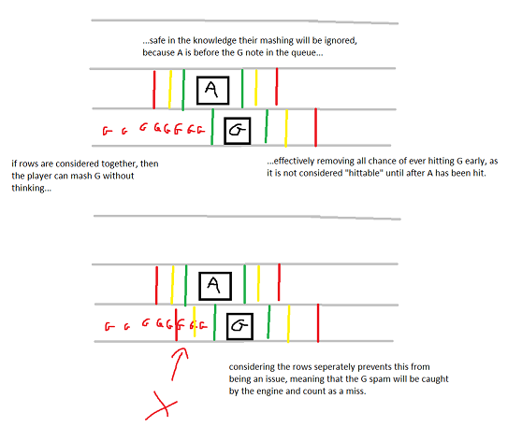

Each time a note is hit, a combo indicator will go up. The combo will multiply the score awarded for each hit by 1+log10(combo+1), rewarding consecutive hits with a higher score, but slowly capping out the score as the combo gets larger. When a note is missed, the combo will be reset.

After processing note hits, the notes will be moved. Each note in the array will have a method called to redraw itself along a new position. The note movement method will check if a note is new on this frame, and set its initial position off-screen if so.

If given time, a scroll speed option may be implemented to allow users to choose how fast notes should appear on screen. The position on-screen is already determined by the millisecond offset and a set scroll speed value, so giving the user the option to change this shouldn’t be hard.

