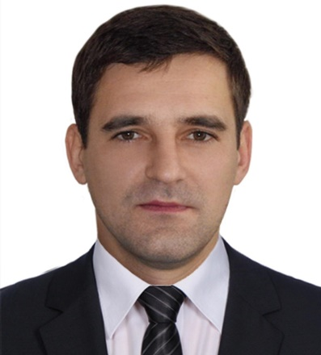YOUR NAME

Dhaka, Bangladesh.

Mobile: Your mobile number

Email: yourmail@gmail.com

**CAREER OBJECTIVES**

Working in a quality based and innovative institution where I will have greater opportunity to apply my knowledge efficiently and by doing so I will be able to improve the quality of the institution and achieve its goal.

**EDUCATIONAL QUALIFICATION**

|  |  |  |  |  |  |
| --- | --- | --- | --- | --- | --- |
| **Degree** | **Institution** | **Board/Faculty** | **Year** | **Group/Dept.** | **CGPA/GPA** |
| M.Sc. | Your University | Your Faculty | 2018 | Your Department | 3.75/4.00 |
| B.Sc. | Your University | Your Faculty | 2016 | Your Department | 3.86/4.00 |
| H.S.C. | Your College | Dhaka | 2012 | Science | 5.00/5.00 |
| S.S.C. | Your School | Dhaka | 2010 | Science | 4.88/5.00 |

**WORK EXPERIENCE**

* JANUARY, 2019 – JULY, 2019

JOB TITLE, COMPANY.

Describe your responsibilities and achievements in terms of impact and results. Use examples, but keep it short.

* AUGUST, 2019 – JUNE, 2020

JOB TITLE, COMPANY.

Describe your responsibilities and achievements in terms of impact and results. Use examples, but keep it short.

* JULY, 2020– PRESENT

JOB TITLE, COMPANY.

Describe your responsibilities and achievements in terms of impact and results. Use examples, but keep it short.

**COMPUTER SKILLS**

* Programing Language : C, C++, Java.
* Operating Systems : Linux, Windows 7 / 8/ 10.
* Office Suite : Microsoft Word, Microsoft Excel, Microsoft PowerPoint.
* Hardware & Software : Able to install any kind of software and maintain computers.

**LANGUAGE SKILLS**

* Bengali: Excellent reading, writing and speaking ability with good proficiency over grammar.
* English: Excellent reading, writing and speaking ability with good proficiency over grammar.

**PERSONAL SKILLS**

* Strong analytical ability
* Strong ability to work with team
* Ability to work under pressure
* Strong report writing skill and presentation skills

**ACHIEVEMENT**

* Obtained Primary Scholarship in 2004
* Obtained Secondary Scholarship in 2008
* Obtained Dean Award in 2016

**INTERESTS**

* Traveling.
* Watching movies, news, cricket.
* Playing cricket, football.

**PERSONAL DETAILS**

Father’s Name :

Mother’s Name :

Nationality : Bangladeshi

Date of birth :

Religion :

Marital Status : Unmarried

Permanent Address :

Blood Group :

**REFERENCE**

|  |  |
| --- | --- |
| 1. Name of 1st reference   Assistant Professor  BUET  01********9  name@gmail.com | 1. Name of 2nd reference   Assistant Professor  BUET  01********5  name@gmail.com |

I, Your Name, hereby to declare that the above furnished information is true to the best of my knowledge and belief.

Sincerely,

**…………………………**

(YOUR NAME)