01709023

Ruifeng Liu

[Ruifeng_Liu@student.uml.edu](mailto:Ruifeng_Liu@student.uml.edu)

# Literature Review I

The papers that I choose as the primary paper is that "**A Data-Driven Approach for Sketch-Based 3D Shape Retrieval via Similar Drawing-Style Recommendation**", and the secondary paper that I choose is that "**A comparison of methods for sketch-based 3D shape retrieval**".

First, let's talk about "**A Data-Driven Approach for Sketch-Based 3D Shape Retrieval via Similar Drawing-Style Recommendation**".

Sketches are a natural and simple way for human expression and communication. Because of this reason, with the advent of multi-touch tablets and styluses, it has become increasingly popular in human-computer interaction. In these years, sketch-based interactive methods have been widely used in many retrieval systems. Particularly, almost all sketch-based 3D model search works have appeared. The opinion of the 3D model leads to unsatisfactory search results. As a result, in the matching process during retrieval, they match each 3D model of the historical user (rather than the projection view). In addition, since the sketches between the current user and the history user may differ greatly, it is also intended to deal with the user's individualized deviations and differences.

In general, sketches can be summarized in two ways:

1. The fuzziness of the sketch information is due to the fact that the sketch's integrity changes with the painting process. Most users who do not have the basic skills of painting may have subtle differences from their actual ideas. That is, there is no fixed mapping between the user's expression and the sketch.
2. The subjective user input caused by user input is not only they are related to their field background, thinking style, hand-painting habits and preferences, but also affected by the graphics structure and equipment. These two features not only make sketches express creative thinking, but also make hand-drawn sketch recognition methods robust enough to support user interaction.

01709023

Ruifeng Liu

[Ruifeng_Liu@student.uml.edu](mailto:Ruifeng_Liu@student.uml.edu)

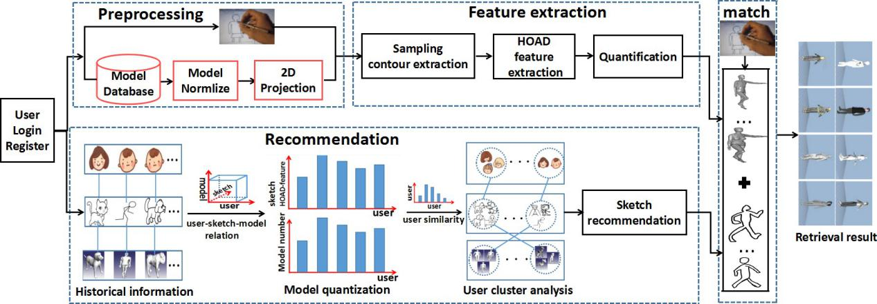

In this article, they introduce a user-based drawing style suggestion for 3D model retrieval. During the retrieval process, the system records the user's sketch and extracts its outline feature vector. Next, the extracted feature vector matches the features of the historical user-recommended sketch rather than the three-dimensional model projection view used in the traditional study. This innovative strategy can avoid the challenges of significant differences between sketches and projected views. Their system uses a recommendation algorithm to find historical users from previous users who have a similar drawing style to the current user. It is worth mentioning that their research adopted a recommendation algorithm based on collaborative filtering (CF), which was successfully used in the recommendation system. However, unlike traditional CF-based methods, traditional CF-based methods use user-provided items as the only source of information for learning recommendations. Their recommendation algorithms not only consider the intrinsic relationship between users, sketches, and models, but also explore Feature representation, not user discussion of the project

My second paper : "**A comparison of methods for sketch-based 3D shape retrieval**"

There are many researches on shape-based shape retrieval, but all of these studies must face a common problem that there is a large deviation between the user's input and the entity. Therefore, the effective search paradigm based on sketch has become a hot topic of content-based 3D object retrieval. Although a large number of sketch-based shape retrieval methods have emerged, none of them attempted to improve the results by adopting a recommendation method to find users with a similar painting style to the target user.

Sketch-based 3D model retrieval focuses on using sketches as input to retrieve relevant 3D models. This intuitive and convenient solution allows users to easily learn and use to search for 3D models. It is also very popular and important to generate 3D animations for related applications such as sketch-based modeling and recognition and 3D reconstruction through 2D storyboard scenes.

However, most of the existing 3D model retrieval algorithms are aimed at querying the framework by model, ie using the existing 3D model as a query. In the field of content-based two-dimensional

01709023

Ruifeng Liu

[Ruifeng_Liu@student.uml.edu](mailto:Ruifeng_Liu@student.uml.edu)

image retrieval and image synthesis, sketch-based methods have been available for some time. On the other hand, in the 3D model retrieval, so far, less work is considered Sketch-by-Sketch framework. In fact, performing sketch-based 3D model retrieval is an unusual task and is also more difficult than querying by model. This is because there is a semantic gap between human-drawn sketches and 3D models in the database, which means that the structure of the query and the target object is different. Specifically, target objects are often provided as precisely modeled objects, and query sketches may differ greatly in detail, abstraction, and accuracy. In addition, a comprehensive evaluation or comparison of a large number of available sketch-based search algorithms has not been conducted so far.

We all know that users are usually non-professionals, and their painting style is related to the field background, thinking style, hand-painting habits and preferences. The first paper focus on the recommendation system where users may have the similar drawing style. The second paper does not focus on the same topic, but it focus on the comparison of different shape-based retrieval. And Analysis the efficiency of each retrieval basing on numbers of result from comparison.