Google Play Store Data Analysis & Visualization
  - A Data Analysis and Visualization Project using Python and Power BI
Tools Used: Python (Pandas, NumPy), Power BI, Google Colab
1. Project Summary
This project focuses on analyzing Google Play Store applications to derive insights about their performance, pricing, installs, and ratings. The analysis involves data cleaning and preprocessing using Python, followed by visualization using Power BI. The final dashboard presents app performance metrics across various categories, content ratings, and types (Free vs Paid).

2. Objectives
• Clean and preprocess raw Google Play Store data for accurate analysis.
• Handle missing values and inconsistent formatting in the dataset.
• Identify relationships between installs, ratings, price, and app categories.
• Build an interactive dashboard in Power BI to visualize app trends.

3. Data Cleaning and Preparation
The data cleaning process was carried out using Python libraries such as Pandas and NumPy on Google Colab. The following steps were followed to ensure the data was ready for visualization:
• Loaded the dataset and performed initial inspection using df.info() and df.describe().
• Replaced missing values in categorical columns (like Content Rating) with mode and numerical columns (like Rating) with mean/median.
• Dropped irrelevant columns such as 'Current Ver' and 'Android Ver'.
• Converted 'Reviews', 'Installs', and 'Price' columns into numeric data types.
• Cleaned 'Size' column by converting values with 'M' and 'K' suffixes into MB units.
• Handled outliers by removing extreme values in installs and price.
• Saved the cleaned dataset as 'Cleaned_google_play_store.csv' for further use.

4. Power BI Dashboard
The cleaned data was imported into Power BI to create an interactive dashboard. The dashboard presents key metrics, comparisons, and relationships among app features such as installs, ratings, reviews, and size. Filters were applied for deeper insights based on category and content rating.
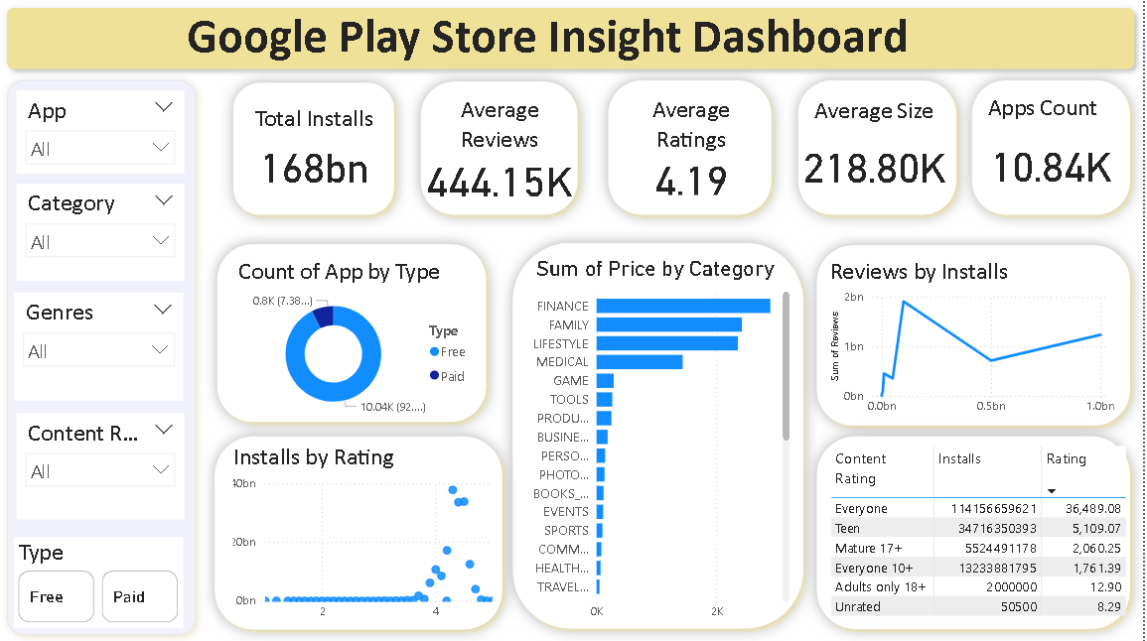

5. Business Insights
1. Over 92% of apps are free, reflecting the dominance of the freemium model in the Play Store.
2. Apps with higher ratings (4.0–4.5) generally have more installs, indicating strong user trust and engagement.
3. There is a positive correlation between reviews and installs — popular apps attract more user feedback.
4. The 'Game' and 'Communication' categories dominate in total installs, while 'Finance' and 'Medical' categories have higher-priced apps.
5. Apps smaller than 50 MB tend to have more downloads, suggesting users prefer lightweight applications.

6. Conclusion
This project demonstrates an end-to-end data analysis workflow — from raw data cleaning in Python to business insight generation through Power BI visualization. The findings highlight patterns in app pricing, category performance, and user engagement that can help developers and marketers make informed decisions about app development and promotion.

